Support Clean Water for Syrian Refugee Camps | Campaign 1
The ongoing conflict in northern Syria has severely disrupted access to clean water, particularly affecting displaced communities living in formal and informal camps in the Afrin region. This project aims to address the critical water shortage exacerbated by the summer heat by delivering water via trucks to approximately 15,000 displaced people over two and a half months. By ensuring a consistent water supply, we aim to prevent water-borne diseases, improve hygiene, and reduce health risks such | Summary
10.000 | total goal
Our project will deliver water by truck daily to 15,000 displaced people in Afrin for two and a half months. This intervention will ensure a steady supply of clean water during the hottest period of the year, reducing the risk of disease outbreaks and improving overall health and hygiene. The consistent water supply will help maintain sanitary conditions, prevent heatstroke, and support the community's resilience during this critical time.  Key Activities:  Water Tank Installation: Installing 100 water tanks across 20 camps to store and distribute water effectively.  Water Purification Systems: Introducing mobile purification units to treat contaminated water sources.  Hygiene Promotion: Conducting hygiene awareness sessions to educate communities about safe water practices and sanitation. | Solution
July 2024 | date of Implementation
5 Camps | Number of cases
Project #65250 | Project code
NW Syria Afrin camps | Distribution location
The IDPs of six resides in a camp in northern Syria. Their water source is a contaminated nearby river, leading to frequent illnesses among the children. The father suffers from kidney disease, and the mother is burdened with managing the household and caring for the children. With no income, they rely on unsafe water, which has worsened their health conditions. This project provided the family with a water tank and regular clean water delivery, significantly improving their health and living conditions. | The story of a family in Syria.
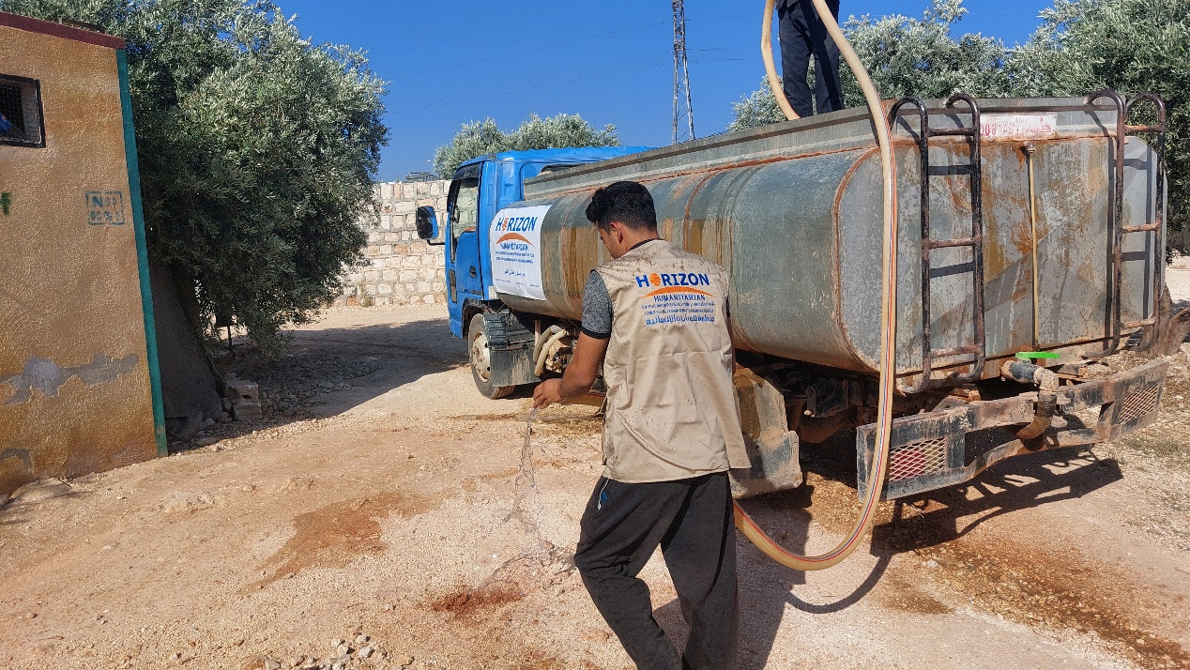  Distribution of Water to the IDPs in Afrin camps  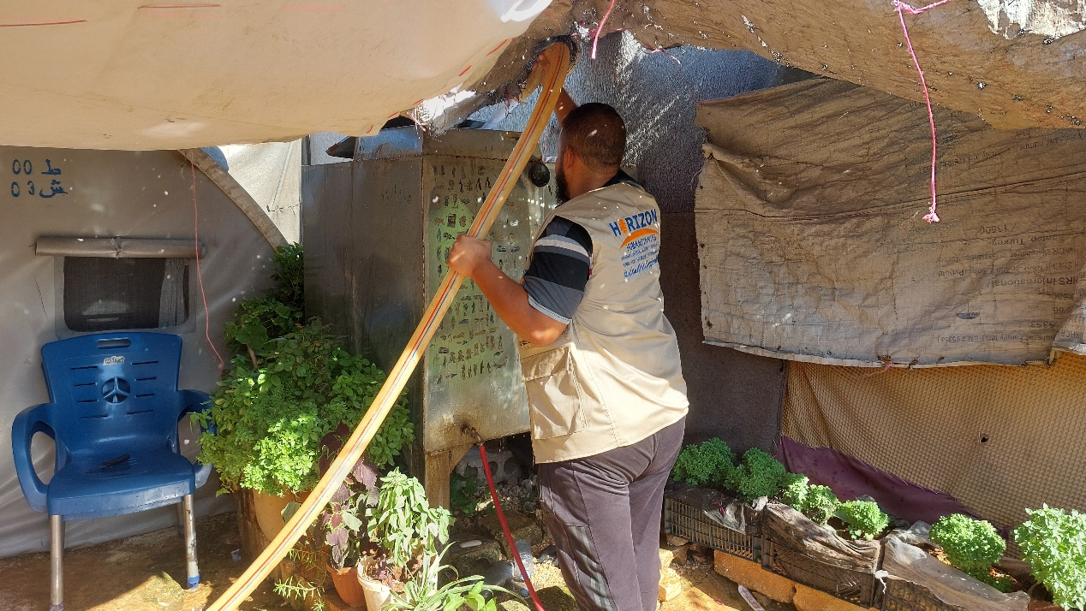  Distribution of Water to the IDPs in Afrin camps  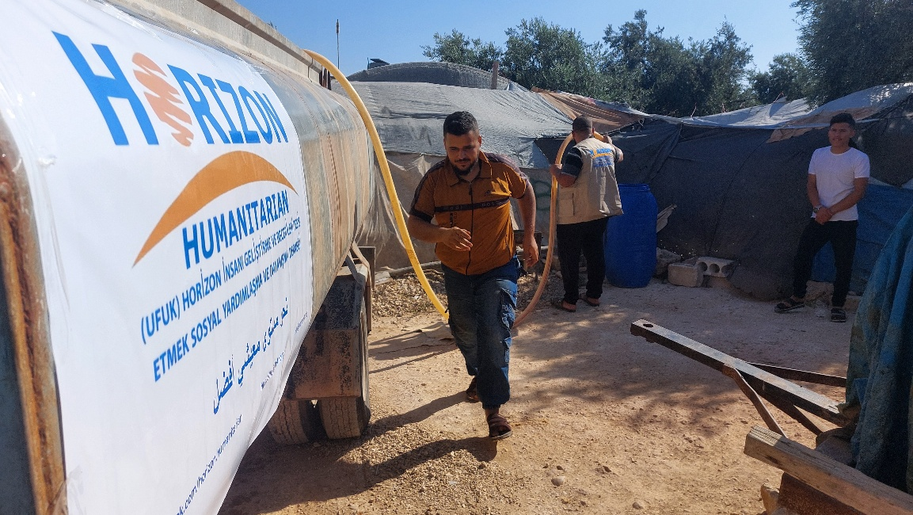  Distribution of Water to the IDPs in Afrin camps  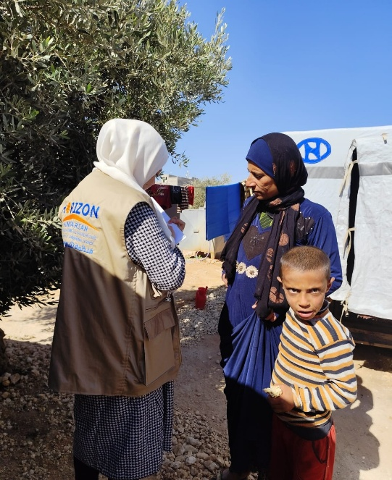  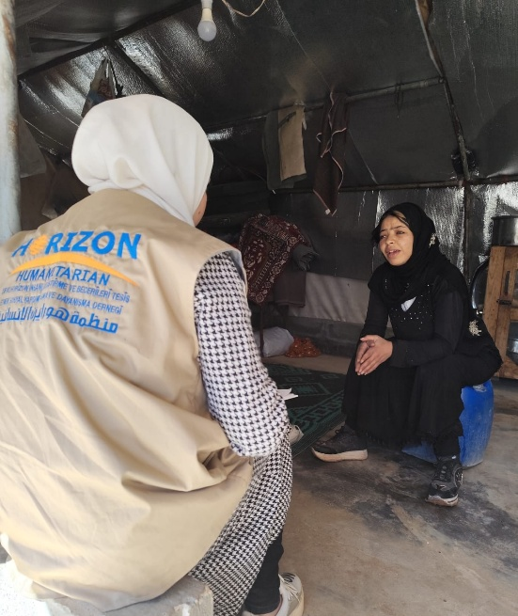  Conducting the PDM in the camps by Hori | Photo Syria

