Feed the Hungry: Support Syrian Refugee Families | Compain 1
The proposed project aims to alleviate the suffering of Syrian refugees and internally displaced persons (IDPs) in Turkey and Syria by distributing food baskets to those most in need. The project responds to the dire living conditions and lack of job opportunities faced by over 600,000 Syrian refugees in Sanliurfa, Turkey, and many more displaced individuals within Syria. Widows, who have lost their breadwinners and struggle to meet basic food needs, are particularly vulnerable | Summary
10.000 | total goal
The solution involves distributing 500 food baskets to the neediest refugees and IDPs in Turkey and Syria. Each basket will contain essential food items such as sugar, tea, rice, oil, and more. The project will involve purchasing food, packing it into boxes, and distributing it across different sectors in Sanliurfa and affected areas in Syria. Media documentation and detailed records will ensure transparency and accountability. | Solution
July, August 2028 | date of Implementation
6 family | Number of cases
14 | Number of boxes
Syria /Turkey | Distribution location
The family consists of 6 members. They came to northern Syria to escape the war in the Aleppo countryside. They now live in a makeshift camp in the north of Idlib.  The father suffers from cancer and the mother is diabetic.  They have four children who live in a tent that does not protect them from the summer heat. They have no source of income. The mother works part-time in ploughing agricultural land. The mother cannot work permanently because she cares for her sick husband and four children. Her youngest son, who is two years old, suffers from diseases due to hunger, lack of food and lack of clean drinking water.  The older children did not go to school before because the mother could not meet their needs.  Two food baskets were distributed to the family to help them meet their food needs for one month. | The story of a family in Syria.
A widow. Her husband died in the war in Syria as a result of the indiscriminate bombing of the countryside of Deir ez-Zor. She has one son. She is accompanied by two children, the sons of her sister who died with her husband during the war in Syria. They entered Turkey in 2017. She lives in a house with the children that does not have all the necessities of life. She cannot work because there is no one to take care of the children. She relies on the help of her neighbours in her life. They do not receive any assistance from official bodies because the house is not registered with the Civil Status Department. Her nephew is mentally ill with Down Syndrome. She cannot leave him alone in the house and therefore cannot work. Two food baskets were distributed to meet their nutritional needs for this month. | The story of a family in Turkey
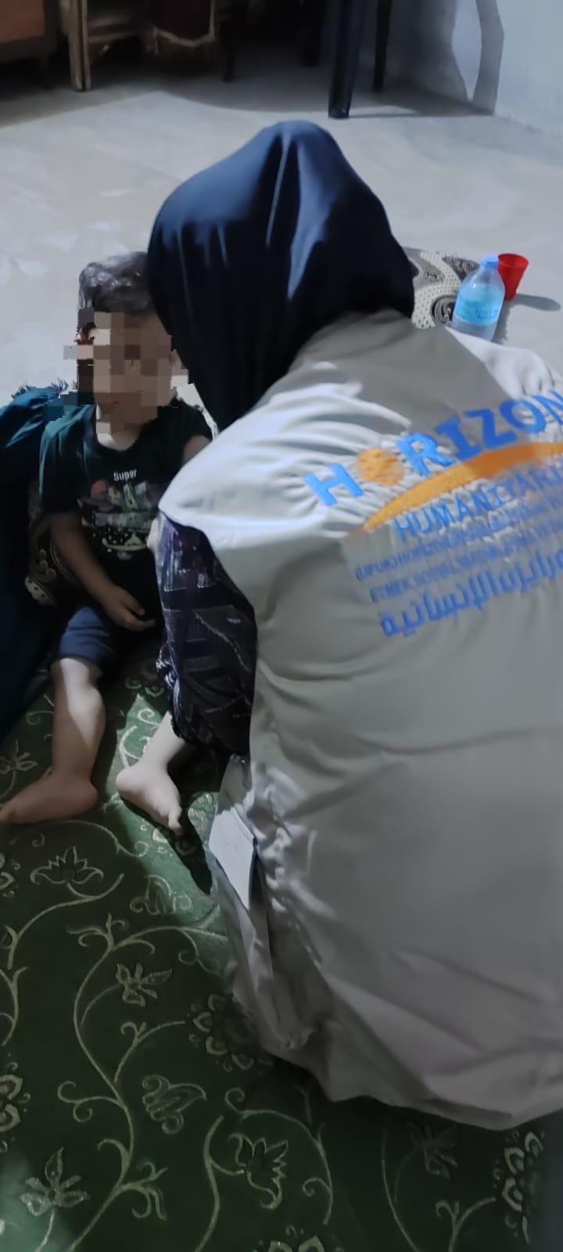  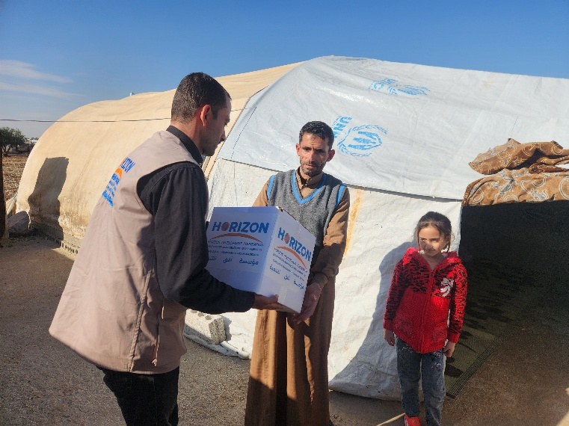  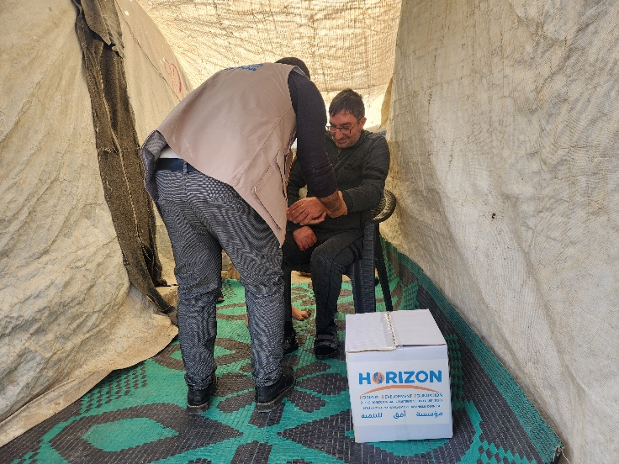 | Photo Syria
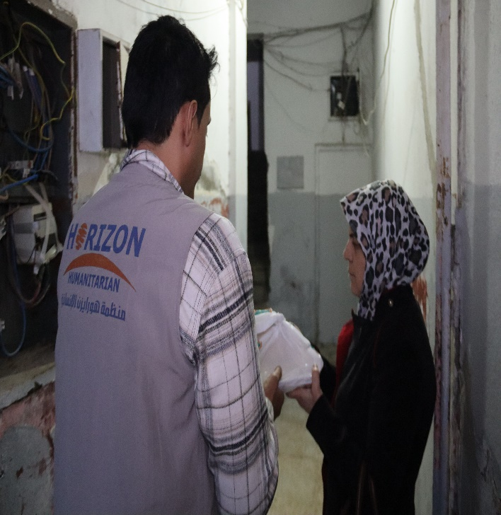  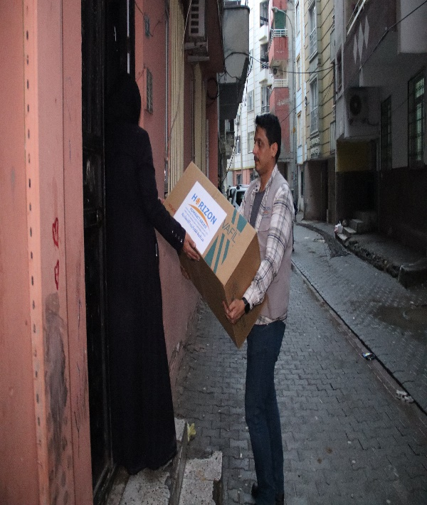  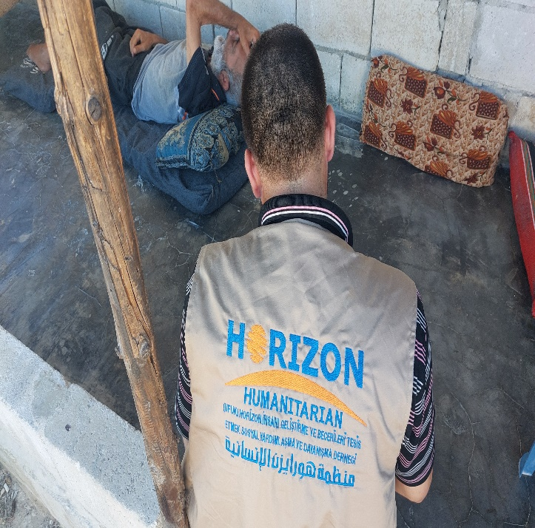 | Turkey photo

