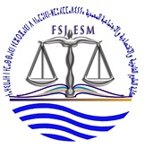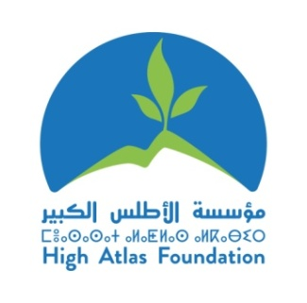

***Pictures of workshops from period November, 2015 to January,2016***

**Photos from the workshop with students and CSOs of Mohammedia on “Model the Harvard Institute for analysis by gender social" on November 14,2015**

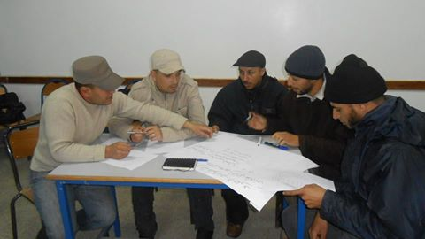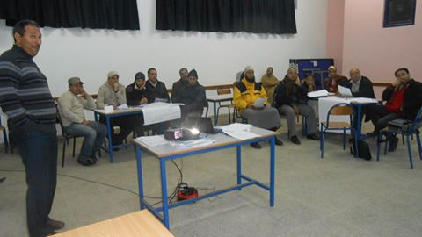 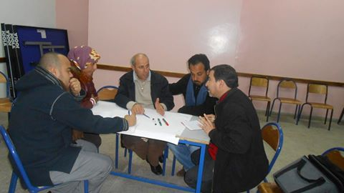

**Photos from the workshop with association Ajial youth of development on “determination of priority projects in the community " on November 20,2015**

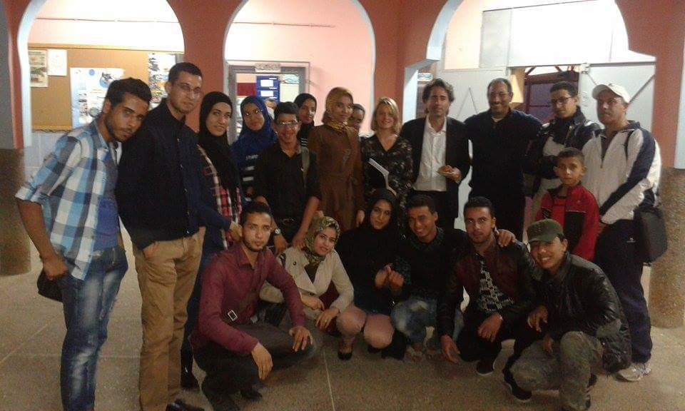 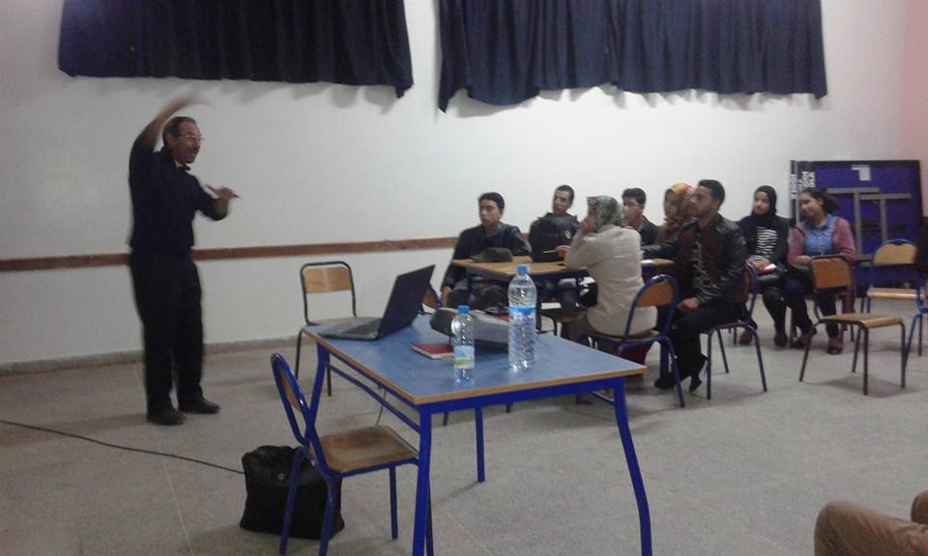 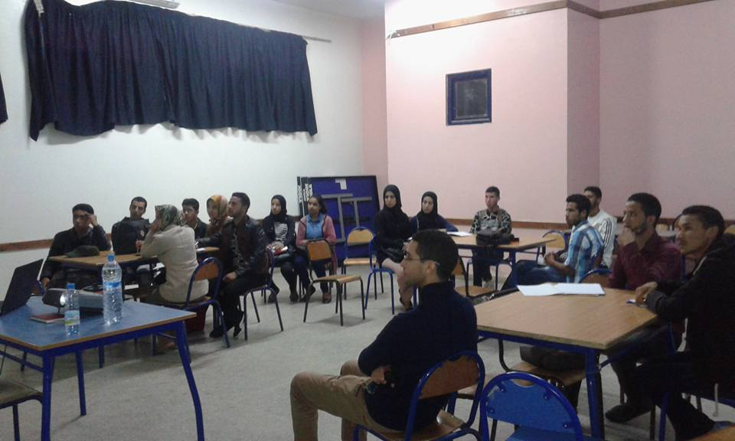

**Photos from the workshop with students and CSOs of Mohammedia on “Techniques of Gender analysis for projects" on November 21, 2015**

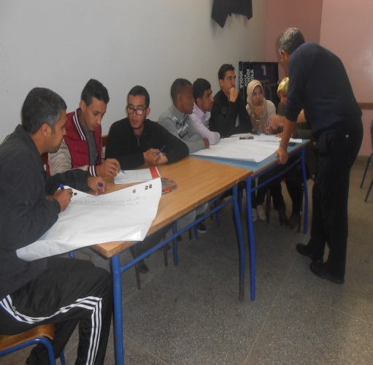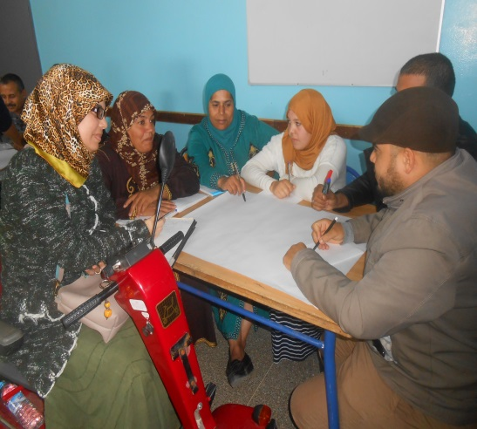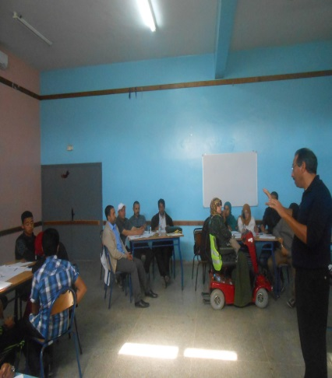

**Photos from the workshop with association Ajial youth of development on “Capacity building for the preparation of project proposal “on December 11,2015**

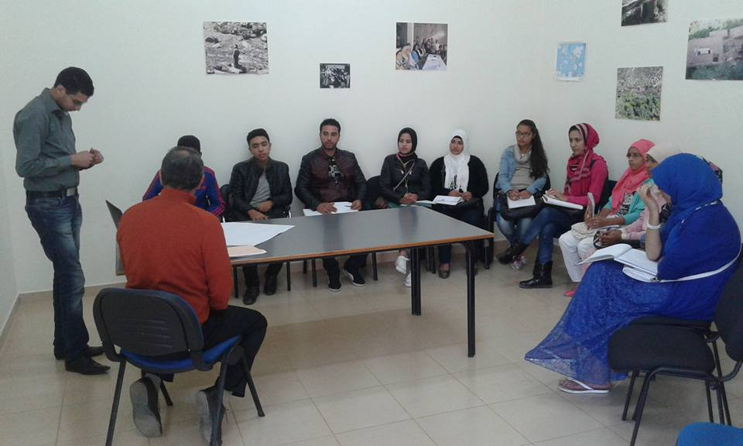 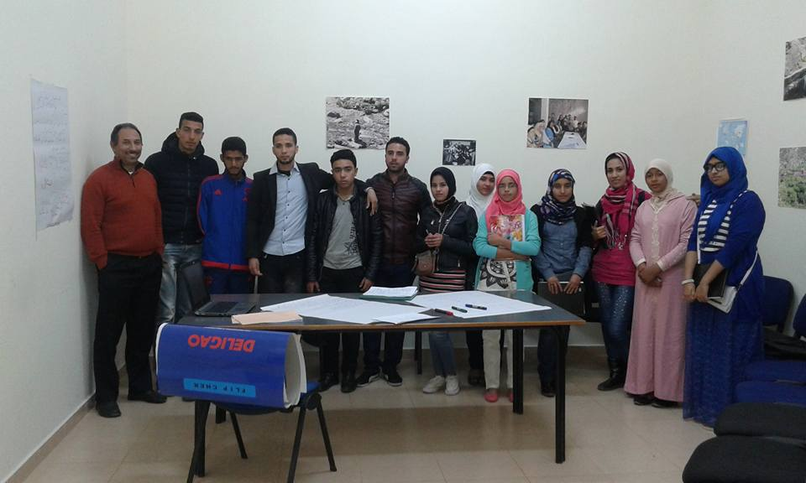

**Photos from the workshop with students and CSOs of Mohammedia on “Conflicts Management" on December 12, 2015**

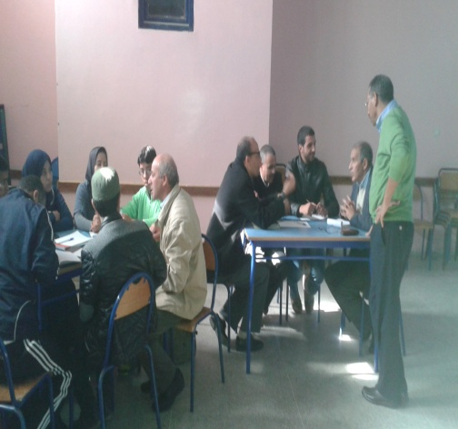 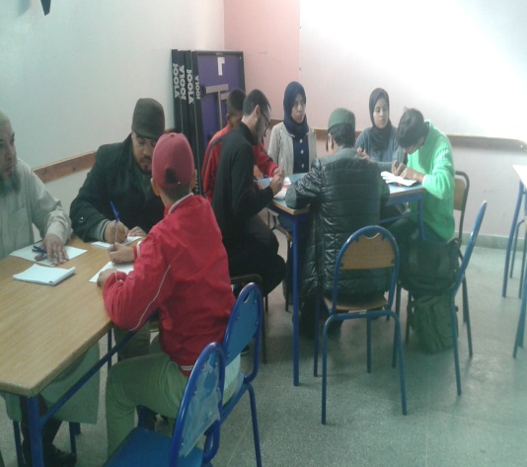 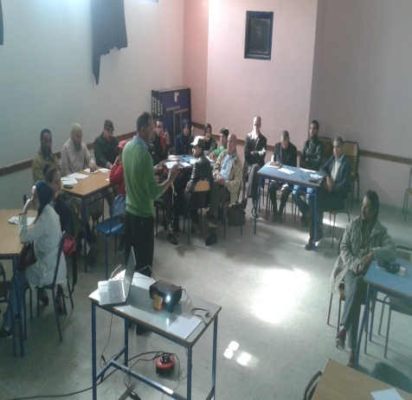

**Photos from the workshop with CSOs at Boujdour on “Presentation of sewing project of association of specific needs" on January 02,2016**

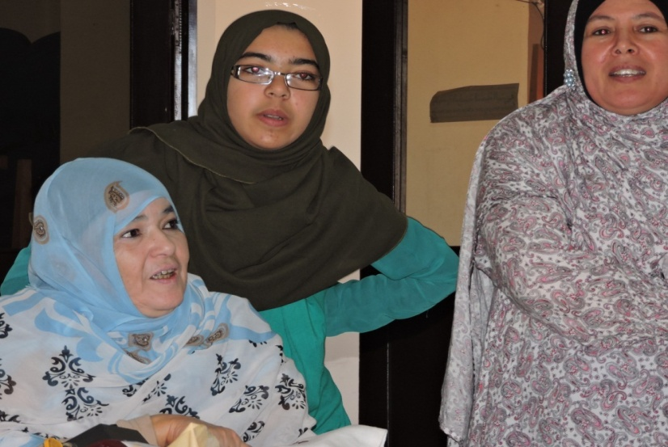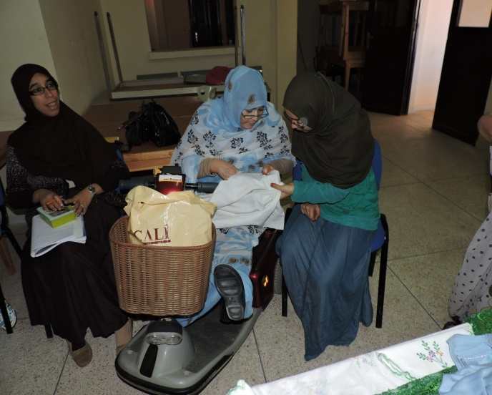

**Photos from the workshop with CSOs at Boujdour on “Modern feminist sewing and embroidery authentic " on January 09,2016**

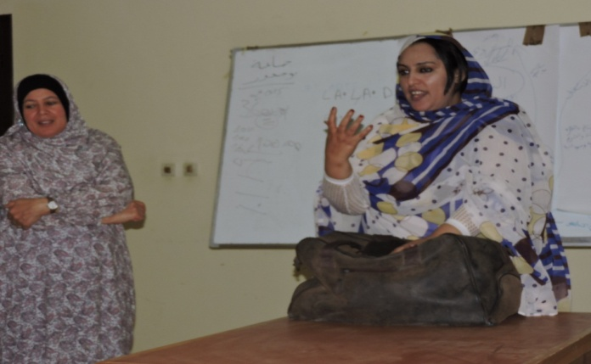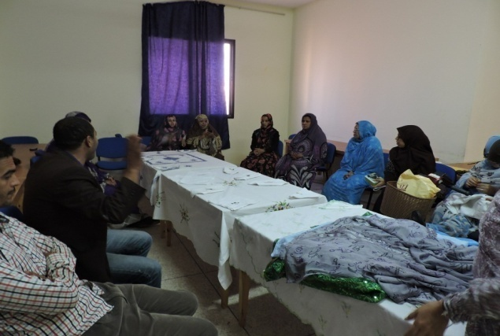

**Photos from the workshop with CSOs at Boujdour on “the criteria of success for development projects “ on January 16,2016**

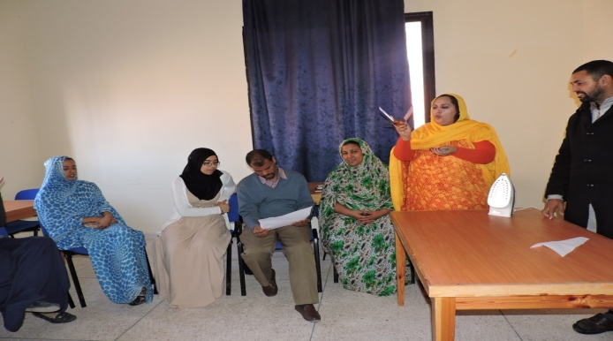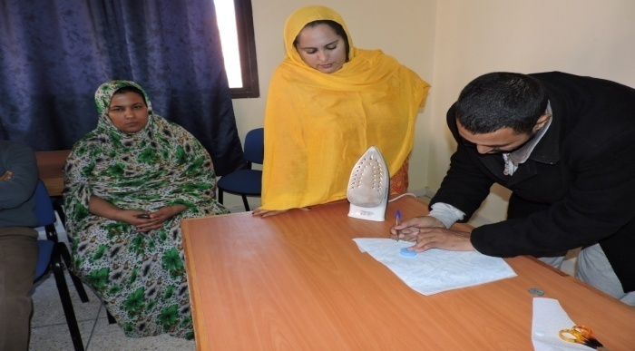

**Photos from the workshop with students and CSOs of Mohammedia on “Negotiation Strategy" on January 16, 2016**

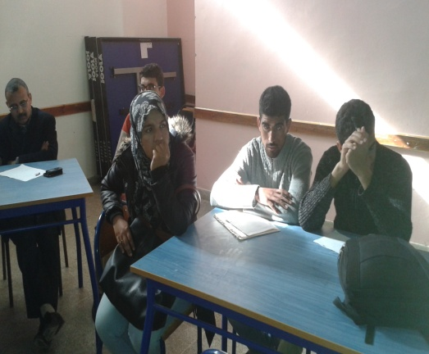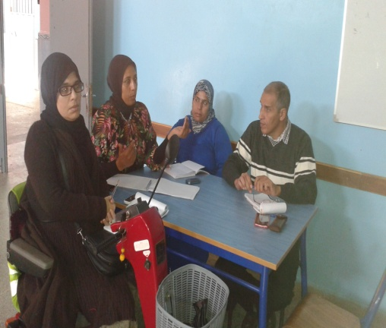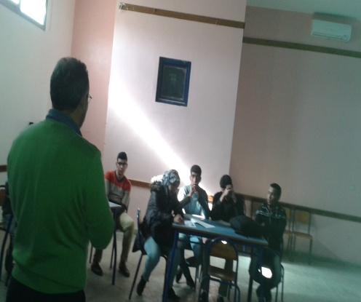

**Photos from the workshop with Legacy International,  Jo Nelson (TAP, Roanoke), Arthur Cutler (Lawyer and Expert in NGO capacity building from Fair Chance, Washington DC) and Booke Stedman (Women inInternational Security, Washington DC) and students and CSOs of Mohammedia on “Discussion of Volunteer Project " on January 20,2016**

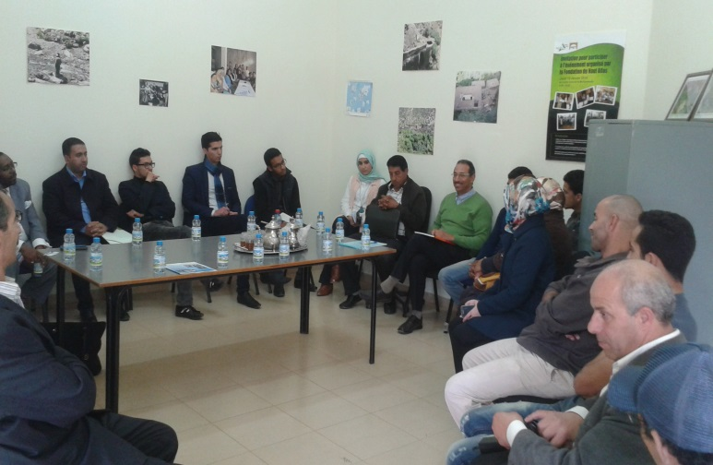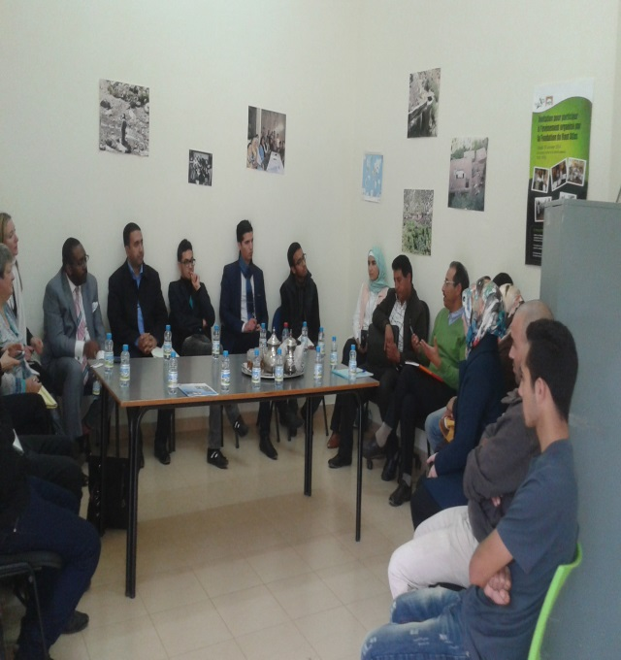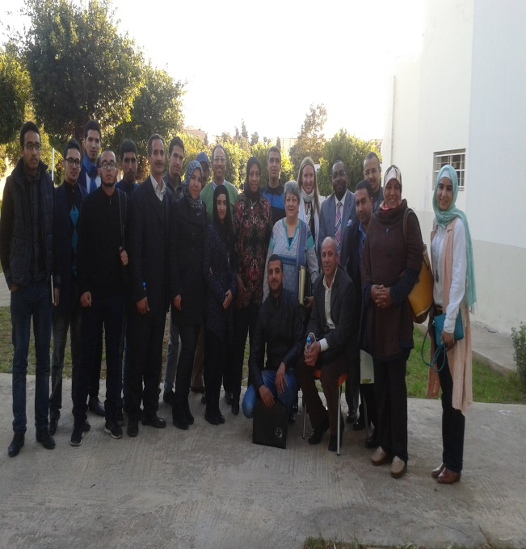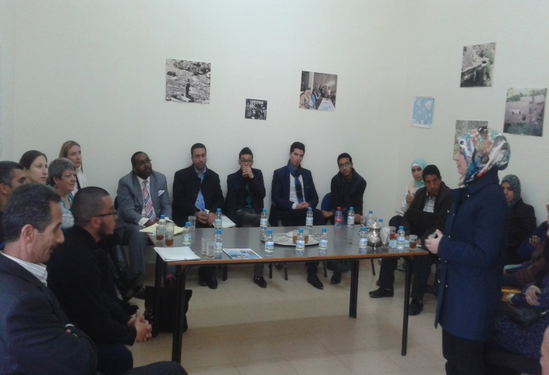

**Photos from the workshop with CSOs at Boujdour on “the sharing of experiences of CSOS of his projects “ on January 21,2016**

