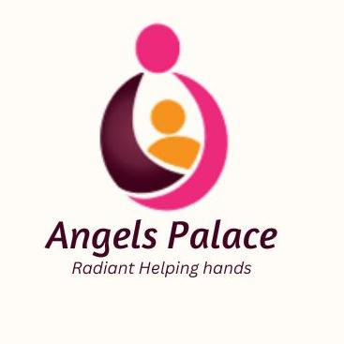

 Our Story

Project Title: RESTORING DIGNITY – END PERIOD POVERTY
Summary: In Rural Zimbabwe... did you know that thousands of orphans and vulnerable Children are deprived of menstrual hygiene products. Getting your period can be an overwhelming and confusing experience. But it can be especially distressing for girls if a period comes as a surprise or is surrounded by secrecy and shame. 1.8 billion people across the world have periods — they’re a natural, healthy and normal part of life. But sadly, the topic of periods is still taboo. Many girls are taunted and shamed about something that is natural. Others are excluded from social and family events. A bad experience with a first period can shape a girls’ perspective of her body for years to come. It can make her feel isolated, stop her from asking for help and from understanding how to manage her periods hygienically. This can lead to infections, worry and upset. As Angels Palace We are dedicated to offering an opportunity for a better future to these children facing challenging circumstances

Recommended 500 character maximum
Funding Amount/Goal: USD 15 000.00

Challenge  1 million of orphans and vulnerable children live in challenging conditions in Zimbabwe Rural, with the majority having no access to menstrual hygiene products. There are many challenges that children need to overcome because of period poverty. Children who have their menstrual cycle monthly need to have good and safe hygiene products and health facilities to visit if required. The lack of access to harmless and hygienic products has caused these orphans and vulnerable children to use other unsafe products. Zimbabwe still have problems creating a safe place for children to manage their menstrual products comfortably and with dignity. Not all schools provide clean toilets and water. This has caused women to wear menstrual products for a long period of time, which can affect their health. The prolonged use of menstrual products, such as pads, tampons, or menstrual cups, increases the risk of infections such as urinary tract infection and bacterial vaginosis. | Solution  Addressing period poverty requires concerted efforts from institutions and organizations to achieve menstrual equity. This involves ensuring access to sanitary products, proper toilets, hand-washing facilities, waste management and hygiene education. Providing resources alone is insufficient. Education on menstrual hygiene for both young girls and boys is crucial to prevent child marriages, early pregnancies, malnourishment, domestic violence, and pregnancy complications, by raising USD 15 000 we ensure dignity pack for 1500 orphans and vulnerable children in rural areas of Zimbabwe | Long-Term Impact  Through educating orphans’ menstrual hygiene, we empower them to look after themselves and overcome challenges they face during their menstrual cycle. We reintegrate them into the education system and provide vocational training to train them to make their own hygiene product that can be useful in the long run This enables them to attend school and gain extra knowledge on menstrual health .  ?

Donation Options:

Amount | Description
$10 | Will cover a dignity pack for a child, including bathing soap,2 towel, 6 packs of pads , undies , a bottle of perfume and roll on for a child plus 1 afternoon meal
$30 | Will cover a dignity pack for 3 children, including bathing soap, 2 towels, 6 packs sanitary pads , undies , a bottle of perfume and roll on for a child plus 1 afternoon meal
$50 | Will cover a dignity pack for 5 children, including bathing soap, 2 towel, 6 packs sanitary pads, undies, a bottle of perfume and roll on for a child plus 1 afternoon meal
Photo Gallery

PHOTO  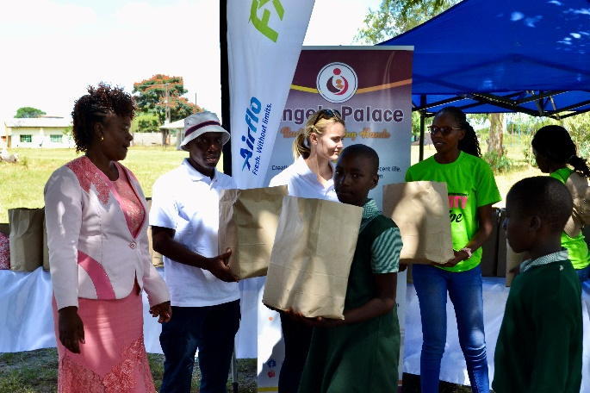 | PHOTO  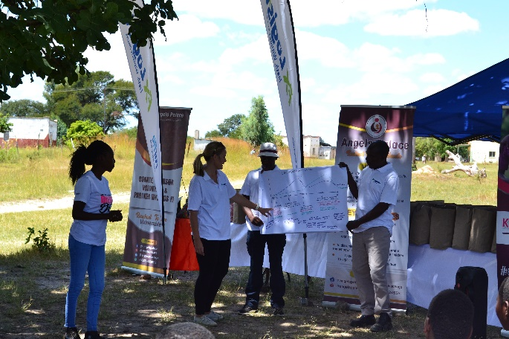
Children receiving a dignity pack | Education on Menstrual Health
PHOTO  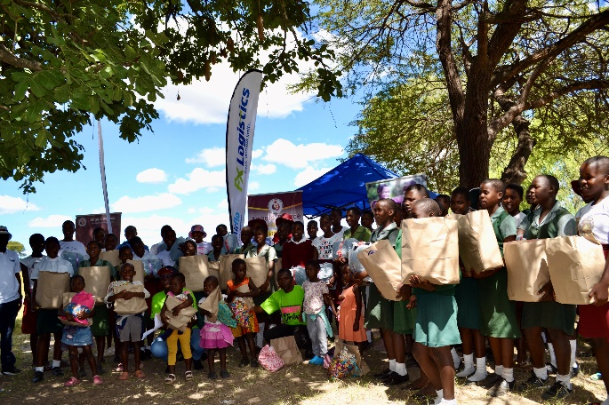 | PHOTO  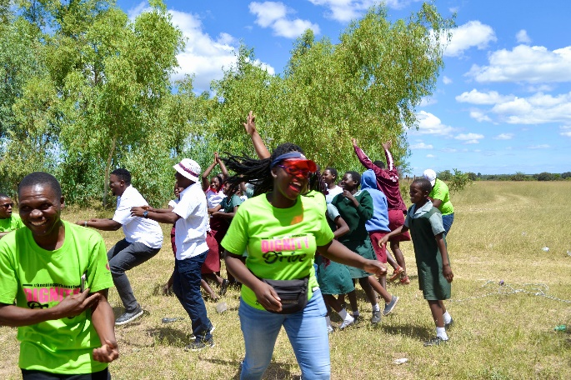
Children with their Dignity Pack | Joyful Moments

