Global Giving Report-SCEF Learning Hub
Location: SCEF Learning Hub Centre
Implementing Organization: Street Children Empowerment Foundation (SCEF)
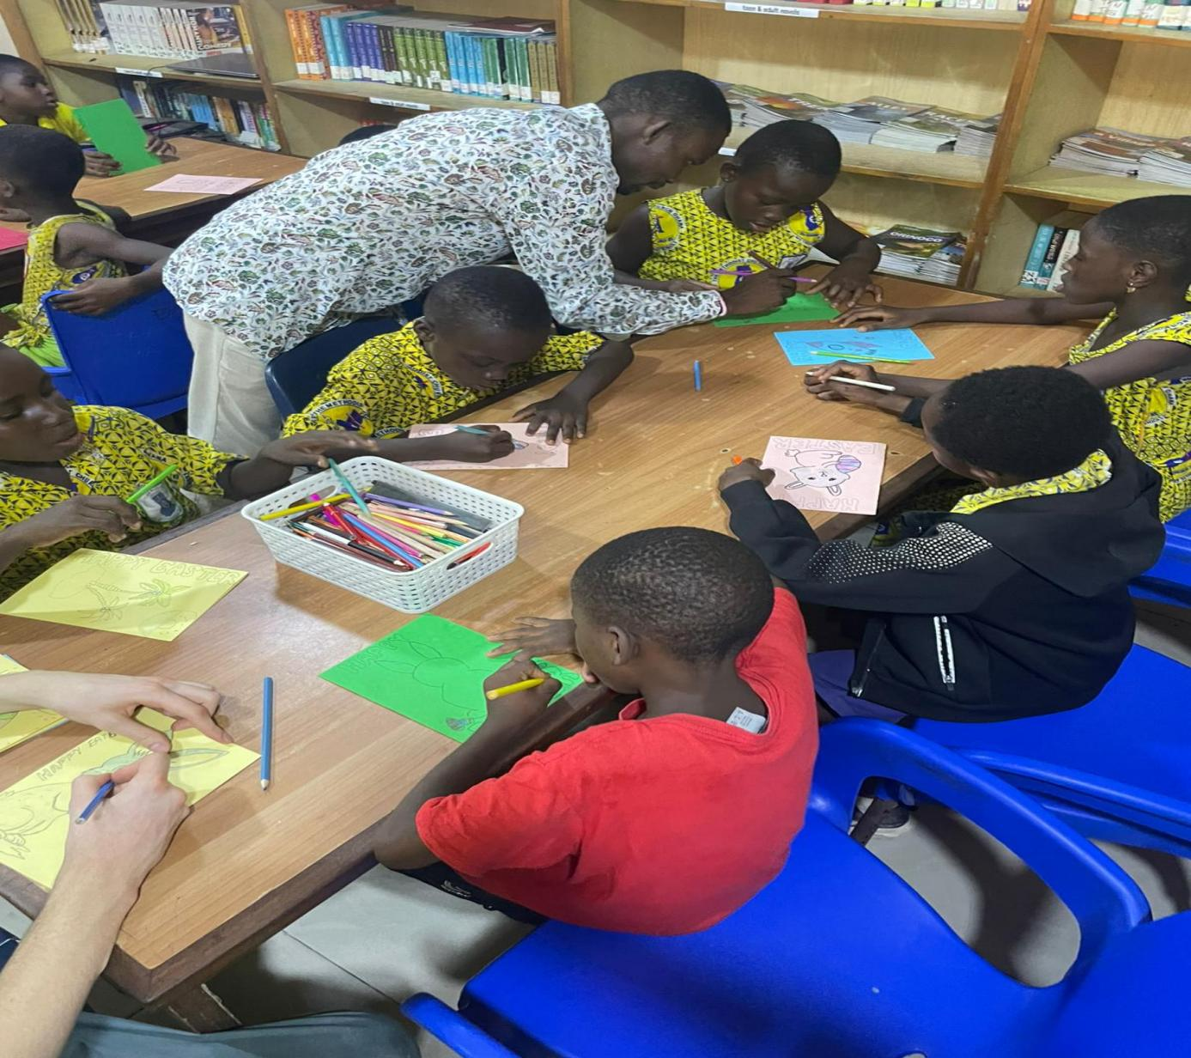

1. Executive Summary
During the past quarter, the SCEF Learning Hub continued to provide structured after-school support focused on:
- Literacy development
- Reading engagement (SCEF Reads)
- Creative arts and craft activities
- Health and life skills promotion, including personal hygiene
This quarter emphasized strengthening foundational reading skills, building creativity, and promoting practical life skills in a safe and supportive environment.
Overall, learners demonstrated increased enthusiasm for reading, improved participation during group sessions, and stronger engagement in creative and life skills activities. The Hub continues to serve as a safe learning space that nurtures confidence, curiosity, and personal growth.
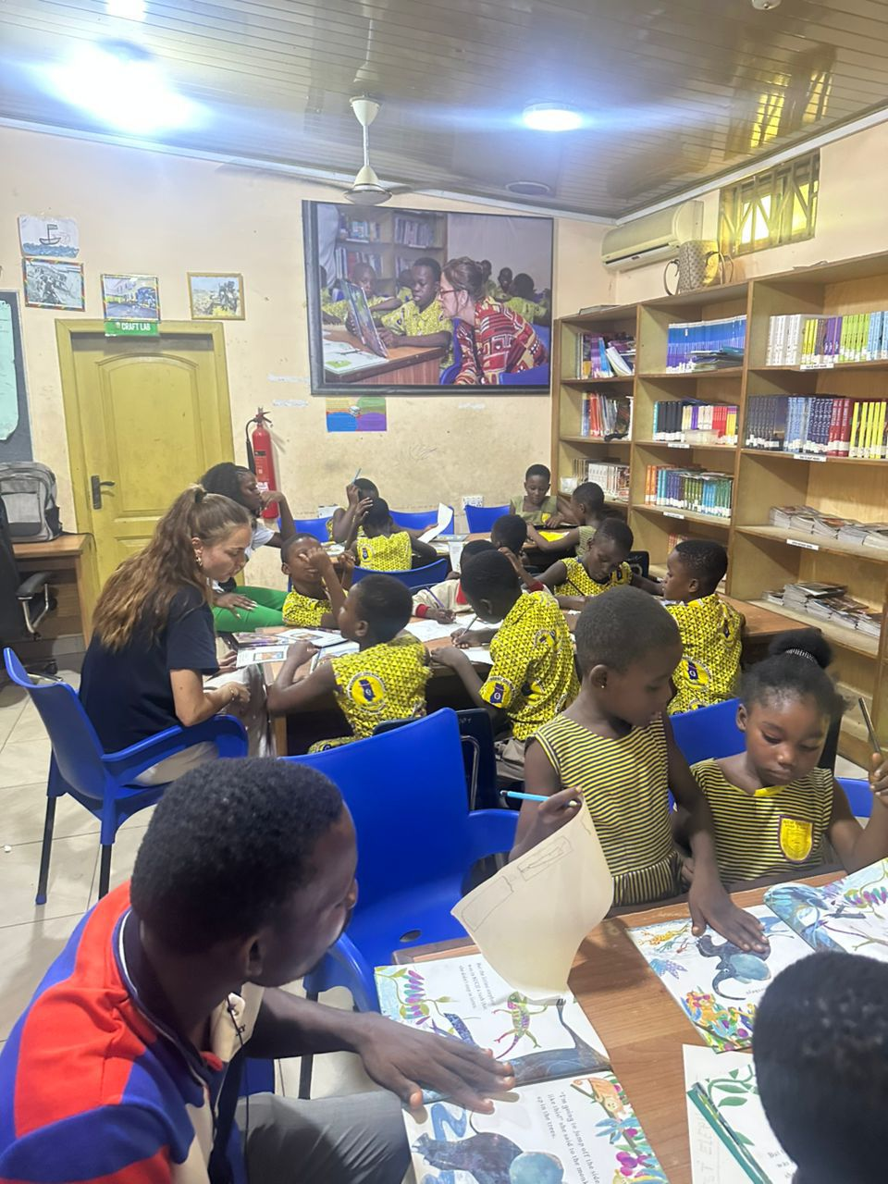

2. Program Overview
The SCEF Learning Hub supports vulnerable and street-connected children by providing:
- Guided reading and literacy support
- Structured reading engagement sessions (SCEF Reads)
- Creative arts and craft activities
- Health, life skills, and personal hygiene education
- A safe, structured after-school environment
The goal is to build literacy, creativity, confidence, and practical life skills that support long-term development.

Key Activities Implemented.
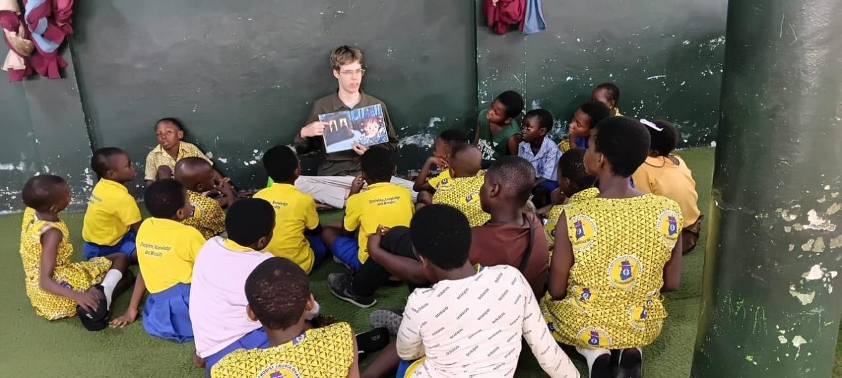

3.1 SCEF Reads Session
During this quarter, children were happily engaged in a SCEF Reads session featuring the book “Alexander von Humboldt.”
The children experienced the joy that comes from listening to a story, understanding it, and reflecting on its deeper meaning.
Through the reading, they learned:
- How nature is deeply connected
- Why protecting the environment is important
- The value of curiosity and lifelong learning
- The joy of following one’s interests, talents, and unique path
Smaller groups were formed to allow:
- More personal interaction
- Open discussion
- Better connection between the story and their own lives
This approach helped children freely express their thoughts and relate the lessons to their personal experiences.

3.2 Paired Reading Practice

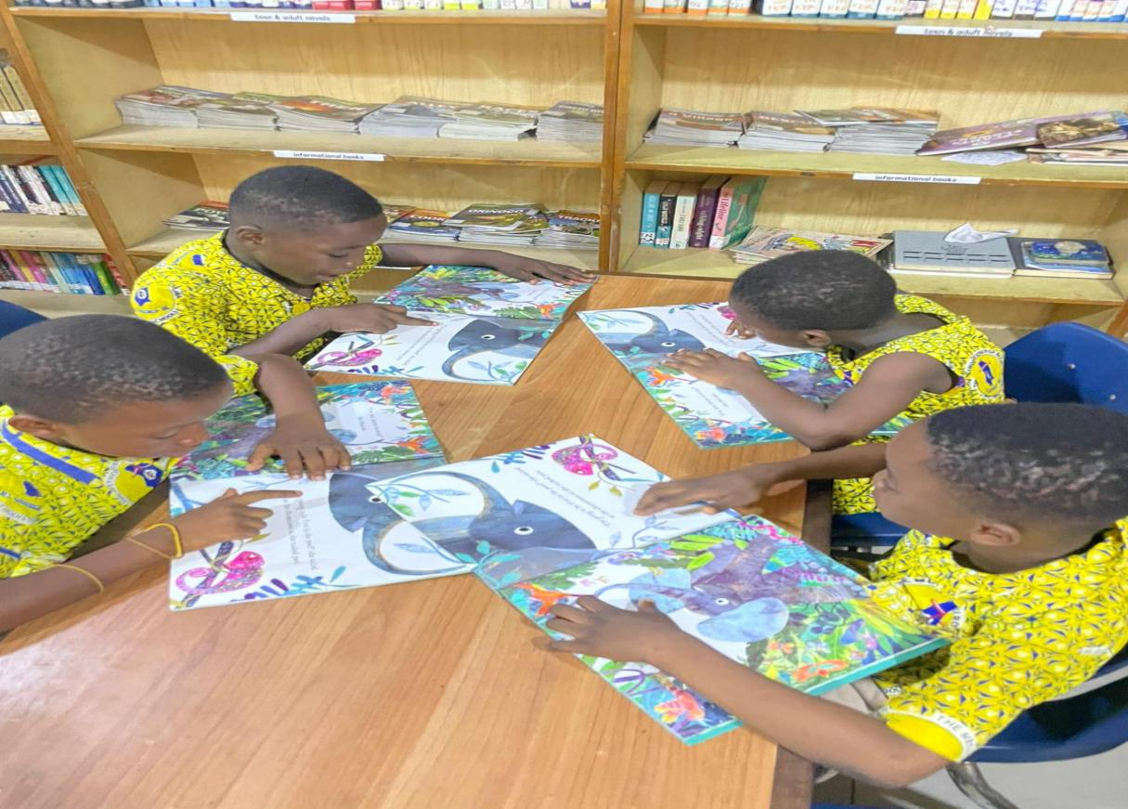
Children practiced paired reading, where they read together in pairs and helped each other with difficult words.
This activity encouraged learners to:
- Listen carefully to their partners
- Decode unfamiliar words collaboratively
- Build reading confidence
- Support and motivate one another
Paired reading reinforced teamwork and strengthened literacy skills in a fun and engaging way.

3.3 Creative Arts and Craft Activity
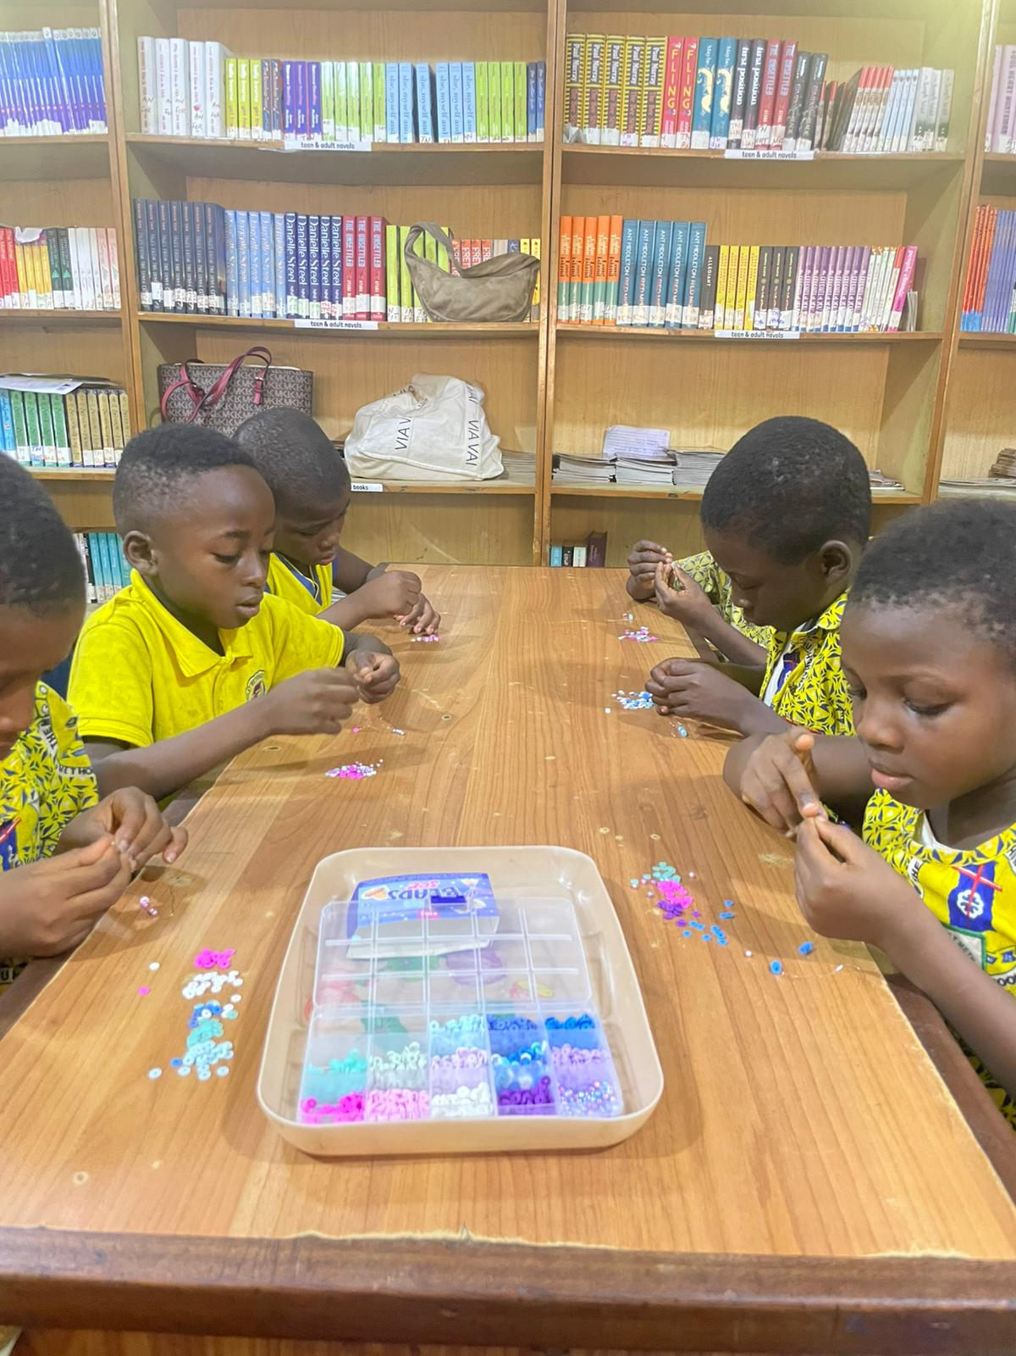
Young learners participated in a craft activity, creating beaded bracelets.
Through threading, patterning, and tying, children made colorful, unique pieces that reflected their creativity and personality.
Each bracelet demonstrated:
- Fine motor skill development
- Patience and concentration
- Confidence and self-expression
The activity fostered pride in personal achievement and encouraged problem-solving through hands-on learning.

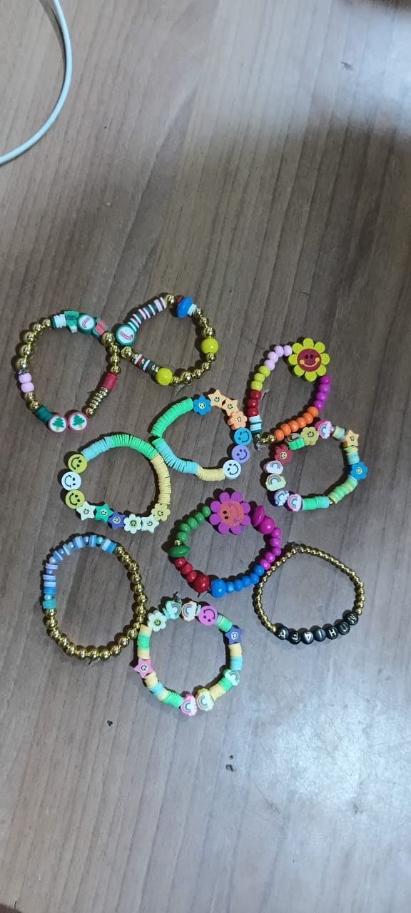

3.4 Health, Life Skills, and Personal Hygiene Promotion

Health and Safety Awareness

Thirty-eight learners attended a session focused on Safety at Home and in the Community.
They learned:
- Safe handling of sharp objects
- Cooking gas safety
- Road safety practices
- Electrical safety precautions
The session included demonstrations and interactive discussions, ensuring learners could recall and apply safety principles in daily life.

Personal Hygiene Session
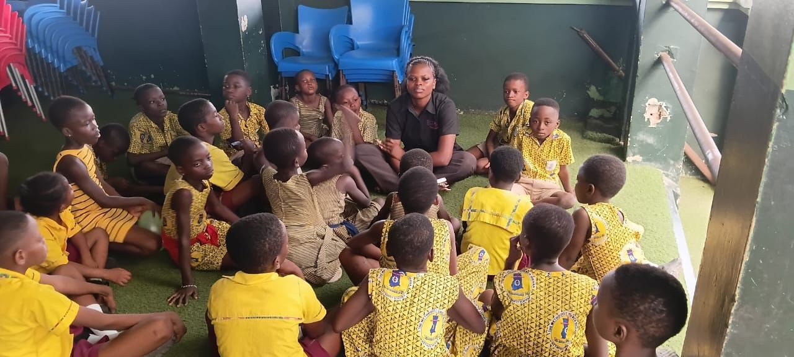
Thirty-two learners (16 boys and 16 girls) participated in a personal hygiene session.
Learners practiced hygiene habits such as:
- Using lemon water while bathing to prevent body odor
- Sneezing and coughing properly into a tissue or elbow
By the end of the session, learners understood the importance of personal hygiene and maintaining cleanliness. The session was interactive and engaging, with learners actively participating and asking questions.

4. Key Results and Observed Impact

4.1 Literacy and Reading Engagement
- Increased enthusiasm during reading sessions
- Improved listening and comprehension skills
- Stronger participation during paired reading and SCEF Reads sessions
- Learners began connecting stories with personal experiences

4.2 Creative Development
- Enhanced fine motor skills through craft activities
- Increased patience and attention span
- Strengthened confidence through completed projects

4.3 Health, Life Skills, and Personal Hygiene
- Learners demonstrated understanding of safety principles and hygiene practices
- Improved awareness of hazards at home and in the community
- Greater confidence in discussing and applying health and safety tips

5. Challenges Identified
- Inconsistent attendance among some learners
- Limited craft materials for expanding creative activities
- Continued reinforcement needed for safety and hygiene lessons

6. Lessons Learned
- Smaller group sessions increase participation and understanding
- Hands-on activities improve retention and engagement
- Practical life skills and hygiene lessons empower learners to apply knowledge in daily life
- Safe and nurturing learning environments foster confidence and curiosity

7. Way Forward (Next Quarter Priorities)
- Continue SCEF Reads sessions with new book selections
- Expand creative arts and paired reading activities
- Conduct additional health, safety, and personal hygiene sessions
- Introduce reflection journals to track reading and learning progress
Strengthen attendance monitoring and follow-up

8. Conclusion
Through structured reading, paired reading practice, creative arts, and health and hygiene education, the Hub continues to nurture:
- Literacy development
- Creativity and confidence
- Practical life skills and personal growth
The Hub remains a safe and transformative space where vulnerable children are empowered to read, think, create, and grow.
With continued structured programming and focused support, the Learning Hub is well-positioned to deepen its impact in the coming quarter.

