

HELP CONSTRUCT A VOCATIONAL BUILDING IN KIBERA, NAIROBI, KENYA.
PROGRESS REPORT – 12TH SEPTEMBER 2024

Project Title: Help construct a vocational building in Kibera
Global Giving Project I.D:64403
The Centre of Love proposed to construct a vocational building in Kibera. This will be a two-storey building where vocational skills in plumbing, fashion & design, hair and beauty will be taught. The building will also have dedicated space for a community library that will be open to residents of Kibera and especially primary and secondary school-going children.
Construction Phase 1 – Substructure Works
Construction of the first phase commenced in April 2024.The demolition of old iron sheet structures commenced in April 2024 and this created space for the proposed 2 storey building. Foundation works commenced and by May 2024 concrete casting for the ground floor was completed.
Phase 1: Demolition of old iron structures and substructure works of the 2 storey building
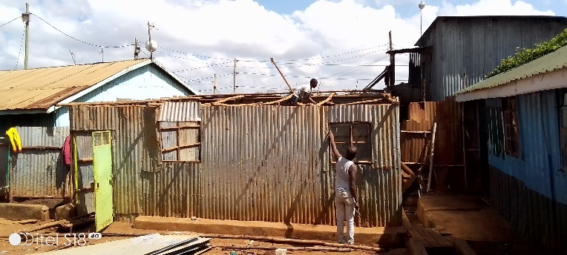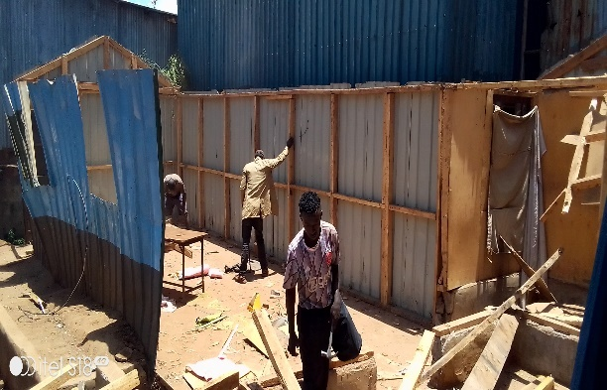
Figure 1: Area youths participating in the demolition of old iron sheet structures
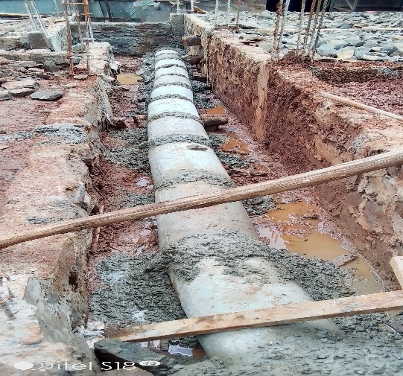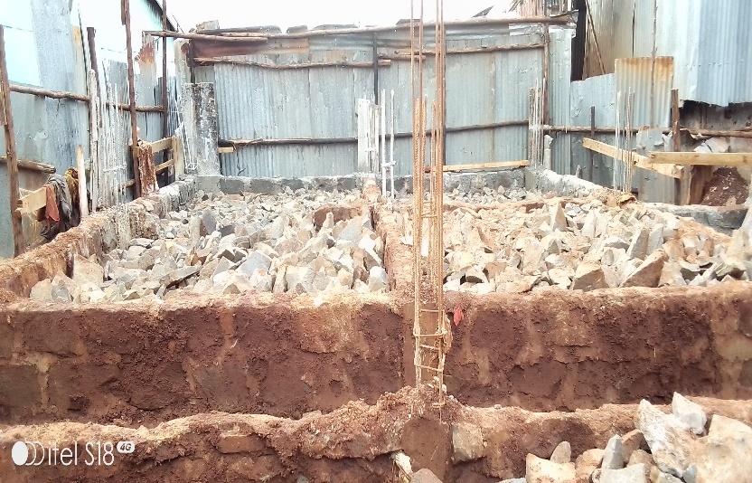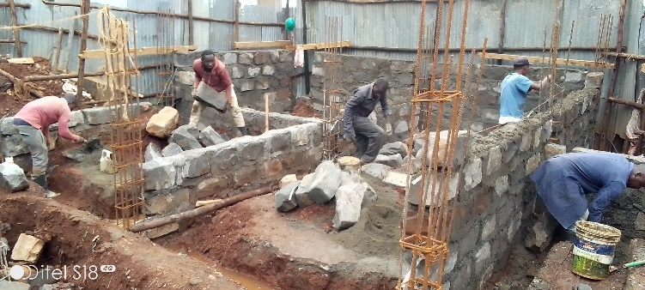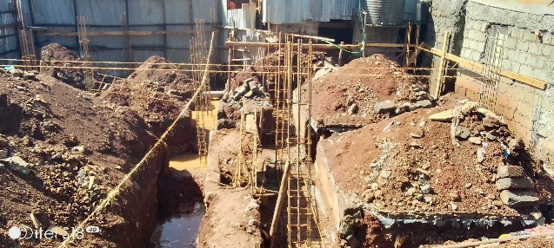
Figure 2: Foundation works of the 2 storey building

Construction Phase 2 – Superstructure works (Columns and Walls)
Superstructure works-specifically wall and columns works commenced in August 2024. So far, the walls and columns are up to 50% completion level. The positive progress of the superstructure works has reignited a lot of enthusiasm among youths in Kibera as they can now start visualizing a space where they will learn skills that will ultimately result in employment and improved livelihoods. The entire construction utilizes services from community members who are skilled in construction and unskilled youths for manual jobs. This has led to more community awareness and ownership of the project.
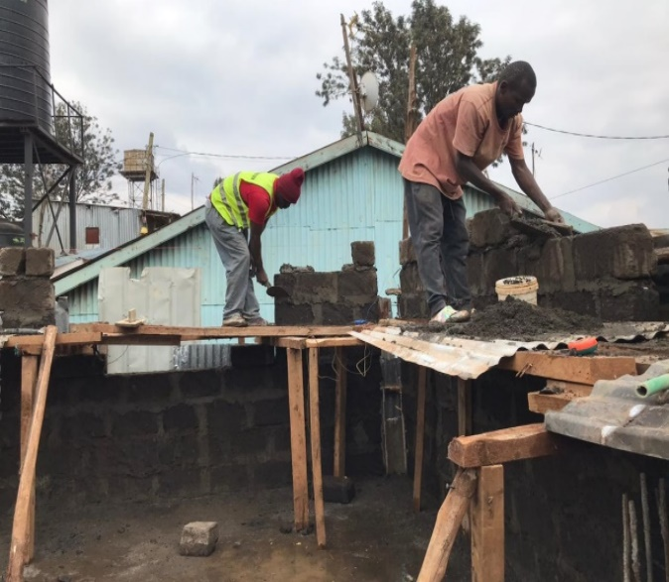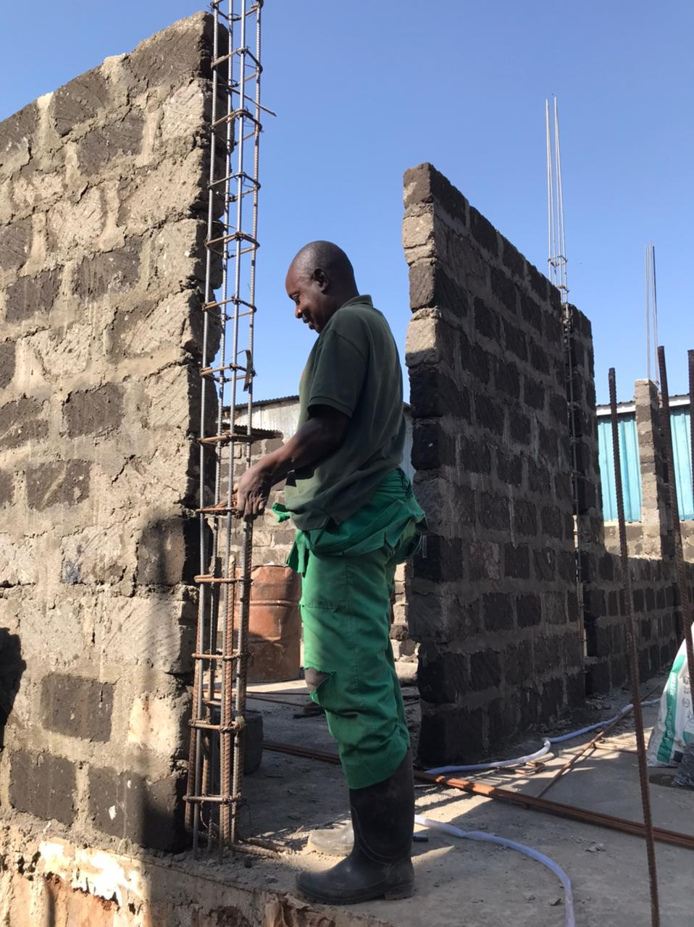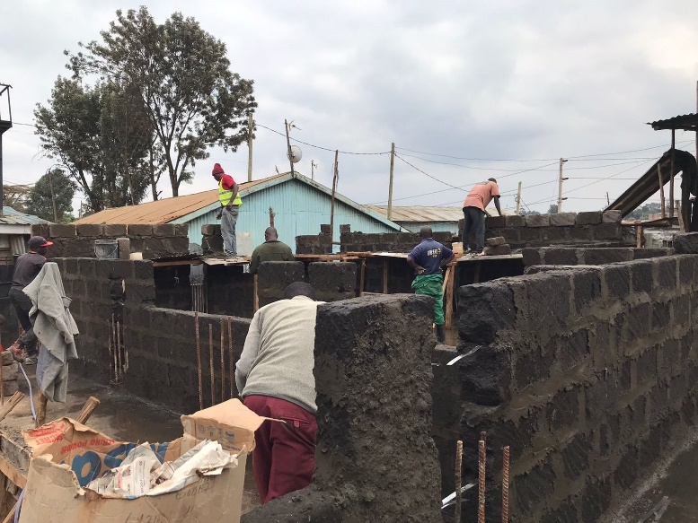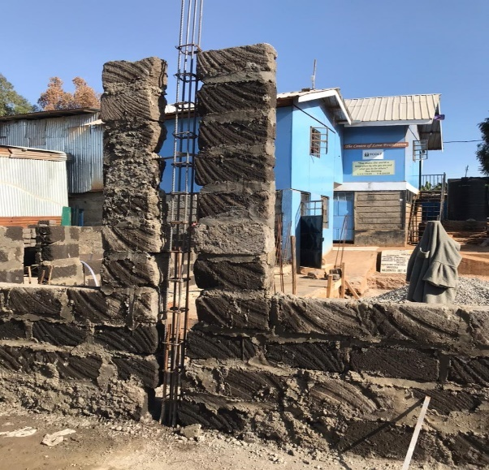
Figure 3: Wall and columns works
Appreciation
The Centre of Love appreciates all its benefactors who have supported it to actualize the vocational building project. Through your support, the first phase i.e. substructure works have been completed and the second phase i.e superstructure works is ongoing. We continue to appeal for your support in this journey of creating a community centre that will be an education hub for underserved women and youths in Kibera.
Felister Muthoni
Manager-The Centre of Love Foundation

