Bi-ANNUAL NARRATIVE REPORT
Development and Ability Organization (DAO)
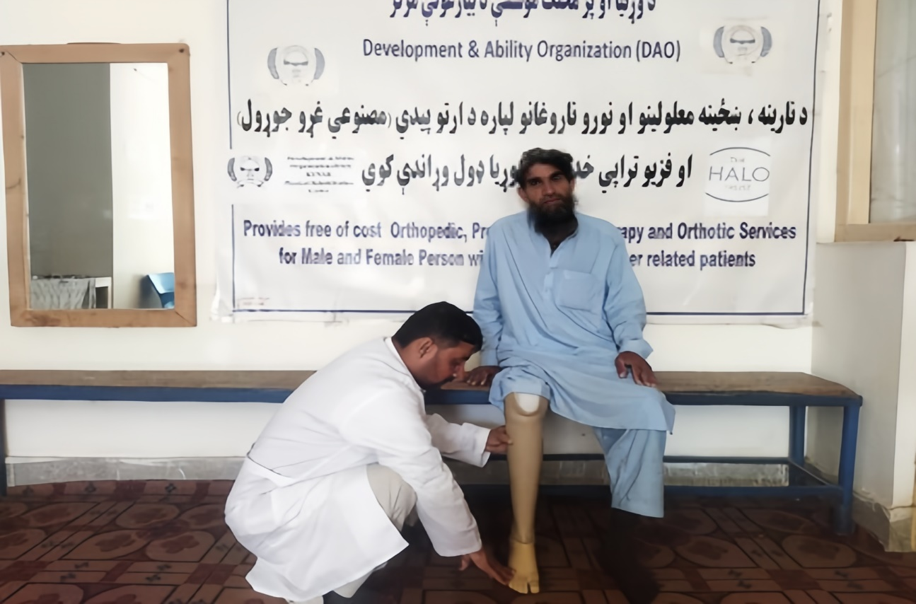
1st January to 30th June 2026
Photo: highlights the provision of physical Rehabilitation services, as a Below-Knee Prosthesis (BKP) was crafted for this landmine survivor on 06/01/2026.

- PROJECT DETAILS
Organization: | Development and Ability Organization (DAO).
Reporting Period: | 1st January to 30th June 2026.
Name of Project: | Provision of Physical Rehabilitation services to ERW victims, landmine Survivors & other Persons with Disabilities in Kunar, Nuristan, and Uruzgan provinces of Afghanistan.
Point of Contact: | Abdul Khaliq Atal- Director ,director@daoafghanistan.org,Abdulkhaliqatal1@gmail.com  Mansoor Omari- Project Leader, pm@daoafghanistan.org, mansoorsulaimankhil@gmail.com  Cell phone: +93 (0) 765585101.

Start Date: 1st January 2026
End Date: 30th June 2026
- PROJECT SUMMARY:

From January to June 2026, the Development and Ability Organization (DAO) continued providing physical rehabilitation and disability-related services to persons with disabilities, landmine survivors, and individuals affected by explosive remnants of war (ERW), as well as other people requiring rehabilitation support.
During this period, DAO delivered 150 physiotherapy sessions, fitted 59 new orthotic devices, and provided 26 prosthetic devices to individuals in need. In addition, the organization continued providing assistive device repair, awareness-raising, psychosocial support, and referral services based on the needs of individuals and communities.
DAO operates two Physical Rehabilitation Centers in Kunar and Uruzgan Provinces, both of which remained operational and continued providing essential rehabilitation services. The Kunar center also extended its services to beneficiaries from Nuristan Province, helping people in remote areas access specialized rehabilitation support that may otherwise be difficult to obtain.
Particular attention continued to be given to women and girls with disabilities, including those requiring prosthetic, orthotic, and physiotherapy services. DAO also maintained its focus on reaching people living in remote and underserved communities, where geographical and logistical barriers can significantly limit access to specialized services.
Despite the challenges associated with remote locations and access to communities, the rehabilitation centers continued their activities without major operational disruption during the period. No significant safety incidents or accidents affecting service delivery were reported.
Overall, the period reflected DAO’s continued commitment to providing accessible, inclusive, and quality rehabilitation services, while supporting persons with disabilities and survivors to regain mobility, strengthen their independence, and participate more fully in their families and communities.

Project Background
This project supports fixed physical rehabilitation centers in Kunar and Uruzgan provinces to assist direct victims of conflict, mine explosive remnants of war (ERW), and all other persons with disabilities, including men, women, and children in their localities. The rehabilitation services provided include physiotherapy, the production of artificial limbs, counseling, psychosocial support, referral services, the preparation of orthotic assistive devices, and disability awareness and prevention sessions in our target areas of Kunar and Uruzgan. Furthermore, it is important to mention that the Kunar Physical Rehabilitation Center also provides services to persons with disabilities from Nuristan province.
The key activities of this project are as follows:
- Physiotherapy services for ERW victims, landmine survivors, and other persons with disabilities.
- Production and distribution of new artificial limbs for males, females, and children with disabilities.
- Production of new orthotic devices.
- Repair of prostheses and orthotic (P&O) devices.
- Referral: War victims, along with other persons with disabilities, need to be referred to connected institutions/hospitals for secondary services, such as providing medicine, X-rays, etc.
- Provision of counseling and psychosocial support to persons with disabilities.
- Provide disability awareness/prevention sessions to ERW/PWDs and the host community.

- SUMMARY OF PROGRESS VERSUS TARGET:
Activities | Contractual Targets | Cumulative Achieved (Beneficiaries) | Cumulative Progress (%) | Quarterly Target Achieved | Beneficiaries Reached – MWBG (Quarter) | Services Delivered (quarter) | Quarter progress (%)
Physiotherapy | 1850 | 591 | 31.94% | 150 | Men 128, Women 0, Girls 5, and Boys 17) | 273 | 8.10%
Orthotic New Service provided | 460 | 218 | 47.39% | 59 | (Men 23, Women 7, Girls 13, and Boys 16) | 59 | 12.82%
Prosthetic New Service provided | 120 | 89 | 74.16% | 26 | (Men 24, Women 1, Girls 1, and Boys 0) | 26 | 21.66%
Repair of Orthotic and Prosthetic Devices) | 360 | 234 | 65% | 56 | (Men 44, Women 2, Girls 3, and Boys 7) | 56 | 15.55%
Awareness Campaigns Executed | 290 | 236 | 81.37% | 69 | (Men 16, Women 28, Girls 19, and Boys 6) | 69 | 23.79%
Psychosocial Support and Counseling Service | 200 | 62 | 31% | 18 | (Men 18, Women 0, Girls 0, and Boys 0) | 18 | 9%
Referral Services | 120 | 70 | 58.33% | 20 | (Men 16, Women 0, Girls 0, and Boys 4) | 20 | 16.66%
Total | 3400 | 1500 | 44.11% | 398 | (Men 269, Women 38, Girls 41, and Boys 50)  =398 | 521 | 11.70

- EMERGING OR EVOLVING RISKS:
Nil
- INCIDENTS OR ACCIDENTS:
Nil

- CASE STUDIES:
Case Study of Female Beneficiary.
Overcoming Disability and Rebuilding Life
Personal Information:
Name: Nasrat Bibi
Father’s Name: Ahmad
Age: 35
Gender: Female
Marital Status: Married
Location: Khas Kunar village, District Khas Kunar, Province: Kunar.
Cause of Disability: Severe reaction to an injection given by a village doctor in childhood
Type of Disability: Leg shortening and muscle weakness, leading to mobility impairment
Date of Incident: 01/01/2008
Introduction:
Nasrat Bibi’s story is one of struggle, resilience, and hope. A devoted mother and wife from Khas Kunar, she endured years of pain and hardship due to her disability. Her journey highlights the power of rehabilitation and assistive technology in restoring mobility, dignity, and independence.
Life before Disability:
Nasrat Bibi was once a healthy, active child. She ran, played, and helped her family with daily chores. Her dreams were simple: to raise a happy family and contribute to her community. However, an unfortunate medical incident changed everything.
The Tragic Incident:
At a young age, Nasrat Bibi received an injection from a local doctor to treat a common illness. Instead of healing her, it caused severe damage to her leg weakened and stopped growing properly. Without proper medical care, her condition worsened over time. Walking became painful, and daily tasks turned into struggles.
Life after Disability:
Nasrat Bibi’s world shrank. She could no longer move freely, care for her children easily, or join family gatherings. The pain was not just physical; she felt isolated, helpless, and dependent on others. Yet, despite her suffering, she never lost hope.
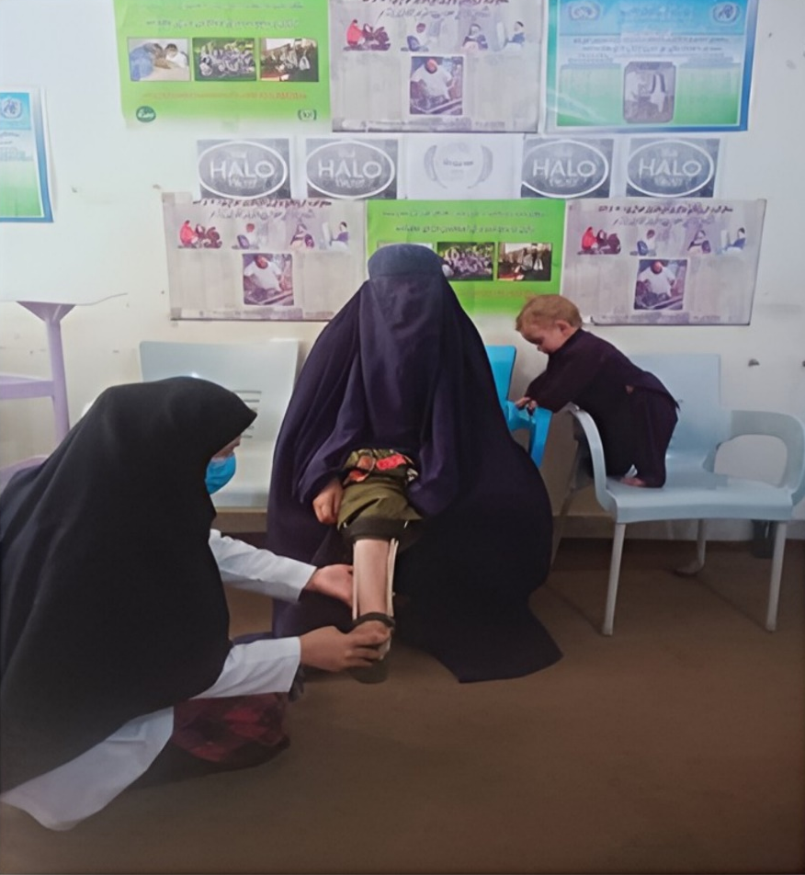

Photo: highlights the provision of physical Rehabilitation services, as Knee Ankle Foot Orthoses (KAFO) were provided for this beneficiary on (13/01/2026).
A New Beginning and Recovery:
In 2025, Nasrat Bibi visited the DAO Physical Rehabilitation Center in Kunar. The team assessed her needs and provided a custom-made Knee Ankle Foot Orthosis (KAFO). The device supported her weakened leg, improved her balance, and restored her ability to walk.
With training and follow-up care, Nasrat Bibi regained strength and confidence. For the first time in years, she could stand tall, move freely, and take care of her family without pain.
Nasrat Bibi’s Message of Hope:
"For years, I was trapped in my own body. I could not walk properly or take care of my children. However, today, this orthosis has given me a new life. I can move again, work again, and live with dignity. To others suffering as I did, never lose hope. Help is possible. Recovery is possible."

Gratitude:
Nasrat Bibi thanked the rehabilitation team and supporters and said, “I will never forget your kindness. You gave me back my strength, my freedom, and my hope. May God bless you for helping people like me?"
Conclusion:
Nasrat Bibi’s transformation proves that with the right support, even the deepest struggles can be overcome. Her story reminds us of the life-changing impact of rehabilitation services and assistive devices. Today, she walks with confidence, a symbol of resilience, courage, and hope for others facing similar challenges. “From strength to pain, from despair to hope, Nasrat Bibi’s journey continues."
A Landmine Survivor Case Study.
Introduction of a Landmine Survivor.
Name: Khurshid Khan
Father’s Name: Noor Habib
Age: 50
Location: Bar Narang village, Narang District, Kunar Province
Cause of Incident: Roadside landmine
Type of Injury: Below-knee amputation (right leg)
Date of Incident: 2016
Life before the Disability:
Khurshid Khan lived in a relatively developed area where life was easier, and people valued education and progress. The region had exposure to civilization, and the locals earned their livelihoods through farming, livestock, and agriculture. He was an educated man and served as a government officer, committed to protecting his country. He played a crucial role in organizing military operations and was the sole breadwinner for his family.
He lived a happy and purposeful life, dedicated to the vision of a peaceful and prosperous Afghanistan. His only wish was to see his country free from conflict. He consistently spread messages of peace and hope to others around him.
How the Disability Happened:
Khurshid Khan was a highly skilled and energetic soldier. His commander often assigned him to front-line duties because of his capabilities in combat. One day, after completing a mission, he was on his way back home when enemies of the nation planted a roadside bomb targeting his vehicle. The explosion seriously wounded him and claimed the lives of his comrades. He was immediately airlifted to the 400-bed military hospital in Kabul. After a thorough medical examination, the doctors concluded that his right leg needed to be amputated to save his life and prevent further complications.
With the family's consent, the doctors proceeded. Khurshid recalls the painful moment he regained consciousness and realized his leg was gone. “That moment was unbearable,” he said. “I can’t describe the pain. All my hopes were shattered. I did not know how I would face my future, my family, and my country. I felt completely broken.”
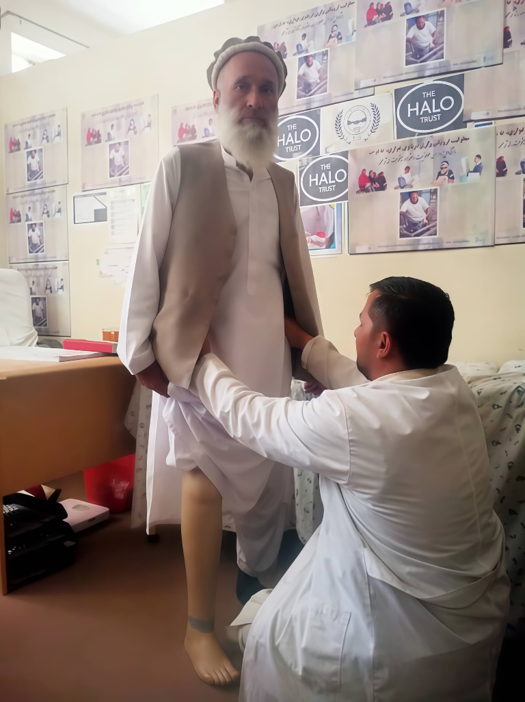

Photo: highlights the provision of physical Rehabilitation services, as a below-knee prosthesis (BKP) was crafted for this landmine survivor on 10/02/2025.

Life after the Disability:
Becoming disabled brought immense challenges. Living in a society where negative perceptions of disability are widespread made it even harder. Khurshid felt abandoned, helpless, and alone.
Afghanistan’s lack of support for people with disabilities meant he faced extreme economic, psychological, and social hardship. He could not work anymore. Life seemed meaningless. He constantly thought, “The whole world is collapsing around me.” He lost hope and believed he would never return to a normal life.
His home was filled with anxiety and fear. The way he lived his life had changed drastically. Every day felt like a significant burden.
A New Chapter with a Prosthetic Limb:
While attending a wedding, Khurshid noticed a young man confidently walking with a prosthetic leg. Curious and hopeful, he approached him. The man shared his journey of recovery and directed Khurshid to the Physical Rehabilitation Center at DAO in Kunar.
With renewed determination, Khurshid visited the center with his brother. The physiotherapy team assessed him, and the prosthetics department took measurements for a custom limb. Weeks later, he received the life-changing call: his prosthetic leg was ready.
At the center, Khurshid broke down in tears upon seeing the limb. Guided by skilled staff, he began gait training. Gradually, he reclaimed his mobility and his life.
A Life Transformed:
The prosthetic leg restored Khurshid's independence, dignity, and joy. He walked again, engaged in daily activities, and supported his family. His confidence soared, his stress faded, and he reintegrated into society as a resilient, empowered individual.
His negative mindset turned into positivity. He felt proud and motivated to represent people with disabilities and show the world that disability is not inability.
His Message to Persons with disabilities:
Disability is not a weakness. Keep trying, keep growing, and never become a burden on others. Challenges are temporary. Every hardship passes, and brighter days always follow. Stay strong, stay hopeful, and stay positive.

Suggestion:
International humanitarian and donor organizations, as well as the Afghan government, must support the Development and Ability Organization (DAO) both financially and logistically, especially in providing raw materials.
DAO is the only physical rehabilitation center in Kunar province that provides valuable services to people with disabilities. Without proper support, many patients like me will face serious challenges.
Most individuals with disabilities cannot afford to travel to other states to access essential rehabilitation services. This center requires urgent attention and ongoing support to continue transforming lives.
Positive Changes:
With unwavering determination and the support he received, Khurshid Khan's life underwent a remarkable transformation:
- He regained his mobility and now walks independently with renewed strength and determination.
- His restored confidence empowered him to reintegrate into society with dignity and purpose.
- He resumed his daily responsibilities and once again became a valued and contributing member of his family.
Expression of Gratitude:
I sincerely thank the Development and Ability Organization (DAO), its hardworking staff, and the generous donors who made these services possible. Thanks to their efforts, men, women, and children with disabilities, including myself, are now living better lives. We are deeply grateful and optimistic that these services will continue to grow and meet the needs of everyone.
Conclusion:
Khurshid Khan’s journey from tragedy to triumph highlights the transformative power of victim assistance, rehabilitation, and community support. Despite the life-altering impact of a landmine explosion, he rebuilt his life with courage and determination. Today, he stands as a symbol of resilience and hope, proof that even in the face of profound loss, recovery and renewal are possible.

- COLLECTION OF PHOTOGRAPHS:
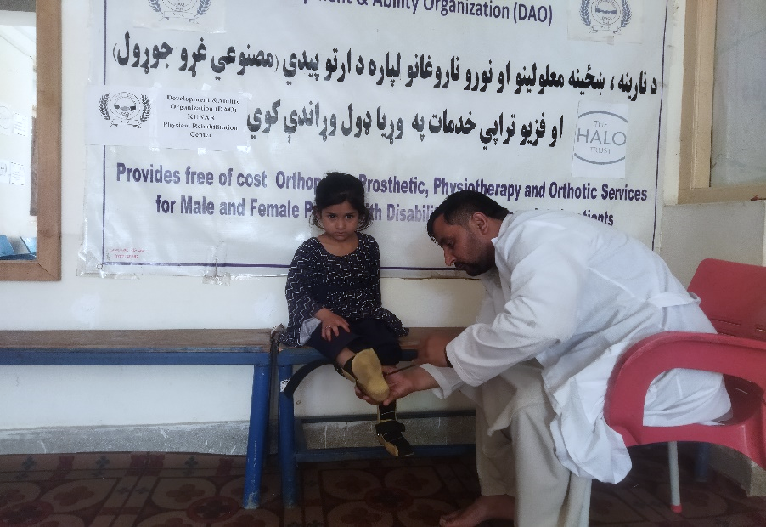

Photo: highlights the provision of physical rehabilitation services, as Ankle-Foot Orthoses (AFOs) were crafted for this beneficiary on 2026/03/11
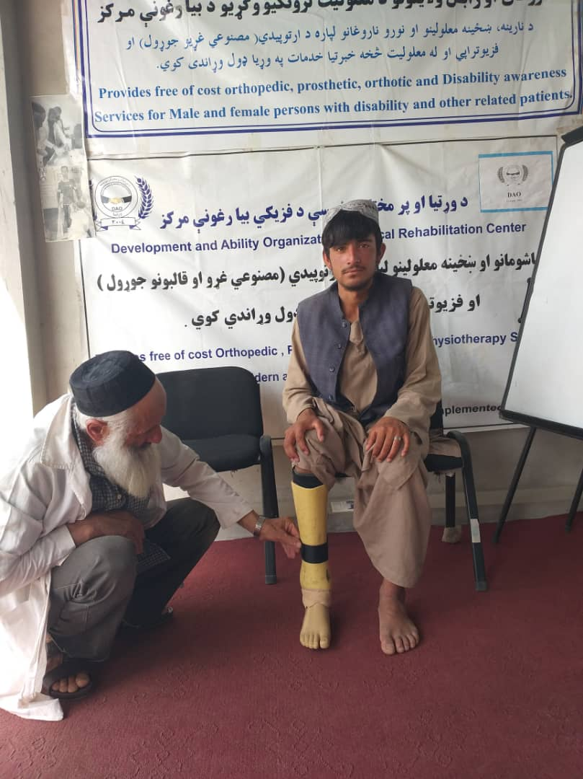

Photo: highlights the provision of physical rehabilitation service, as a Below Knee Prosthesis (BKP) was repaired to this landmine survivor on (02/04/2026).
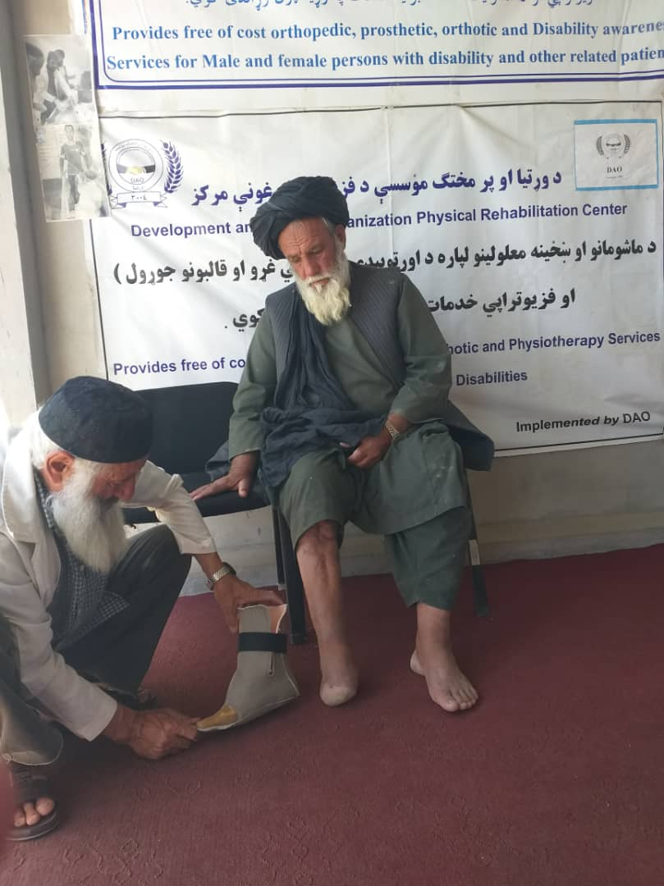

Photo: highlights the provision of physical rehabilitation service, as a Partial Foot Prosthesis was crafted for this landmine survivor on (04/05/2026).
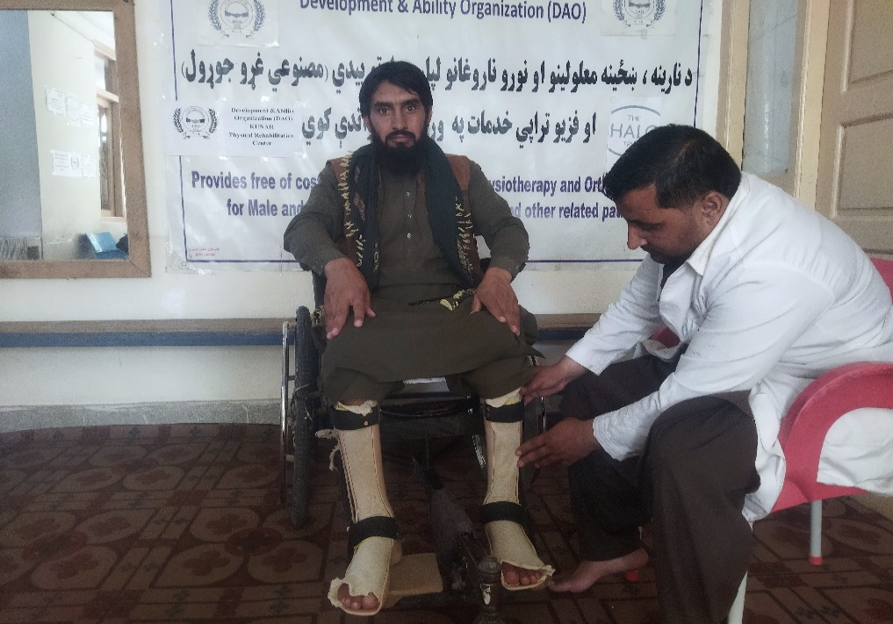

Photo: highlights the provision of physical rehabilitation service, as bilateral Ankle Foot Orthoses were provided to this beneficiary on (07/06/2026).

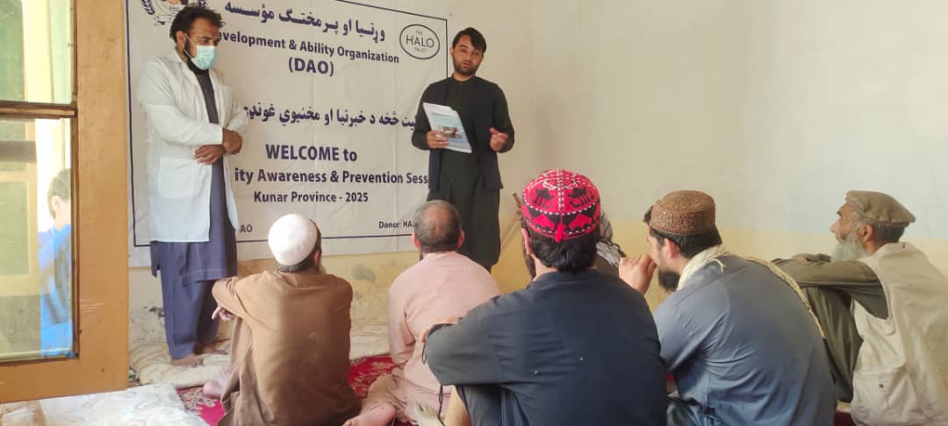

Photo: Highlights the provision of a disability awareness and prevention session to the host community and male persons with disabilities on 2026/06/28, in Kunar Province.

(Kabul), SUN 5, July 2026.
____________________________________________________________________
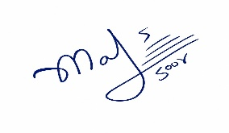

Mansoor Omari Project Leader.

