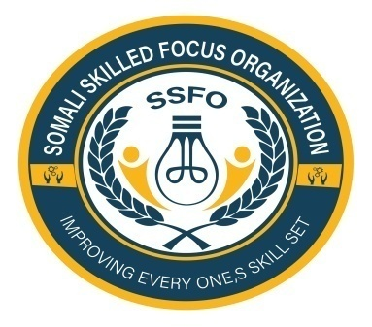
Somali Skilled Focus Organization Quarterly Project Progressive Report
Project name | Empowering Buhoodle District Girls through education project
Organization | Somali Skilled Focus Organization
Location | Buhoodle District SSC Khatumo State of Somalia
Project No. | 64270
Reporting period | April 2025
Report completed by | Mohamed Abdihakin Osman
Title | Project Leader
Email | Mohamed.hakim.ssfo@gmail.com
Contact Number | +252618072944
 | 10/4/2025
  Submission Date

1. Introduction
This report outlines the progress made during the quarter in the "Empowering Buhoodle Girls through Education" project. The focus has been on increasing enrollment, enhancing educational access, improving infrastructure, and fostering community engagement.
2. Goal Progress
- Goal: Increase enrollment by 20% compared to the previous quarter.
- Current Enrollment Status: Enrollment increased from 180 girls to 300, resulting in a percentage increase of . 20% we are on track to meet our goal.
3. Activities Overview
.1. Awareness Campaign
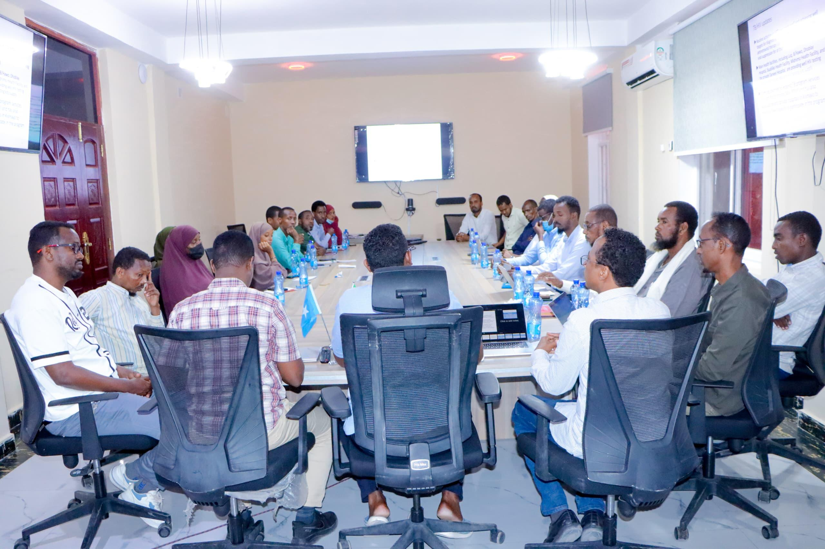
- Launched a successful awareness campaign that reached over 100 families in Buhoodle, utilizing community meetings and local leaders to inform about the importance of education for girls.
- Created promotional materials (flyers, posters) in both Somali and English, resulting in increased inquiries from parents about enrolling their daughters in school.
3 Partnerships with Local Schools
- Strengthened partnerships with [number] local schools, facilitating smoother enrollment processes. Collaborative meetings were held with educational authorities to align strategies and share resources.
4. Skills Development Workshops
- Expanded workshop topics to include financial literacy and life skills training. Over [number] girls participated, receiving resources and tools for life management.
- Organized a career guidance session with local professionals, exposing [number] girls to diverse career opportunities, helping them envision their future beyond traditional roles.
5. Infrastructure Improvements
- Conducted an assessment of existing infrastructure needs, identifying priority areas including library resources and sports facilities.
- Procured essential supplies, such as books and educational materials, enhancing the learning environment for 50 girls.
6. Parent Engagement
- Conducted two workshops for parents focused on supporting their daughters' education and career aspirations, attended by [number] parents.
- Established a parent-teacher association that now meets monthly, fostering ongoing communication and collaboration between parents and educators.
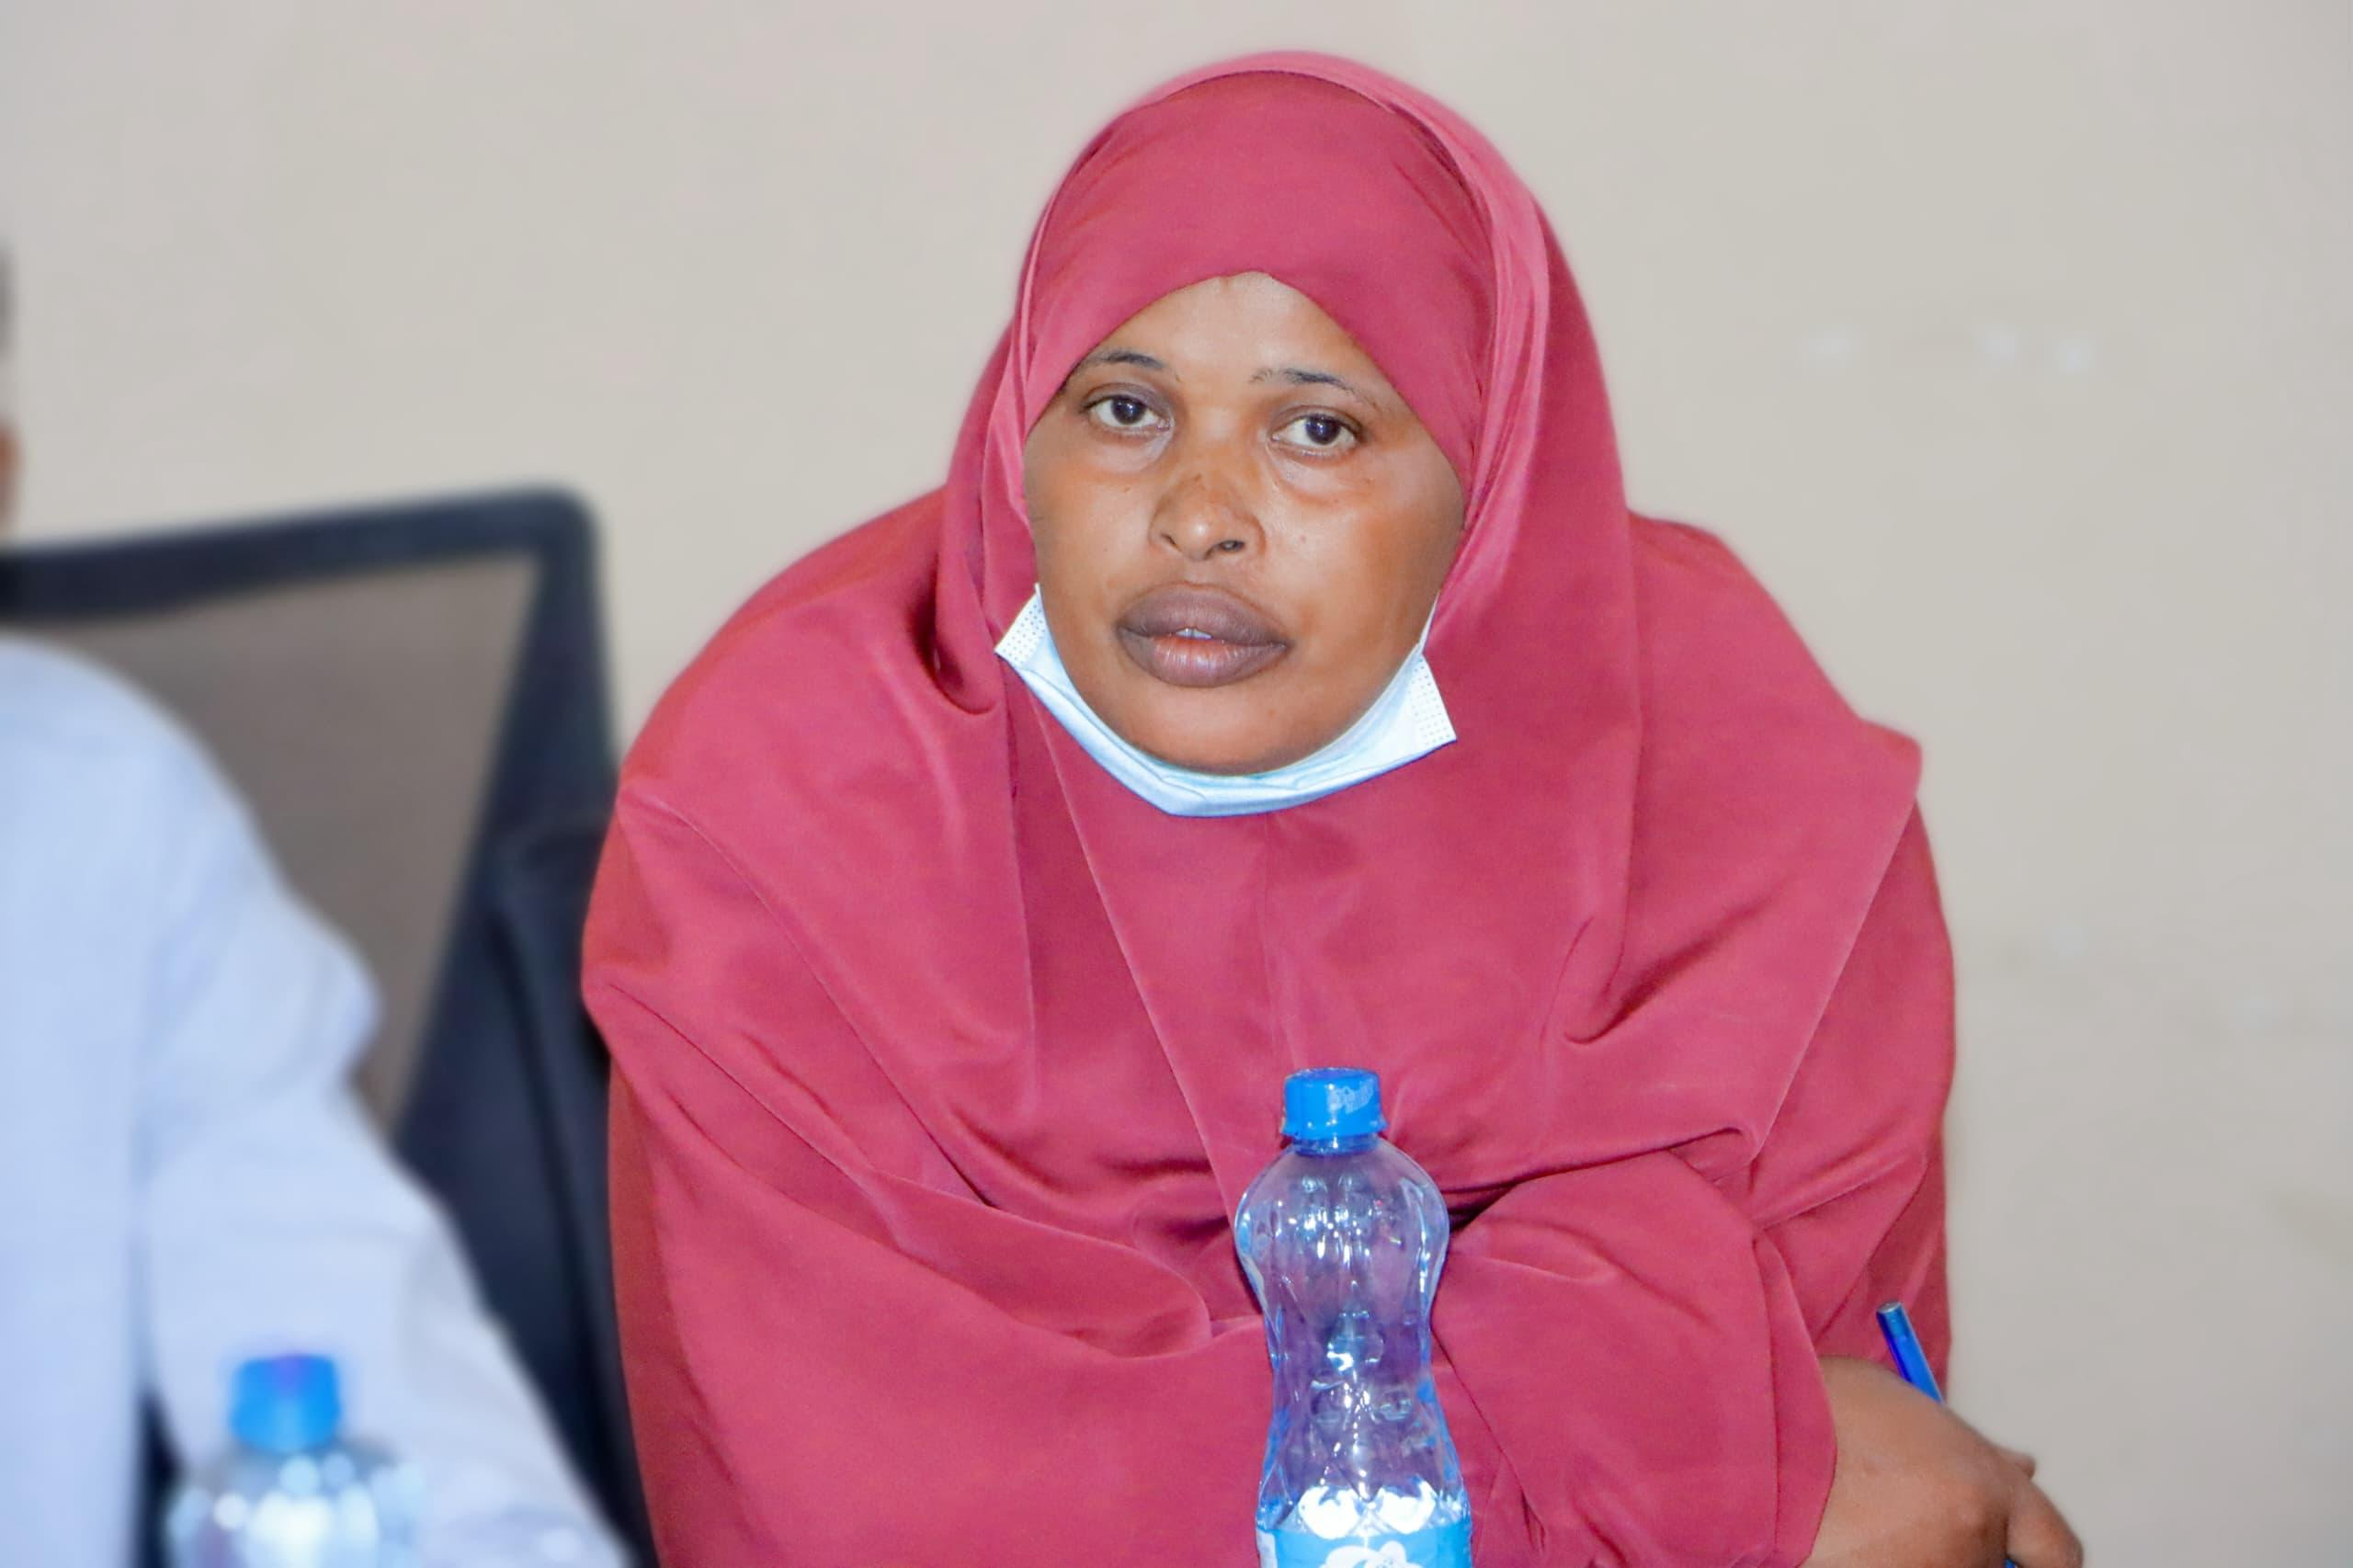
Halima A Mother who’s her daughter benefited from the girls education project in Buhoodle district
7. Community Outreach
- Hosted a community event on 15 January 2025 showcasing the achievements of girls involved in the program. This event brought together over 50] community members and garnered positive feedback.
- Engaged with local media, resulting in 3 articles/news segments highlighting the project's impact, thus amplifying awareness in the Buhoodle District.
Success Story of Iqra and Anisa
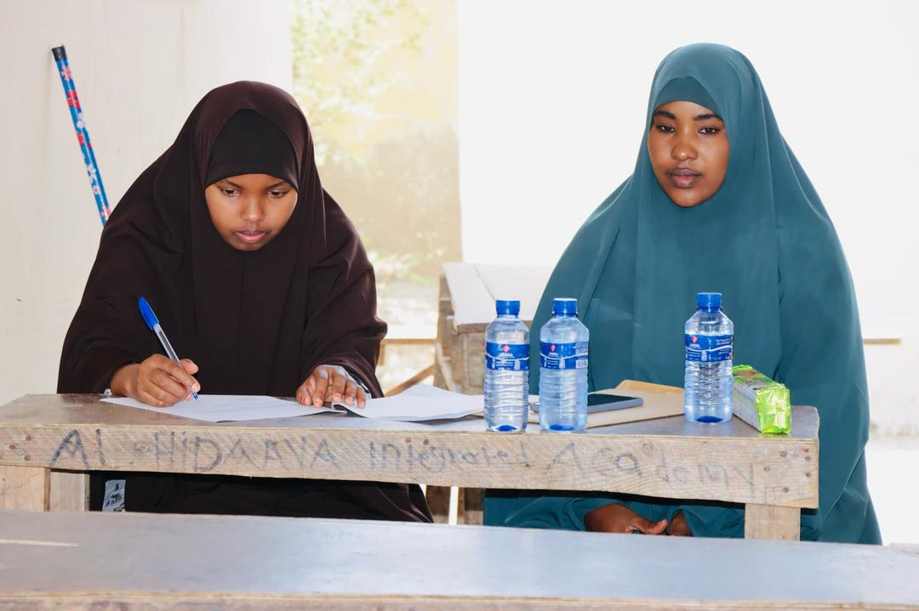
Background
In Buhoodle District, where traditional roles often limit girls' access to education, stories of change are emerging. Two remarkable young girls, Iqra and Anisa, illustrate the transformative impact of the Somali Skilled Focus Organization's "Empowering Buhoodle District Girls Through Education Project."
Iqra’s Journey
Iqra, a 14-year-old with dreams of becoming a doctor, faced numerous challenges in her pursuit of education. Coming from a family that valued early marriage for girls, Iqra struggled to convince her parents of the importance of education. Her turning point came when she attended an awareness workshop organized by the project, where she learned about the career opportunities available through education. Inspired by the stories of successful women, Iqra returned home motivated to plead her case once more.
With renewed determination, Iqra spoke to her parents about the future she envisioned. The workshop had equipped her with valuable information, which she shared with them, highlighting the significance of education for girls. After much discussion, her parents agreed to support her schooling, realizing that education could lead to independence and a better life for their daughter. Today, Iqra excels in her studies, consistently ranking at the top of her class. She credits her progress to the encouragement and resources provided by the program, which instilled in her a belief that she can achieve her dreams.
Anisa’s Transformation
Anisa, 12 years old, was struggling academically when she first joined the project. Coming from a lower socio-economic background, her family could not afford tutoring or additional learning materials. Anisa attended one of the skills development workshops focused on academic support and life skills, where she received a comprehensive overview of effective study techniques and time management strategies.
Recognizing her potential, the project provided Anisa with tutoring in subjects she found challenging, particularly mathematics and science. With the help of dedicated tutors and peers, Anisa began to thrive academically. She developed a passion for learning, discovering that she enjoyed solving problems and conducting experiments.
The transformation in Anisa’s confidence was remarkable. From hesitant and unsure, she blossomed into an engaged and enthusiastic student. With her newfound skills, she not only improved her grades but also became a role model for her classmates. Anisa now aspires to pursue a career in engineering, believing that education is the key to her success.
8. Academic Performance Monitoring
- Implemented a monitoring and evaluation system that tracks academic progress for over 300 girls. Regular assessments identify areas where additional support is necessary.
- Provided tutoring in subjects such as Math., English, and Environment Education resulting in a marked improvement in grade averages for participating girls.
9. Next Quarter Work Plan
- Continue the awareness campaign with additional outreach methods.
- Further engage local schools to sustain and increase enrollment rates.
- Organize more advanced workshops addressing digital literacy and entrepreneurship.
- Prioritize infrastructure improvements based on current assessments.
- Enhance parental workshops to focus on long-term educational planning for their children.
- Plan another community event to celebrate girls’ successes and motivate further community involvement.
10. Challenges and Recommendations
- Challenges:
- Some parents remain hesitant about sending their daughters to school due to cultural beliefs.
- Limited infrastructure can hinder the learning experience.
- Recommendations:
- Increase targeted discussions with community leaders to address cultural barriers.
- Pursue additional funding or partnerships to improve infrastructure.
11. Conclusion
Overall, this quarter has shown significant progress toward empowering girls in Buhoodle through education. Goals for enrollment and community involvement are being met, and ongoing efforts are expected to yield even greater results in the coming months.
Thank you for your continued support and commitment to women's empowerment and community development.
Warm regards,
Mohamed Abdihakin Osman
Project Leader
Somali Skilled Focus Organization

