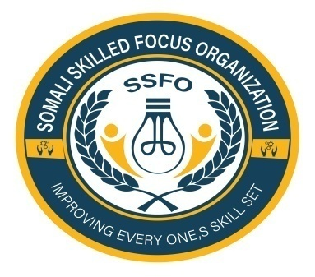
Somali Skilled Focus Organization Quarterly Project Progressive Report
Project name | Empowering Buhoodle District Girls through education project
Organization | Somali Skilled Focus Organization
Location | Buhoodle District SSC Khatumo State of Somalia
Project No. | 64270
Reporting period | 0ctober 2025
Report completed by | Mohamed Abdihakin Osman
Title | Project Leader
Email | Mohamed.hakim.ssfo@gmail.com
Contact Number | +252618072944
 | 14/10/2025
  Submission Date

- Introduction
This report provides an overview of the progress made towards empowering girls in the Buhoodle District through our education project during the reporting quarter. Key achievements, challenges faced, and action plans for the next quarter are highlighted.
2. Project Objectives
- Increase access to quality education for girls in Buhoodle District.
- Improve retention rates of girls in schools.
Enhance the educational outcomes of girls through tailored support programs
3. Key Achievements
Enrollment:
  - An additional 150 girls enrolled in local schools this quarter, resulting in a total enrollment of 300 girls since the project's inception.
Scholarship Distribution:
  - 100 scholarships awarded to girls from low-income families to cover tuition and school supplies.
Capacity Building Workshops:
  - Conducted four workshops focused on life skills and leadership for 120 girls, fostering confidence and self-advocacy.
Community Engagement:
Organized two community awareness campaigns that reached over 500 families, emphasizing the importance of girls’ education
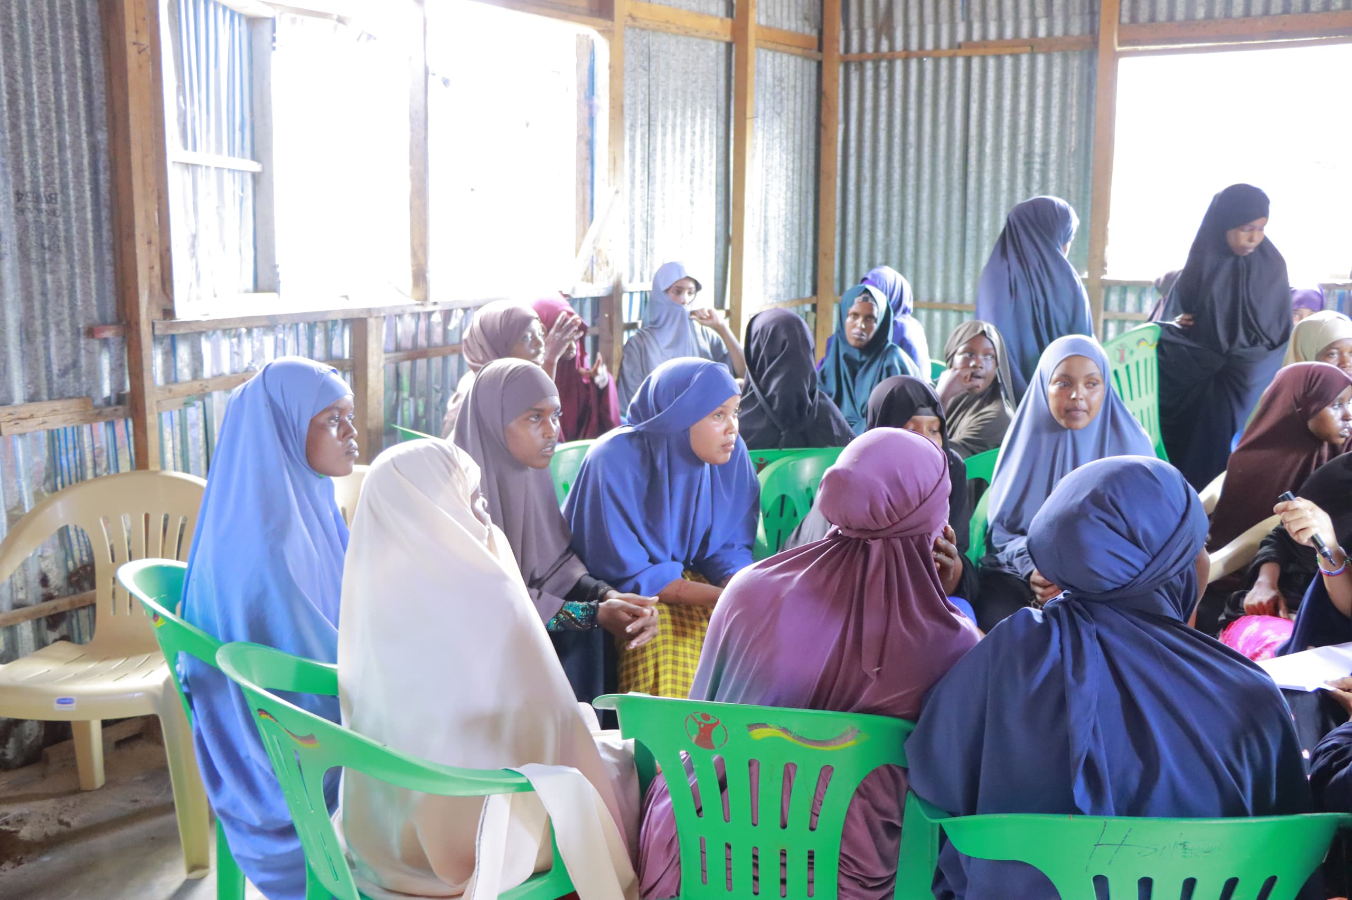
. Challenges Faced
- Cultural Barriers:
  - Some families remain resistant to sending their daughters to school due to traditional beliefs.
- Resource Limitations:
  - Lack of sufficient learning materials such as textbooks and stationery for all enrolled girls.
- Infrastructure Issues:
  - Inadequate school facilities in some areas hinder the learning experience.

5. Next Steps and Action Plans
- Targeted Awareness Campaigns:
  - Develop targeted awareness campaigns addressing cultural barriers, engaging local leaders and influencers to promote girls’ education.
- Resource Mobilization:
  - Seek partnerships with local NGOs and businesses to acquire additional learning materials and school supplies.
- Infrastructure Advocacy:
  - Engage with local authorities to advocate for improvements in school infrastructure to create a conducive learning environment.

6. Monitoring and Evaluation
- Analysis of attendance records indicates a 15% increase in girls’ school attendance compared to the previous quarter.
- Baseline assessments conducted at the beginning of the program show improved confidence among participants, with 80% reporting increased participation in class activities.
7. Testimonials
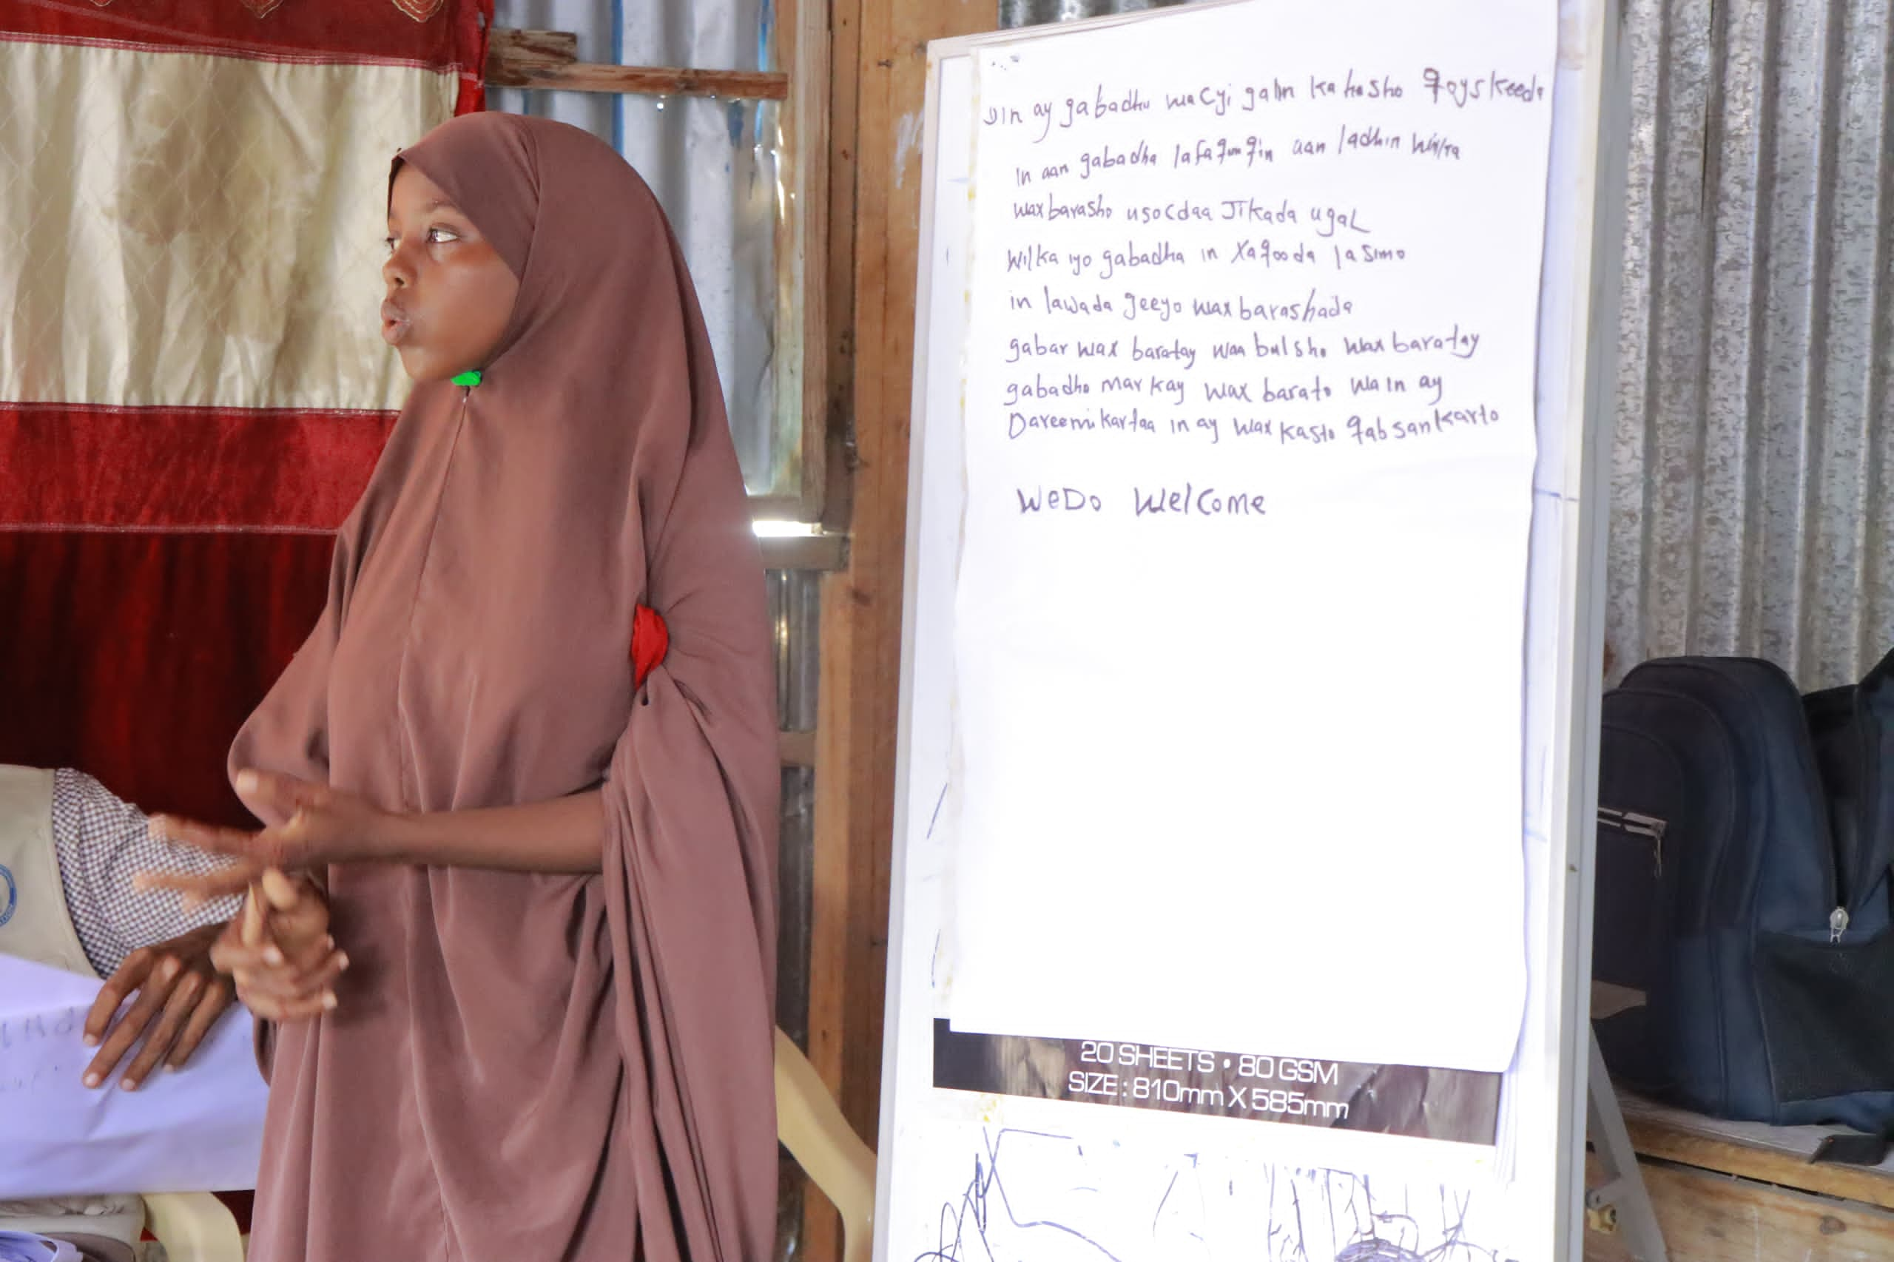
“My daughter has become more confident and excited about going to school. The support we received made a huge difference.” – A parent from Buhoodle District.

8. Conclusion
The Empowering Buhoodle District Girls Through Education Project has made significant strides this quarter in promoting girls' education. Continued efforts will focus on overcoming challenges and sustaining momentum in empowering girls to realize their full potential.

Thank you for your continued support and commitment to women's empowerment and community development.
Warm regards,
Mohamed Abdihakin Osman
Project Leader
Somali Skilled Focus Organization

