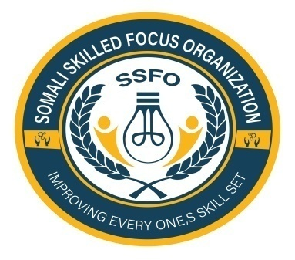
Somali Skilled Focus Organization Quarterly Project Progressive
Project name | Empowering Buhoodle District Girls through education project
Organization | Somali Skilled Focus Organization
Location | Buhoodle District SSC Khatumo State of Somalia
Project No. | 64270
Reporting period | September-December 2024
Report completed by | Mohamed Abdihakin Osman
Title | Project Leader
Email | Mohamed.hakim.ssfo@gmail.com
Contact Number | +252618072944
 | 31/12/2024
  Submission Date
Introduction:
Somali Skilled Focus Organization (SSFO) is pleased to present the quarterly report detailing our efforts in empowering girls in Buhoodle District through education. The following activities were implemented during the reporting period:
1. Increased Enrollment:
- A total of 100 new girls were enrolled in our educational programs, surpassing our initial target of 80.
- Outreach campaigns and community mobilization efforts contributed to the increased enrollment rates.

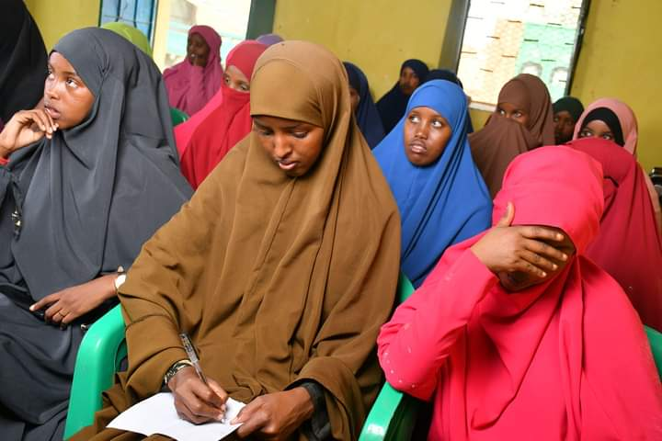
2. Skills Development Workshops:
- Conducted monthly skills development workshops focusing on computer literacy, vocational training, and entrepreneurship.
- The workshops were well-received, with positive feedback from participants indicating increased confidence and practical skills.
3. Infrastructure Improvements:
- Renovated and equipped two classrooms with furniture, computers, and learning materials.
- Improved infrastructure created a conducive learning environment for girls, enhancing their educational experience.
4. Parent Engagement:
- Organized bi-monthly parent engagement sessions to raise awareness about the importance of girls' education.
- Encouraged parental support and involvement in monitoring their daughters' progress and participation in school activities.
5. Community Outreach:
- Conducted community outreach programs to promote the value of education for girls.
- Collaborated with local leaders and stakeholders to advocate for gender equality in education.
6. Academic Performance:
- Monitored and evaluated the academic performance of girls in the program.
- Implemented tutoring sessions and mentorship programs to support girls in achieving academic excellence.
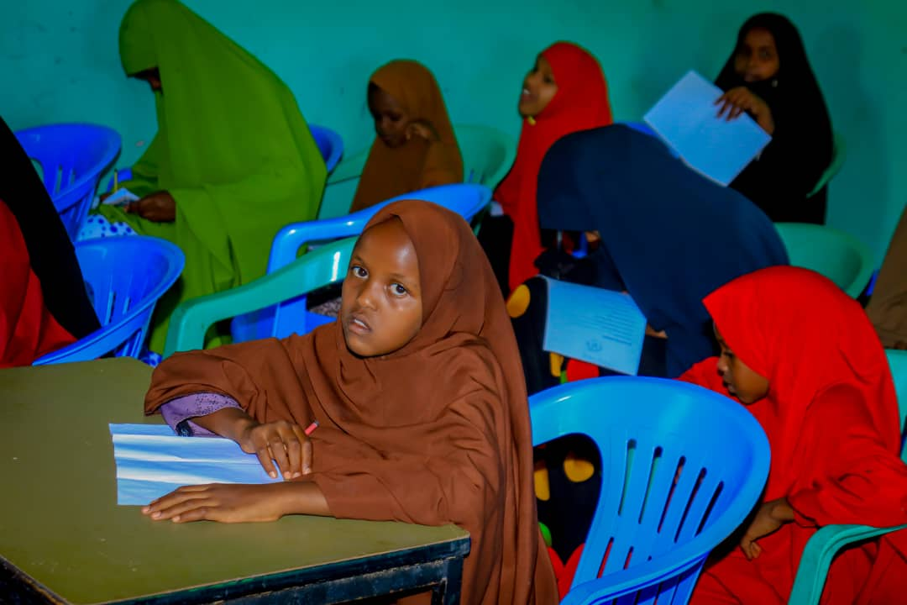

Somali Skilled Focus Organization is excited to share with it is Partners and Donors some powerful impact stories of individual deprived girls who have benefited immensely from our girls' education project. These stories underscore the life-changing impact of education on the lives of vulnerable girls in our community.

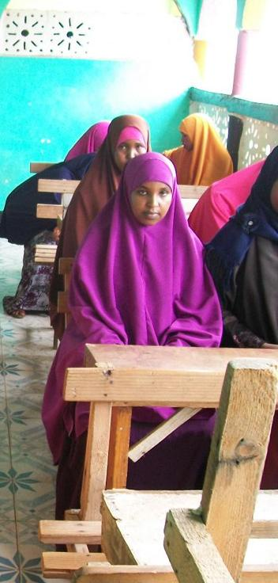
The Story of Ayan: Empowered by Education in Buhoodle IDP Camp
Ayan was a bright and ambitious young girl living in the Buhoodle IDP Camp, where hope often seemed like a distant dream amidst challenging circumstances. Despite facing adversity and limited opportunities, Ayan held onto the belief that education was her ticket to a better future.
When Somali Skilled Focus Organization launched the Empowering Buhoodle District Girls through Education Project in the camp, Ayan saw a glimmer of hope. The project aimed to provide educational resources, support, and opportunities specifically tailored for girls like her in the community.
Eager to seize this chance, Ayan enthusiastically joined the project's initiatives, attending workshops, skill development programs, and educational sessions designed to empower and uplift young girls in the camp. Through the project, she found mentors who believed in her potential, guidance to navigate educational challenges, and a supportive community that encouraged her every step of the way.
As Ayan immersed herself in the learning opportunities provided by the Somali Skilled Focus Organization, her confidence grew, her academic performance improved, and her aspirations soared. She discovered a passion for science and innovation, inspired by the hands-on activities and interactive learning experiences facilitated by the project.
With the support of the Somali Skilled Focus Organization, Ayan received access to quality education, resources, and mentorship that transformed her life trajectory. She excelled in her studies, unlocking her full potential and realizing her dreams of pursuing higher education and a career in the STEM field.
Today, Ayan stands as a shining example of the impact of the Empowering Buhoodle District Girls through Education Project. Her success story serves as a testament to the transformative power of education, resilience, and community support in breaking barriers and empowering young girls to reach their fullest potential.
As Ayan continues to thrive and inspire others in the Buhoodle IDP Camp, her journey symbolizes the ripple effect of empowerment and opportunity created by initiatives like the one led by Somali Skilled Focus Organization. Through education, determination, and unwavering support, Ayan's story embodies the hope and promise of a brighter tomorrow for all girls in Buhoodle District.
Lessons Learned from Empowering Buhoodle District Girls through Education Project
1. Community Engagement is Key:
- Engaging with the local community, including parents, leaders, and stakeholders, proved crucial in promoting girls' education.
- By involving the community in awareness campaigns and outreach efforts, we were able to garner support and raise the importance of educating girls.
2. Tailored Programs Yield Positive Results:
- Designing education and skill development programs specifically for girls in Buhoodle District led to increased enrollment and participation.
- Customizing workshop topics and activities to address the unique needs and interests of the girls resulted in higher engagement and positive feedback.
3. Infrastructure Enhancements Improve Learning Environment:
- Improving infrastructure, such as classrooms and learning materials, significantly contributed to creating a conducive learning environment for the girls.
- Investing in infrastructure enhancements not only boosted girls' academic performance but also instilled a sense of pride and ownership in their educational journey.
4. Parental Involvement is Critical:
- Establishing regular communication channels with parents and fostering their active involvement positively impacted girls' educational outcomes.
- Parents play a crucial role in supporting and encouraging their daughters' education, and ongoing engagement initiatives proved to be effective in this regard.
5. Monitoring and Evaluation Drive Progress:
- Implementing a robust monitoring and evaluation system enabled us to track the progress of the girls and identify areas for improvement.
- Regular assessments and feedback mechanisms facilitated continuous improvement in program delivery and the overall educational experience for the girls.
6. Collaboration and Partnerships Strengthen Impact:
- Collaborating with local schools, educational authorities, and community organizations amplified the reach and impact of the project.
- Building strong partnerships fostered resource-sharing, network expansion, and collective efforts towards advancing girls' education in Buhoodle District.
Moving Forward:
- Applying these key lessons learned, Somali Skilled Focus Organization aims to further enhance its efforts in empowering girls through education in Buhoodle District.
- By leveraging community engagement, tailored programs, infrastructure improvements, parental involvement, monitoring and evaluation, and strategic partnerships, we are committed to continuing our mission of promoting girls' education and empowerment.
Next Quarter Work plan:
1. Goal:
- Increase enrollment by 20% compared to the previous quarter.
2. Activities:
- Launch an awareness campaign targeting out-of-school girls and their families.
- Strengthen partnerships with local schools and educational authorities to facilitate enrollment processes.
3. Skills Development Workshops:
- Expand workshop topics to include financial literacy and life skills training.
- Organize a career guidance session to expose girls to diverse career opportunities.
4. Infrastructure Improvements:
- Identify and prioritize additional infrastructure needs, such as library resources and sports facilities.
- Procure necessary supplies and equipment to enhance learning environments.
5. Parent Engagement:
- Conduct workshops for parents on supporting girls' education and career aspirations.
- Establish a parent-teacher association to foster ongoing communication and collaboration.
6. Community Outreach:
- Host a community event showcasing girls' achievements and contributions to education.
- Engage with local media to amplify awareness of the organization's impact in Buhoodle District.
7. Academic Performance:
- Implement a monitoring and evaluation system to track girls' academic progress and identify areas for improvement.
- Provide additional tutoring support for subjects where girls may need extra assistance.
Moving Forward:
As we reflect on our achievements over the last three months, Somali Skilled Focus Organization remains dedicated to further expanding our impact and reach within Buhoodle District. Our commitment to empowering girls through education is unwavering, and we will continue to work closely with the community to create sustainable change and opportunities for all girls in the region.
We express our gratitude to our partners, supporters, and stakeholders who have contributed to the success of our initiatives. Together, we can make a lasting difference in the lives of Buhoodle District girls and pave the way for a brighter, more inclusive future.
Thank you for your ongoing support and belief in our mission to empower and educate girls in Buhoodle District.
Prepared by: Mohamed Abdihakin Osman
Signature:

