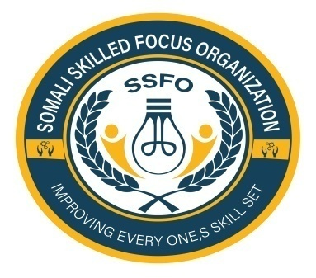
Somali Skilled Focus Organization Quarterly Project Progressive
Project name | Empowering Buhoodle District Girls through education project
Organization | Somali Skilled Focus Organization
Location | Buhoodle District SSC Khatumo State of Somalia
Project No. | 64270
Reporting period | June -August 2024
Report completed by | Mohamed Abdihakin Osman
Title | Project Leader
Email | Mohamed.hakim.ssfo@gmail.com
Contact Number | +252618072944
 | 31/8/2024
  Submission Date

Summary:
Over the past three months, Somali Skilled Focus Organization has made substantial progress in our efforts to empower girls in Buhoodle District through education. Through a variety of activities, including educational assessments, scholarship programs, increased school enrollment, and community outreach engagement, we have seen positive outcomes and impact on the lives of marginalized girls in the district.
Achievements and Progress:
1. Buhoodle District Girls Education Assessment:
- Somali Skilled Focus Organization Conducted comprehensive educational assessments for girls in Buhoodle District to identify their needs, challenges, and aspirations.
- The assessment helped us tailor our programs and interventions to address the specific needs of the girls in the community.
2. Scholarship Program for Marginalized Girls:
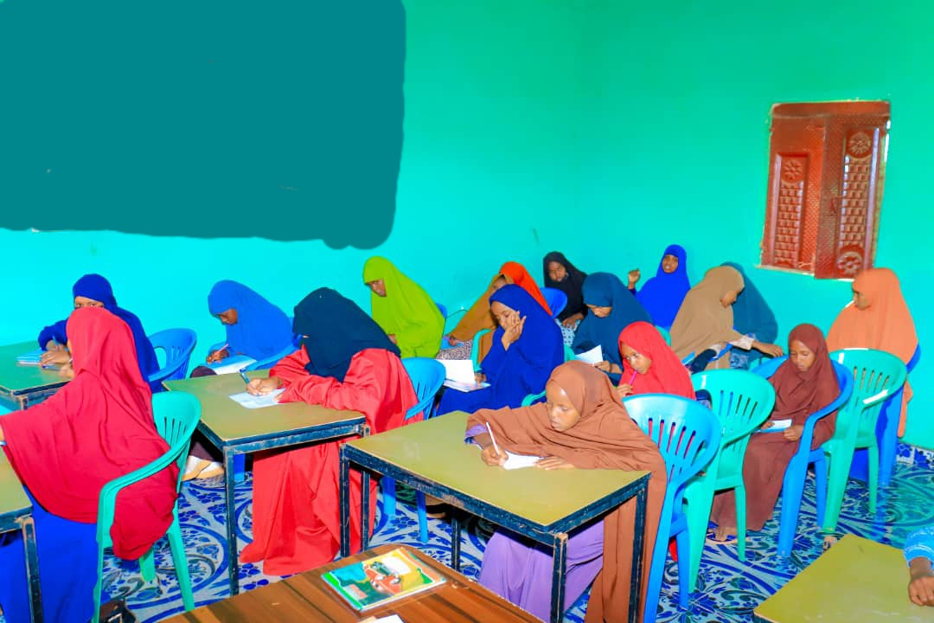
- Successfully supported and provided scholarships to 50 girls from marginalized communities in Buhoodle District.
- The scholarship program has enabled these girls to access quality education, covering school fees, supplies, and other essential resources.
3. Increased School Enrollment:
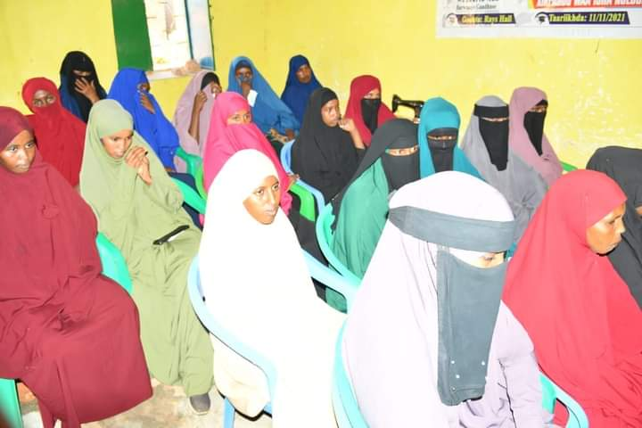
- Implemented targeted outreach campaigns and awareness initiatives that led to a noticeable increase in school enrollment among girls in the district.
- The efforts resulted in a 15% rise in the number of girls enrolling in schools within the project's target areas.

4. Community Outreach Engagement:
- Engaged in various community outreach activities, including meetings, workshops, and awareness sessions, to promote the importance of girls' education.
- Collaborated with local leaders, parents, and community members to garner support and involvement in advancing girls' education in Buhoodle District.
Impact Stories: Transformative Journeys of Deprived Girls who benefited Empowering Buhoodle District girls through Education Project Scholarship Program
Somali Skilled Focus Organization is excited to share with it is Partners and Donors some powerful impact stories of individual deprived girls who have benefited immensely from our girls' education project. These stories underscore the life-changing impact of education on the lives of vulnerable girls in our community.
1. Sadia’s Journey to Empowerment: Sadia, a 16-year-old girl from a marginalized community, faced numerous obstacles in accessing education due to financial constraints. With the support of our education project, Sadia was able to enroll in school, receive scholarships, and access mentorship programs. Through hard work and determination, Sadia excelled academically and is now pursuing her dream of becoming a teacher. She has become a role model for other girls in her community, inspiring them to believe in the power of education.
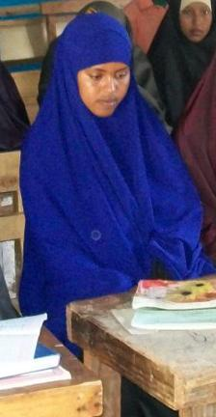
2. Halima’s Resilience and Determination: Halima, s a 15-year-old girl who had to drop out of school to support her family, found hope through our girls' education project. With the provision of flexible learning opportunities and vocational training, Halima was able to continue her education while acquiring practical skills. Today, Halima runs her own small business and is financially independent. Education has not only transformed Halima's life but has also empowered her to uplift her family out of poverty.
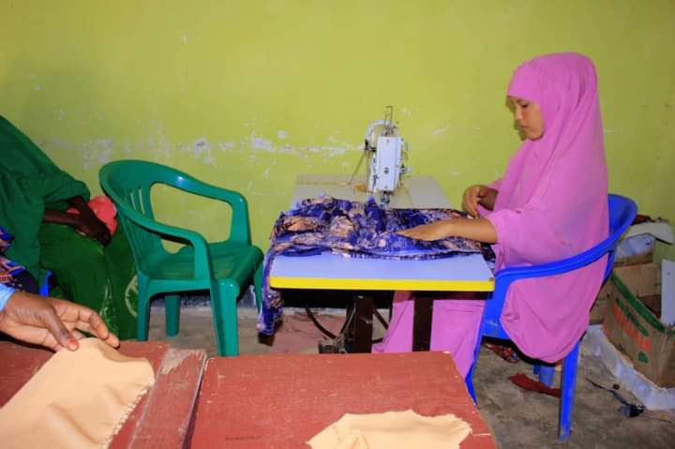
3. Aisha’s Path to Self-Discovery: Aisha, a 16-year-old girl who faced gender-based discrimination and societal restrictions, found a safe space for learning and growth in our education project. Through access to quality education, life skills training, and emotional support, Aisha gained the confidence to pursue her interests in the arts. She is now a talented painter and storyteller, using her creativity to advocate for social change and women's rights in her community.
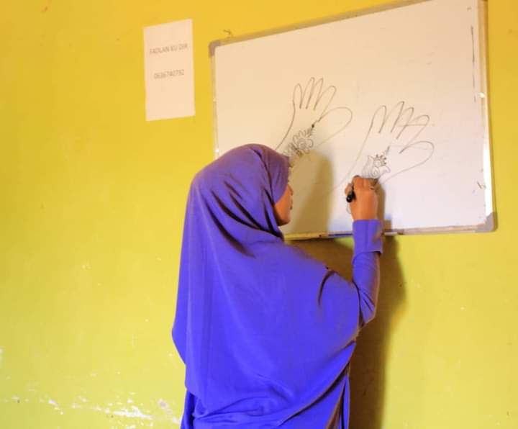
These stories illustrate the profound impact of our girls' education project in empowering deprived girls to break free from the cycle of poverty and inequality. By investing in their education and well-being, we are not only changing individual lives but also building a more inclusive and equitable society for all.

Lessons Learned:
1. Importance of Community Involvement: Community buy-in and participation are crucial for the success of girls' education projects, highlighting the need for sustained engagement with local stakeholders.
2. Tailored Support: Providing tailored support to address the specific needs and challenges faced by girls, such as scholarships, mentorship, and life skills training, can have a significant impact on their educational outcomes.
3. Adaptability: Flexibility and adaptability are key in navigating unforeseen challenges, such as the shift to remote learning, and adjusting project activities to meet the evolving needs of girls in the community.

Work plans and Progress of next Quarter from September- December 2024
Activity | Time plan
1. Increased Enrollment: We will be pleased to report a 20% increase in the enrollment of girls in our education programs compared to the previous quarter. This growth signifies the growing accessibility and appeal of our initiatives within the community. | October 2024
2. Skills Development Workshops: Somali Skilled Focus Organization will successfully conduct a series of skills development workshops focused on areas such as leadership, communication, and computer literacy. Over 100 girls actively participated and reported increased confidence and knowledge in these key areas. | September 2024
3. Infrastructure Improvements: With the support of local partners and donors, we will able to renovate and equip two additional classrooms in our learning center. This expansion will allow us to accommodate more students and provide a conducive learning environment. | October 2024
4. Parent Engagement: Somali Skilled Focus Organization will establish ongoing communication channels with parents and caregivers to involve them in their daughters' education journey. Through regular meetings and feedback sessions, we have seen an improvement in parental support and engagement with the project. | October 2024
5. Community Outreach: Somali Skilled Focus Organization project team will conduct several community outreach events to raise awareness about the importance of girls' education and the services we provide. These efforts have resulted in increased interest and participation from families in the Buhoodle District. | September 2024
6. Academic Performance: Preliminary assessments indicate an overall improvement in academic performance among participating girls. Somali Skilled Focus Organization will observe higher attendance rates, engagement in activities, and progress in key subjects, reflecting the impact of our educational interventions. | November- December 2024

Moving Forward:
As we reflect on our achievements over the last three months, Somali Skilled Focus Organization remains dedicated to further expanding our impact and reach within Buhoodle District. Our commitment to empowering girls through education is unwavering, and we will continue to work closely with the community to create sustainable change and opportunities for all girls in the region.
We express our gratitude to our partners, supporters, and stakeholders who have contributed to the success of our initiatives. Together, we can make a lasting difference in the lives of Buhoodle District girls and pave the way for a brighter, more inclusive future.
Thank you for your ongoing support and belief in our mission to empower and educate girls in Buhoodle District.

Prepared by: Mohamed Abdihakin Osman

Signature :

