
Accommodation and Repairs Budget Report
Promise Giving Children’s Home
Prepared for: Fiona And Her Friends
Prepared by: George Onyango, Director
Date: 27/3/2025

1. Introduction
The Promise Giving Children’s Home is committed to providing a safe, nurturing, and supportive environment for the 100 vulnerable children under our care. To maintain and improve their living conditions, this report outlines the budget required for accommodation enhancements, essential repairs, educational expenses, and recreational facilities. Our goal is to ensure that the children have a sustainable and comfortable home while also receiving quality education and opportunities for play and development.
2. Project Objectives
The primary objectives of this project are as follows:
Renovation of Existing Infrastructure – Upgrading living spaces to enhance safety, hygiene, and comfort.
Repairs and Maintenance of Essential Utilities – Ensuring a stable supply of water, electricity, and proper sanitation facilities.
Structural Integrity Improvements – Strengthening the buildings for long-term sustainability and durability
Timely Payment of Rent and Utility Bills – Ensuring a stable living environment without disruptions.
Provision of School Materials and Uniforms – Equipping the children with necessary educational resources.
Payment of School Fees – Ensuring all children have access to uninterrupted education.
Playground Unit Installation – Providing safe and engaging outdoor play equipment to support children's physical and social development.
3. Budget Breakdown
The budget for the accommodation, repairs, school-related expenses, and playground installation is outlined in the table below:
Category | Description | Cost in Kshs
Accomodation (Rent) | Monthly rent for the children's home (12months) | 720,000.00
Tiles Intallation | For 3 rooms | 89,200.00
Ceiling Installation | For 3 room and veranda | 43,463.00
Utility Bills | Electricity for 12 months | 84,000.00
Plumbing | 2 Toilets repair | 8,000.00
Windows Repair | 8 windows repaired | 9,500.00
Clothes Shelves | Clothe shelves for 3 rooms | 39,275.00
School fees | For 3 secondary students | 89,752.00
Home Painting | Interior and exterior painting | 58,850.00
School Uniforms | Materials for school uniforms | 63,310.00
Play Ground | Materials for play ground unit | 64,450.00
Total | Amount | 1,269,800.00

4. Conclusion and Recommendations
To ensure the well-being and stability of the children at Promise Giving Children’s Home, it is essential to secure the necessary funding for accommodation, repairs, school expenses, and recreational facilities. We recommend:
1. Timely funding allocation to prevent disruptions in rent payments, utilities, and school fees.
2. Regular maintenance checks to reduce long-term repair costs and ensure structural integrity.
3. Seeking partnerships and sponsor-ships to supplement resources for school materials, renovations, and playground installation.
4. Implementing sustainable practices such as rainwater harvesting and solar energy to reduce long-term utility expenses.
5. Ensuring playground safety by using high-quality materials and conducting regular inspections.
5 Expected Outcomes
Upon completion of this project, the following outcomes are anticipated:
Improved living conditions with safer and more hygienic accommodations.
Reliable access to essential utilities such as water, electricity, and sanitation.
Enhanced structural integrity of the facilities.
Uninterrupted education for all children.
Increased recreational opportunities fostering physical and social well-being.
A more stable and sustainable environment for the children.
6. Conclusion
This budget report highlights the critical areas requiring financial support to sustain and improve the living conditions of children at Promise Giving Children’s Home. With adequate funding, we can ensure a secure, educationally supportive, and developmentally enriching environment for the children under our care. We appreciate the continued support and commitment from stakeholders in making this project a success.

We appreciate your continued support in making a difference in the lives of these children. Please let us know if any adjustments are needed in the budget or if further details are required

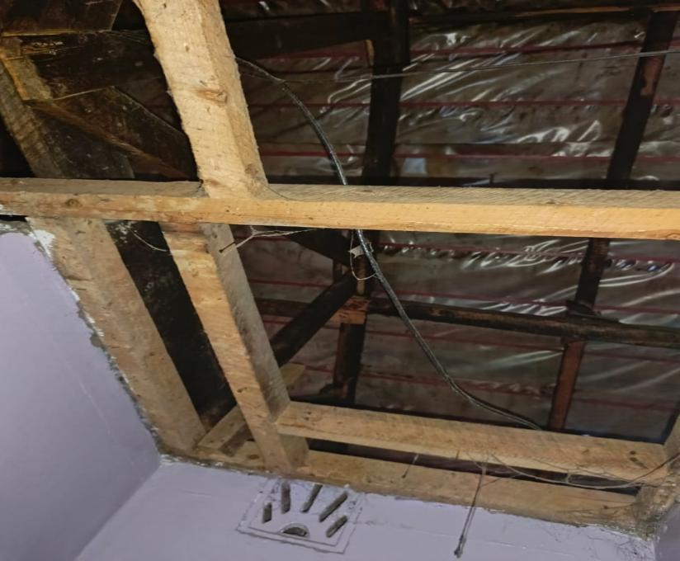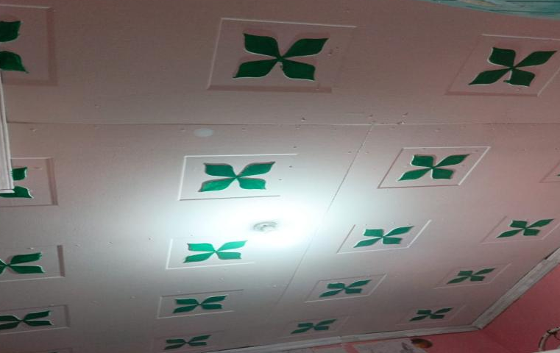
BEFORE AFTER
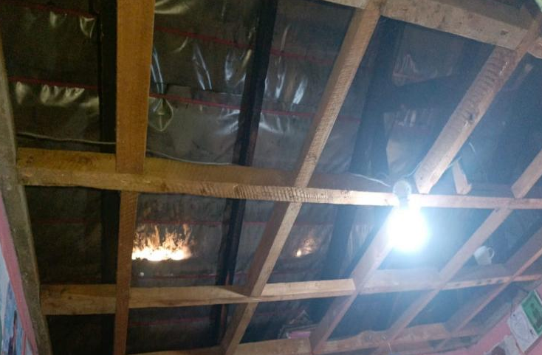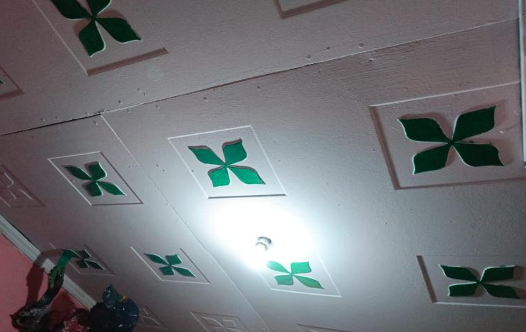
BEFORE AFTER
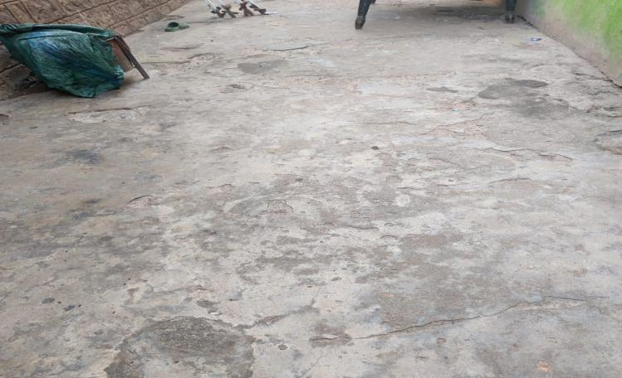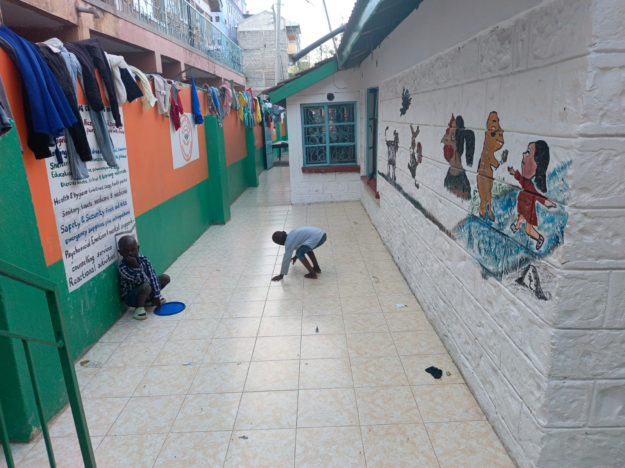
BEFORE AFTER
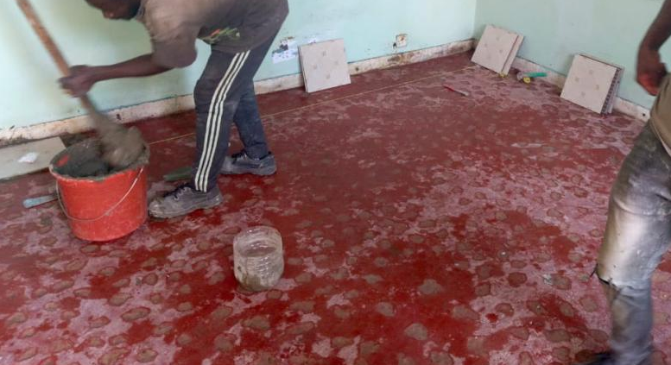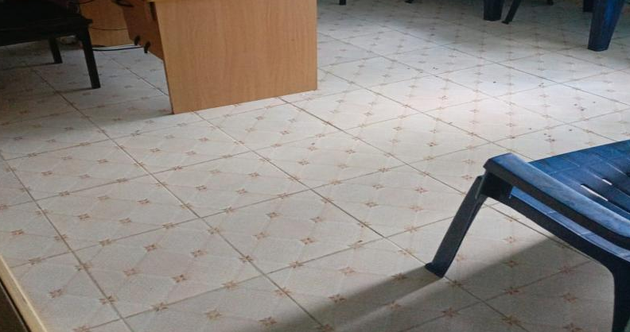
BEFORE AFTER
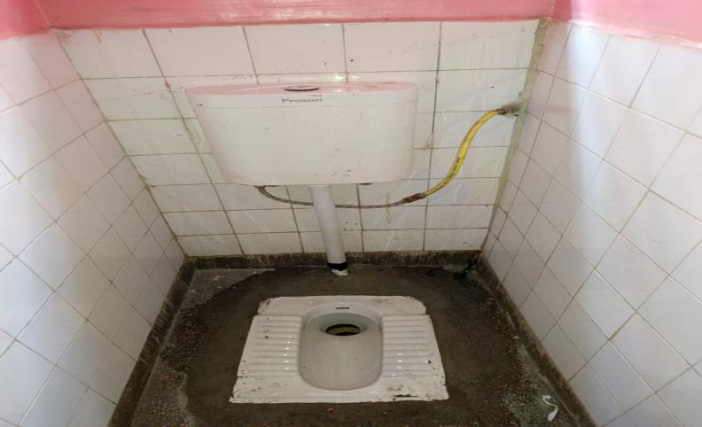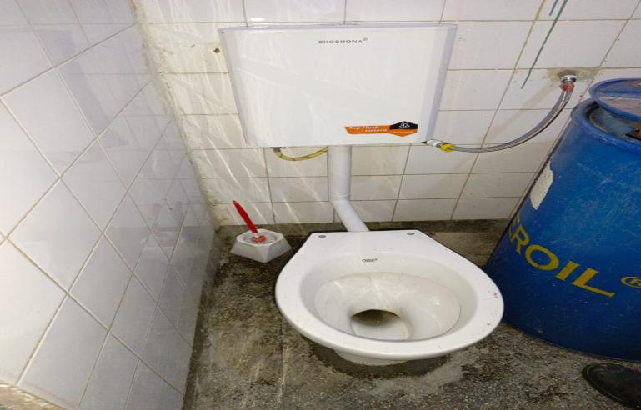
AFTER AFTER
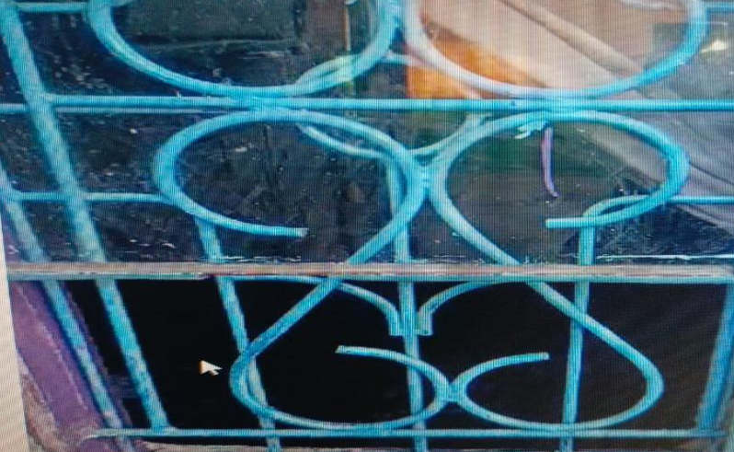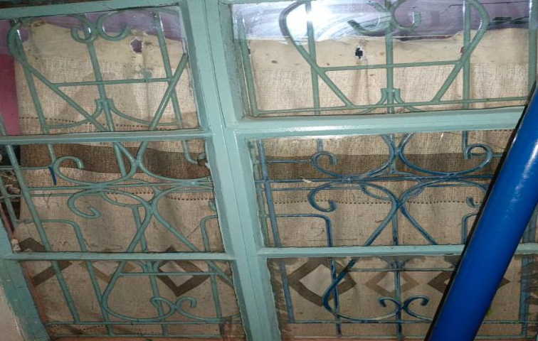
BEFORE AFTER
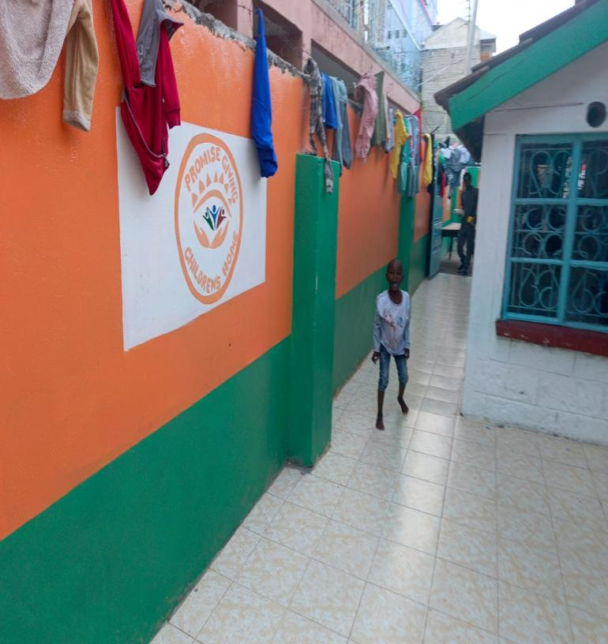
AFTER PAINTING EXTERIOR DECORATION
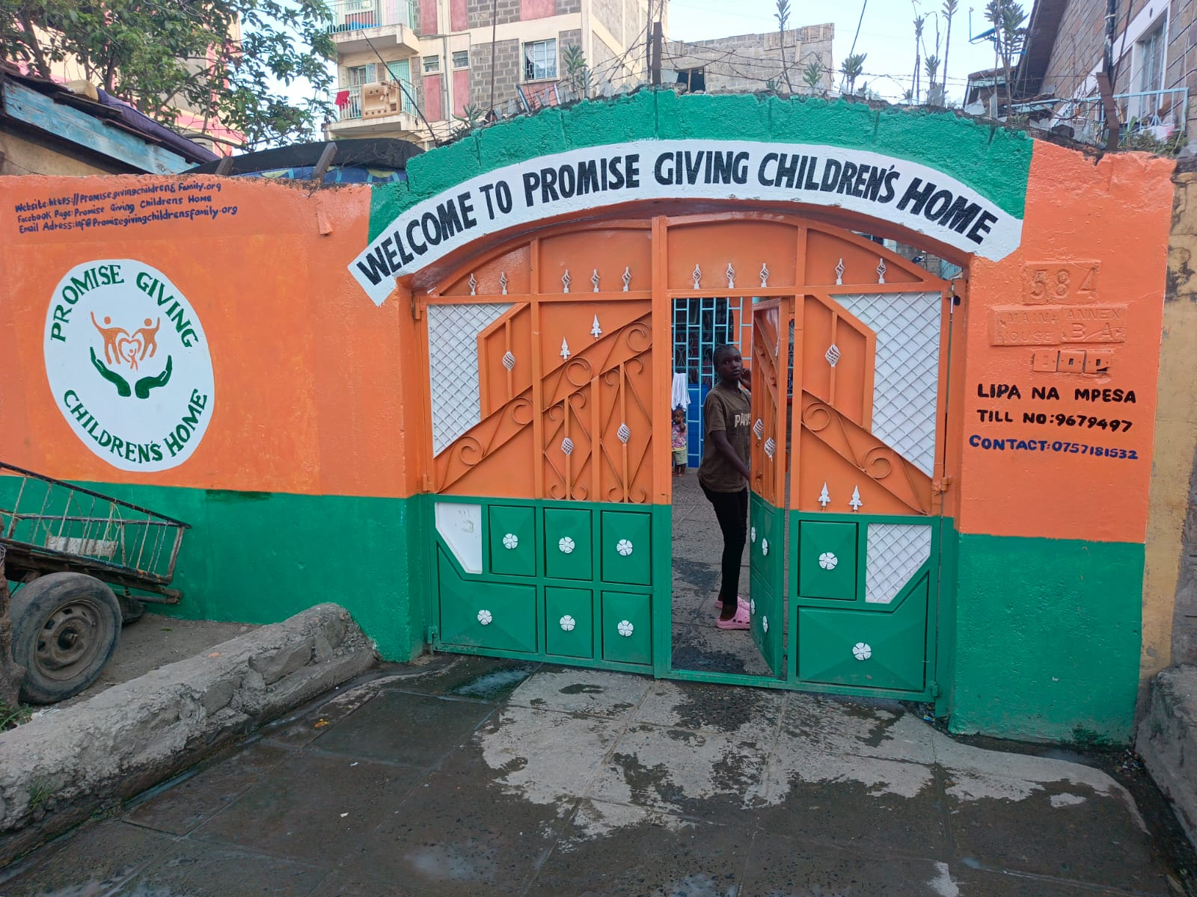
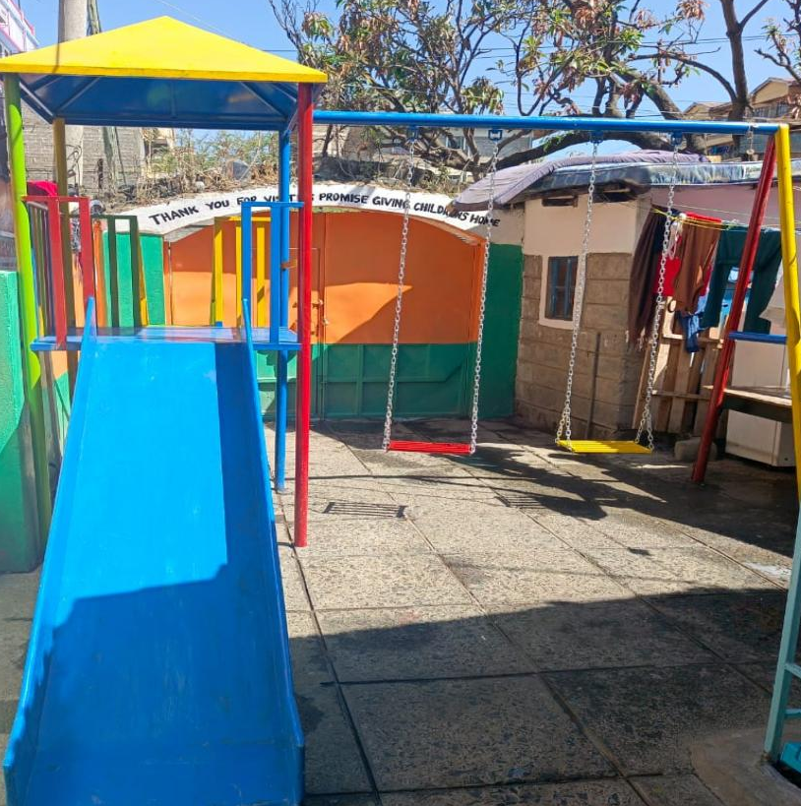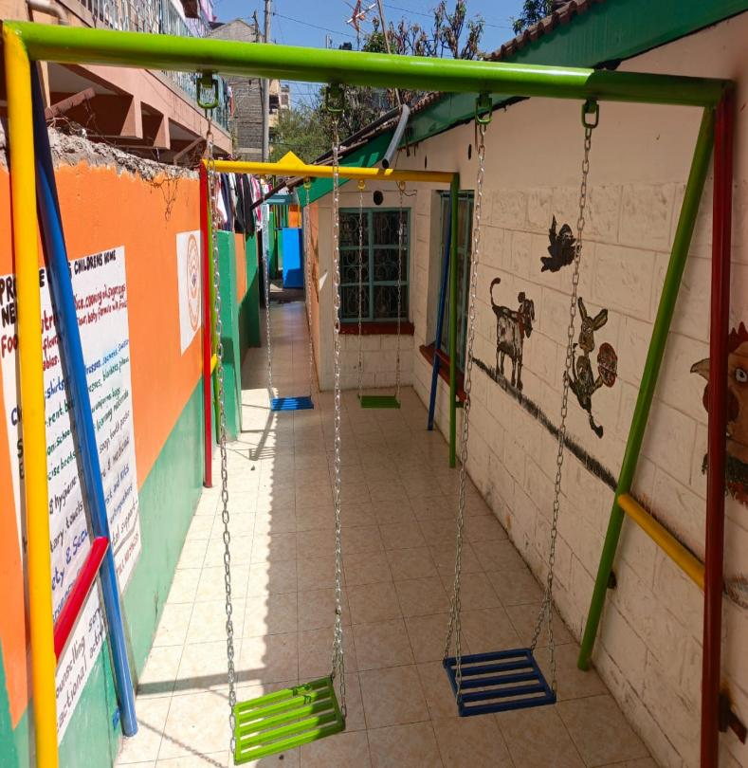
PLAYGROUND AFTER INSTALATION 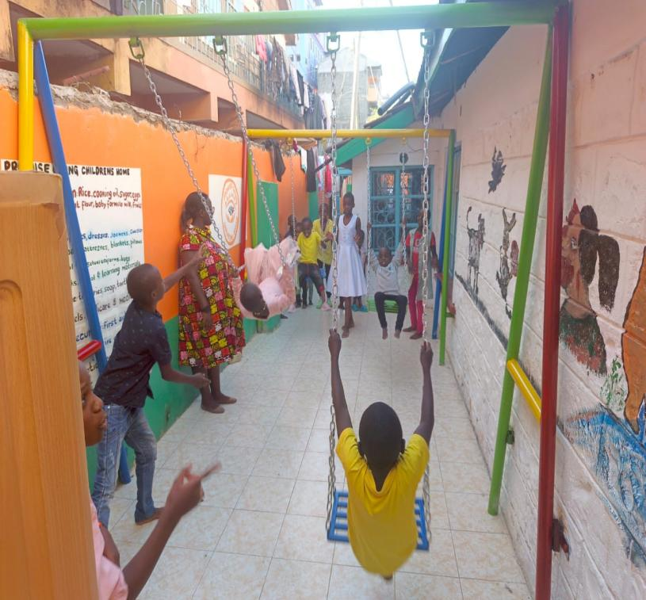 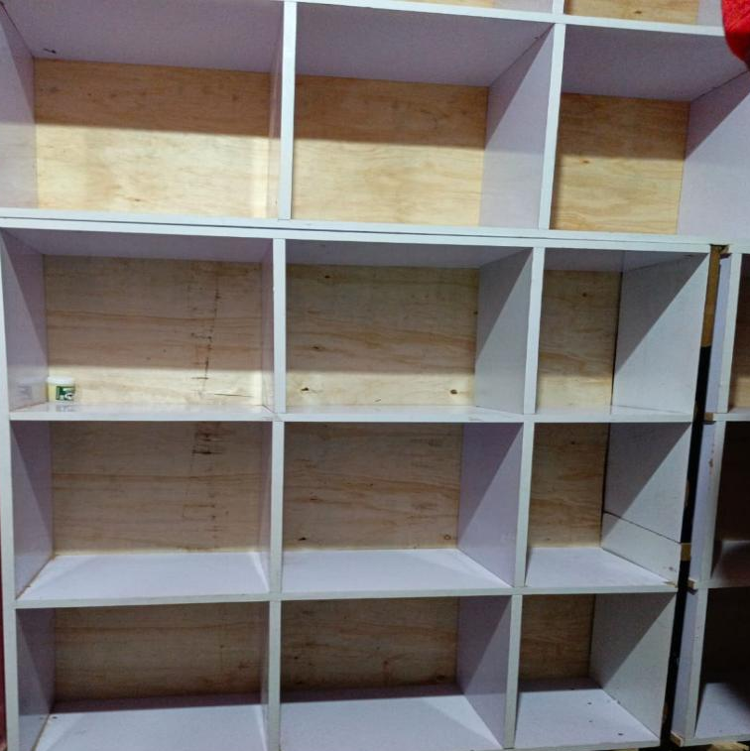
OUR CHILDREN HAVING THEIR TIME CLOTHES SHELVES

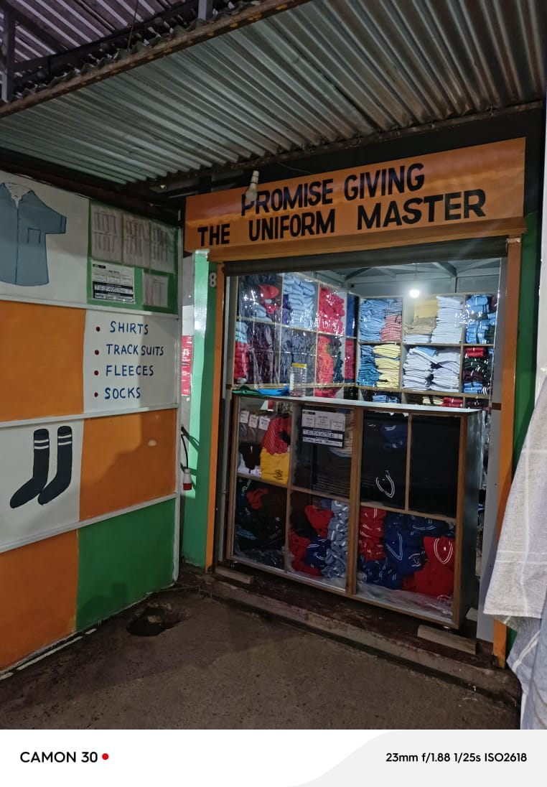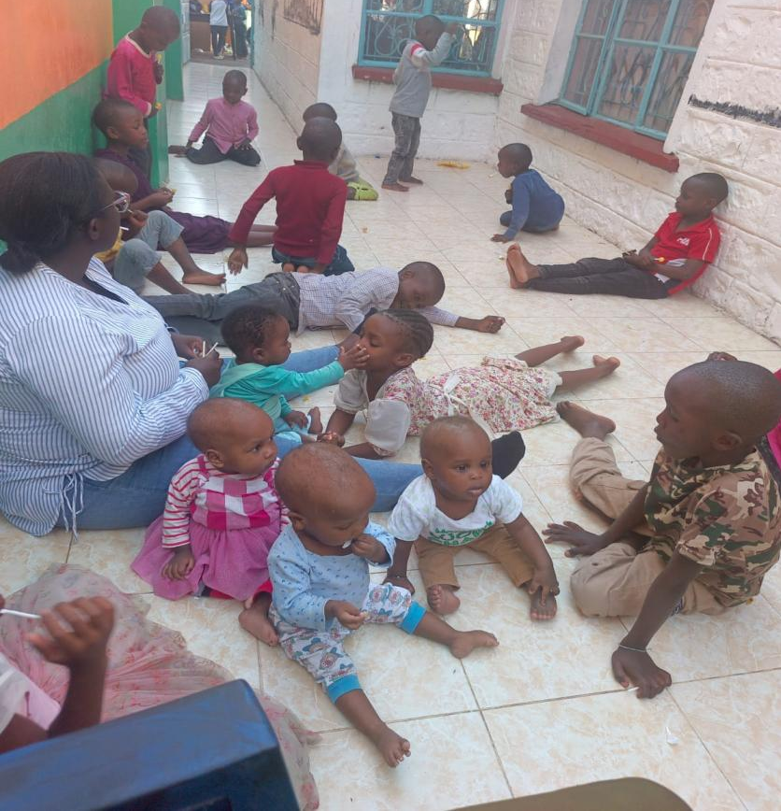
INCOME GENERATING FOR SUSTAINABILITY our children having quality time
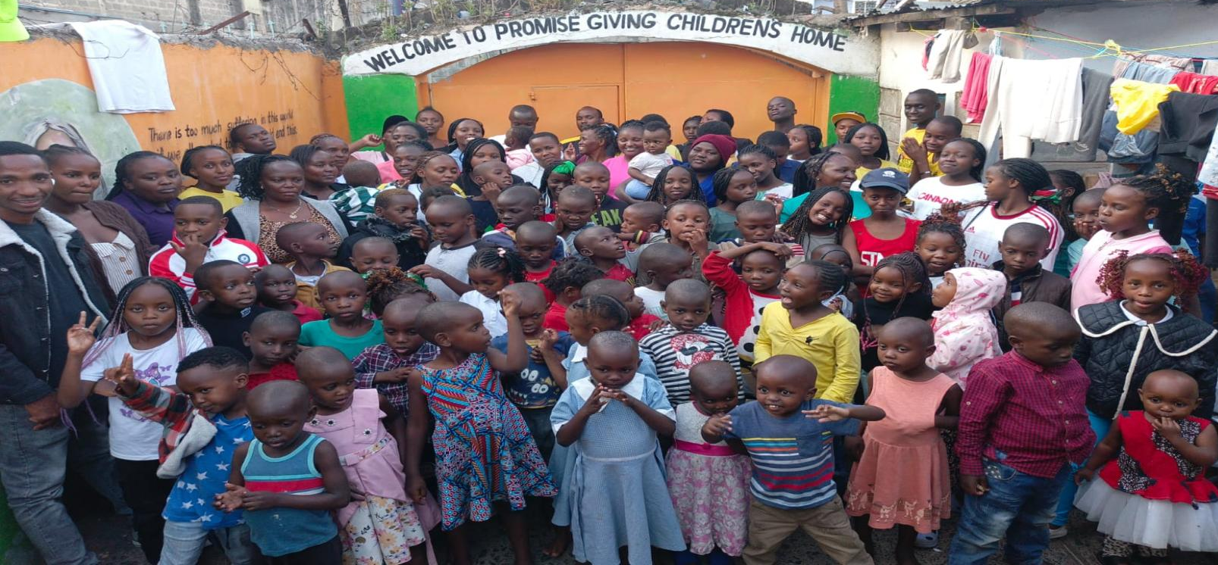
SOME OF CHILDREN IN OUR CENTER
