Ref: 20028.06.01.2024.08.26.72 30th August, 2024
Title or Subject of Report | Sponsor A tree for a child's future in Bangladesh-quarterly report
Project Report | One Tree for One Child: When a child is born, Global Community Organization volunteers visit the family's home and plant a tree in their yard. This tree symbolizes the beginning of a shared journey of growth, as trees provide fruit, shade, oxygen, biodiversity, and shelter. In the past three months alone, 3,200 children have received a tree, marking the continuation of this initiative to enrich both their lives and the environment. The tree plantation will carry on, ensuring a greener, healthier future for generations to come.
Project Report | ABALAMBAN Initiative: ABALAMBAN is a self-reliant, self-employment initiative aimed at supporting helpless and underprivileged families through the provision of fruit trees. After gathering and verifying the details of families with newborn children, impoverished households are identified. Fruit trees are then planted in their home yards, helping to meet both the nutritional and economic needs of the family. In the last three months, ABALAMBAN has successfully established fruit gardens for three families, with aspirations to reach and support many more in the future, with the help of generous contributions.
Author Name | AMINUL ISLAM
Author Title | EXECUTIVE DIRECTOR
Photos and Documents
  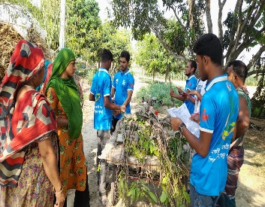 | 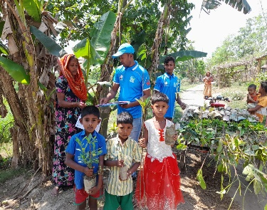 | 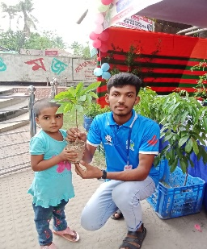 | 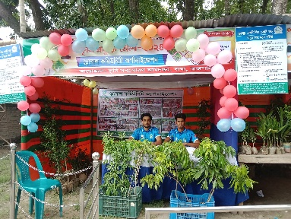
  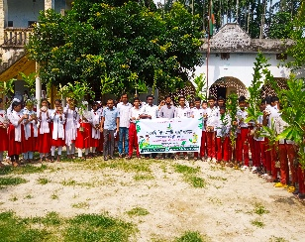 | 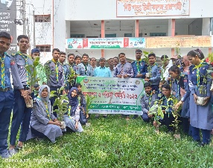 | 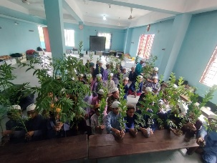 | 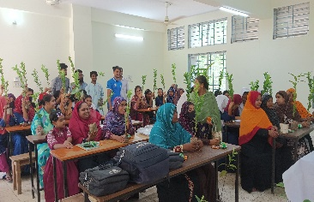
  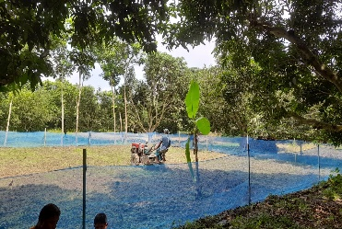 | 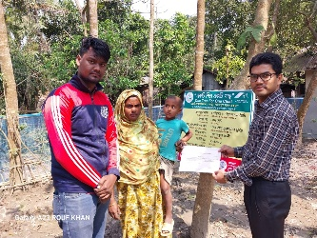 | 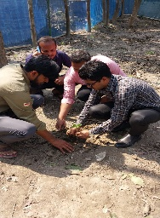 | 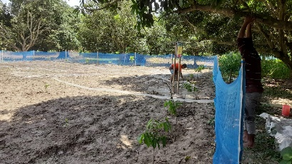
Links | https://www.facebook.com/GlobalCommunityOrganization
Report Location | South Milik Bagha, Bagha-6280, Rajshahi, Bangladesh

