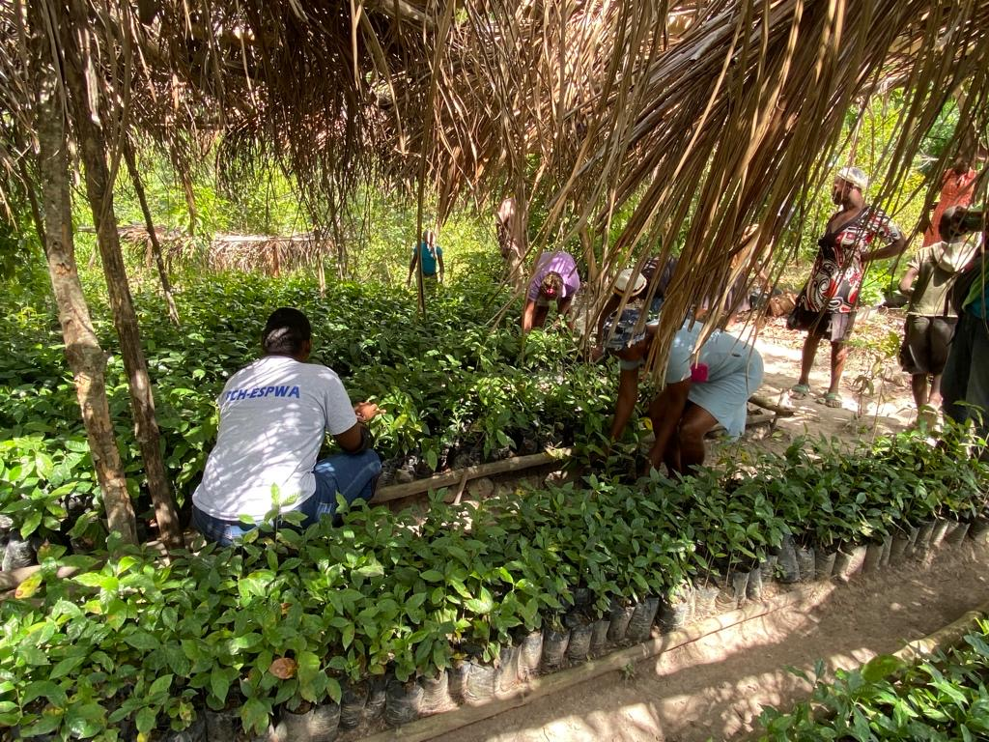
Hope & Solidarity 4 Haiti

In Creole, we say “Lespwa fè viv”. Hope keeps us living. Give hope to Haiti. Support our communities!
The situation in Haiti is catastrophic. Violent gangs have seized control of Port-au-Prince where most private and public institutions have traditionally been centralized, and the country is suffering as a result. The political vacuum does not help.
The focus of the media and of the world has been on the worst of Haiti. Our organization and our network focus on its best: our people full of spirit and anchored in family values, and our communities where people stand in solidarity with each other to continue to live, hope, and dream of a better future. “Lavi ap kontinye” as we say in Creole. Life goes on.
For the past 14 years, ESPWA and Fondation Communautaire Haitienne-Espwa have been working with and for Haitian communities through thick and thin, through hurricanes, earthquakes, political upheaval, and everyday life. We have helped our communities get back on their feet after Hurricane Matthew, the 2021 Earthquake, reached out and supported uninformed community residents through the Covid 19 pandemic, understood (as we always do) that resilience is built on community residents’ ability to be self-sufficient and better able to support themselves financially. Not just meeting needs but also focusing on community dreams. We have helped over 200,000 community residents in the Grand Sud. We have built a new model of economic development for Haiti, one that puts Haitians at the leadership of their communities and in control of their lives.
Today, as the unprecedented political and socio-economic crisis is plunging Haiti into its worse ever humanitarian crisis, we ask you to stand in solidarity with Haiti and support our work for and with Haitian communities.
- Cholera is back with a vengeance and attacking our communities- help us fight back and save lives.
- Hunger is a reality more than half of Haitians. Help us increase small farmers ‘agricultural production, support community residents’ private garden/’jaden lakou”.
- Economic development increases resilience and community health. Support our economic development initiatives that support community priorities (agricultural product transformation, fishermen association, farm animal programs, micro-enterprise and community group savings and loans programs -also called “Mutuelles Solidarités”, and more!).

Every contribution that you give in solidarity with Haiti brings hope and support to our communities.

Mèsi anpil! Thank you very much!

The Haiti Community Foundation Network on behalf of the Haitian communities that we serve

