**M&E REPORT ON THE TEENAGE MOTHERS WHO RECEIVED SEWING MACHINES FROM THE FOUNDATION AFTER TRAINING**

**Introduction**

**Purpose of the Report**: To assess some beneficiaries’ effective utilization of the sewing machines received.

**Background Information: As** part of teenage mothers’ empowerment programme, some beneficiaries received training in tailoring, while others took on training as hairdressers, beauticians, retailers and high school students.. This was to enable them acquire sewing skills, pattern drafting, stitching techniques, and gain practical experience in the handling and the design of various fabrics, as well as, gain customer service and business management skills. Following the training, sewing machines were presented to them.

**Rationale for Providing Sewing Machines:**

* As an empowerment tool because sewing machine is a critical asset that will enable immediate application of acquired skills for startups and income earning.
* Sustainability: By owing a machine, they can establish long-term self-employment rather than rely on temporary paid-employment opportunities.
* Independence: The machine reduces dependency on external resources, allowing them to work from home or set up small workshops.
* Skill Utilization: It ensures that the skills acquired during the apprenticeship do not go to waste due to lack of tools.

**Methodology**

* Field visits to beneficiaries’ locations (homes)
* Interactive engagement with beneficiaries to collect relevant information about the usage of the sewing machines.
* Observation of the beneficiaries in the course of work.

**Findings**

Two (2) out of three (3) beneficiaries are actively using the machines.

1. Grace, a resident of Alayi at Bende LGA, Abia State

As a 17 year old teenage mother, she struggled with poverty. She joined the AAAF sewing apprenticeship program with no prior skills.

Post-Apprenticeship Journey: After receiving her sewing machine, Amarachi Grace set up a small tailoring shop in her mother’s house almost immediately. Currently, she has been able to secure a gradual steady stream of clients for school uniforms, alterations and custom designs. Her income averages #15,000.00 monthly allowing her to support herself and her child. She hopes to expand her services to include renting a shop so as to have enough space to accommodate potential apprentices, increasing her earnings.

Amarachi’s success highlights the program’s potential to empower participants for self-sufficiency and community development.

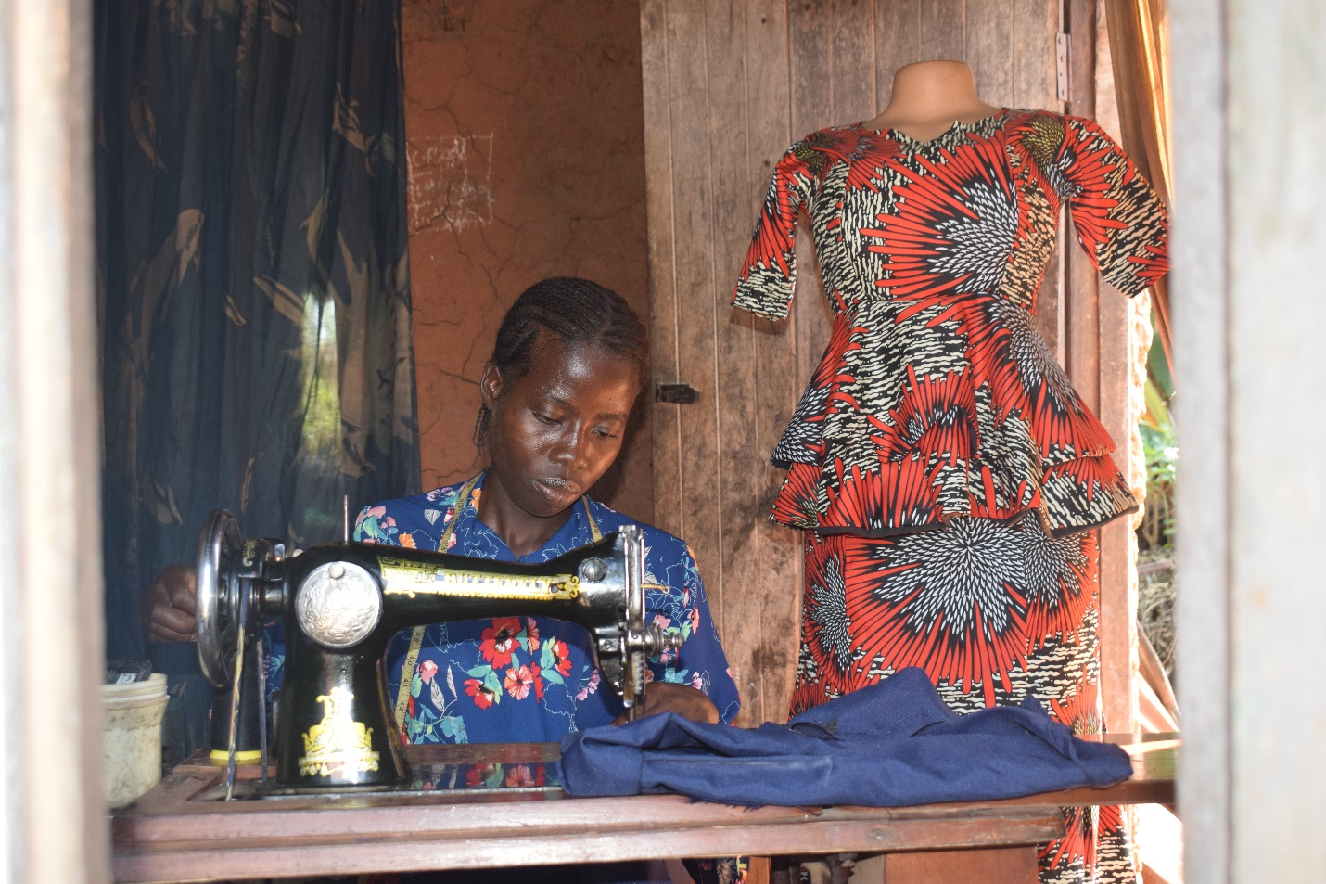**Amarachi focusing on her job**

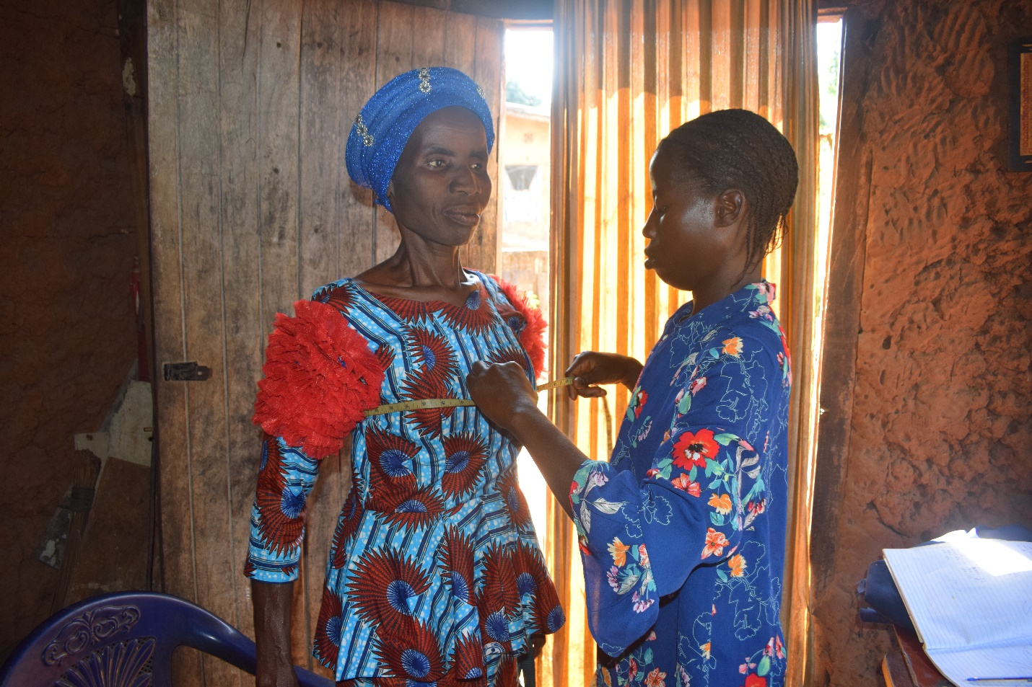**Amarachi taking the measurement of one her clients.**

1. Sopuruchi, a resident of Umuezeagwu at Umuahia North LGA.

Sopuruchi had basic sewing skills before joining the AAAF program but lacked confidence and equipment to start her business.

Post-Apprenticeship Journey: After being gifted a sewing machine at the end of the one-year apprenticeship, Sopuruchi has since assumed usage of the machine. She also uses the machine personal sewing, alterations and custom designs. According to Sopuruchi, her income averages #12,000.00 monthly which still allows her to cater for herself and child. She still uses her father’s house as she hopes to expand when things get better for her.

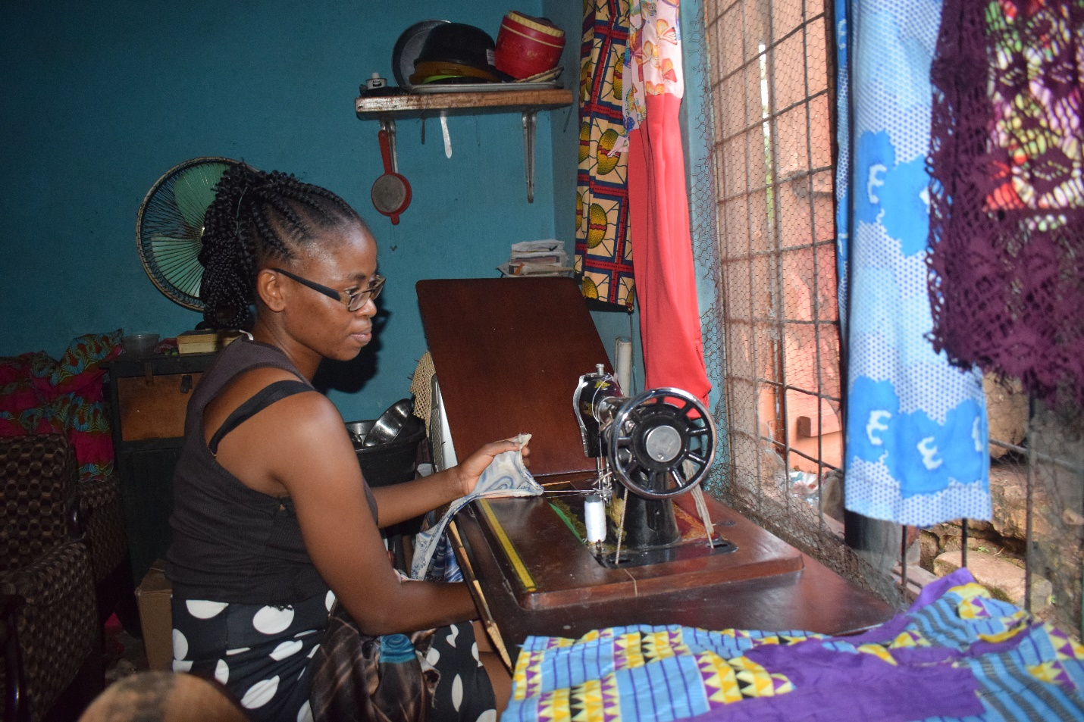**Sopuruchi doing what she enjoys**

1. Happiness

Location: Unknown

I learnt during the course of my visitation that she got married and relocated. All efforts to reach was abortive

**Conclusions:**

The tailoring skill development component of the Foundation’s Teenage Mother Empowerment Programme is about 70% successful. All participants received sewing machines, ensuring they had the necessary tools for entrepreneurship, as the provision of machines was a critical enabler for beneficiaries like Grace and Sopuruchi. As the machines were delivered as intended, their impact depends heavily on the readiness and motivation of the beneficiaries. Economic empowerment was achieved.

**Recommendations**

* AAAF to conduct regular visits or calls to assess machine usage, income generation, and challenges.
* Maintain a database of beneficiaries’ progress to identify trends and address challenges early.
* Offer advanced skills workshops in areas like embroidery, fabric printing or digital tailoring to increase competitiveness.