WEEK ELEVEN REPORT ON THE CROCHET AND KNITTING VOCATIONAL SKILLS TRAINING

Overview of Activities
The eleventh week of the Crochet and Knitting Vocational Skills Training was fully dedicated to individual project production. At this stage of the program, participants have acquired a wide range of crochet and knitting techniques, and the week was set aside for them to apply these skills independently.
Participants spent the entire training period working diligently on their personal projects, created based on everything they have learned so far. These projects include:
- Cardigans (front, back, and neck rib sections)
- Mufflers
- Customized slippers
- Crochet scrunchies
- Bags made from plastic canvas
- Granny square patterns
- Colour-change knitting samples
- Other creative items inspired by what they have learned

Preparation for Exhibition
In addition to their personal assignments, participants also began producing special items for the upcoming exhibition.
This exhibition will serve as a platform to showcase their creativity, skill mastery, and craftsmanship to the public, trainers, and supporting organizations.
Each participant is putting in their best effort to ensure their exhibition pieces reflect:
- Neat finishing
- Creativity in color combinations
- Adequate mastery of techniques
- Professional presentation
The atmosphere throughout the week was focused, vibrant, and purpose-driven, with everyone committed to producing impressive and market-ready items.
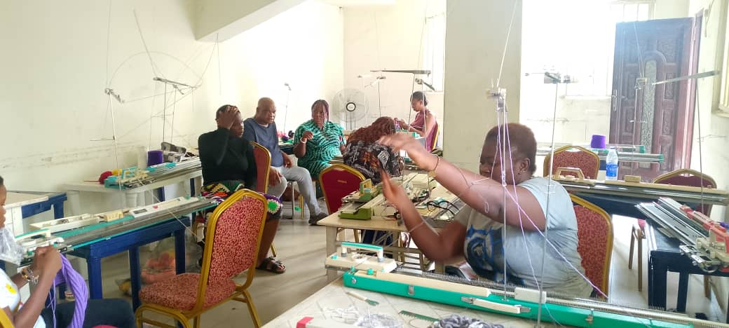

Trainer’s Support and Supervision
The facilitator provided close supervision, moving around the training hall to:
- Offer corrections and guidance where necessary
- Ensure proper stitch formation and pattern accuracy
- Encourage participants to refine their finishing
- Assess the readiness of items intended for exhibition
This hands-on support boosted the confidence of trainees as they worked independently.
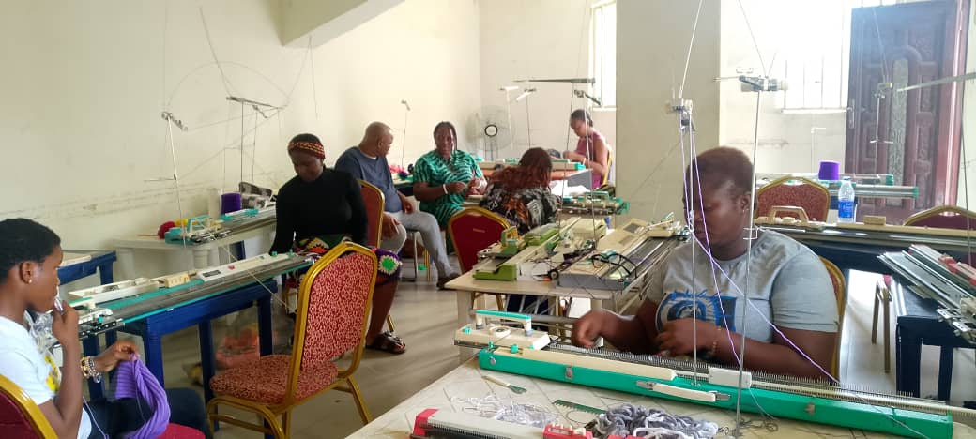

General Observations
- Participants demonstrated strong dedication and creativity.
- Peer support remained high as they shared ideas, assisted one another, and compared progress.
- The quality of work has greatly improved, showing clear evidence of skill growth.
- The excitement toward the upcoming exhibition motivated them to work harder and smarter.

Conclusion
Week Eleven was a highly productive period focused on refinement, creativity, and practical application of all skills learned since the training began. By working on personal and exhibition projects, participants strengthened their independence, confidence, and readiness to use these vocational skills for income generation.
The training is steadily approaching its final phase, and the participants are showing impressive commitment as they prepare to showcase their achievements.

