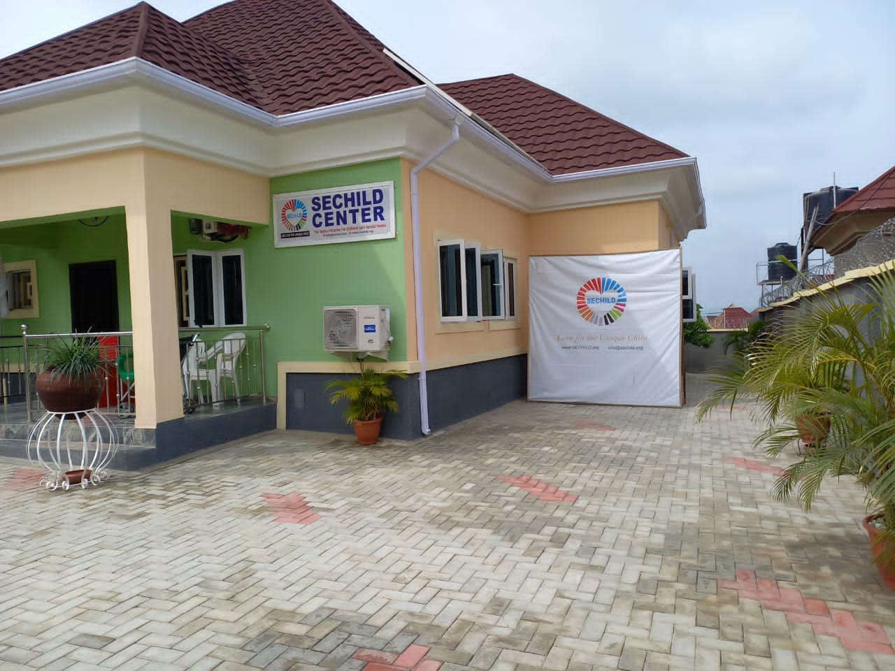

ANNUAL REPORT

THE SEDOO INITIATIVE FOR CHILDREN WITH SPECIAL NEEDS-SECHILD

2023

Table of Contents
President’s Remarks 4
About SECHILD 5
SECHILD’s Mission and Vission 6
Appeal for Support 7
Filling of Annual Returns with Corporate Affairs Commission 8
Filling of Tax Incentives with Federal Inland Revenue Service 9
Tranforming Lives 10
Guiding Light 11
Empowering Kuje 12
Breaking Barriers 13
Advocacy Meeting with Stakeholders 14
Village Square Dialogue 15
Empowering Voice 16
Therapy 17
Recruitment and Training of Peer Educators 18
Stakeholders Review Meeting 19
Capacity Building 20
Assessment of Primary Health Care Centers in Kuje 21
Collaboration Horizon 22
Collaborating with Economic and Financial Crime Commission-EFCC 24
Empowering Organizations 25
Empowering Voices 26
Celebrating Heroes 27
Garki Hospital Partnership 28
Tersoo's Triumph 29
Kuje Impact 30
Transformative Impact 31
Breaking Chains 37
We Ring The Bell 38
Advocacy with Sector Leaders 39
Empowering Children wih CP 40
Parents Visit 41
Advocacy Journey 42
Journey with Liliane Fonds/TLMN 43
Photography and Story Telling 44
Transformative Journey 45
Transformative Stories 46
Lilian Fonds/The Leprosy Mission Nigeria Visit 47
Partnerships-Keeping Children Safe/ International Cerebral Palsy /Global Giving 48
WHO Civil Society Commission Membership 49
Tech To The World Partnership 50
Strategic Dialoue-Global Giving 51
SECHILD's Impactful Presence 52
Harmony of Giving 53
Strengthening Partnerships 54
NIDOE Europe Partnership 55
Exceptional Intern 56
A decade of Triumph 57
Building Inclusive Communities 58
Powering Hope/ Honoring Lucy Adaa 59
Powering Hope 60
Media Engagement/Trainings 61
Challenges 62
Partnerships & Support 63
Chairman's Remarks 64
Contact Us 65

President’s Remarks
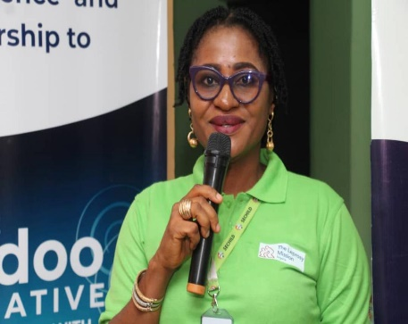Dear members and supporters of SECHILD,
I am thrilled to reflect on the remarkable accomplishments of The Sedoo Initiative for Children with Special Needs in 2023. With immense pride and gratitude, our commitment to providing quality therapy services, fostering capacity building, and offering vital support to children with disabilities has never been stronger.
This year marked a pinnacle in our journey, witnessing unprecedented growth as we expanded our coverage and worked tirelessly to bridge the gap between children with disabilities and society. The resounding success of our major project, "Improved Access to Primary Health Care Service for Children with Disabilities in Kuje," stands as a testament to our dedication and the invaluable support received from Liliane Funds through The Leprosy Mission Nigeria.
Our engagement with the Kuje community not only raised awareness about the unique needs of children with disabilities but also fervently advocated for their protection. We amplified the voices of change-makers, contributing to the implementation of the "Prohibition of Discrimination against Persons with Disability Act (2020)." Additionally, our focus on capacity building and counseling for primary healthcare service providers, caregivers, and parents further solidifies our holistic approach.
I extend heartfelt gratitude to our hardworking Chairperson, the Board of Trustees, and our equally committed staff for their unwavering support. With these achievements as our initiative, we eagerly anticipate reaching even greater milestones in the future.
Thank you for your continued dedication and support.

Sincerely,
Kawan Aondofa-Anjira (MRS, FIMC, CLIM)
ABOUT THE SEDOO INITIATIVE FOR CHILDREN WITH SPECIAL NEEDS-SECHILD
The Sedoo Initiative for Children with Special Needs (SECHILD), founded in January 2011, aims to improve the well-being of vulnerable children and caregivers, especially those with disabilities like Cerebral Palsy. SECHILD offers residential care services, including rehabilitation and therapy, and advocates for children's rights to education, healthcare, and protection from violence. Through partnerships with government bodies, NGOs, and corporate sponsors, SECHILD has positively impacted over 15,000 lives in Nigeria, focusing on advocacy, education, rehabilitation, and support programs. In 2023, SECHILD successfully implemented a health care grant, furthering its mission with a dedicated team and community support.

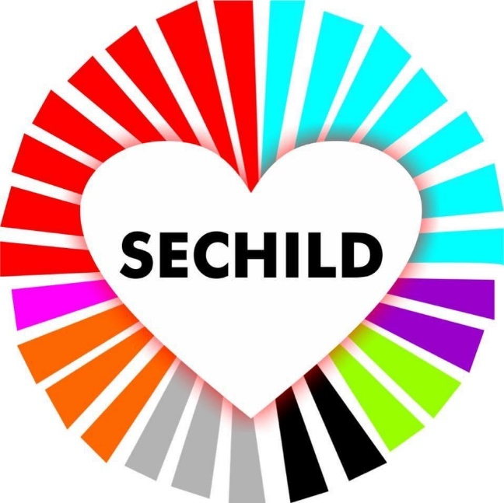
Love for the Unique Child

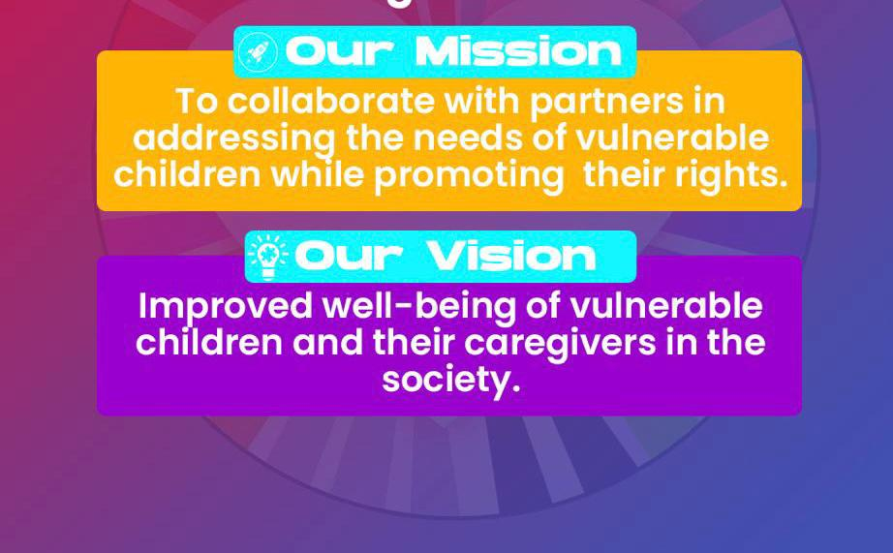
Wheels of Hope: A Call for a Dedicated Bus for Children with Cerebral Palsy
SECHILD urgently calls for support in acquiring a dedicated bus to ensure safe and reliable transportation for children with Cerebral Palsy. The absence of a dedicated bus hampers efforts to provide comprehensive care, hindering timely transport during critical health situations. The organization seeks divine guidance and support, emphasizing the urgency of this need to extend services beyond the center’s boundaries and reach remote communities.
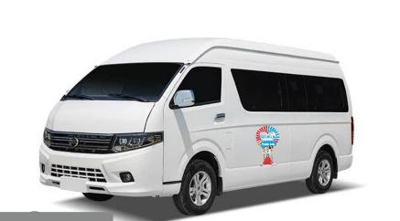

*Appeal for Generosity: Transform Lives with Your Donation*
Every therapy we provide is fueled by the generosity of individuals like you. Your contribution isn't just a monetary gift; it's the key to unlocking an hour of transformative 'SECHILD Care.' Imagine the impact: in that hour, a child might take their first step, sit independently for the first time, or learn to dress and feed themselves. Your donation keeps our commitment alive – a commitment to respite, advocacy, awareness, special education, and life-changing therapies for children with Special Needs. Your support becomes the catalyst for moments that define a child's journey toward independence and fulfillment. Join us in making a lasting difference. Your contribution is more than financial; it's a gift of hope, progress, and possibility. We are profoundly grateful for your belief in the uniqueness of our children and the positive change your donation brings to their lives. Together, we can create hours filled with milestones and achievements for every child under our care. Thank you for making these possibilities a reality.

Cost of Residential Care, Therapy and Education for One Month
Therapy | Feeding | Medical | Diapers/  Toiletries | Electricity/  Fuel/  Cooking Gas | Education | Miscellaneous | Salaries | Total
N200,000 | N250,000 | N300,000 | N600,000 | N160,000 | N120,000 | N130,000 | N2,000,000 | N3,760,000

*"Empowering Lives: The Sedoo Initiative for Children with Special Needs-SECHILD"* Since its inception in January 2011, SECHILD has been a beacon of hope for children with special needs in Nigeria. From addressing individual cases of brain malfunction to advocating for broader issues like Cerebral Palsy, SECHILD has evolved into a comprehensive initiative supporting vulnerable children and individuals with disabilities. In 2023, SECHILD actively champions the cause of children with Cerebral Palsy, advocating for financial support and aligning with global and national initiatives. The organization's call for freely available health insurance for these children empowers parents and caregivers. SECHILD's commitment to creating inclusive environments ensures that every child feels valued. With initiatives ranging from special education to mental health support, SECHILD impacts over 5000 lives, guided by core values of resilience, teamwork, and empowerment. Through advocacy, community outreach, and global partnerships, SECHILD breaks societal barriers and envisions enhancing the quality of life for children with special needs in Nigeria.

*"SECHILD's Triumph: Annual Returns Filing with Corporate Affairs Commission-CAC Marks a Transformative Chapter"*
SECHILD, devoted to uplifting children and women, reached a milestone on April 18, 2023, filing annual returns with the Corporate Affairs Commission. This narrative showcases the organization's commitment, detailing achievements, projects, and lives touched—a testament to resilience, compassion, and a relentless pursuit of positive change. The filing symbolizes collective triumph, positioning SECHILD as a beacon of hope, transparent, and compliant. This historic day reaffirms SECHILD's dedication to transparency, accountability, and the noble cause they champion, leaving an indelible mark on their organizational history and in the hearts of those they serve.

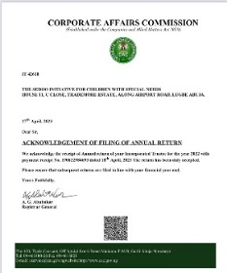

*"SECHILD's Federal Inland Revenue Service-FIRS-Financial Integrity: A Commitment to Transparency and Compliance" - 2023* In its ongoing commitment to transparency and good governance, SECHILD proudly submits its 2022 annual financial report to the Federal Inland Revenue Service (FIRS). Adhering to legal obligations within Nigerian tax laws, SECHILD employs the Tax Promax platform for digital submission and provides hard copies, ensuring accessibility for FIRS. This steadfast dedication to timely and accurate filing epitomizes SECHILD's pledge to transparency, integrity, and responsible financial management, fostering trust and confidence among stakeholders. As the organization persists in its mission to support children with special needs, it remains resolute in upholding the highest standards of corporate governance.

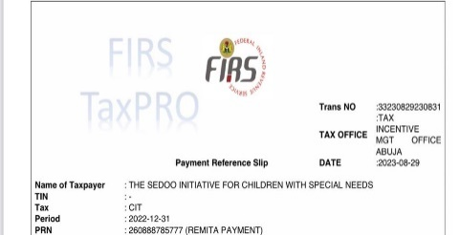

*"Transforming Lives: SECHILD’s Advocating for Children with Cerebral Palsy"*
In 2023, SECHILD, committed to advocating for children with Cerebral Palsy, actively engaged in transforming the narrative surrounding their well-being. Stories of change emerge as SECHILD addresses the challenges faced by families, particularly the financial burdens hindering healthcare access. SECHILD's efforts align with global and national initiatives, echoing the principles of the United Nations' Sustainable Development Goal 3 and supporting Nigeria's Child Rights Act 2003. Through legislative frameworks, SECHILD works to ensure that children with Cerebral Palsy have access to essential medical assistance and services, navigating the complexities of their holistic well-being. The call for action resonates strongly with SECHILD's mission, as they champion the cause of freely available health insurance for children with Cerebral Palsy. By doing so, SECHILD envisions empowering parents and caregivers to prioritize their children's needs without the constraints of financial challenges, a transformative step in line with the right to social protection. SECHILD's commitment to promoting love and care is evident in their hands-on approach. Through various initiatives and programs, they strive to create inclusive and supportive environments where every child, regardless of their abilities, feels valued and cherished. These stories of change highlight the transformative power of love, emphasizing the universal right to equal attention, love, and friendship for all children.

The organization recognizes the transformative power of therapy in the lives of children with Cerebral Palsy. SECHILD actively advocates for accessible and affordable therapy options, aiming to empower these children with the tools needed to thrive. In conclusion, SECHILD's narrative in 2023 revolves around advocating for children with Cerebral Palsy, addressing the formidable challenges faced by families. By prioritizing the rights of these children and actively advocating for universal health coverage, SECHILD contributes to significant change. Through collaborative efforts and a commitment to creating inclusive and supportive environments, SECHILD envisions enhancing the quality of life for these children, enabling them to reach their full potential.

Guiding Lights - SECHILD’s Empowering Journey with Children with Cerebral Palsy

In the heart of SECHILD's mission lies a meticulously crafted residential facility, fostering a sense of community for children with Cerebral Palsy. The organization goes beyond conventional care, empowering families through comprehensive training programs. Trained staff, personalized care plans, and tailored sitting frames reflect SECHILD's commitment to transforming lives with thoughtful and individualized support.

SECHILD's inclusive Residential Care and Therapy Services provide a supportive space where children can thrive, emphasizing motor skill development and holistic care. The organization's impactful partnership with Liliane Fonds highlights tangible improvements in educational opportunities and community-based initiatives, showcasing the transformative power of collaboration.

Precision in support is evident in SECHILD's approach to customized sitting frames, ensuring optimal comfort and safety for children with Cerebral Palsy. The organization's dedication to empowering change through capacity building and partnerships is showcased in its annual report, emphasizing ongoing improvement, community outreach, and creating an inclusive environment for every child.

SECHILD's steadfast commitment to capacity building covers diverse areas, fostering a continuous learning environment for internal and external stakeholders. Collaborations with esteemed organizations, such as Liliane Fonds, contribute to improved performance and overall growth. Monthly training sessions ensure staff stays updated, empowering them to make informed decisions aligned with SECHILD's mission.

As SECHILD continues its mission to support children with special needs, the focus on capacity enhancement remains a top priority, evident in the Training and Event Calendar showcasing ongoing improvement initiatives and strategic partnerships with external organizations. The impact of continuous training and professional development initiatives is seen in improved performance, increased motivation, and a positive work environment. Caregivers, integral team members, contribute significantly to SECHILD's success and growth.

"Empowering Kuje: Liliane Fonds and The Leprosy Mission Nigeria's Impact on SECHILD" Liliane Fonds (LF) and The Leprosy Mission Nigeria (TLMN) joined forces with SECHILD to revolutionize healthcare for children with disabilities in Kuje. Together, they improved infrastructure, empowered professionals, and raised community awareness through their joint mission, "Improving Access to Primary Health Care Services for Children with Disabilities." LF and TLMN's support led to increased community awareness, better healthcare access, and tailored services for Cerebral Palsy. SECHILD's collaborations extend to national levels, leaving a lasting legacy of hope and resilience in Kuje.

*SECHILD's Gratitude to Liliane Fonds* In February 2023, Liliane Fonds and TLMN organized a pivotal meeting at Exclusive Serene Hotel, where SECHILD actively shaped the trajectory of the partnership. Discussions in Abuja highlighted tangible improvements, inspiring a renewed sense of purpose in achieving meaningful change. SECHILD extends sincere appreciation to Liliane Fonds for their visionary partnership, recognizing the enduring impact on children with special needs.
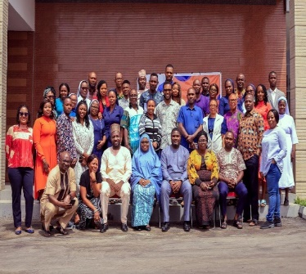

Participants
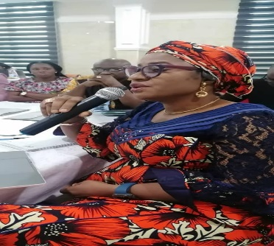
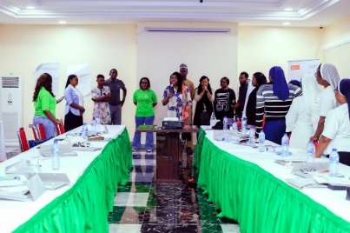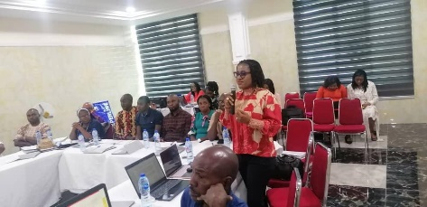
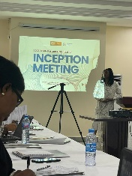
President SECHILD speaking

*Breaking Barriers: A Collaborative Healthcare Journey* "Liliane Fonds, The Leprosy Mission Nigeria, and SECHILD unite in a transformative healthcare project for children with disabilities in Kuje. Focused on Cerebral Palsy, the year-long initiative delivers specialized medical care, therapy, and support, sparking profound impacts. SECHILD's broader 'Inclusive Community Development Project' empowers Kuje communities through stakeholder mapping, leading to advocacy for changes in health insurance and healthcare policies. This holistic approach engages diverse stakeholders, including governmental bodies and grassroots organizations, fostering a comprehensive narrative of change."
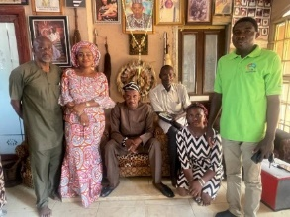
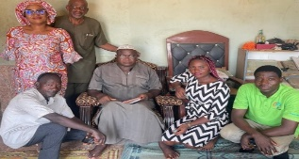
With Community Leader With Community Leader of Pasali
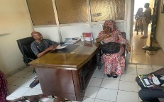
With Kuje Area Council head of Health Department

Advocacy Meeting with Sector and Community Leaders
Advocacy Meeting - March 23, 2023: SECHILD Center hosted an impactful Advocacy Meeting under The Sedoo Initiative. Government bodies, including the Health Department and Education Ministry, pledged support for children with disabilities. The Health Department committed to improving healthcare accessibility in Kuje Area Council, while the Education Ministry vowed to implement inclusive policies. The local business community pledged employment opportunities and vocational training, challenging societal norms. Community leaders emerged as champions, pledging to eradicate stigma through awareness campaigns.
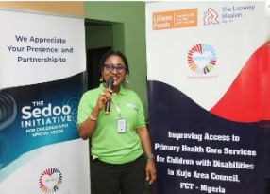
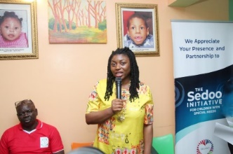

President SECHILD addressing Stakeholders The Leprosy Mission Nigeria Represented
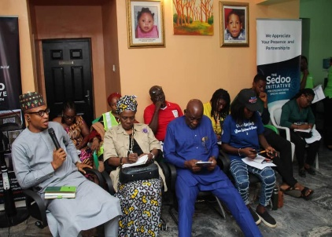
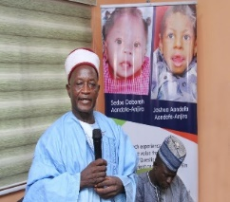
Minister of Health represented Community Leader Speaking
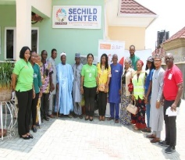

Stakeholders

Village Square Dialogue - April 2023: The Sedoo Initiative organized a Village Square Dialogue at Chief of Pasali Palace, Kuje Area Council. Chief S.P., initially distant, became an advocate for children with disabilities, showcasing the impact of grassroots advocacy and fostering dedication to their welfare and rights within and beyond the community.

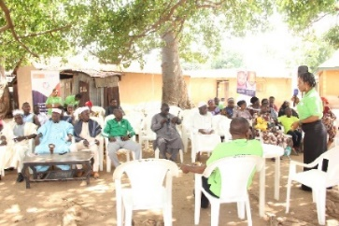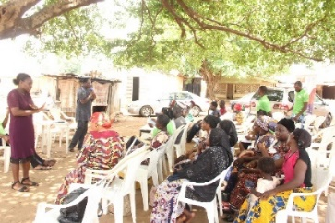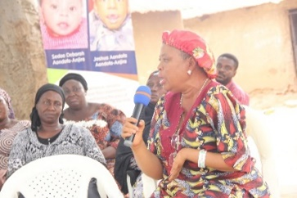
President SECHILD speaking Kuje Area Council representative speaking Leader Advocacy for Women with Disabilities
AWWDI speaking

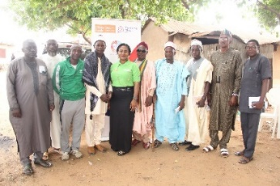
Stakeholders

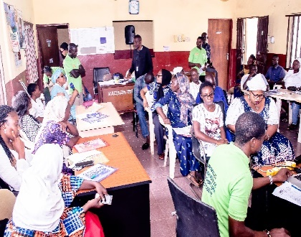
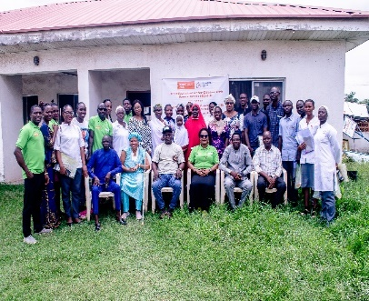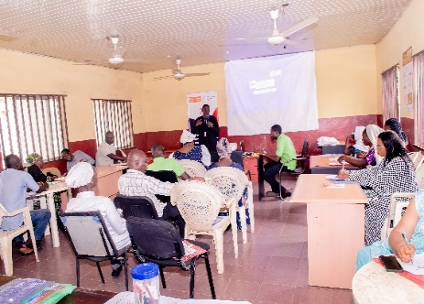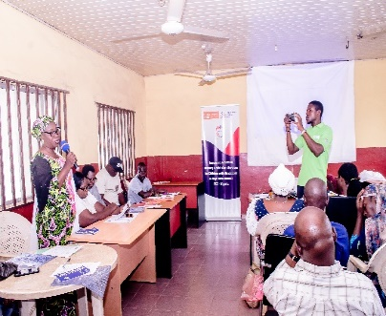

Empowering Voices - Training of Trainers on Disability Rights and Inclusion

The Sedoo Initiative's "Empowering Voices" Training of Trainers on Disability Rights and Inclusion, held on June 15, 2023, in Kuje Area Council, Nigeria, marked a pivotal moment in fostering awareness and advocacy for disability rights. With 40 participants representing diverse sectors, the training empowered individuals to independently champion the cause, resulting in positive changes across communities and within the healthcare sector. The collaborative approach and government engagement showcased the collective power of education, leading to a more inclusive and compassionate society in Kuje Area Council.
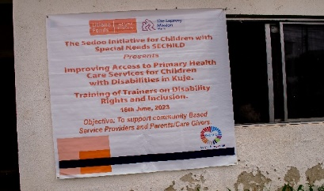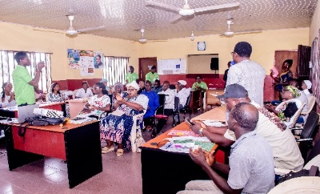

Monthly Therapy for Children with Disabilities and Caregivers: Monthly Therapy Sessions at SECHILD: Achieving a significant milestone, SECHILD provided therapy services for 50 children. Among them, 20 had sessions at the residence, and 10 on an outpatient basis. A remarkable transformation was observed, with 10 previously immobile children now able to sit with assistance, showcasing improved mobility and reduced limb stiffness. All 50 children accessed Physio/Occupational and Speech Therapy, emphasizing holistic development. This success reflects SECHILD's dedication to enhancing the overall well-being and development of the children, highlighting the positive impact of their therapeutic interventions.

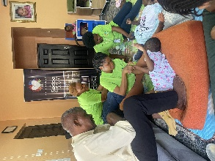

Recruitment, Training, and Inauguration of 30 Peer Educators on Guidance, Promotion, and Protection of Fundamental Human Rights of Children with Disabilities: In 2023, our commitment to addressing the challenges faced by children with disabilities reached new heights through the recruitment, training, and inauguration of 30 Peer Educators in Kuje Area Council. Collaborating with key stakeholders and utilizing a multifaceted approach, we successfully amplified awareness, engaged communities, and broke down barriers. With tangible outcomes in thirteen communities and media amplification, the project has set a strong foundation for ongoing efforts in championing the fundamental human rights of children with disabilities in Kuje Area Council.
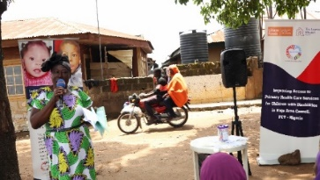
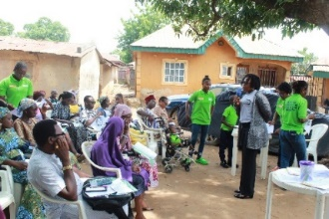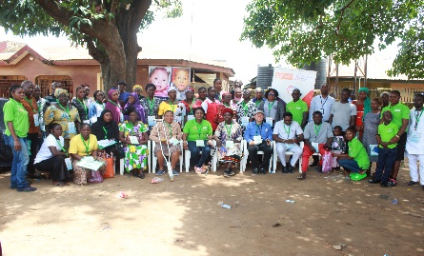
Rep. of National Orientation Agency speaking Representative of The Leprosy Mission Nigeria Peer Educators, organizers and partners

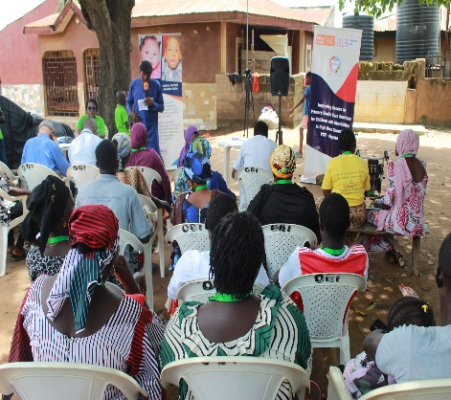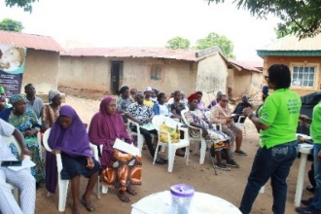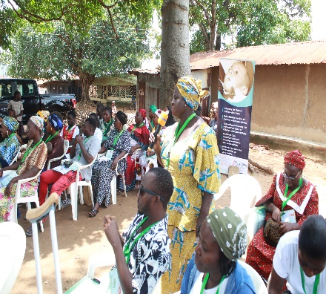
Physiotherapist Explaining Cerebral Palsy President SECHILD speaking A Peer Educator Pledging

Stakeholders Strategy Review Meeting: Advocacy Meeting with Sector Leaders, Parents, CSOs, and Other Stakeholders: SECHILD Center's October 17, 2023, Advocacy Meeting rallied stakeholders for policies aiding healthcare access for rural disabled children. The session identified challenges, opportunities, and strategies, securing commitments from 28 participants. Notable results involved NIMC enrolling kids on the National Identification Portal and FCT Primary Health Care Board pledging disability rights training. The report underscores the importance of ongoing dialogue, collaboration, and tackling challenges for sustained advocacy in support of children with disabilities.
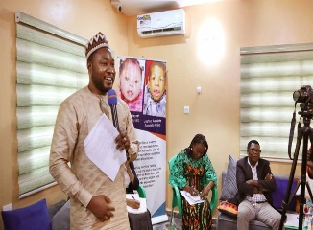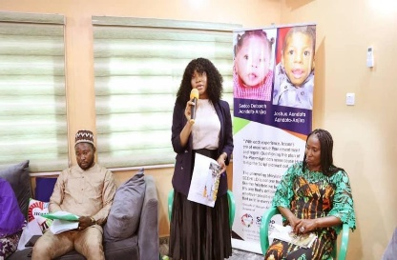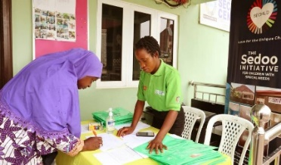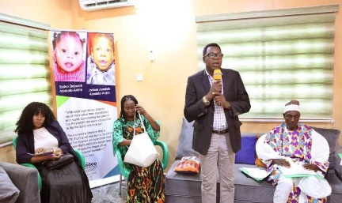
The Leprosy Mission Nigeria National Commission for Persons Representation of FCT PHCB Representative of Kuje Area Council
Representative with Disabilities making commitments

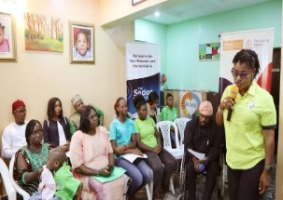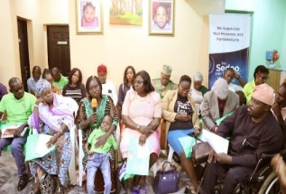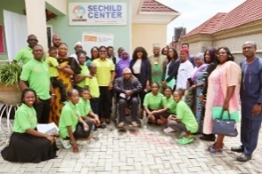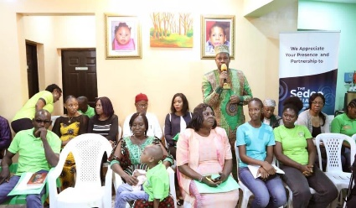
President SECHILD A mother sharing her experience Stakeholders National Identity
Management Commission giving assurance

Quarterly Media Engagement: ** Empowering Voices: SECHILD's triumphant Quarterly Media Engagement showcased the power of radio and social media in championing disability inclusion. Through partnerships with Love FM and Armed Forces Radio, the initiative inspired widespread support and active public participation, emphasizing the importance of sustained awareness and advocacy. Despite challenges, this transformative journey stands as a testament to the resilience of unheard voices, promising a future where every voice, regardless of ability, resonates with strength and purpose.

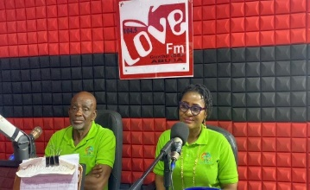
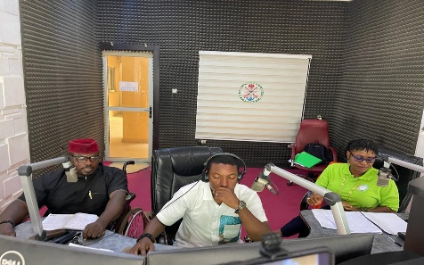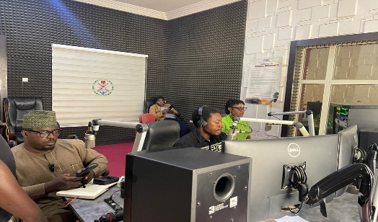
President SECHILD with the Physiotherapist At Armed Forces Radio-on Caring Hands At Armed Forces Radio for 3rd
at Love FM 1st Quarter Engagement 2nd Quarter Engagement Quarter Engagement

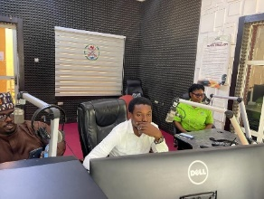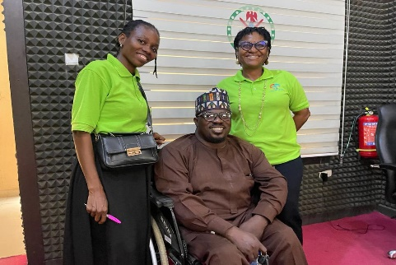
Media Engagement At Armed Forces Radio for the 4th Quarter With the presenter Christin Obiora after the program

Monthly Capacity Building of Project Staff: "Silent Empowerment: "Silent Empowerment: SECHILD's Success in Sign Language Capacity Building" highlights transformative changes: Eunice Atera and Rebecca Bala showcase improved skills and confidence, while Uzor Nwaokolo's commitment to sign language promotes inclusivity. Sewuese Iorhuna's effective communication and Tersoo's improved interactions exemplify SECHILD's impactful mission. President Kawan Aondofa-Anjira's declaration of signing as the official language solidifies organizational dedication to excellence and inclusivity. This annual report emphasizes SECHILD's ongoing commitment to creating an inclusive environment for children with special needs through sustained efforts, adequate staffing, and continuous training.
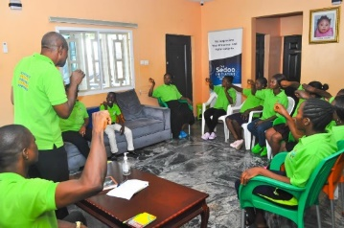
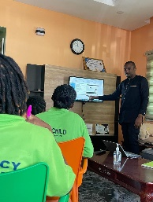
Sign Language Training Training on Concept Note and Proposal Writing
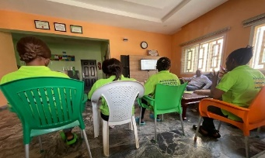
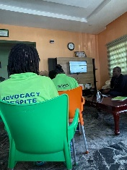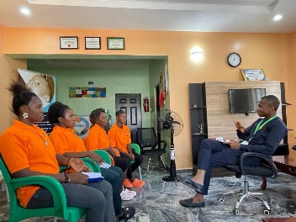
Fundraising and Financial Procedure/Management Project Management

Training on Budget and Budgeting Advocacy Training

Assessment of Primary Health Care Centers and Basic Education Centers in Kuje: Conducted assessments to understand the status of health facilities and services, supporting demands for quality services aligned with legislative frameworks.

Collaborative Horizons: SECHILD’s Positive Impact on Children with Special Needs- Social Development Secretariat Partnership: SECHILD and the Social Development Secretariat joined forces on September 26, 2023, signaling a transformative alliance for children with special needs. SECHILD's commendable commitment to Cerebral Palsy management stood out during a comprehensive inspection by the SDS in Nigeria's Federal Capital Territory. The positive outcome not only validated SECHILD's excellence but also paved the way for future collaborations, promising impactful change in the lives of these children and their families.

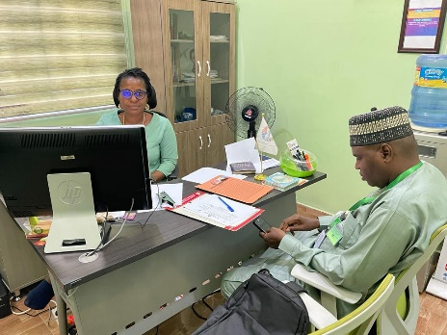
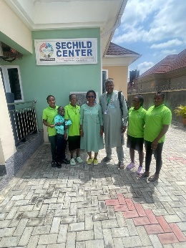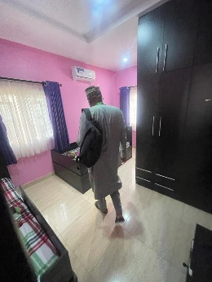
SDS representative in the With Team SECHILD Inspecting SECHILD Center

Collaborating to Fight Financing of Terrorism (CFT) Workshop: Strengthening SECHILD’s Resolve: SECHILD actively participated in the “Collaborating to Fight Financing of Terrorism (CFT)” workshop organized by the Economic and Financial Crimes Commission (EFCC). Over two intense days, SECHILD immersed itself in knowledge regarding Counter Financing of Terrorism, fostering collaboration and determination to protect vulnerable children from the shadows of terrorism. The workshop equipped SECHILD with insights to enhance strategies and interventions, emphasizing a collaborative effort against terrorism financing.
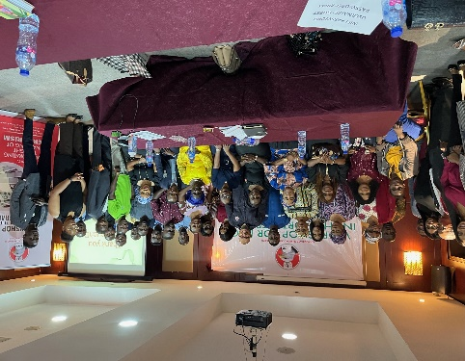
SECHILD Representative in Lemon Shirt, Participants and organizers

"Empowering Change Through Capacity Building and Partnerships"*: SECHILD's annual report underscores our unwavering commitment to growth and sustainability through capacity building and collaborative partnerships. Our team's skill enhancement covers diverse areas, fostering a continuous learning environment. Notable collaborations with organizations like Liliane Fonds-LF, TLMN, EU, British Council, TAF Africa, WARDC, and EFCC contribute to monthly training sessions, ensuring staff stays informed and aligned with SECHILD's mission. The impact is evident in improved performance, heightened motivation, and a positive work environment, echoing our dedication to supporting children with special needs.

Empowering Organizations: Insights from EU-ACT Coaching Session: In December 2023 at Lagos Continental Hotel, EU-ACT Program’s coaching by TAF Africa fueled SECHILD's growth. Enhancements in management skills boosted engagement and collaboration, leading to improved filing, software adoption, and regular training. EU-ACT's impact was evident in networking events, like the Peer To Peer Learning Session, which facilitated collaboration among nonprofits. SECHILD's transformation highlighted positive changes in practices and community perception, supported by the European Union and British Council.
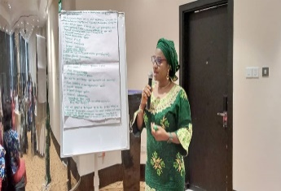
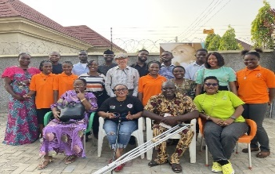 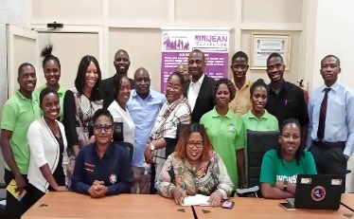
President SECHILD presenting at the EU-ACT Peer to Peer Learning at SECHILD Center Peer to Peer Learning hosted by Mimi Jean
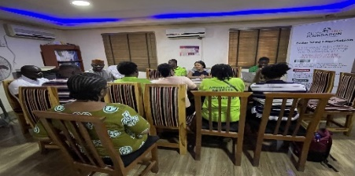
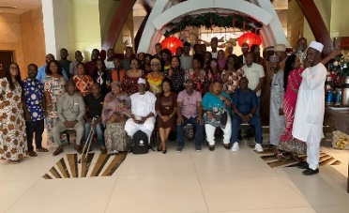 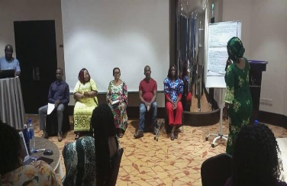
Peer to Peer Learning hosted by Cedar Seed Participants at EU-ACT reflective learning Presenting for Edo and FCT organizations
in Lagos Continental Hotel President SECHILD

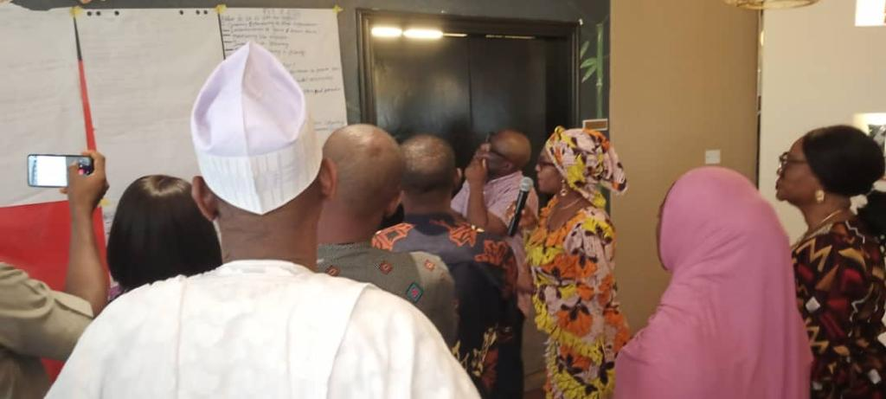
President SECHILD presenting for her group-Edo/FCT
Empowering Voices for Cerebral Palsy Awareness: Leading up to World CP Day, SECHILD collaborated with The Engraced Ones, parents, and NGOs to raise awareness about Cerebral Palsy (CP). A heartfelt speech by Kawan Aondofa-Anjira, Founder SECHILD and a mother and caregiver shared personal experiences, resonating with parents in the audience. The event highlighted the impact of dedicated centers like SECHILD and inspired parents to advocate confidently for their children with CP. SECHILD actively participated in World Cerebral Palsy Day on October 6, 2023, advocating for inclusivity and empowering children with Cerebral Palsy. The organization raised awareness about the challenges faced by people with disabilities and collaborated with schools, government agencies, parents, and organizations to promote accessibility, equal opportunities, and disability-friendly environments.
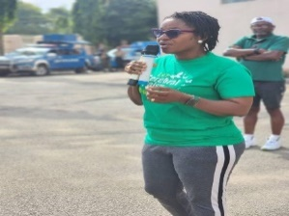
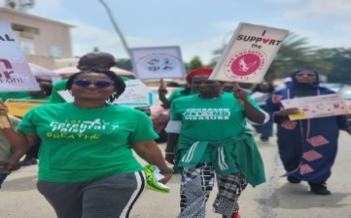
President SECHILD Guest Speaker at The Engraced Ones World CP Day Celebration
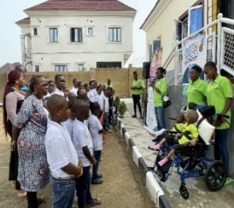
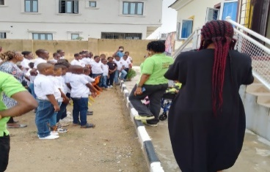

SECHILD at a school creating awareness on CP Advocating for Inclusive Education on 2023 World CP Day
in commemoration of the 2023 World CP Day

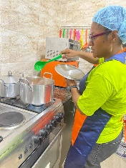
Celebrating Heroes - SECHILD Caregivers’ Year-End Appreciation Event: SECHILD's Year-End Appreciation Event celebrated caregivers, recognizing their pivotal role in supporting children with Cerebral Palsy. The event highlighted their commitment with surprise gifts, urging collective action for a more inclusive society. SECHILD's caregivers, unsung heroes of compassion, embody dedication, build trust, navigate challenges gracefully, and create a supportive network, showcasing the profound impact of the human connection. In the grand narrative of SECHILD, these caregivers emerge as celebrated heroes, the driving force behind the commitment to exceptional care and support.
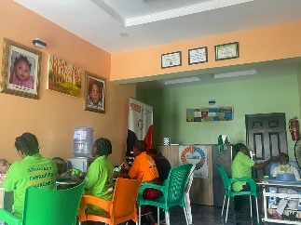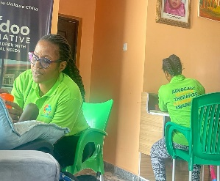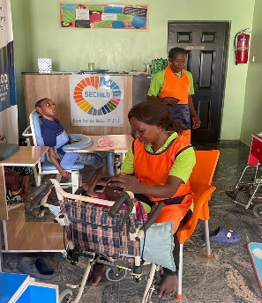
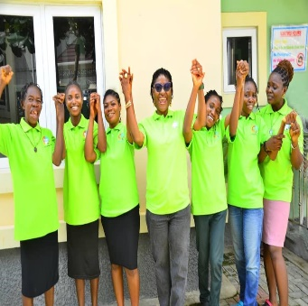
Garki Hospital Partnership: A Journey of Healing and Community Support: In 2023, SECHILD's narrative took a poignant turn with the Garki Hospital partnership, exemplifying resilience, collaboration, and community support. Patience, facing adversity during therapy, underwent surgery at Garki Hospital, supported by dedicated caregivers. Financial challenges arose, met with an anonymous group covering half the expenses. Garki Hospital's generous discount eased the burden, and SECHILD committed to settling the remaining amount in the future. Patience's triumphant journey showcases the strength of collaboration and community support, emphasizing the profound impact partnerships can have on the lives of children under SECHILD's care. This experience reinforces SECHILD's commitment to nurturing healing and growth through impactful partnerships.
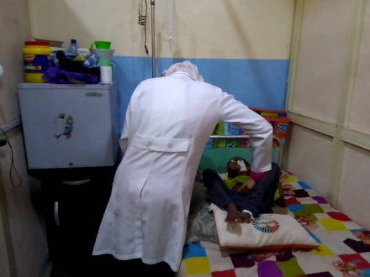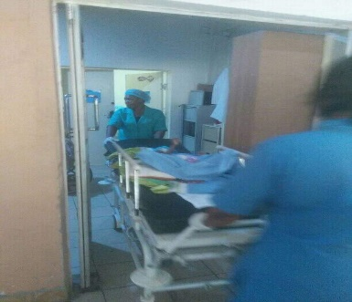
Nurse attending to Patience Wheeling to the theater

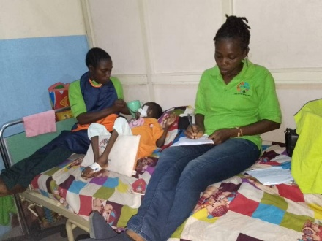
Caregivers with Patience in the hospital

Tersoo's Triumph: A Decade of Resilience, Artistry, and Inspiration*: "Tersoo's Triumph: A Decade of Resilience, Artistry, and Inspiration" eloquently recounts Tersoo's journey, emphasizing the transformative power of inclusive education and unwavering support. From his early years marked by uncertainty to the celebration of his 10th birthday, Tersoo's story becomes a guiding light, inspiring a societal shift towards greater inclusivity and compassion. His resilience, artistic expression, and the community impact underscore the universal truth that, with the right environment, every child can thrive and contribute meaningfully to humanity.
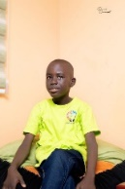
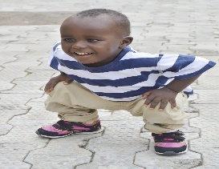
Tersoo at 3 Tersoo at 10

"SECHILD & NIMC: Transforming Lives through Inclusivity for Cerebral Palsy": In a landmark collaboration, SECHILD partnered with NIMC to integrate children with Cerebral Palsy into the national identity system, revolutionizing equal access and recognition. Isaiah and Favour's stories exemplify the transformative power of this initiative, breaking barriers and reshaping societal perceptions. Beyond identification, the collaboration sparked advocacy, community impact, and policy implications, creating a ripple effect of positive change. This partnership serves as a beacon
of hope, illustrating how simple yet powerful initiatives can foster inclusivity and compassion in society.
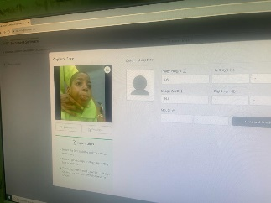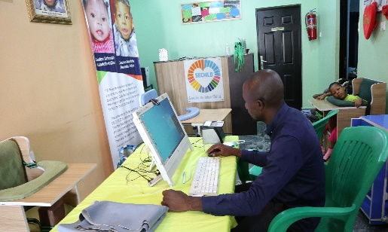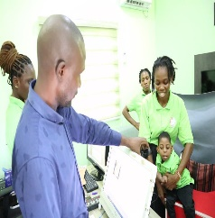
Registration of Favour National Identity Commission Staff Enrollment at SECHILD Center

SECHILD's Impact in Kuje: SECHILD transformed healthcare in Kuje by championing inclusivity, upgrading facilities, and expanding services. Their collaboration with local councils and health clusters showcased tangible results, fostering inclusivity and equality. Advocacy Meeting: Unity in Action Diverse stakeholders joined forces, creating a network of support through volunteer peer educators, breaking geographical barriers and illustrating the power of unity in transformative change. Uniting for Inclusive Healthcare SECHILD's collaborative journey, endorsed by Mr. Justice, showcased the transformative impact of commitment and shared vision, integrating health insurance packages and partnering with national agencies and NGOs. Breaking Barriers: Chiefs and Leaders Unite Chief S.P's transformation became a catalyst for community-wide change, with leaders prioritizing the well-being of children with disabilities, symbolizing a commitment to break barriers and foster inclusivity. These narratives highlight the power of awareness, collaboration, and collective commitment to foster inclusivity for vulnerable children with disabilities in Kuje.

SECHILD's Transformative Impact: Addressing Cerebral Palsy"* The Inspiring Journeys of Triumph at SECHILD: The Sedoo Initiative for Children with Special Needs-SECHILD has become a beacon of hope, transforming the lives of children with Cerebral Palsy through dedicated care and support. These below heartwarming success stories illustrate the transformative impact of SECHILD’s person-centered approach, tailored interventions, and commitment to inclusivity.
Individual Child Success Stories:
Isaiah’s Journey to Speech: • Isaiah, once unable to speak, underwent a remarkable transformation through SECHILD’s specialized therapy and assistive devices. • Progress in speech and motor skills empowered Isaiah to actively engage in everyday activities, boosting his confidence and overall well-being.
Patience’s Physical Development: • Patience, lacking adequate care, flourished under SECHILD’s quality care and therapy, showcasing remarkable growth and beauty. • This journey not only highlighted Patience’s potential but also instilled self-confidence, proving that with support, children with Cerebral Palsy can thrive. Tersoo’s Journey to Inclusive Education and Self-Expression:
Tersoo, facing educational barriers, thrived academically through SECHILD’s intervention, emphasizing the power of inclusive education. • Tailored programs focusing on communication and sensory integration empowered Tersoo to express himself through sign language and assistive technology.
Torkuma’s Journey: A Tale of Empowerment and Resilience:• In a Nigerian village, Torkuma's resilience and SECHILD's support unfolded a transformative journey. From overcoming physical challenges through therapy to breaking societal barriers, Torkuma emerged as an artist and advocate, showcasing the impact of dedicated empowerment. His story reflects the transformative power of unwavering support and belief in the abilities of children with special needs.Torkuma’s journey with SECHILD is a shining example of empowerment and resilience, illustrating the transformative power of dedicated support, inclusivity, and an unwavering belief in the abilities of children with special needs.

These success stories exemplify the transformative impact of SECHILD, proving that every child, regardless of ability, can overcome barriers and contribute to society. The dedication of The Sedoo Initiative highlights the importance of inclusive programs in building a more equitable and compassionate world, where every child’s potential can shine beyond barriers.
Empowered Mothers, Flourishing Futures: SECHILD supports not only children with Cerebral Palsy but also empowers mothers to work, earn a living, and create brighter futures. Inspiring experience of mothers from SECHILD narrates that beyond its impact on children with Cerebral Palsy, The Sedoo Initiative’s holistic approach supports both children and their mothers. Within the heart of SECHILDe's impactful work with children with Cerebral Palsy lies an equally compelling story of empowerment for mothers. Many success stories illuminate how The Sedoo Initiative is not only supporting children but also empowering mothers to work, earn a living, and chart a brighter future for their families. SECHILD recognizes the multifaceted challenges faced by mothers of children with Cerebral Palsy. Their approach is holistic, encompassing specially designed interventions, educational workshops, and skill enhancement opportunities tailored to meet the unique needs of these resilient mothers.

*Individual Mothers Success Stories:*
1. Christy's Journey with The Sedoo Initiative** Meet Christy, a resilient mother facing the challenges that come with raising an eight-year-old boy diagnosed with Cerebral Palsy. In her own words, “I was told my child is not a normal child, that he has just come to exploit them, but thank God for SECHILD."
**The Challenge: ** Christy's journey began with the harsh realization that her child's condition led to societal prejudice and misconceptions. The lack of support and understanding left her feeling helpless, uncertain about the future, and burdened by the weight of societal judgment.
**The Turning Point: ** Enter The Sedoo Initiative for Children with Special Needs-SECHILD, a beacon of hope for Christy and her son. SECHILD not only recognized the potential in every child but also understood the importance of supporting parents in their journey.
**The Intervention: ** SECHILD provided Christy with a care and therapy home tailored to meet the unique needs of her son. This support not only addressed the challenges associated with Cerebral Palsy but also empowered Christy with the gift of time.
**Empowerment Through Support: ** With her child receiving specialized care at SECHILD, Christy found the freedom to engage in income-generating activities. SECHILD's holistic approach not only focused on the well-being of the child but also recognized the importance of supporting parents like Christy.
**The Transformation: ** Today, Christy stands as a testament to the transformative power of support and empowerment. She has not only found financial stability but has also become an inspiration to others in similar situations. Christy's ability to earn a sustainable income showcases the positive impact of having a dedicated care center for children with Cerebral Palsy.
**A Message of Gratitude and Hope: ** Expressing her gratitude, Christy stated, "I pray that God would reward her (referring to SECHILD), and the government will support her." Her journey highlights the potential for positive change when organizations like SECHILD intervene, providing support, understanding, and hope for a brighter future. In conclusion, Christy's success story is a poignant reminder that with the right support and intervention, children with special needs can thrive, and their parents can find renewed hope and empowerment. SECHILD's commitment to making a difference has not only transformed the life of Christy's family but stands as a beacon for others facing similar challenges.

**Alice: Empowering Careers, Transforming Lives: Alice's Journey with The Sedoo Initiative Success Story: Meet Alice, a highly skilled professional who temporarily stepped away from her trade to care for her child. Recognizing the importance of economic empowerment, The Sedoo Initiative stepped in, offering Alice retraining opportunities and a nurturing care home for her son, Miracle, since 2014. Alice, appreciative of the care provided, mentions, "They have been taking good care of my son, allowing me time to do my trade." Despite the significant challenges of having a blind husband, The Sedoo Initiative tailored a program for Alice, featuring flexible working hours and supportive supervisors. With this support, Alice confidently rejoined the trade. Today, she not only thrives in her trade, providing financial stability for her family, but also serves as a powerful role model for her child, illustrating the transformative impact of The Sedoo Initiative in empowering careers and transforming lives.

** Tina: Nurturing Dreams, Building Futures: Tina's Success with The Sedoo Initiative Success Story: Tina, a determined mother, envisioned a support system for mothers facing similar circumstances. With The Sedoo Initiative's unwavering support, Tina proudly shares, "We haven't paid anyone a Naira since we brought Patience here, and Patience has changed." This vital assistance has given Tina the opportunity to engage in income-earning activities, selling foodstuffs and other items in the village market, while providing crucial support to her family. The Sedoo Initiative's visionary approach, guided by Amina's leadership, has not only created job opportunities but has also fostered inclusive care and development for children with Cerebral Palsy. Tina's success story exemplifies the transformative impact of The Sedoo Initiative, not just in opening income opportunities for mothers but also in ensuring top-notch childcare services for children with special needs. It stands as a testament to the initiative's commitment to nurturing dreams and building futures for families facing unique challenges.

**Bridget: Embracing Hope, Celebrating Progress: A Mother's Journey with The Sedoo Initiative Success Story: Meet Bridget, a resilient mother whose five-year-old daughter has been receiving exceptional care at The Sedoo Initiative for over four years. Bridget's journey is a testament to the unwavering support and transformative impact that SECHILD has had on her family's life. When Bridget first approached SECHILD, she faced the challenges of caring for a child with Cerebral Palsy, navigating the complexities of the condition with limited resources. However, since her daughter became a part of SECHILD's care program, Bridget has witnessed remarkable progress. The specialized care, therapy, and nurturing environment at SECHILD have empowered Bridget's daughter to overcome obstacles, develop essential skills, and enhance her overall well-being. Mary expresses her gratitude, stating, "SECHILD has been a blessing for us. My daughter has not only received excellent care but has also made significant strides in her development." This success story highlights the dedication of SECHILD in providing comprehensive care for children with special needs and the positive impact it has on families. Bridget's journey with SECHILD stands as a beacon of hope, showcasing that with the right support and nurturing environment, every child, regardless of their abilities, can reach their full potential.

** Benedina:* Empowering Journeys: A Mother's Triumph with SECHILD's Outpatient Therapy Program Success Story: Meet Benedina, a determined mother whose two-year-old daughter has been receiving outpatient therapy at The Sedoo Initiative for over one year. Benedina's journey exemplifies the transformative impact of SECHILD's comprehensive outpatient therapy program. When Benedina first enrolled her daughter in SECHILD's outpatient therapy, she was seeking support and guidance to navigate the challenges of Cerebral Palsy. Through SECHILD's tailored training programs, Benedina learned essential therapeutic techniques to continue her daughter's care at home. Empowered by the knowledge and skills acquired during the training sessions, Benedina has become an active participant in her daughter's therapy journey. She proudly shares, "SECHILD not only provided effective therapy for my daughter but also equipped me with the skills to continue the therapy at home. It's empowering to be an integral part of my child's progress." SECHILD's commitment to providing not only quality therapy but also empowering parents like Benedina has made a significant impact on the lives of families facing the challenges of Cerebral Palsy. Benedina's success story is a testament to the effectiveness of SECHILD's outpatient therapy program in fostering independence and resilience in families dealing with special needs.

**"Breaking Barriers: Mrs. Adamu's Journey with SECHILD"* In the heart of a community, Mrs. Adamu faced challenges caring for her son with Cerebral Palsy. Constant judgment and discrimination left her overwhelmed, but her life transformed with the discovery of SECHILD. Entering the center, she found hope, belonging, and a supportive team. SECHILD became a beacon of support, offering resources, education, and tailored care for her son's development. At an advocacy meeting, Mrs. Adamu shared her heartfelt testimonial, pledging to be a voice for families affected by disabilities. Her determined advocacy efforts successfully shifted community attitudes, fostering acceptance and dispelling misconceptions. Mrs. Adamu's inspiring journey reflects the positive impact of SECHILD and determined advocacy in creating a more inclusive and supportive community.

A Caregiver’s Experience* "Transforming Hearts: Rebecca's Journey with SECHILD"* The dedicated caregiver Rebecca found herself on an unexpected journey when she joined SECHILD, an organization focused on advocating for children with disabilities, particularly those with Cerebral Palsy. Rebecca's unexpected journey with SECHILD, led to a transformative experience. Initially unfamiliar with disabilities, her encounters with resilient children ignited a passion for advocacy. Through training and interaction, she gained knowledge and skills, becoming an advocate for understanding and support. Her impactful testimonial inspired change, fostering compassion and inclusion within the community.
Empowered by SECHILD, Rebecca led workshops and advocated for inclusive policies, extending her influence beyond professional life. Her personal transformation echoed the organization's mission, leaving a lasting legacy of love, compassion, and advocacy. A New World Unveiled. As Rebecca continued her journey with SECHILD, she formed lifelong connections with the children and their families. Together, they worked to create an inclusive and supportive environment where every child, regardless of ability, could thrive. Rebecca's journey with SECHILD served as a testament to the transformative power of love, compassion, and advocacy. Her legacy left an indelible mark, reminding everyone that understanding and acceptance could break down barriers, creating a world where everyone was valued and included. Through Rebecca's story, SECHILD continued its mission of fostering empathy and education for a more inclusive society.
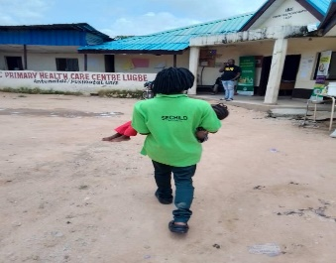
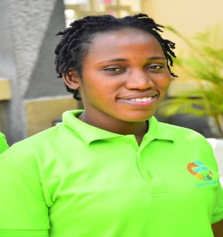
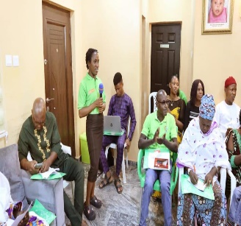
Rebecca Taking a child to the clinic Rebecca sharing her experience at one of our stakeholders meeting

"Mama Eunice Atera's Journey at SECHILD" Mama Eunice's SECHILD journey began in 2012, unfamiliar with Cerebral Palsy but full of compassion. Despite initial challenges, her dedication led her to become an advocate and caregiver. She immersed herself in learning, acquiring knowledge and practical skills to provide holistic care. Mama Eunice's empathy and dedication nurtured both the physical and emotional well-being of the children. Her advocacy efforts broke down stigmas and misconceptions within the community. From caregiver to beacon of hope, Mama Eunice's journey showcased the transformative power of love and determination. Her impact extended beyond SECHILD, becoming a catalyst for change in society.
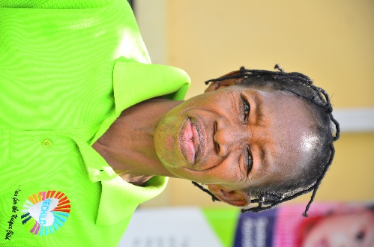
Mama Eunice Atera
"Breaking Chains: SECHILD’s Triumph Against Child Labor in Nigeria" SECHILD played a crucial role in NACTAL, organizing a sensitization campaign in Abuja on the World Day Against Child Trafficking. The campaign educated police officers at Lugbe/Airport Road Police Station on identifying child labor signs and their role in protection. Community engagement in urban slums raised awareness and commitment to ending child labor. The report highlights collaboration's power in addressing social issues for Nigeria's children's better future.
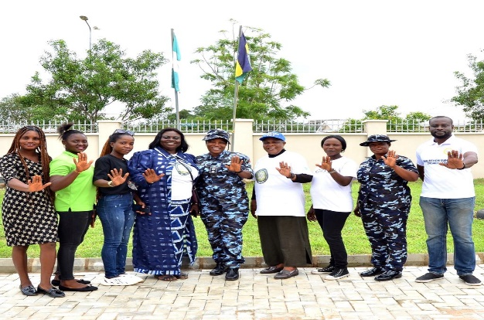
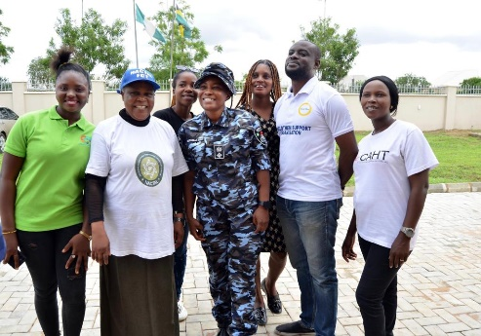
SECHILD in Lemon shirt,NACTAL members and a Police Officer SECHILD in Lemon shirt,NACTAL members and Police Officers

We Ring the Bell: *We Ring the Bell: A Collaborative Triumph in Inclusive Education*
SECHILD, Liliane Fonds, and The Leprosy Mission Nigeria joined forces in 2023, uniting under the "Three Zero Strategy" of zero transmission, zero disability, and zero discrimination. The collaborative focus on "Inclusive Play-based Early Childhood Education" culminated in the impactful "We Ring the Bell" event. Stakeholders gathered to discuss the practical implementation of play-based learning strategies, sharing success stories and influencing policy considerations for a more inclusive educational landscape. "We Ring the Bell" represents a collective commitment to fostering an equitable and compassionate future for children with disabilities.
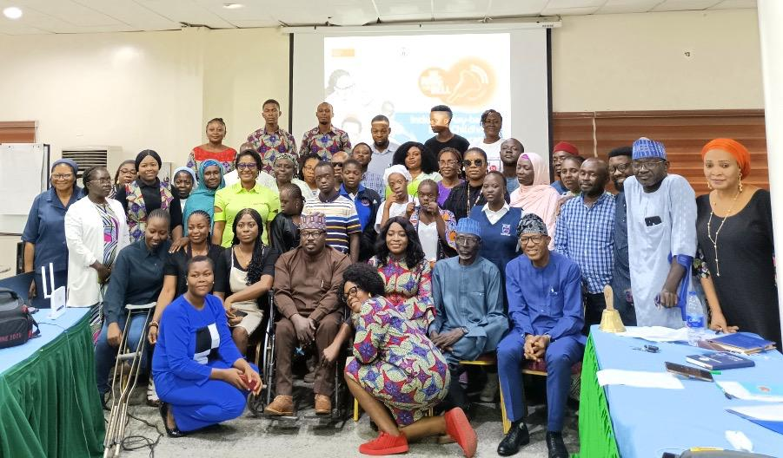
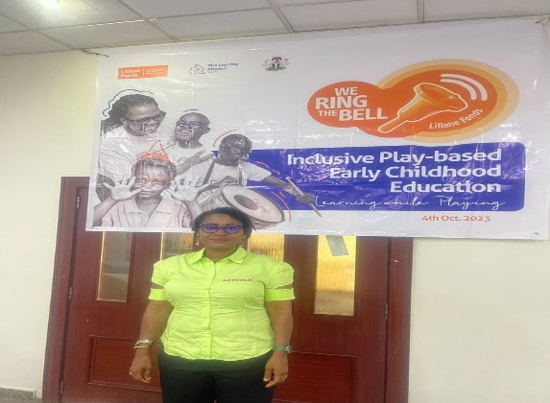
Participants with The Leprosy Mission Nigeria President SECHILD at the event

"Inclusive Fellowship: Breaking Barriers, Building Bonds" showcases stories from SECHILD Center's RCCG ICC Children's Church. Amelia became an inclusivity advocate, sparking acceptance beyond SECHILD. Jacob found support and empowerment through workshops. Emily extended inclusivity to neighboring communities, fostering societal change. Churches and organizations joined, making inclusivity a vibrant reality.

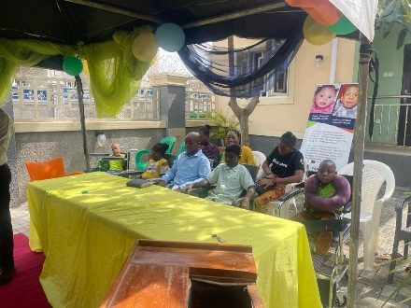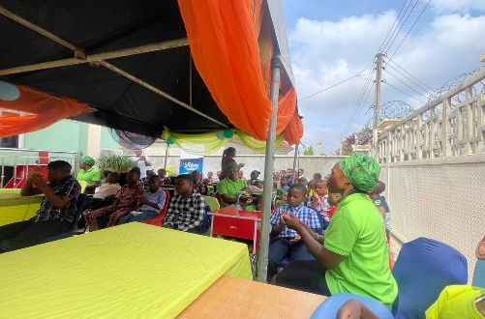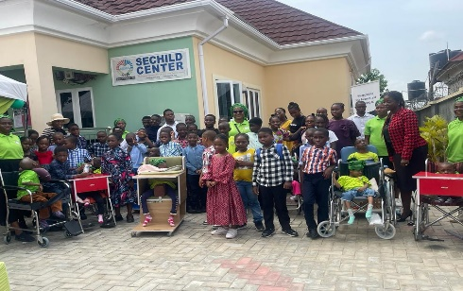
Service at Center Children and a caregiver participating Inclusive Worship

Advocacy with Health Sector Leaders on Improved Primary Health Services for Children with Disabilities: Building Collaborative Progress: Harmony in Healthcare: Unveiling Collaborative Progress at SECHILD's Stakeholders Meeting: SECHILD's stakeholders meeting on March 23, 2023, united diverse stakeholders, including Civil Society Organisations and Government Ministries. The Ministry of Health pledged support and training for children with special needs. Collaboration with the National Health Insurance Agency aims to ease financial burdens. Traditional leaders mobilized parents, breaking stigma for accessible healthcare.
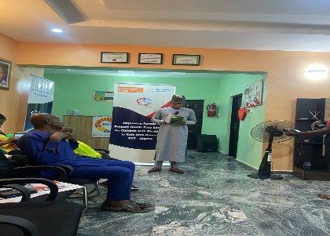
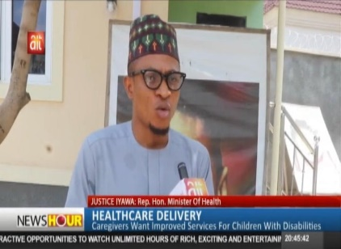
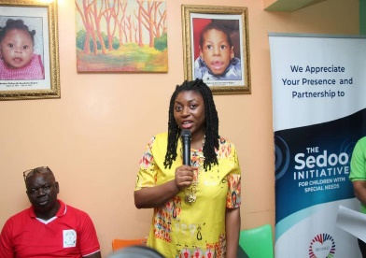
Representative Minister of Health Media Briefing Liliane Fonds/ The Leprosy Mission Nigeria
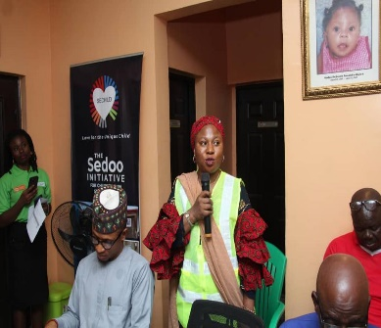
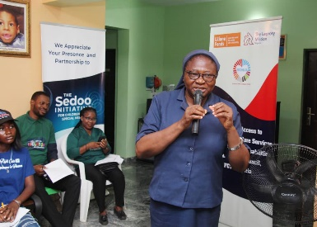 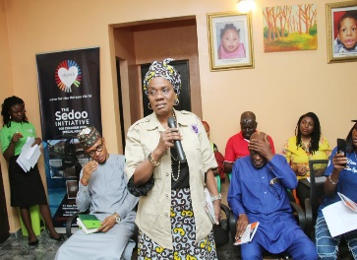
National Health Insurance Agency Daughters of Charity/Hope Centre The Engraced Ones

Empowering Children with Special Needs: A Remarkable Journey of Our Therapist
This illuminates the inspiring journey of a therapist dedicated to empowering children with special needs. Beginning with early experiences and education, the therapist's intrinsic motivation shapes a profound understanding of the challenges faced by these children. Empathy emerges as a transformative force, allowing her to connect deeply with each child, unlocking doors to their potential. Through a collaborative approach, she partners with families and professionals, creating a united support system. Beyond her therapeutic role, the therapist advocates for the rights and inclusion of children with special needs, breaking down barriers and challenging societal biases. The narrative celebrates triumphs, highlighting moments of progress and success that showcase her unwavering dedication and the indelible impact on the lives of these children. In conclusion, the therapist emerges as an embodiment of compassion and advocacy, breaking barriers, empowering families, and inspiring lasting change in the field of special education.
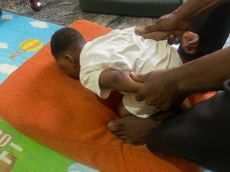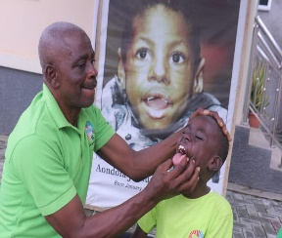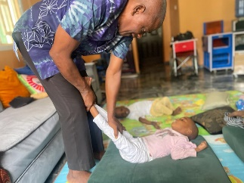
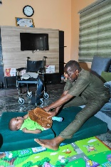
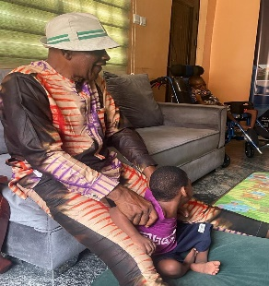
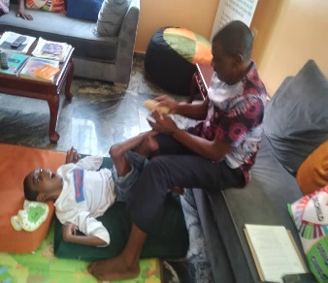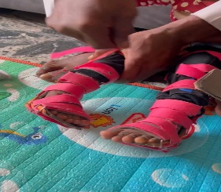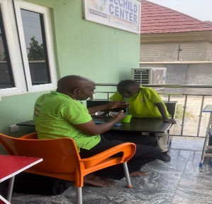

SECHILD Center: Heartwarming visit from parents, expressing deep gratitude for transformative impact on their child with Cerebral Palsy. Their appreciation fuels our commitment to improving well-being, strengthening our mission. A Heartwarming Visit and Words of Appreciation: Strengthening the Well-being of Children with Cerebral Palsy at SECHILD Center
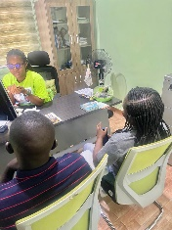
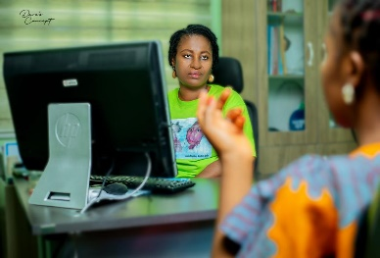
“SECHILD’s Journey: Advocating Safe School Administration and Child Rights” In November 2023, SECHILD made a significant impact at the WARDC workshop in Abuja, focusing on legislative advocacy for safe school administration and child rights. During the 2-day event, SECHILD fostered collaboration and shared success stories, becoming a catalyst for change. The emphasis on inclusive learning environments and combating violence in schools defined SECHILD’s commitment. The workshop’s success reflected SECHILD’s dedication, equipping participants with knowledge for positive change in education systems. SECHILD’s presence laid the foundation for a future where schools and care/rehabilitating centers are safe for all children, protecting their rights through legislative advocacy.
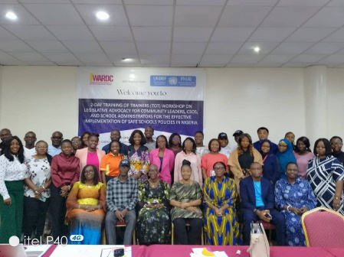
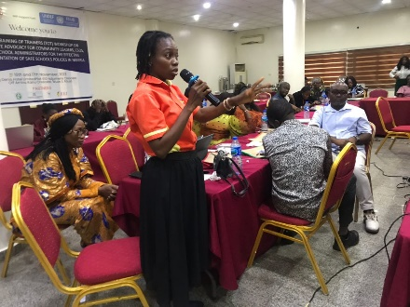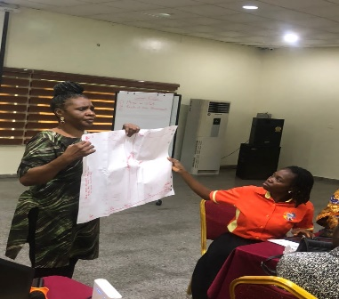
Participants and Organizers SECHILD Representative sharing Group Work

*"Empowered Advocacy: SECHILD's Journey to Creating Inclusive Impact"*
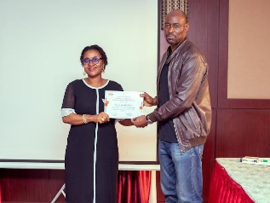
"SECHILD's Advocacy: Transformative Training, Empowered Impact" In July 2023, SECHILD, dedicated to supporting children with disabilities, underwent a game-changing Advocacy Plan training. Organized by The Leprosy Mission Nigeria and Liliane Foundation, the immersive experience armed SECHILD with invaluable tools, inspiring newfound confidence in their advocacy efforts. The engaging sessions facilitated networking with like-minded organizations, offering fresh strategies and emphasizing effective stakeholder engagement. Leaving with a deeper understanding of advocacy, SECHILD felt empowered, translating newfound confidence into strengthened efforts and a realization of their role in a broader movement. The training sparked potential partnerships, envisioning collaborative efforts. This transformative experience serves as a stepping stone for SECHILD, enhancing their advocacy capacity and fueling a passion to create positive change for the children they support.
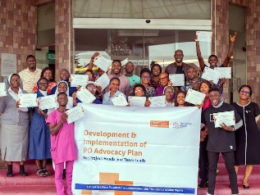
Participants with President SECHILD in black and white President SECHILD receiving Certificate of participation
dress on the right from the head of Programs The Leprosy Mission Nigeria

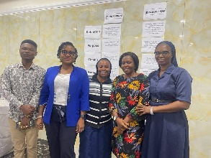
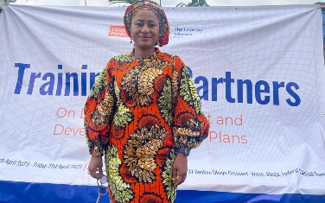
"Empowering Change: SECHILD's Journey with Liliane Fonds and The Leprosy Mission Nigeria": Strengthening Data Management and Monitoring and Evaluation and Referral Pathways through Partner Training: In Abuja from April 19th to 21st, SECHILD underwent transformative training at the Exclusive Serene Hotel, titled "Strengthening Data Management and Monitoring and Evaluation and Referral Pathways through Partner Training," led by Liliane Fonds and The Leprosy Mission Nigeria. This collaboration fortified SECHILD and partners in data intricacies, enhancing their ability to make informed decisions. Grateful for the pivotal role played by Liliane Fonds and The Leprosy Mission Nigeria, SECHILD is dedicated to integrating the acquired knowledge for a brighter future for children with special needs. This collaboration strengthens SECHILD's commitment to turning knowledge into tangible improvements, inspiring meaningful change on its ongoing journey.
President SECHILD in blue jacket With Other Participants President SECHILD

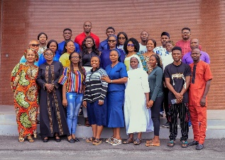
Participants with President SECHILD in orange Ankara on the left
We are deeply grateful to Liliane Fonds and The Leprosy Mission Nigeria for their invaluable support and guidance throughout 2023. We remain committed to ensuring that the knowledge gained during trainings is put into practice, thus bolstering our organization's ability to make a lasting impact on the lives of children with special needs.
Capturing Change: SECHILD's Transformative Journey in Photography and Storytelling From December 11th to 14th, SECHILD embarked on a remarkable journey at Jades Hotel in Abuja, participating in Liliane Fonds and The Leprosy Mission Nigeria's Photography Training for partner organizations. The three-day event proved to be a catalyst for transformative change within SECHILD. Immersed in a comprehensive training covering photography, storytelling, and mobile videography, SECHILD honed their communication skills essential for portraying the profound work with children with special needs. The curriculum, meticulously designed by Liliane Fonds and The Leprosy Mission Nigeria, delved into every aspect, from the art of composition to the intricacies of editing. Through hands-on exercises, including community captures, SECHILD and fellow participants delved into the creative process, developing compelling content while upholding the principles of ethical storytelling and privacy protection. This immersive experience not only enhanced technical skills but also fostered a deep sense of responsibility towards the subjects being documented. The culmination of the training was a showcase on the final day, where SECHILD unveiled their work, now enriched with newfound skills and perspectives. The images and stories presented reflected not only technical proficiency but also a profound understanding of the lives of children with special needs. Liliane Fonds and The Leprosy Mission Nigeria's commitment to empowerment shone through in the success of this training. SECHILD emerged from the event with elevated capabilities, poised to effectively communicate and advocate for children with special needs. This journey at Jades Hotel stands as a testament to the power of collaboration and education in bringing about positive change.
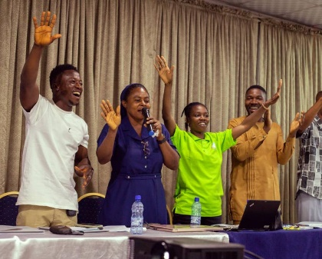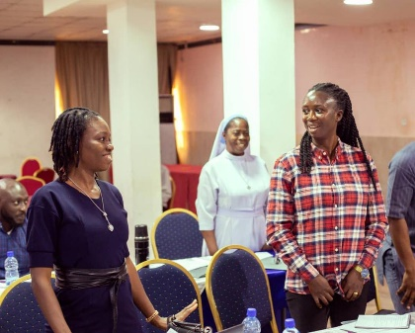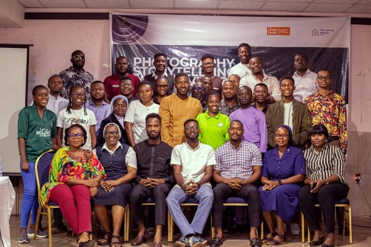
Some Participants’ demonstrating Representative of SECHILD in dark blue Participants with Organizers

Empowering Change: SECHILD's Transformative Journey in Strategic Governance"*
SECHILD's transformative journey started at a pivotal December 4, 2023 workshop in Abuja, led by TAF Africa. They actively contributed insights with the National Commission for Persons with Disabilities, marking a milestone in enhancing communication and leadership skills for individuals with disabilities in government roles. This collaboration underscores a shared commitment to advancing inclusion, initiating a powerful narrative of change.
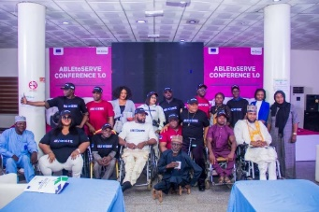
Participants with Organizations
"Hope Centre Kubwa: SECHILD's Commitment to Inclusive Education and Transformation"*SECHILD President, during a recent visit to Hope Centre Kubwa, witnessed the transformative impact of inclusive education on children with disabilities. Collaborating with organizations like Daughters of Charity, Liliane Fonds, and The Leprosy Mission Nigeria, SECHILD is committed to improving infrastructure, staff training, and expanding therapeutic programs for an inclusive society.
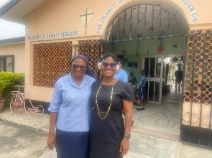
Head, Hope Center with President SECHILD during the visit
*"SECHILD's Gratitude and Stories of Transformation at the 2023 TLM-Nigeria Annual Retreat" SECHILD's Presence at 2023 TLM-Nigeria Annual Retreat: Held at Ibeto Hotel from November 5 - 9, 2023, SECHILD actively participated in the LFTLMN Partners Annual Workshop. Keynote speakers like Mr. Pius emphasized proactive planning beyond LF funding. Discussions with Mr. Jan reassured continued support post-LF, fostering trust. Team-building activities led by Christine uncovered shared aspirations and addressed concerns. Jeffrey shared insights into LF's photo mission. Discussions on organizational sustainability and future goals ensued, envisioning resilient organizations by 2026. SECHILD expressed gratitude to LF and discussed gaps in vocational skills for self-sustainability. Mr. Jan's prospect of visiting SECHILD was warmly received, marking a significant development. Overall, SECHILD's active contribution to collaborative planning for a post-LF future was evident, reflecting a commitment to networking and addressing challenges.
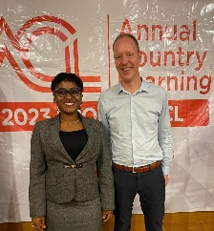
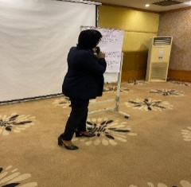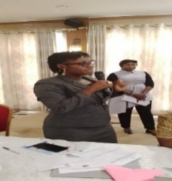
SECHILD President with Mr. Jan of Liliane Fonds Group Presentation led by President SECHILD President SECHILD sharing her experience

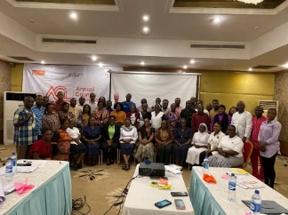
Participants

"*SECHILD's Milestone Visit: On November 8th, representatives from Lilian Fonds and The Leprosy Mission Nigeria visited SECHILD, witnessing the impactful initiatives firsthand. They engaged with children, gaining insights into their progress and aspirations, and praised SECHILD's dedication and collaborative spirit. The visit highlighted the transformative collaboration between the organizations, reinforcing their shared commitment to enhancing the lives of children with disabilities. This pivotal moment magnified the importance of SECHILD's mission and the strength of collaboration in driving positive change.
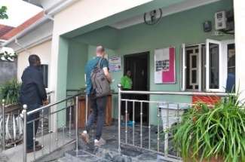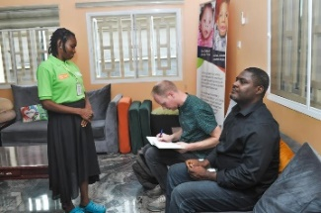
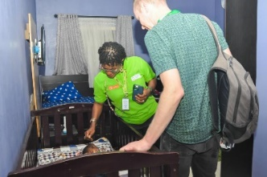
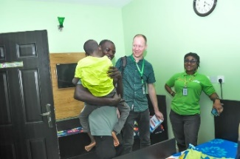
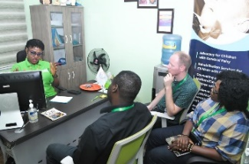
Liliane Fonds and The Leprosy Mission Nigeria Team At SECHILD Center Mr. Jan Signing In

In the President’s Office With one of the children In one of the Care Room
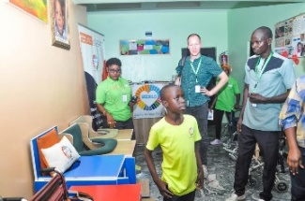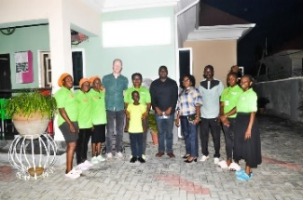
Tour of SECHILD Center The visiting team with SECHILD

*Fortifying Safeguarding Commitment: SECHILD Joins Keeping Children Safe Network*
"SECHILD strengthens its commitment to safeguarding by joining the Keeping Children Safe network, a significant step towards ensuring the rights and safety of children with disabilities in Nigeria. Explore their impactful initiatives at [SECHILD's website](https://sechild.org/)."
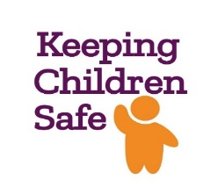

*Advancing Advocacy: SECHILD Joins International Cerebral Palsy Society for Positive Impact in Nigeria* "SECHILD's partnership with the International Cerebral Palsy Society marks a milestone in advancing advocacy for children with special needs in Nigeria, fostering positive change through global collaboration and support."
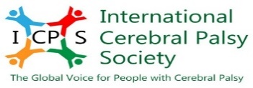

*Empowering the Well-being of Children with Special Needs: On May 11th, 2023, The Sedoo Initiative marked a pivotal moment by becoming an official nonprofit partner of GlobalGiving. This alliance signifies a global commitment to enhancing the well-being of children with special needs and their caregivers. Mrs. Kawan Aondofa-Anjira's vision led SECHILD to earn prestigious badges, recognizing their transformative project's compliance and success. Congratulations to The Sedoo Initiative for achieving this remarkable milestone, promising a brighter, more inclusive future for children with special needs in Nigeria and beyond.
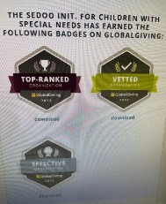
Badges Earned
*Embracing Global Health Advocacy: SECHILD Joins WHO Civil Society Commission*
SECHILD joyfully joins WHO's Civil Society Commission, dedicated to shaping evidence-based policies, championing health equity, and expanding healthcare access, marking a transformative chapter in global health advocacy..
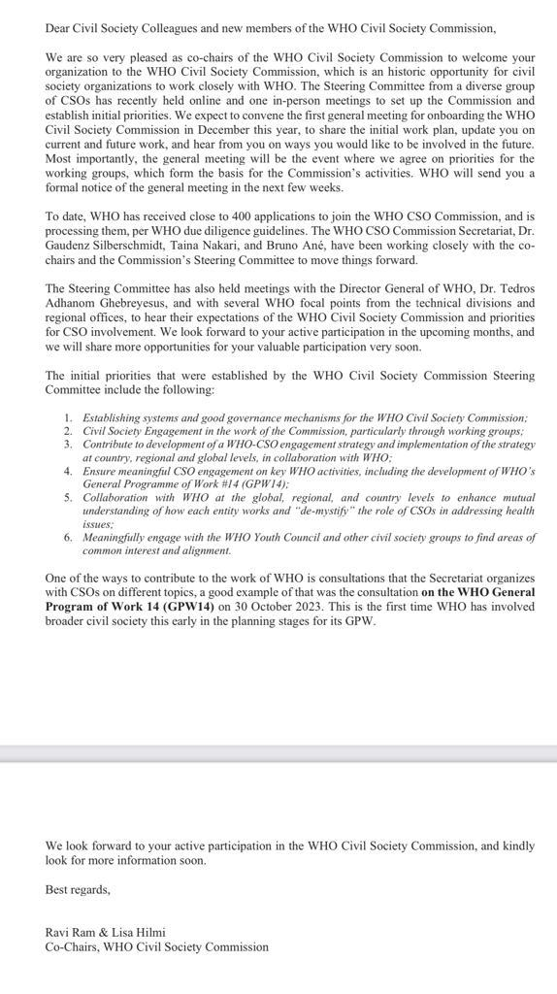
Celebrating SECHILD's "Tech To The Rescue" Project Verification and Inclusion: Exciting news fills the air! SECHLD has triumphantly secured verification for its groundbreaking project, "Tech To The Rescue." After a meticulous assessment, we are thrilled to announce the official inclusion of our initiative in the prestigious Tech Companies database, emphasizing its recognition and potential impact in the technology sector. This verification stands as a badge of honor not only for the merit of the SECHILD project but also as an invitation for collaboration and support from various tech companies. Heartfelt congratulations on this remarkable achievement! “Tech To The Rescue" has undoubtedly brought, inspiring stories of change as it begins making a real impact in the lives of those we aim to support. Together, we're forging a brighter future!
“Empowering Futures: A Transformative Journey through the Child Safeguarding Summit 2023" by Keeping Children Safe-KCS: "Empowering Futures: A Transformative Journey through the Child Safeguarding Summit 2023" by Keeping Children Safe-KCS showcased impactful stories of change. A devoted teacher implemented safety measures, empowering students to become advocates. A childcare professional embraced tech innovations, ensuring timely interventions. A parent's participation fostered open dialogues at home, creating a communicative family environment. Collaborative initiatives flourished, forming a network of support that transcended boundaries, reflecting the summit's role as a catalyst for a collective commitment to child safety and a secure future.
"*"Connecting Hearts and Minds: CP360 Family Forum and ICPS AGM Inspire Hope and Collaboration"*"CP360 Family Forum and ICPS AGM, held on November 13, 2023, united parents, caregivers, and medical professionals in a transformative day dedicated to Cerebral Palsy (CP) prevention and management. Through heartfelt narratives, informative sessions on best practices, and fostering connections, the event became a beacon of hope and collaboration, leaving attendees inspired and equipped for the journey ahead."

"Strategic Dialogues: SECHILD's Virtual Partner Visit with GlobalGiving": In a transformative virtual collaboration between SECHILD and GlobalGiving, President Kawan Aondofa-Anjira led a dialogue that delved into aligning missions and enhancing collaboration. The exchange, rich with insightful queries, transcended geographical constraints, fostering a commitment documented in the notes section. This collaboration promises to shape the future endeavors of both organizations.
The Sedoo Initiative for Children with Special Needs, born in 2011, draws inspiration from Sedoo and Aondofa, championing the rights of special needs children facing neglect, taboos, or spiritual ostracization. In a virtual meeting on November 30, 2023, with GlobalGiving, SECHILD showcased its operations, emphasizing proactive approaches, including continuous caregiver training and prompt therapy sessions.
Top priorities, such as sustainability, therapy for children with Cerebral Palsy, and safeguarding children's rights, underscore SECHILD's mission. Challenges like managing expenses and securing consistent funding are met through partnerships with the government, boards, community leaders, parents, and like-minded foundations.
SECHILD relies on diverse funding sources, with GlobalGiving providing valuable insights and best practices. While desiring more frequent donations, SECHILD appreciates GlobalGiving's overall helpfulness. Looking ahead, the organization envisions continuous engagement and the highlighting of outstanding organizations. Corporate partner grantees face challenges, but occasional support has been secured.
Expressing gratitude for past support, The Sedoo Initiative eagerly anticipates increased engagement, more donors, and continued growth in their mission to create positive change for children with special needs.

"Catalysts of Change: Illuminating Stories from the WHO & CSO Commission Meeting - December 14, 2023" In the transformative embrace of the WHO & CSO Commission Meeting on December 14, 2023, a narrative of change unfolded in the realm of global health. Delegates, guided by a shared vision, immersed themselves in compelling projects that cast a spotlight on the indispensable role of Civil Society Organizations (CSOs). In this pivotal moment, the meeting not only acknowledged the unsung heroes within these organizations but also solidified resolutions as actionable pathways towards a future marked by equitable vaccine distribution, enhanced healthcare, and unified responses to emerging challenges.

SECHILD's Impactful Presence at the 2023 National Conference on Civil Society Operational Environment in Nigeria: In December 2023, the WHO and CSO Commission Meeting marked a turning point in global health. Delegates, driven by a shared vision, examined impactful projects, spotlighting the vital role of Civil Society Organizations. Acknowledging unsung heroes, the meeting affirmed resolutions as actionable pathways for equitable vaccine distribution, improved healthcare, and unified responses to emerging challenges.
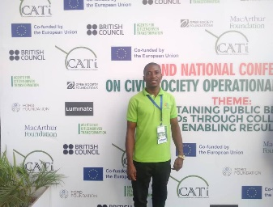
SECHILD Representative
"SECHILD's Transformative Journey: Empowering Women through Environmental Advocacy" SECHILD, passionate about environmental causes, seized an opportunity for change at the information session organized by Women Environmental Programme (WEP) and Urgent Action Fund (UAF) Africa in Abuja. SECHILD actively participated in the informative gathering on December 14, 2023 which took place at the Albert Ballin Hall, Abuja. This session provided SECHILD with valuable insights into securing funding for her environmental initiatives and connected her with like-minded individuals and resources.
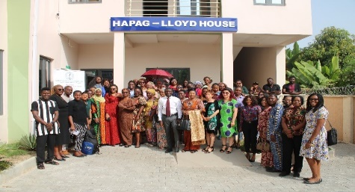
Participants

"Celebrating Apostle Joshua Selman's Birthday: A Joyful Day of Giving from the School of Ministries-Koinonia"*On June 16th, 2023, the School of Ministries-Koinonia transformed Apostle Joshua Selman's birthday into a day of profound change, as members joyfully gave back at the SECHILD Center. This act of generosity not only celebrated their mentor but also highlighted the enduring impact of his teachings on unity, love, and purpose. The day left an indelible mark, echoing the spirit of positive transformation within the community.
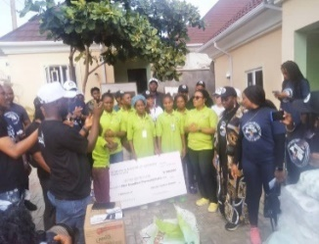
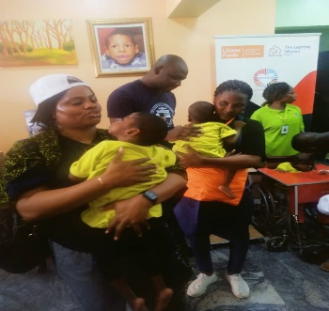 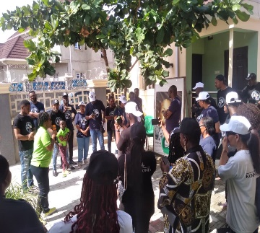Presentation of Cheque of N500,000 The Koinonia with the SECHILD children President SECHILD address

"Harmony of Giving: "Green Worship 6.0, led by Pastor Wale Adenuga, united music enthusiasts and philanthropists at The Fountain of Life Church in Lagos. The concert successfully raised funds for SECHILD, Joy in Africa Foundation, To Omo Re School, and Let Cerebral Palsy Kids Learn Foundation, touching hearts and transforming lives through the powerful blend of music and compassion.
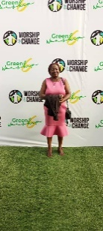
Representative of SECHILD at the 2023 Green Worship Concert
Strengthening Partnerships: Plan International Nigeria's Mutual Assessment Visit to SECHILD: The recent mutual assessment visit by Plan International Nigeria has become the cornerstone of SECHILD's hope for a fruitful partnership. This pivotal moment not only acknowledged the impactful initiatives of SECHILD but also sowed the seeds of optimism for the future. Plan International Nigeria, recognizing the significance of SECHILD's commitment to creating a positive impact on children's lives, has laid the foundation for a collaborative journey. The meeting, filled with open dialogue and discussions on achievements and challenges, established a framework for mutual support and shared goals. Beneficiary interactions served as a poignant reminder of the real-world impact of SECHILD's programs. On-site visit, provided insights into the operational aspects of SECHILD's initiatives, and instrumental in the comprehensive assessment.
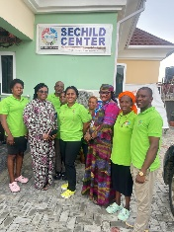
Plan Team with SECHILD

Advocating for Children with Cerebral Palsy: A Transformative Visit to FCT Secretariat: Our organization visited an FCT area council on November 10th, 2023, to advocate for children with Cerebral Palsy (CP), stressing inclusion, education, and healthcare. We presented CP prevalence and impact, urging early detection and intervention. Personal caregiver stories highlighted the need for specialized education and therapy. Community engagements led to local authorities pledging support for inclusive education and healthcare. Collaboration with professionals and NGOs shows a commitment to positive change. Our visit amplified CP voices, with hope for more inclusive environments. We'll monitor pledged initiatives and expand advocacy to other FCT area councils for a society where every child can thrive.

* "NIDOE-Europe and SECHILD: A Collaborative Journey for Children's Well-being"*July 21, 2023, marked a pivotal moment as NIDOE-Europe and SECHILD united for children with special needs in Nigeria. Their collaborative journey, born from NIDOE-Europe's charitable initiative, blossomed into a lasting partnership focused on improving the well-being of vulnerable children. The NIDO-Europe Foundation launch in Abuja further cemented this collaboration, with SECHILD's President, Kawan Aondofa-Anjira, inspiring attendees with a vision for inclusive support. This narrative highlights the transformative power of organizations uniting for meaningful change, emphasizing the impact of collective efforts on the lives of children with special needs.
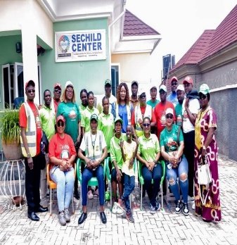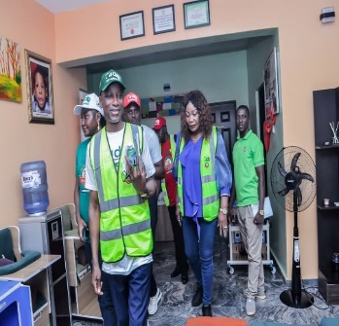
Members of NIDOE with SECHILD A tour of SECHILD Center
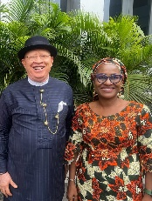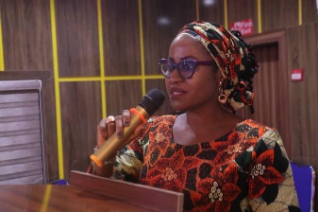
ED TAF Africa and President SECHILD at NIDOE launch President SECHILD appreciating NIDOE

Acknowledging an Exceptional Intern: Towards the end of 2023, we honored an exceptional intern whose positive impact on our organization has been outstanding. This report serves as a token of appreciation for her positivity, eagerness to learn, team spirit, and helpful ways, which have significantly enhanced our work environment. From the beginning, the intern's optimistic attitude became a guiding light for our team, fostering a motivating atmosphere and promoting unity. Throughout their internship, she demonstrated a remarkable readiness to learn and grow, actively seeking feedback and dedicating spare time to self-improvement. Her commitment to taking on new challenges reflected a genuine thirst for knowledge. Notably, the intern's exceptional team spirit and helpful nature significantly boosted overall team productivity, leaving a lasting impact on the organization. Thank you for being an exceptional intern!
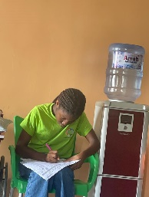
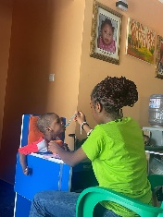
Welcoming a New Child with Cerebral Palsy: SECHILD Center's Commitment to Care and Rehabilitation: SECHILD Center warmly welcomes a new child with Cerebral Palsy, offering dedicated care and rehabilitation. With round-the-clock caregivers and therapists, the center provides solace to the mother, ensuring her daughter's well-being in a nurturing environment. Generous donors enable the center to fulfill its mission of never turning away a child in need, offering comprehensive support.
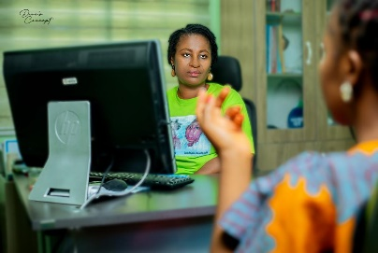
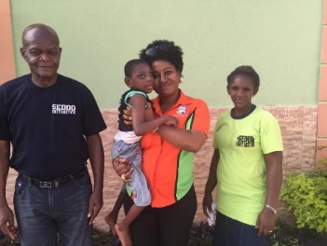
International Day of the Boy Child In honor of International World Day of the Boy Child”: SECHILD celebrates International Day of the Boy Child, highlighting the well-being of children with disabilities. We spotlight Tersoo's journey and challenges, participating in the Africa Children Runway event with The Engraced Ones in Abuja. This initiative promotes inclusivity, breaks barriers, and showcases talents, fostering unity and empowering children with disabilities. Together, we aim to redefine perceptions and create a more inclusive society.

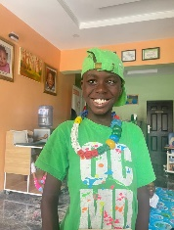
"A Decade of Triumph: Miracle's Journey at SECHILD" A Decade of Triumph: Miracle's Journey at SECHILD" Over the past ten years, SECHILD has been the beacon of hope for Miracle, a child with Cerebral Palsy, and their blind father. A chance encounter at a charity event led them to SECHILD, where tailored interventions and unwavering support transformed their lives. Through SECHILD's adaptive programs, Miracle thrived, and their father found empowerment in a nurturing community. Their story, marked by resilience and progress, embodies the transformative power of compassion and community support. Today, they stand united, symbolizing the indomitable spirit within SECHILD, where every challenge is met with courage, and every heart finds its melody in the symphony of change.
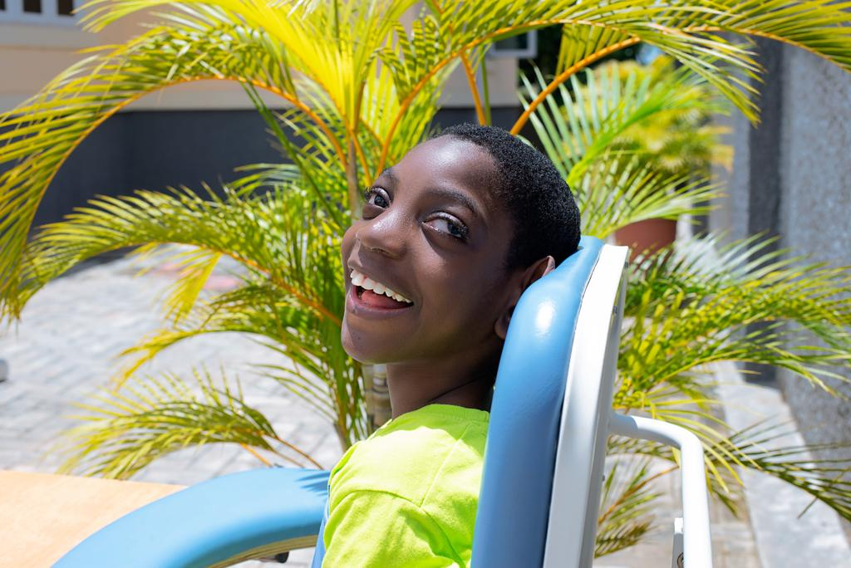

"Building Inclusive Communities" showcases impactful narratives in advocacy and healthcare.

1. *Advocating for Inclusion:* Leaders from various sectors gather to discuss awareness and empathy, with a community leader publicly committing to fostering a compassionate community. 2. *Promoting Inclusion and Well-being:* SECHILD's dedication to children with Cerebral Palsy is evident in their comprehensive approach, including research, medical services, and sensitization campaigns, exemplified in a Village Square meeting in Kuje.

3. *Navigating Healthcare Horizons:* Collaboration between SECHILD and AWWIDI focuses on a patient-centric approach, community empowerment, and healthcare access, inspiring collective efforts for transformative healthcare initiatives.
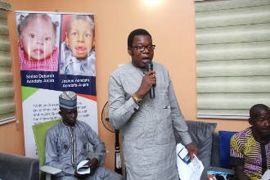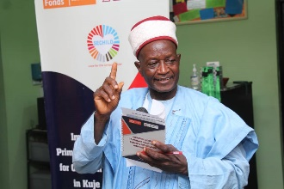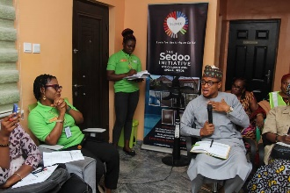
Representative of Kuje Area Council Community Leader Representative of Minister of Health
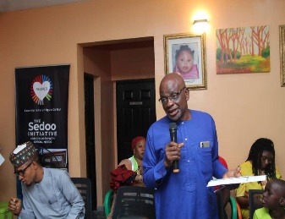
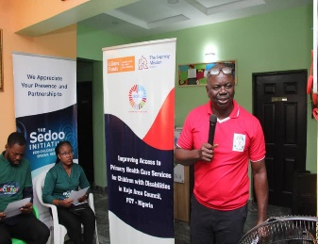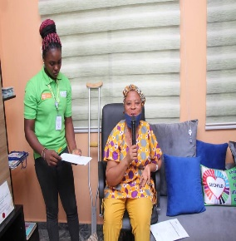
Physiotherapist Representative National Health Insurance Agency Leader of AWWIDI Kuje
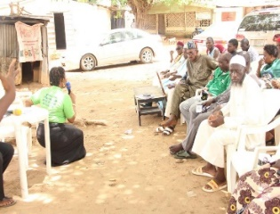
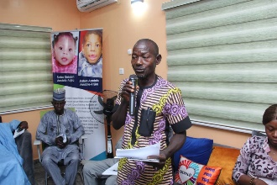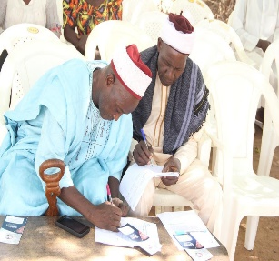
President SECHILD thanking Community Leaders Field Worker Community Leaders Signing
*Breaking Barriers: A Journey Towards Inclusion and Equality for Children with Cerebral Palsy* "In my 2023 holiday break, I witnessed a family facing pressure to abandon their child with Cerebral Palsy, highlighting the urgent need for social acceptance. Despite outdated beliefs, we supported the family and admitted the child to SECHILD Center. This incident underscores the ongoing battle against prejudices. Children with Cerebral Palsy deserve love and equal opportunities. Let's create a more inclusive society where every child can flourish and be celebrated.
Kawan Aondofa-Anjira

*"A Day of Dedication: Witnessing SECHILD's Compassionate Care"*:""Dr. Solomon Aondona Igbayue, a dedicated volunteer at SECHILD, plays a pivotal role in the compassionate care provided at the facility. His testimonial highlights SECHILD's exceptional commitment, showcasing tailored care plans, supportive mealtime gatherings, and transparent communication with families. His involvement underscores the profound impact SECHILD has on the lives of children with Cerebral Palsy and their families, making it a truly inspiring place."
*Harmony for Hope: SECHILD's Dance Group Raises Funds for Children with Cerebral Palsy* : In the heart of SECHILD, the Dance Group, a blend of professionals and children from the center, takes the stage to raise funds and awareness for children with Cerebral Palsy. Born within SECHILD's care center, this group showcases diverse dance styles, challenging societal norms and advocating for inclusion. In 2023, they achieved a remarkable feat, raising 10% of funds for the center. Buoyed by success, SECHILD plans to expand, collaborating nationally and internationally, aiming to engage wider audiences and champion the cause of children with Cerebral Palsy. Their journey exemplifies how passion and talent can transform, paving the way for a more inclusive future in Nigeria.

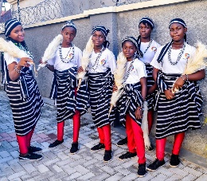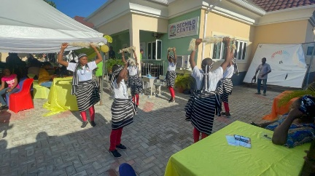

"Powering Hope: A Transformative Partnership Between SECHILD and MTN Foundation": In December 2023, the Sedoo Initiative for Children with Cerebral Palsy encountered a transformative moment as the MTN Foundation extended a generous hand, providing a new generating set and substantial food items. This remarkable donation became SECHILD's bedrock, guaranteeing uninterrupted power supply crucial for essential therapy programs. The ripple effect was felt deeply, alleviating the financial strain on families and fortifying the organization's mission. The MTN Foundation's act of kindness not only empowered SECHILD but also illuminated the enduring strength of collaborative compassion in community transformation. This narrative celebrates the convergence of philanthropy and purpose, illustrating the profound impact when organizations unite to uplift those facing adversity. "Powering Hope" exemplifies the profound change that can emerge when compassion fuels action, showcasing the potential for positive transformation within our communities.

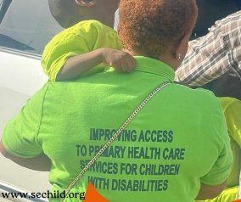
"Honoring Lucy Adaa's Legacy at SECHILD": SECHILD mourns the loss of Lucy Adaa, a devoted member of the Care Department. Her unwavering dedication to children with special needs leaves a lasting imprint. While her physical presence is missed, her legacy of commitment lives on. SECHILD extends condolences to Lucy's family and pledges to continue her work with the same passion. Lucy's influence remains an inspiration, guiding SECHILD's mission in helping children with special needs.
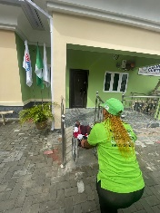
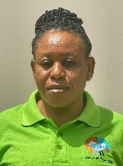
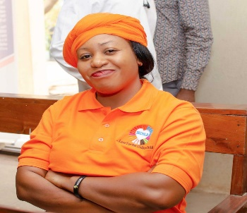

Media Engagements/Trainnings
MEDIA RECRUITMENT PEER EDUCATORS-AIT - Shortcut.lnk
https://www.facebook.com/share/p/ytmPSCrFBeNeGTaK/?mibextid=qi2Omg
https://fb.watch/nJ2ZnlU6Mx/?mibextid=NnVzG8https://kapitalfm.gov.ng/2023/10/18/stakeholders-advocate-improved-access-to-phcs-for-children-with-disabilities/
thisdaylive.com/index.php/2023/10/19/group-seeks-improved-healthcare-services-for-children-with-disabilities
https://www.youtube.com/live/_CGodzRQfbM?si=sc9FYSz_wXQUiYHn
https://www.youtube.com/live/_CGodzRQfbM?si=sc9FYSz_wXQUiYHn
https://youtu.be/QLXwyj4Oxq4?si=KD-Jgt94I1PoDTPX
*2023 Training and Event Calendar:*
1. Stakeholder Forum to Review Access and Response to Sexual and Gender-Based Violence (SGBV) in Northwest Nigeria - February 15th, Dennis Hotel, Abuja, Neem Foundation
2. Inclusion First 2023-Liliane Fonds/The Leprosy Mission Nigeria Partner Organizations Inception Meeting - February 16th-18th, Exclusive Serene Hotel-Abuja, Lilliane Fonds/The Leprosy Mission Nigeria
3. Training on Data Management, M&E Plan, and Referral Pathway - April 19th-21st, Exclusive Serene Hotel-Abuja, Lilliane Fonds/The Leprosy Mission Nigeria
4. Training on Development & Implementation of Advocacy Plan - June 4th-7th, Grand Pela Hotel & Suites Abuja, Liliane Fonds/The Leprosy Mission Nigeria
5. Report Launch and Basic Education Dialogue - August 8th, Dennis Hotel, Abuja, Human Development Initiatives/MacArthur Foundation
6. Enhancing Organizational Capacity of Organization of Persons with Disabilities in FCT Nigeria - August-December, SECHILD Center Abuja, European Union, British Council/TAF Africa-EU-ACT
7. We Ring The Bell Campaign - September 22nd, Dennis Hotel Abuja, Lilliane Fonds/The Leprosy Mission Nigeria
8. National Conference on Civil Society Operational Environment in Nigeria - November 8th-9th, NAF Conference Center, Abuja, CSO Accountability and Transparency Initiative Ltd/Gte/British Council
9. Annual Country Learning Training Workshop - November 5th-8th, Ibeto Hotel Abuja, Lilliane Fonds/The Leprosy Mission Nigeria
10. Training on Accounting Software & Book-keeping - November 12th-14th, SECHILD Center Abuja, In-house
11. Training of Trainers on Legislative Advocacy for Safe Schools Declaration for Community Leaders, CSOs, and School Administrators - November 16th-17th, Dennis Hotel, Abuja, Women Advocate, Research & Documentation Center WARDC/UNDEF/FNUD
12. Training on Sign Language - November 20th-27th, SECHILD Center Abuja, In-house
13. Coaching and Mentoring Reflective Session - December 3rd-7th, Lagos Continental Hotel, European Union and British Council-EU-ACT
14. Strategic Communication and Leadership Training for Persons with Disabilities in Government - December 4th, Dennis Hotel, Abuja, by TAF Africa
15. Information to access Funding - December 14th, Albert Bailin Hall, Abuja, Women Environmental Program and Urgent Action Fund Africa
16. Photography, Storytelling, and Mobile Videography Training - December 11th-14th, Jades Hotel Abuja, Lilliane Fonds/The Leprosy Mission Nigeria
17. Counter Financing Terrorism Training on Collaborating to Fight Financing of Terrorism - December 13th-14th, Grand Pela Hotel, Abuja, Economic and Financial Crimes-EFCC

Challenges Facing SECHILD:*
1. Economic Fluctuations: The organization grapples with rising market prices impacting the cost of caring for the children, restocking kitchen items, and managing administrative expenses. Economic challenges pose limitations on service provision.
2. Logistical Issues: Nigeria’s economic hardships result in challenges such as a lack of vehicles, fuel shortages, and poor transportation systems. These issues affect emergency hospital visits, therapy sessions, and overall advocacy efforts. Frequent power cuts further compound these logistical challenges.
3. Staff Welfare: Ensuring the welfare of staff and care workers is crucial, with the expansion of responsibilities highlighting the need for more hands. Although committed volunteers contribute, addressing staff payment is imperative for sustained service. The addition of six new staff members in 2023 underscores the priority on staff welfare.
4. Diversifying/Funding: The project’s expansion makes keeping up with fundraising efforts challenging. Reliance on personal donations and crowdfunding hampers planning ahead. The organization actively works on diversifying funding sources, improving grant application processes, and enhancing staff capacity in fundraising and resource mobilization.
5. Access to Education: Limited access to comprehensive and inclusive education, especially up to the secondary school level, remains a challenge. The center outsources education, facing reluctance from most schools to admit children with Cerebral Palsy, particularly those on the severe spectrum.
6. Inadequate Funding: Securing consistent and adequate funding is an ongoing challenge, constraining project implementation, attracting new supporters, and raising awareness about the organization’s mission. Improving fundraising strategies and resource mobilization skills are vital for overcoming this challenge

How to Support SECHILD
SECHILD is a non-profit organization that is improving the well-being of vulnerable children and their caregivers. They rely on support and donations from partners and individuals. To support our cause, you can become a partner by donating into:
The Sedoo Initiative for Children with Special Needs
Fidelity Bank Plc.
5601004308
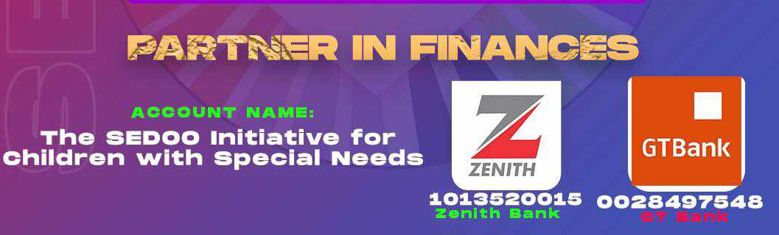

Call on +2247037734576 Or
Visit:
SECHILD Center
Light Gold Estates, Phase 4
After Trade more Estate Airport Road
Abuja, Federal Capital Territory-Nigeria
Additionally, you can support SECHILD by sending a mail to
info@sechild.org visit our website www.sechild.org and follow our social media accounts
Facebook: https://www.facebook.com/sechildcenter?mibextid=LQQJ4d
Twitter:@sechildcenter
Instagram: sechildcenter

You can also celebrate with us at SECHILD Center or engage SECHILD cultural dancers for special events.

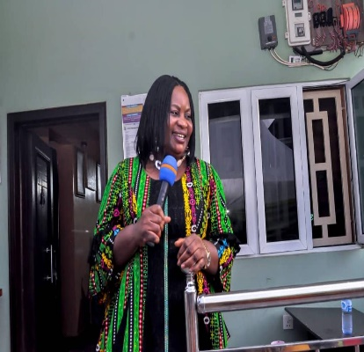
Dear SECHILD Family,
As we embark on a new year, I reflect on our remarkable 12-year journey at the Sedoo Initiative for Children with Special Needs—SECHILD. More than an organization, SECHILD has been a beacon of hope, driving positive change and showcasing the transformative power of collective action. Our commitment to advocating for children with Cerebral Palsy and their families fuels every initiative, program, and success.
As Chairman of the Board of Trustees, I urge us to reaffirm our dedication to making a difference in the lives of persons with disabilities. SECHILD is not merely an organization; it's a movement. In 2024, we aim to amplify our impact globally, addressing the unique needs of persons with disabilities through advocacy, research, and a focus on inclusive education and diverse communities.
Our commitment goes beyond words; it's a pledge to create meaningful opportunities in schools, workplaces, and communities. Collaboration with diverse stakeholders is essential for true change. Reflecting on 2023, our intervention programs empowered parents, instilling hope and resilience. Scaling these initiatives in the upcoming year, we'll elevate our impact further.
Engaging sector leaders, CSOs, traditional and religious leaders, health workers, and utilizing media channels, we aim to amplify our voice globally. Our mission is clear – policies must be implemented, partnerships forged, and collaborations strengthened. In the face of challenges, we find opportunities to innovate and grow.
Let the spirit of SECHILD inspire us as we stride into 2024 with renewed determination, knowing that together, we can create a world celebrating the abilities and contributions of every individual. Here's to a year filled with growth, innovation, and success.
Together, we will make a difference.
Warm regards,

Barr. Aver Gavar
Chairman Board of Trustees
