**Report of our second visit in Lushagala Internally Displaced Persons Camp in Karisimbi Goma, North Kivu, the Democratic Republic of Congo**

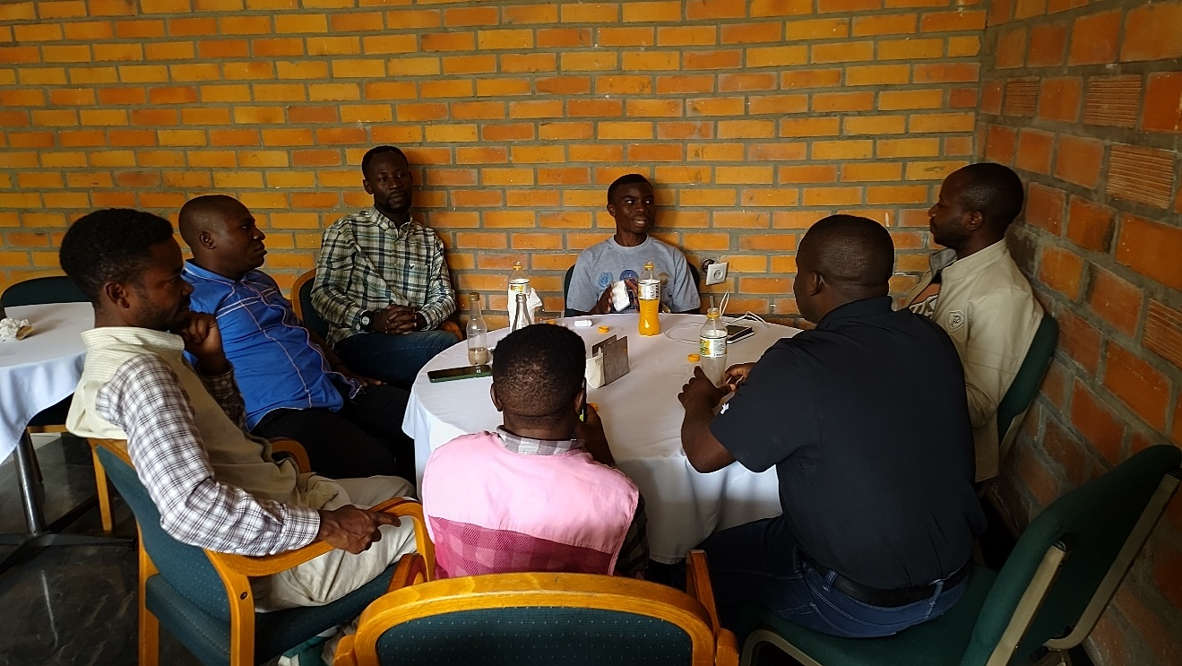

***Planning on actions towards IDPs in Goma, we cannot remain silent***

Together with other actors mainly: The Urban Youth Council, the Provincial Youth Council, the NDSCI, LUCHA, COJESKI, North Kivu and IDPs representatives, we have put in place this team to address few things that effect IDPs in Goma and around Goma currently.

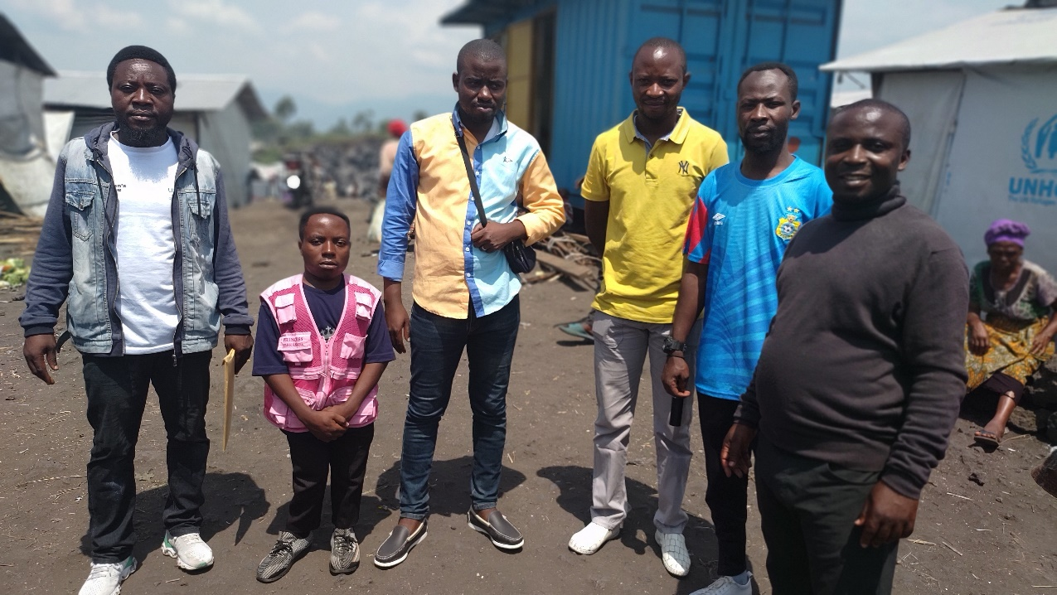

***Our field visit in Lushagala IDP Camp in Karisimbi, Goma RDCongo,***

**Problems**

We have so far identified the following problems which have caused our desire to contribute for the solutions.

There are various allegations that IDP Camps are shelters and favor M23 Rebels infiltrations in order to attack Goma and that this is done in solidarity with some IDPs in camps,

There is more acts of intolerance towards the IDPs by the host communities, whereby IDPs who are begging in order to survive are abused, chassed and perceived as security threats,

Tensions between IDPs and the host communities over the relief aid whereby IDPs claim that some people in host communities are getting advantage of this,

**Introduction**

DRCongo is now the first country in the world with the highest number of Internally Displaced Persons according to the United Nations, the current war by M23 backed by Rwanda has pushed away millions of people who are now residing in Goma and around Goma, living alongside the host communities which has been also its self a result of displacement, actually estimations indicate that more than 70% of the population in Goma have history of displacement in the past, not only caused by the war but also by the Nyiragongo Volcano. Goma itself is isolated from the rest of North Kivu Province and is facing challenges of food because the rebels have cut off all roads that facilitated food from the other parts to reach Goma, it is in this circumstances that the debate over the existing humanitarian interventions is now a hot one.

But despite this debate about who should benefit from the relief aid and who should not, we are facing the pull and push of what should be a priority and where more efforts should be focused on between the relief aid and the desire to restore peace and stability so that people can go back to their homes. Yet this war has clearly shown us the close relationship between displacement and poverty, and even if people go back the issue of poverty will remain.

**Interventions on ground**

Two tendencies are observed, while the local organizations members of the Civil Society are pushing for the end of the war so that people can go back, most of the international humanitarian relief aid agencies and organizations are pushing for the increase of the aid and for better conditions in order to grant aid to IDPs and other people in need, this is mainly what comes in all their media briefing. *And the question remains, until when we shall call for relief aid to IDPs*?

**Our Project:**

**Promoting pacific cohabitation between IDPs and the host Communities around Goma**

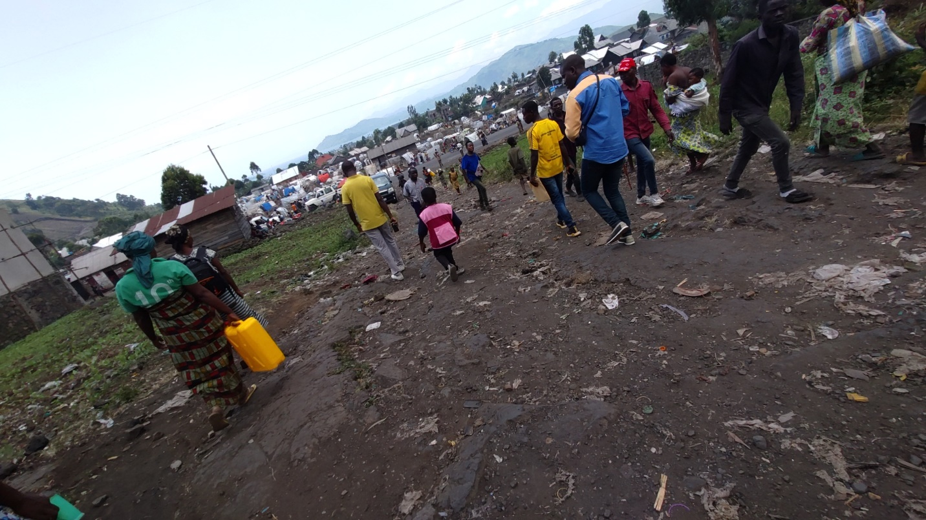

***Some parts of Lushagala IDP Camp in Goma, North Kivu/ DRC***

On Saturday February 17th, 2024 we visited Lushagala IDP Camp in Karisimbi Division, Goma Town, North Kivu- DRC. This camp is dominated by Bahunde, Batembo, Bahutu, and few Tutsi, that is the uniqueness of this camps exactly because it has Tutsis, this has helped us to understand the situation and face the reality in which a certain category of Tutsi believe that they cannot live together with other communities and that they should be somewhere alone.

The camp is highly populated currently with new arrivals from Sake a town that is facing the war, and many people as per now are sleeping outside. Beyond the civil population the camp also hosts members of various armed groups including the DRC Army people and their families who also found themselves in the camp. The security of people in the camp is the top major problem because so many actors have guns, and at least each day there is a person that is killed by a gun in the camp.

The camp has a leadership at all levels but also facing the challenges with those who carry guns and in most cases these civilians camps leaders have not much to say before the guns. The presence of guns in almost IDP Camps around Goma remains the major challenge.

Lushagala IDPs camp is facing serious challenges with water, and has no recreation activities for the people, in order to get these services which can help people to forget the effects of the war, the IDPs have to travel to the host communities around in order to access sometimes water, a football pitch, a church, a market, a hall for leisure activities…..

The only existing play-ground which is a property of the Youth Council is not used and needs to be worked on so that it can provide an alternative to young people especially to get where to play from and make themselves busy.

Sex activity is one among the problems which affect so many especially the parents who claim that their children are victims of various sexual activities and in this situation involved in unprotected sex which is exposing them to risks of HIV/AIDs. The host communities are much aware that they will get cheap sex in the camp so they do come here to pick young girls in exchange of money, because these girls also want to survive and earn a living.

The camps is facing the challenge of ethnic divisions and often grouping in areas which people are settled according to their ethnic belonging and that it is more connected to the planning of the camp which lacks a proper planning. There are unfriendly and unfair competition to the available few opportunities in terms of employment, trainings and other opportunities in which some people believe they were granted because of their ethnic belonging and others excluded because of their ethnic background. Unfortunately there are no activities that put people together and focus on cohabitation.

The existing humanitarian relief aid is limited to some people, there are so many others who do not get that aid apart from these new ones, allegations indicated that there are people who have been there for long and have not yet accessed the aid. People in the camps were wondering about the kind of the aid that they are given, and do not understand how decisions are made and who make the decisions because the food that they are given is not the food which they use here. So you give it to people but they sell it order to buy what they want, that is why you see IDPs food being sold in the markets in Goma. It was also not clear why they are not given money as it is being done in other IDP Camps around Goma, eating food which they are not used to, is perceived as one among the causes of sickness in the camp. There is also a problem of clear information between the humanitarian relief aid agencies and the people about the quantity of the aid each person should get. For example the coupon indicated that one person should get food of 118$ USD, but when they distribute this, they get something of not more than 50$, so we do not know what happens to the rest of the aid.

**Challenges with the host communities**

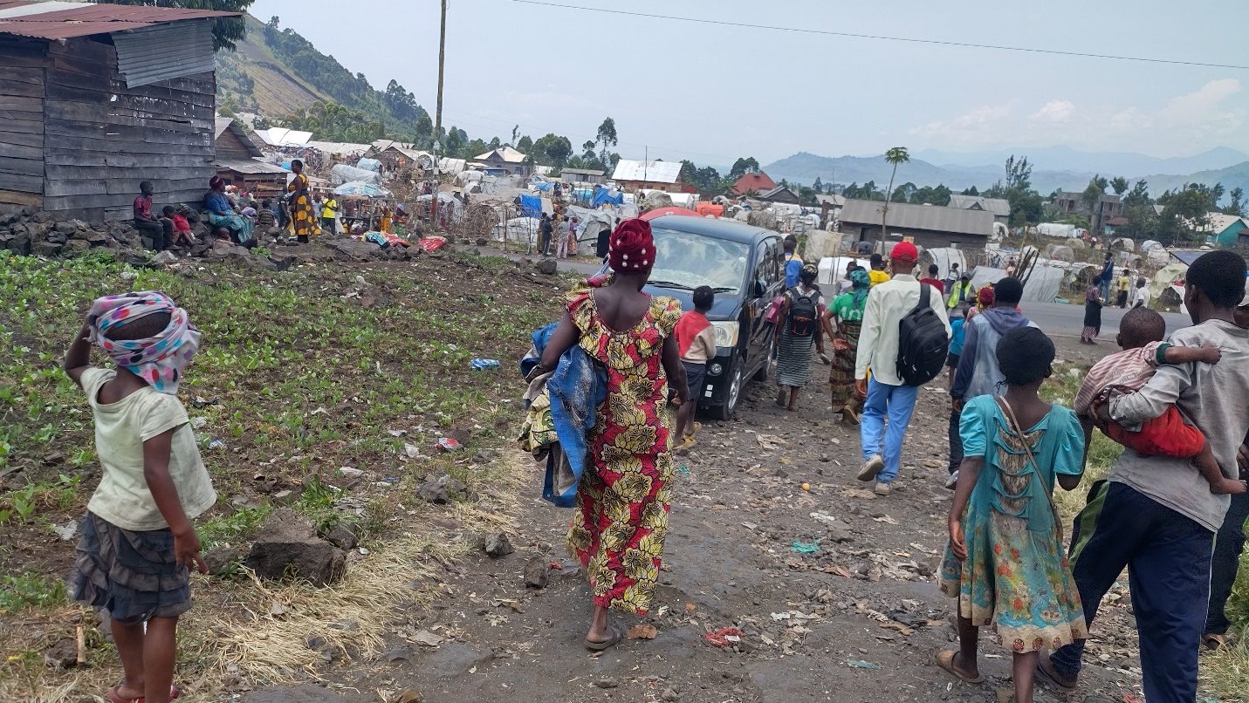

***This is Lushagala IPDs Camp alongside the host communities***

There are always incidents of caused by thieves and generally the local host communities perceive that these thieves always come from the camp, in some cases the host communities want to be considered as the priority for everything and in many cases IDPs are in difficult situations are abused by members of the communities. Much as the host communities gave their land where IPDs are living, they do not yet feel the real solidarity in terms of interaction with them. Some people do come to visit the IDPs and they come with some food depending on what they can have. Generally people from the host communities are the ones who buy food from IDPs and things are discussed and agreed upon freely.

**Conclusion**

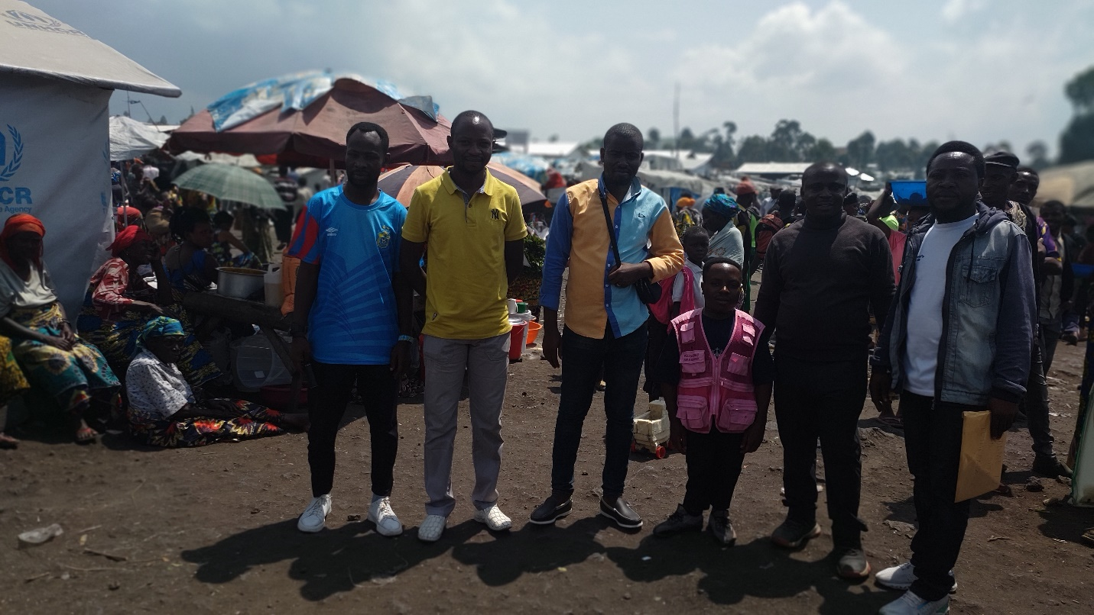

***This is one of the trading centers and the main in the Camp where offices are also located,***

While it is important to survive every day, the desire of the IDPs is to return home in their respective villages is their first demand, once peace and stability are restored. Our actions then should focus on both helping people to live together but also advocating for peace in their villages through the end of war, and this should also be one among the priorities of all those who are in relief aid chain in North Kivu.

Various activities should then be considered in this angle and the next visit will be in Rusayu One IDP Camp in Nyiragongo.

**Actors involved:**

Kulihoshi Musikami Pecos: Coordinator of COJESKI North Kivu,

Jules Ngeleza: Chairperson of the Youth Councils, Goma Division

Germain Mirhonyi: President of NDSCI North Kivu,

Moise Akilimali: President of the Youth Council, Kyeshero

Saleh Lushombo: LUCHA, Goma

Claude Rugo: Chairperson of the Youth Council Karisimbi Division,

Daniel: Representative of the Provincial Youth Council in North Kivu,