MY HISTORY I AM ALEX BUCHUNGA BIGERA

INSIDE AND OUTSIDE MY COUNTRY

Birth, for Alex BUCHUNGA, I am Congolese by Nationality, I was born in the Democratic Republic of Congo, in the Fizi Territory at division of Mutambala Bashimunya sector in the east, Village Bivumu Province in South-Kivu, since 25/January/1987,Aged 38 in a family of thirteen children (13), two of whom have already passed away, but the other eleven are all alive, among the children I Alex BUCHUNGA BIGERA am the seventh child (7). The names of my parents are Neema Therese, my father is Lawi Matenga BIGERA, my grandfather and grandmother are called BIGERA and OMWE but since the Songambele war in 1996, they have passed away in the world, due to the challenges of the war that have plagued our country until now 2025. The killing of my grandparents during this war in 1996 when I was with them spark all our memory and pushed me to think more about the war. I remember how they were bushed on that day on that Hill in that village, in that very Protestant Church where they took a time to rest. As my father came back to look for them, he found them dead.

So, my life story and my entire history is a mixture of my existence and the war, because as you can see only after less than 10 years on this year on this earth, I started experiencing wars until now.

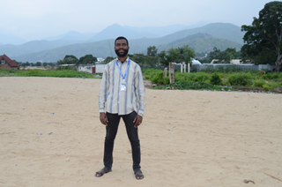

***Alex BUCHUNGA BIGERA a General Coordinator at CAPRIDIS***

***This picture here is presenting the what makes Uvira beautiful are mountains/Lake Tanganyika beaches as our City of Uvira is a city of tourism, only in Uvira we have a hot site water called Maji ya Moto at Commune Kavimvira Kala.***

We fled to many parts in Fizi Territory where we lived in some villages in the Ngandjya Sector, where life stopped because I could not go to school, people were being killed every day and surprisingly all our cows were looted by armed groups, from that moment we became too poor. After the war, we came back with the intention to return to our village but we stayed in a place called Kandale for something like six months as we gathered information about the war in the areas. During this moment we lost our last born by the name of Masomo BIGERA and this also affected my mind and forced me to raise more questions about this war, why the war and what should be done to stop the war so that my family members could continue to live.

When we came back to our former refugees, we found that the whole areas were now being controlled by Tutsi Armed Groups who submitted us to torture and to forced military recruitment. This situation became unbearable for me, and in order to survive I escaped up to my aunt place and from there I managed to move up to Tanzania in Rugufu One refugee camp in Kigoma but the life situation was heard, I opted to move to Burundi. In the year 2001 I moved to Burundi in a refugee camp, where I first got the opportunity to learn the basic computer skills in Chishere, Buganda Division in Cibitoke Province. It was because of these basic computer lessons that I developed love of Computer and now I can fully write to you these notes. It is clear that you came up with the idea to teach us Computer may not know how it has been so much important in our lives, I also believe that donors who funded these computer lessons may not up to now much they contributed to our lives but I’m here to thank them, in case one may come across this story. The computer training took me six months, and after than I moved back to DRC and stayed with my sister in Fizi kyonwe, Kaboke Division.

But also, so many armed forces fought regularly for the control of the area and targeted young people to put them in the army by force. So, in 2006 I went again to Burundi where I first stayed in a Restaurant where I was working as a cleaner and in the process, my boss was a Muslim and in order to keep my job I changed my name and became Alex Issa Ramazani. But in 2007 I moved to the refugee camp in Burundi called Musasa, in Ngozi Province where I stayed as a refugee until 2008 when I together with my colleagues decided to move to Uganda. However, our first attempt to move to Uganda in 2007 was not successfully because we were arrested at the border between Uganda and Rwanda and we were deported back to Burundi in the same Musasa Camp. The reason why we were arrested at the Kagitumba Border in Uganda, was that we were militia groups and that we could not be allowed to enter Uganda, soldiers came and took us back Rwanda being detained in a Barracks Military where we were tortured for 3 months, unfortunately no one knew that we were arrested, then we were released, we were tortured to the point that I lost conscience, and later on we were located to Rwamagana. During the detention period in Rwanda we slept in a Container, we could eat the food called rest of over from what the soldiers were eating, and during the day we worked in gardens belonging to the army. Later on, we were deported back to Burundi, and when we reached in the Camp in Burundi they also arrested for two weeks. When we were released, I happen to get in contact with my brother who stayed in Uganda and managed to help now to relocate to Uganda in Nakivale Refugee Settlement as he guided me on how to cross. In 2008 I reported myself to UNHCR in order to claim for a refugee status in Kampala and then I was relocated to Nakivale Refugee Settlement.

I am Alex BUCHUNGA BIGERA, I completed my education primary and second school, from the first grade 1-6 of the ninth grade, in our village at Bivumu Primary School, but from the year 1996, the war caused my life with my family and all my brothers and neighbors to go through difficult challenges, on top of life, I was still a very young child. I would not have been able to strengthen my services alone without my parents and my brothers. It became a big problem, there we fled to a place called Nemba in the Ngandjya sector of Fizi division, there we did not have the experience of a difficult life. 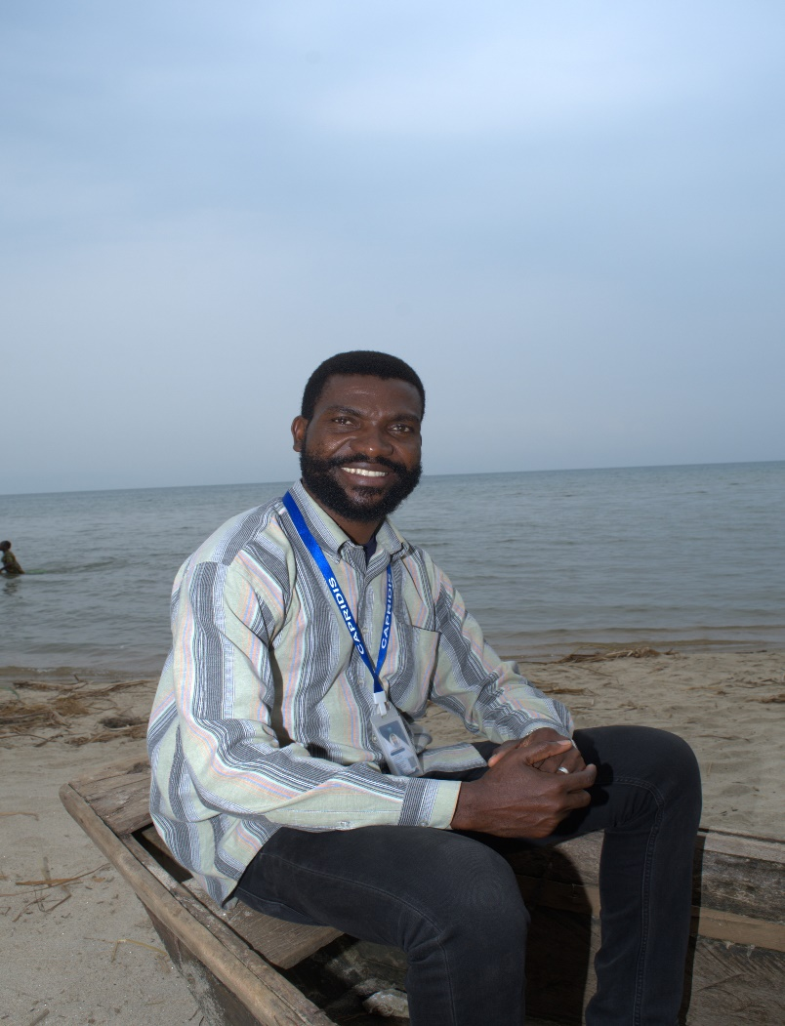

***At the Lake Tanganyika in Uvira has a national road no.5 passes in the city of Uvira from Bukavu from Kisangani to Katanga this lake bordered by Burundi, Tanzania, Zambia and Fizi Territory of South-Kivu as well Uvira is also located in the South-Kivu Bukavu Province of DRC.***

The problem of education became a problem for me when the war destroyed my dreams or along with other children, in general. In 1998 we returned home, I continued my basic education until 2000, from there until 2002-2007, I was in secondary school in Burundi at the Musasa Refugee Camp in Ngozi Province,

I went to the East African Community in Tanzania, Burundi, Rwanda, Uganda, Kenya, and other countries, when it began to deal with various education on the protection of the lives of my fellow refugees in Uganda Kampala in 2008, when I was on my training team at Makerere University, I studied Peace and Development, in the department of Makerere University from 2008-2010-2013-20214-2016.

It is during this that I was deployed in various places in Uganda for internship in refugee camps that I was once gain confronted with the reality of the refugee life in camps. However, I observed that Uganda received a lot of relief aid for refugees and unfortunately refugees did not get what they deserved to get. My internship linked me to the Refugee Law Project which was under Makerere University and which helped me to know and understand a lot of things going through the refugees in Uganda. 

***Alex BUCHUNGA BIGERA in Uganda at Nakivale Refugee Settlement, this picture here presented my career and my passional in filmmaking as a Film Producer/ Actor***

There in whole Uganda I was only a Refugee Film Producer who started a Production Project in the hands of Ugandan Government and UNHCR included other partners since 2014

There I was produced many educative and refugee’s rights films included documentaries and interviews was Conduced by me in the settlement of Nakivale and outside of the settlement in the cities and settlements of Uganda.

***I started a project called Nakivale Movies Company this NMC was leady by myself Alex BUCHUNGA BIGERA as a Film Producer by Professional,*** which works in the Nakivale Refugee Settlement Isingiro District of western Uganda and in order to amplify the voices of refugees, organize them better and help them to advocate for their well-being, this youth project became the pillars of our lives, we grew up and prepared various actors such historians to play as film production or acting, directing, videography skills, music skills, life skills, along with comedy, people, modeling, drama, sports, acrobats, and various games, which helped many young people along with mothers in the camp and outside the camp, I taught them different things to fight against poverty and promoted awareness about refugee rights, leadership and community participation among others. I was not with my parents who have grown up in the DRC, there I started living as an orphan who does not have children, I have all been through it because of the war, remember that war is not good it causes many people's dreams to be ruined.

It was in this year 2008 in which I discovered that I have a talent to be able to defend other people who cannot defend themselves, through the education I studied in various courses on life and development. I was in this year in which I realized that my knowledge was capital and could change the lives of so many people in Nakivale Refugee Settlement, much as I could not give people food, money and other basic needs but many were so happy because of these various activities I put in place.

2017-2021-2022, I registered a Company limited by Guarantee called Stand for the Refugee Africa (SRA) in the city of Kampala Uganda, I have been the CEO-Cofounder of SRA, which was bringing up refugees together without discrimination, refugees and host communities all benefited through SRA, which was involved in dealing with the lives of refugees in Uganda and outside Uganda.

Through NMC (Nakivale Movies Company), which later became SRA (Stand for the Refugee Africa), became a very strong initiative which benefited so many young people and also involved conferences, workshops, trainings, dialogues, interviews and invitations through the United Nations High Commissioner for Refugees (UNHCR) and the Office of the Primary Minister (OPM) With partners also through different local and foreign organizations, SRA has worked well in general.

Challenges, over all those years I have gone through different challenges, which made me able to live a life of fear when I have had to defend our rights with all the projects that have gained trust through UNHCR, with its partners, when I stood up for our rights, that's when my happy life changed in general. I found myself without rights or security in Uganda, the story and tragedy of being imprisoned, unjustly and harassed became too much for me and I found myself without rights immediately. With these initiatives I became a target of the Uganda Security Services and faced various forms of persecutions, including the denial refugee assistance and even the resettlement opportunities in order to punish me so that I do not continue and that I may serve a lesson to others who were also vocal on refugees’ issues in Nakivale Settlement.

March 01/2022 that's when I decided to leave Uganda to return home to the DRC, I had to run away again like a refugee who has fled from Uganda to the DRC, there I have was in a situation of protection over my life, I did not bring anything because of the fear of my life which had been at high risk in Uganda.

My life Alex BUCHUNGA BIGERA, when I arrived in my country DRC, before I had dealt with the problem of Refugees, Immigrants, Internally Displaced and Disasters, in the country of DRC, having gone through a difficult life due to the constant war, then it became my dream to come and work in my country DRC, first teaching the forced community and host community about peace, freedom, unity, love for development, also teaching them English and handicrafts such as property management, agriculture, animal husbandry, basic education and additional education, I mean professional skills or secondary schools and University in the English program. I have actually started these activities along with encouraging community members to join my idea which I have grown to need to be able to succeed in an environment of strengthening all programs for humanitarian response projects.

I came here in DRC to contribute to the solution, as this country is facing a long period of wars and one among the causes is the issues affecting forced migrants and refugees who were abandoned and left to themselves. I came here so that I can bring a solution to this challenge and help both refugees to claim protection and the country to solve this problem and claim back peace.

In March 2023, I successfully obtained a registration document from the DRC capital City of Kinshasa and my organization is now called “Stand for the Refugee in DRC” (SRD) as the General Coordinator of SRD. I agreed to obtain a document under the law of DRC in the Humanitarian sector, in August 8/2023 I started the English School Project which has been successful until 100 students and more have succeeded in obtaining Certificates through SRD in partners with Women Child Protection (WCP) together with Youth Alliance Entrepreneurship Y.E.A Global in Florida USA. English is one of the ways to enable the forced community and host community to be able to exercise their right to choose their lives through education, business and the opportunities that exist in general to better their future lives.

My dream has been to create a coalition of organizations that work on a completely humanitarian basis, it has been part of my life and goals, Alex BUCHUNGA BIGERA, actually from Uganda, that time I have made it a joint venture with refugee organizations at Nakivale Refugee Settlement, there we had a Consortium called the Association of Community Based Organizations of Nakivale (ACBON) in that coalition, I had been working as a Communication and Media Officer, yes here also in July 2024, SRD under my leadership Alex BUCHUNGA BIGERA, yes I have also succeeded in uniting seven organizations together so that we can strengthen all programs together to help and enable work within the DRC in important services, in the sector of interventions of settlement program for refugees in DRC.

When I did research on this sector since 2022 when I arrived in my beloved country DRC, I really discovered that forced communities are going through very big challenges. In this protection sector and other sectors such as education, health care or mental health, food security, commercial business, communication program, human rights, peace, agriculture, communication skills, etic…. I really found the challenges are many?

Since September 6, 2024 we started a chapter and launched CAPRIDIS with the National Commission for Refugees (CNR) in partnership Officially and this partnership at CNR is signed by ALEX BUCHUNGA BIGERA a Film Producer by Professional as CAPRIDIS Coordinator, as a Consortium that is addressing the protection challenges of Refugees, Immigrants, Internally Displaced and Disasters they are experiencing in the DRC, especially in the East of the Democratic Republic of the D R Congo, CAPRIDIS is doing the identification of their cases on the protection process of going abroad or to a third country for refugees from outside the DRC, such as Burundi, Rwanda and other different countries. We have already identified refugees, who have Refugee Family Attestations. Since 2023-2025 up to now my entire time, energy and money are used in the field of helping refugees and other forced migrants in difficult situations in South Kivu, the Democratic Republic of Congo.

Refugees who are applying for refugee status/ Refugee family Attestations are 3070, Refugees in emergencies’ needs 180 all cases are available for refugees from Rwanda 1994, Burundi, 1972,1993-2015 all are at risk in difficult life conditions in the city of Uvira, the CAPRIDIS Head Office is located in Uvira, Avenue: Kasavubu, Nº.06 Quarter: Kavimvira at Commune Kavimvira, South-Kivu Bukavu Province of DRC.

Uvira is a city that borders DRC, Uvira Kiromoni border to Burundi Katumba border to Bujumbura the capital City of Burundi, also DRC, Uvira Kamanyola border to Rwanda bugarama border at plain of Ruzizi River, and Uvira is at Lake Tanganyika also the mitumba mountains are what make Uvira beautiful, from the Lake Tanganyika, we have beautiful fishes called Mikeke or Mikebuka in African Languages, Uvira have a second port after Matadi port, Uvira is a hot place due to lack of good environment tree plantation program, it borders Fizi and Mwenga Territories, I have chosen to serve the forced Community and host community in Uvira, because Uvira is in the middle of all services.

Because of the social connection with people in Uvira, because of my origin connected to people in Uvira and because of the high number of undocumented migrants who are always in open conflict with the host communities, I opted to start my journey of the refugee protection from here in Uvira.

Work experiences, I already have experience in this sector since 2008 until now I have worked with various organizations in Uganda outside Uganda and internationally in general, such as School for International Training (SIT) in Kampala Uganda, UNHCR Uganda and Geneva, UNHCR for Australia in Australia, CIYOTA, in Kampla Uganda, Youth Arise Network (YAN) in Rwamwanja Refugee Settlement Kamwengwe District of Uganda, ACBON in Nakivale Refugee Settlement in Isingiro District, Refugee Council of Australia (RCOA) in Australia, etc.…….. for my experience is 17 years of my experience in this fields of humanitarian response approach program in Africa and beyond Africa. More in the refugee’s rights sector we have worked with Mr. Kulihoshi Mushikami Pecos Luc, he was one of the Community Refugee Leaders in Kampala Uganda, he also returned home to strengthen humanitarian programs in the DRC, Goma Province. He is my witness of all I faced in Uganda.

We are currently facing a funding challenge to improve the quality of services for forced communities and host communities, as our overall goals are very much in line with our vision. CONSORTIUM OF ASSOCIATIONS FOR THE PROTECTION OF REFUGEES, IMMIGRANTS, INTERNALLY DISPLACED PERSONS AND DISASTERS

“CAPRIDIS”

My plans for refugees and the country

So far I’m proud that I’m the very first generation of Congolese now involved in the protection of refugees in DRC, we want to promote durable solutions to refugees and claim international protection for every refugee in the Democratic Republic of Congo, this alone will contribute to the long lasting peace in this country and will reduce and end so many community conflicts and open wars in various areas where refugees are in on open war with the host communities.

My efforts and struggle are to promote the full protection of refugees and help them to feel well taken into consideration in terms of their need, creating opportunities to expand their dreams and empower them through capacity building.

**The story done by ALEX BUCHUNGA BIGERA**

**In Uvira Town, at Commune-Kavimvira**

**Tel: +243 995 665 578 WhatsApp or Call direct**

**E-mail:** [**alexbfilmed8@gmail.com**](mailto:alexbfilmed8@gmail.com)

**E-mail :** [**capridiscoordination@gmail.com**](mailto:capridiscoordination@gmail.com)