Cyber illegal wildlife trade monitoring- South Asia hub
The rapid expansion of internet access, social media platforms, e-commerce marketplaces, and digital communication tools has significantly changed the way illegal wildlife trade operates. Sellers can advertise wildlife and wildlife products to large audiences, connect directly with buyers, shift between platforms, and use coded language or private channels to avoid detection. In response, the South Asia regional hub undertakes focused cyber monitoring and analysis to identify, assess, and track illegal wildlife trade activity across online spaces in the region, including social media platforms, websites, e-commerce portals, and other digital channels.
The WTI cyber-IWT team analyses emerging trends, species in trade, trafficking methods, priority geographies, and potential criminal linkages to support evidence-based responses. It also contributes to enforcement by sharing actionable leads with relevant agencies, supporting investigations, seizures, rescues, and wider disruption efforts, including reporting illegal wildlife sale content for removal from online platforms. By combining cyber monitoring, regional coordination, and practical support, the team aims to convert data into disruption and strengthen responses to wildlife trafficking across the region.
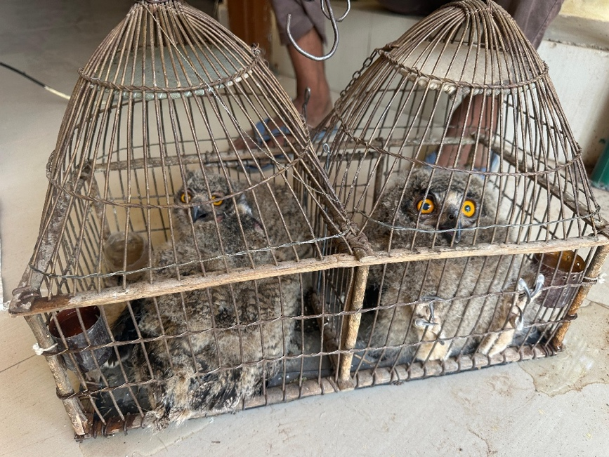
Figure 1- Successful seizure of person selling Eurasian Eagle Owl on Social media

Figure 2- Successful seizure of person selling Flap shell turtles on social media

