

Lighting the Way to Safer Deliveries: Solar Power Transforming Maternal Care in Karin Clinic

Prepared by: Herbert Onen

Executive Summary
Power outages in Gulu have historically disrupted maternal healthcare, putting mothers and newborns at risk. The introduction of solar power in maternity wards has eliminated night-time blackouts, ensured consistent hot water for hygiene, boosted staff confidence, and increased the number of mothers delivering in our facilities. This report highlights these impacts and advocates for extending solar power to Outpatient Departments (OPD) to strengthen overall healthcare services.

1. Background
- Problem: Frequent load shedding disrupted maternity services; night-time deliveries and hygiene practices were compromised.
- Impact on Staff: Midwives worked under unsafe conditions, reducing morale and confidence.
- Impact on Mothers: Limited trust in clinics led to low facility-based delivery rates.

2. Solar Power Intervention
- Location: Maternity wards in both Karin health center 3 clinics
- Technology: Solar panels with battery backup powering lighting, hot water systems, and essential equipment
- Objective: Ensure reliable electricity for safe, uninterrupted maternal healthcare

3. Achievements & Impact
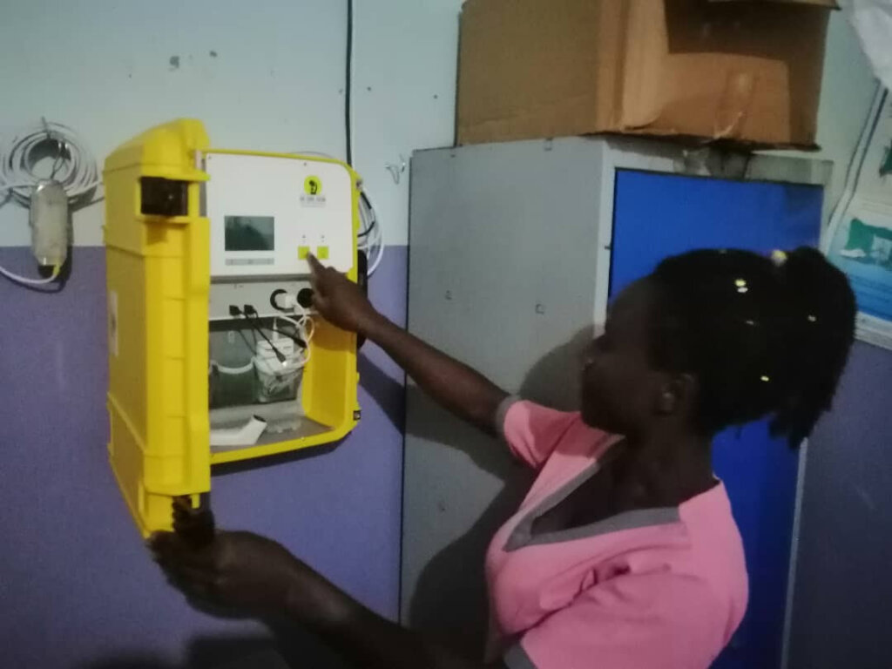

3.1 Continuous Power Supply
- Maternity wards now have uninterrupted electricity, eliminating risks associated with blackouts.
- Night-time deliveries are now safe and efficient.

3.2 Improved Maternal & Neonatal Care
- Reliable lighting supports accurate and safe procedures during deliveries.
- Hot water availability improves hygiene, reducing postnatal infections.

3.3 Increased Staff Confidence & Morale
- Midwives report higher job satisfaction and improved ability to provide quality care.

3.4 Higher Facility Utilization
- More mothers choose the clinics for delivery due to safety and reliability.
- Noticeable increase in facility-based deliveries since solar installation.

3.5 Hygiene & Postnatal Care Improvements
- Continuous hot water supports cleaning, sterilization, and maternal comfort.
- Contributes to faster recovery and healthier postnatal outcomes.

4. Community Impact
- Increased trust in local clinics
- Improved maternal and neonatal health outcomes
"Before the solar lights, I was scared to give birth at night. Now, I felt safe, and the midwives were able to help me and my baby well," shares Grace Achieng, a recent beneficiary.’’

5. Challenges & Opportunities for Support
- Key departments—especially the OPD—still depend on unreliable grid power, affecting diagnostics and treatment quality.
- Expanding solar power clinic-wide requires additional funding and technical support beyond current resources.
These gaps present a strong opportunity for partners to make a transformative, life-saving impact.

6. Priority Recommendations
- Expand Solar Power to OPD:
Ensure uninterrupted diagnostics, treatment, and emergency services, boosting patient safety and community trust.
- Support Maintenance & Monitoring:
Sustain system performance, prevent breakdowns, and protect previous investments for long-term reliability.
- Invest in Solar Expansion Through Strategic Partnerships:
Donor and partner support will enable full clinic-wide solar coverage, strengthening resilience and improving healthcare outcomes for thousands.

The solar power initiative has revolutionized maternity care in our clinics, saving lives, improving hygiene, and increasing both staff confidence and maternal facility utilization. Expanding solar power to OPD and other departments is a critical next step to ensure comprehensive, uninterrupted healthcare for the community.

