Appendix 3: Documents and Information about the Recipients

(A) CERTIFICATE of Incorporation as a registered company and then as a registered NGO

- Photo-copy of Certificate of Incorporation

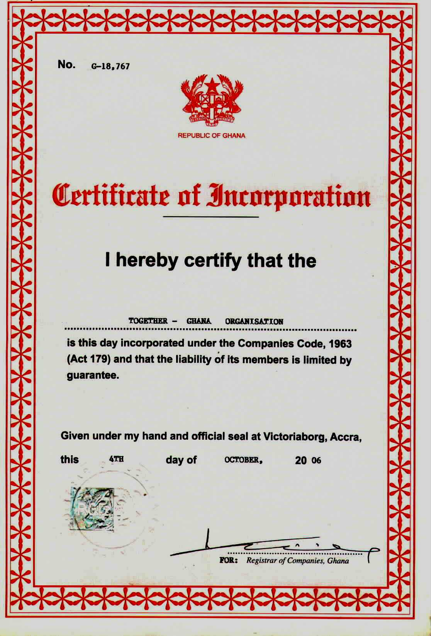

Photo-copy of Certificate Showing as a Registered NGO- Certificate of Registration Renewed in 2009- this Certificate should be renewed annually to indicate activeness.

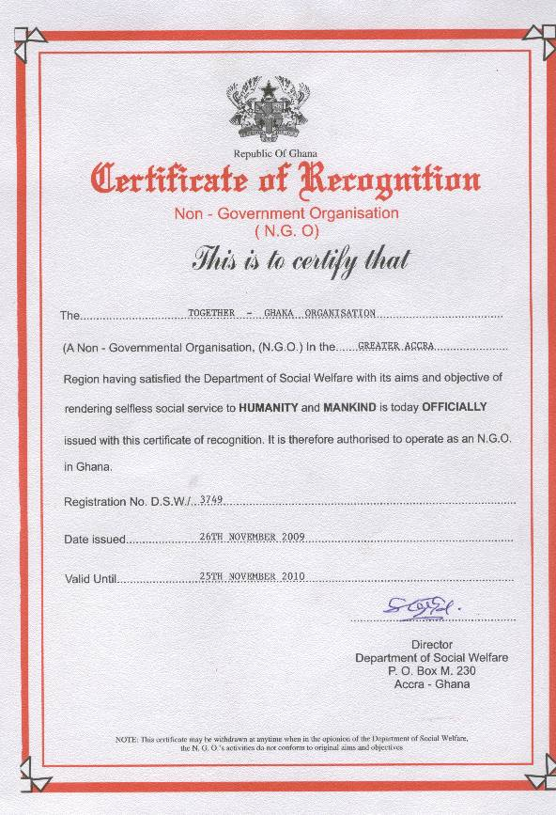

Appendix 4

(B) Names and Roles of Persons Acting in the Name of the Organization

