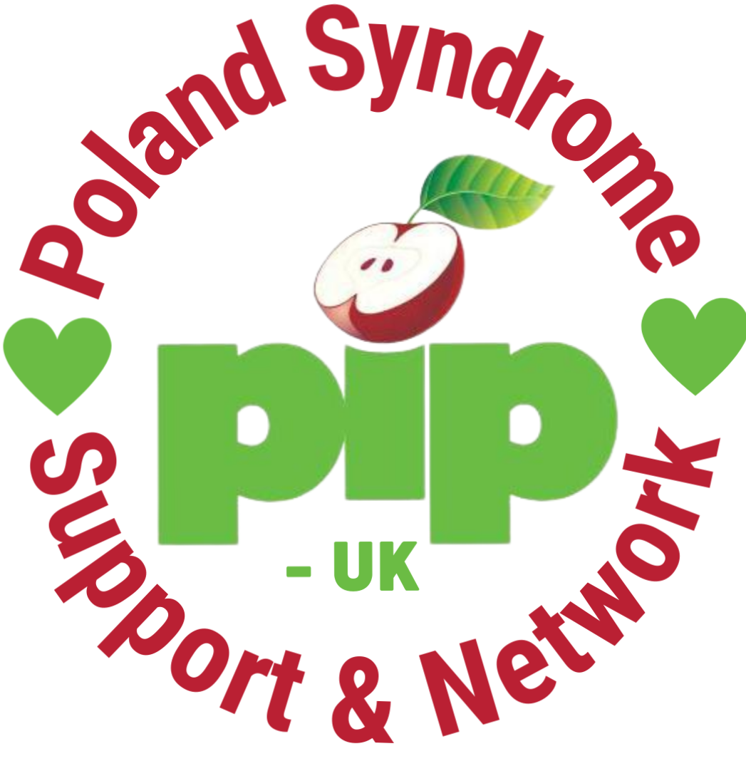

Start Here: Poland Syndrome + You
Welcome! We’re so happy you’re here.
Whether you are seeking a diagnosis, newly diagnosed, or have been living with Poland Syndrome for many years, you are very welcome here.
This guide has been created to support you — to help you find trusted information, connect with others who understand, and remind you that you are not alone. Wherever you are on your journey, there is a place for you in our community.
Here’s how you can connect, find support, and get information:

Getting a Diagnosis

The best way to get a diagnosis for Poland Syndrome is by asking your GP for a referral to a geneticist. While Poland Syndrome is not currently considered a genetic condition, a geneticist is the best specialist to perform the necessary tests and provide a full diagnosis, ruling out other conditions.

Unfortunately, our specialist clinics currently only support children. We hope in the future to expand them to adults too.

If you have faced challenges getting a referral, it can help to take a trusted friend or relative with you as an advocate. Many families in our community have experienced being turned away at first. Having someone with you can make a real difference in being heard.

If you would like us to provide a supporting letter for your GP, we are happy to help — we will just need the patient’s name and date of birth.

While You Are Waiting for Diagnosis

While you wait for your diagnosis, you are warmly invited to connect with others and learn more about Poland Syndrome:
- Read the latest medical paper from the Italian Poland Syndrome Association on treatment and diagnosis:
View the Paper
- Learn more about Poland Syndrome symptoms on the GARD website:
Poland Syndrome on GARD
- Visit our website for more information about Poland Syndrome, diagnosis, and community news:
PIP-UK Website

🌟 Stay Connected
- Membership & Newsletter Sign-Up: Hear all the latest news and events! Sign up here

- Private Facebook Group: A safe space to share experiences and ask questions. Join here
- Community Register: Help improve treatment and diagnosis by adding your story. Join here
- Ladies’ Only WhatsApp Group: We also help moderate a friendly, global WhatsApp group for women of all ages living with Poland Syndrome. To join, simply send us your mobile number and we will add you. 07708 209874 to join.
- Women's Only Facebook Group: A space led by volunteer Tamsyn. Join here

🏥 National Clinic for Poland Syndrome
There is now a dedicated clinic for children with Poland Syndrome in the UK at the Birmingham Women’s and Children’s Hospital, providing specialist care for children and young people. This is a huge step forward for early diagnosis, coordinated care, and long-term support.

More details can be found on our website: pip-uk.org

✨ Find Support

Mental Health and Emotional Support
Living with Poland Syndrome can affect not just our physical health, but also how we feel about ourselves, our bodies, and the world around us. Whatever stage you are at, it's completely normal to need a little extra support sometimes — and it’s important to know that help is available.
- We have a page full of mental health resources on our website, including links to supportive articles and organisations who understand the unique challenges of living with visible differences.
Visit here: https://pip-uk.org/poland-syndrome-mental-health-resources
- We also recommend Angel Connects — a private psychotherapist within our community who has experience supporting people with Poland Syndrome and visible differences and can meet online.
You can find out more or contact her here: https://www.angelconnects.com/
Please remember: reaching out for emotional support is a sign of strength, not weakness. You are never alone.

🧠 Trusted Medical Information
- Poland Syndrome | NIH Rare Diseases
- Consensus based recommendations for PS led by Italian PS Association

📚 Useful Resources
New Parents
- Support from Changing Faces
- Raising a child with a Limb Difference Video
- LimBbo Foundation Parents Booklets

School Resources
- Changing Faces: Teachers Guide
- Preparing for School | Changing Faces
- Reach Charity: Starting School

We can also arrange a Zoom or school visit to share more about Poland Syndrome — just ask!

🏋️‍♀️ Health and Wellbeing
Back, Neck & Shoulder Care
- Top Tip: Ask for a self-referral to a specialist physiotherapist and request a referral to an orthopaedic consultant.
- Share the trusted medical links above if your healthcare providers aren’t familiar with PS.
- Swimming, strength work, and somatic movement therapy may help as reported by many people in our community! Find a practitioner here: Clinical Somatics Directory
Protective Vests
- Great for activities like cycling or hockey: Hockey Warehouse
Physiotherapy Exercises
- View Recommended Physio Exercises

🎀 Bras and Body Confidence
- Evenly Community FB Group: Join here
- Evenly Bra Inserts (Great with Royce Bras): Check them out
- Symmetrista Bra for Asymmetry: Learn more
- Tamsyn’s Blog (Life with PS): Read here

Listen to Our Podcast: What About PS?
We know how powerful it can be to hear from people who truly understand what you're going through. That’s why we created What About PS? — a podcast by and for the Poland Syndrome community.
Each episode features honest conversations with people living with PS, covering everything from diagnosis and body image to dating, parenting, and self-acceptance. Whether you’re newly diagnosed, decades into your journey, or supporting a loved one, this is a space where you can feel seen, heard, and connected.
🎧 Listen here: https://pip-uk.org/what-about-ps

🎤 Other Helpful Resources
- Help with Bike Adaptations and more From LimbBo
- Ask Lewis (JAAQ mental health Q&A about Poland Syndrome): View here
- Volunteer with Us: Fill out the Volunteer Form
- Learn More About Poland Syndrome: PIP-UK Website

💛 Support and Spread Awareness
Did you know that every time you wear our merchandise, you're helping raise vital awareness and funds for our charity? Whether it’s a hoodie, T-shirt, or badge, your purchase directly supports the Poland Syndrome community.
🛍️ Shop here:
- F.P. Uniformz Collection
- PIP-UK Teemill Store
Every order helps us continue our mission to connect, support, and advocate for people affected by Poland Syndrome.

