Transforming Lives, Cultivating Futures"
During this quarter at Casa Hogar Remar Occidente, we have continued to strengthen our commitment to the comprehensive protection and development of girls who have been victims of, or are at risk of, human trafficking. We remain firmly convinced that every girl deserves to grow up in an environment of love, safety, and opportunity.
During this period, we reaffirmed our mission to provide emotional, educational, and developmental support to the girls in our program. Through therapeutic workshops and emotional support spaces, we continue to offer tools for healing deep wounds, focusing on rebuilding their lives with love and dignity.
One of the most significant advancements has been the introduction of new developmental workshops. This quarter, we launched a makeup workshop, aimed not only at technical skill-building, but also at strengthening self-esteem, self-awareness, and self-expression. For many of them, it has become a space for personal exploration, allowing them to reconnect with their identity and rebuild their self-image in a positive way.
.

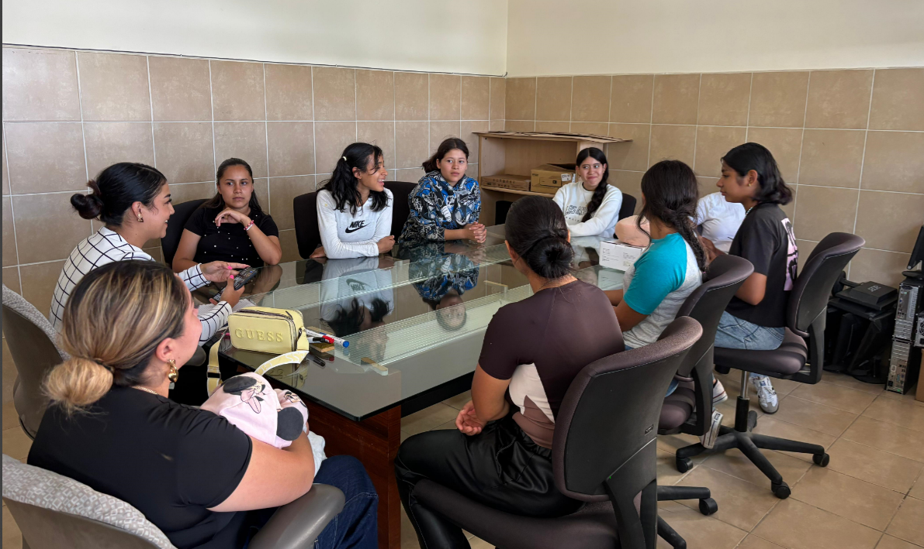

We also began creating a community garden, a project that has sparked great enthusiasm. This garden is not only an educational and therapeutic tool but also an emotional refuge: a living space that the girls learn to care for, observe, and nurture—just like themselves. The shared responsibility of maintaining it strengthens values such as commitment, teamwork, and a sense of belonging.

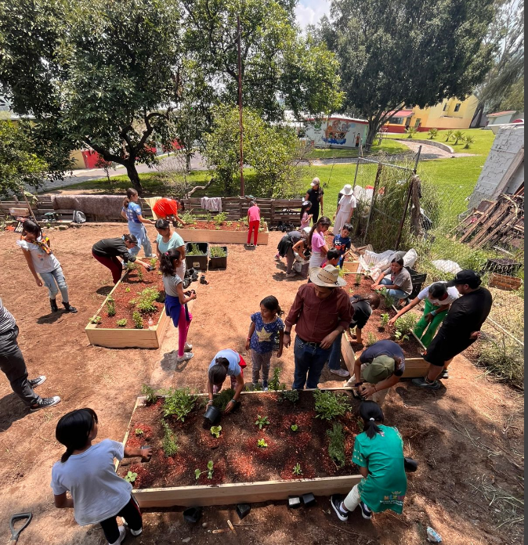

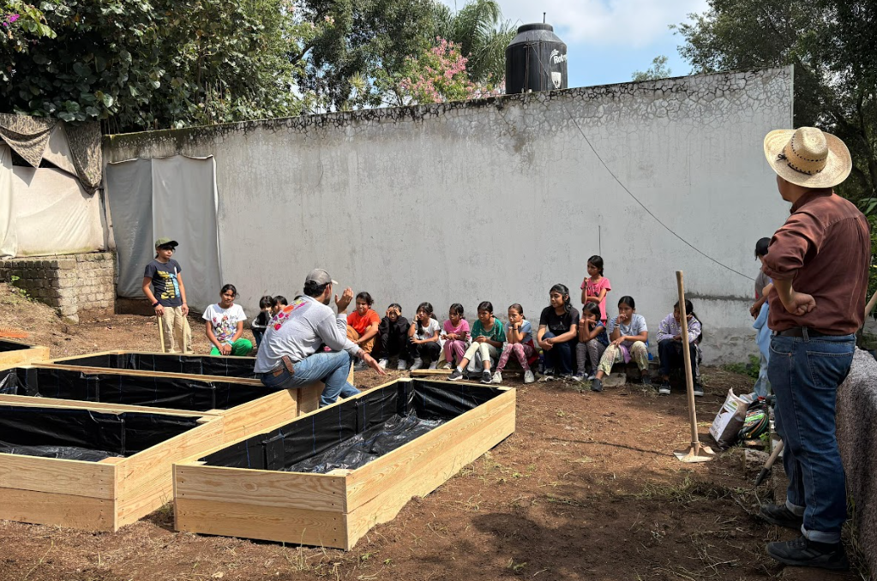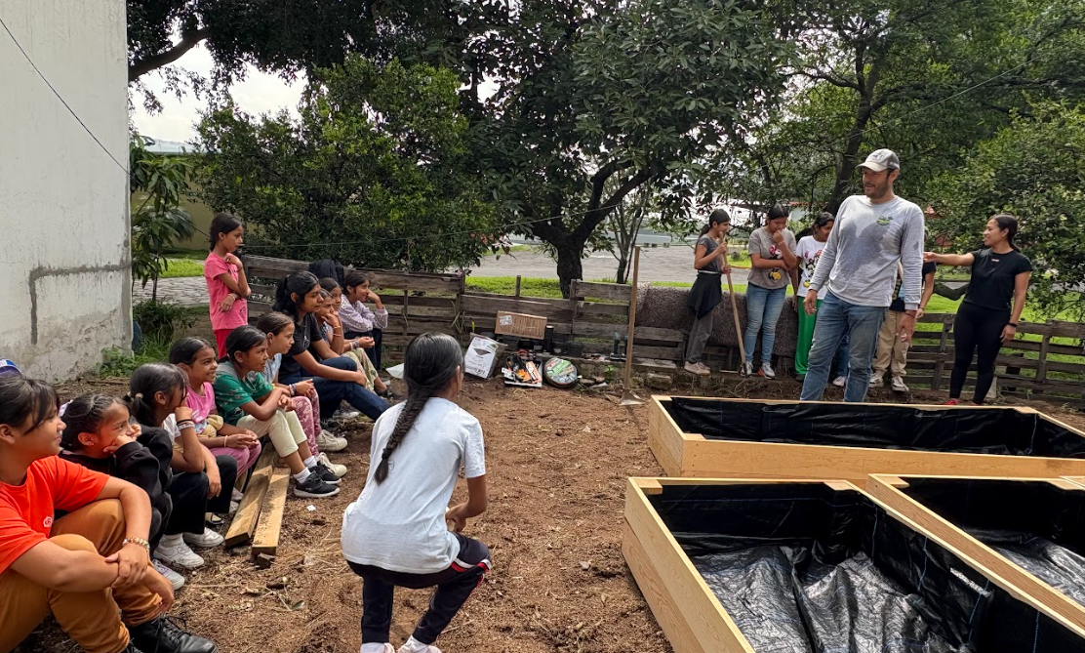

At the same time, we continue to run our psychological workshops, with both individual and group sessions, which remain the cornerstone of our support process. Through these sessions, we work on emotional regulation, strengthening resilience, and addressing past trauma, with special attention to each girl's personal history.
In the educational area, efforts remain focused on ensuring access to schooling and academic continuity. We adapt the learning processes to the specific needs of each beneficiary, promoting life skills, conscious decision-making, and the construction of life projects free from violence.
Every step we take is guided by the desire to see them flourish—to help them find their voice and build a hopeful future.
We deeply thank all the individuals, institutions, and partners who believe in our cause and allow us to continue. Thank you for walking with us on this path of transformation.
Together, we continue sowing hope, rebuilding lives, and fighting for a childhood free from trafficking, violence, and neglect.

