“From Refuge, Towards Freedom”.
During this quarter, we continued to work with firmness and commitment to transform the lives of the girls who are part of our children's home and the Program for the Protection of Children against Human Trafficking. Our approach continues to be comprehensive, placing the children at the center as active subjects of rights and protagonists of their own development.
We continue to strengthen our commitment to the protection and integral development of the girls and adolescents who are part of our program. Our mission remains clear: to offer a safe, formative and hopeful alternative to the risks of harmful practices.
We have reinforced the psychological workshops, where our beneficiaries receive professional individual and group accompaniment, focused on strengthening their self-esteem, emotional management, resilience and overcoming traumas. This accompaniment has been fundamental for their emotional and social integration, especially in cases where the girls have been victims of violence or exploitation.
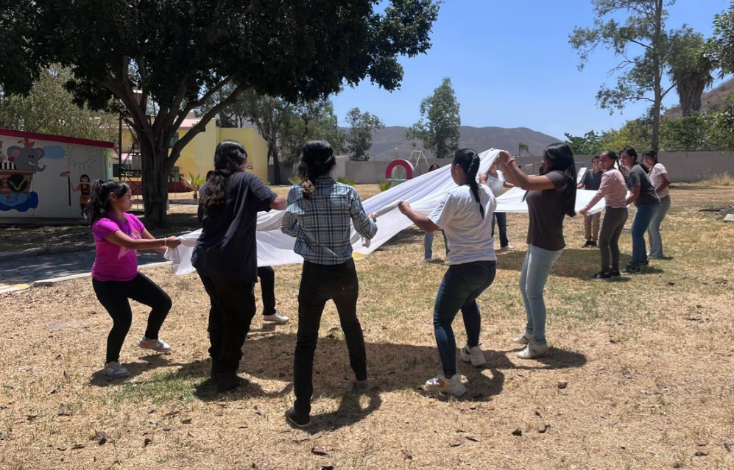
In the area of education, we continue to promote access to literacy, basic education and continuing education, adapted to the needs of each girl, promoting not only the recovery of knowledge, but also the motivation to continue their academic training. We have also initiated new activities focused on life skills and job training, with an emphasis on female empowerment, decision-making and risk prevention.

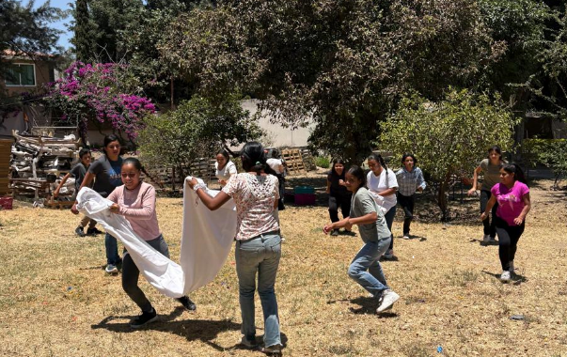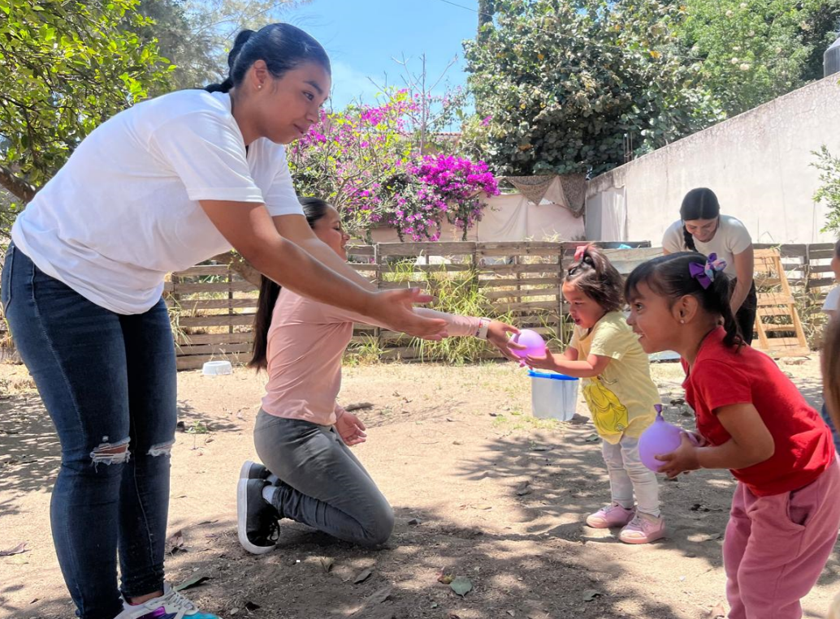

We have observed notable progress in the participation of girls in the spaces for reflection and artistic expression, which has allowed us to create an environment of trust, creativity and positive coexistence.
The needs are many, but the response of our girls to the opportunities motivates us to move forward.
We reiterate our commitment to offer them a safe, respectful and transformative environment, where every girl can imagine and build a different future, free from violence, exploitation and discrimination.
We are deeply grateful to all our allies, donors and collaborators for their trust and constant support. Together, we are sowing hope and building a more just country for our children.
This progress would not be possible without the support of our partners, donors and collaborators. Thank you for your support.

