AWARENESS AND SENSITIVITY

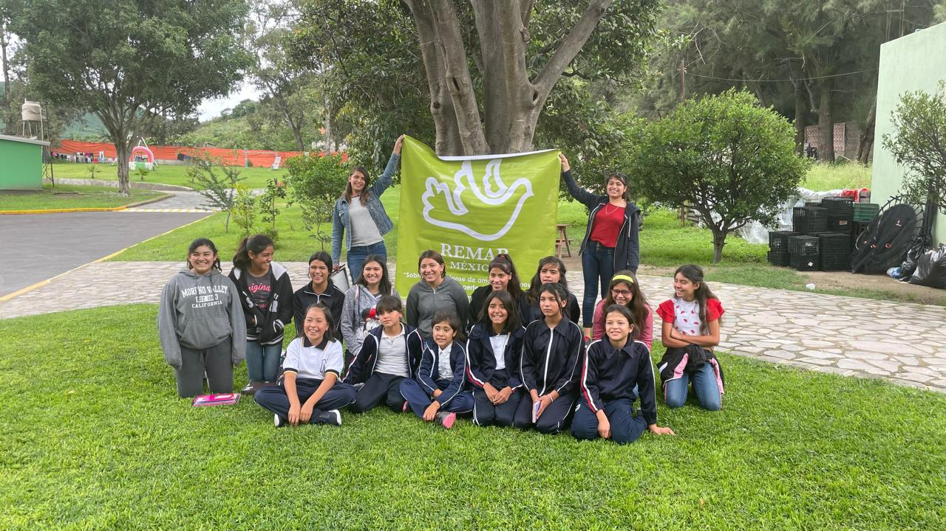

Over the years of working directly with vulnerable populations, especially whit girls, boys and adolescents in situations of risk, physical and sexual abuse, etc. We have noticed how they have normalized their abuse, coming to think that these practices are natural and without being aware that they are actually victims, so these patterns of abuse are constantly repeated and passed from parents to children; for us it has been very important to emphasize the awareness of our beneficiaries, through workshops, campaigns and educational programs that include training in values ​​and life skills.

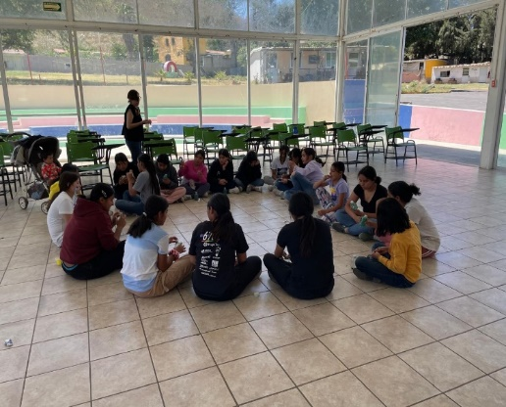

During this last quarter, Remar Occidente has provided support to:
- 75 Girls, Boys, Adolescents, Teenage Mothers and Migrant Minors, offering them decent spaces, covering their basic needs of food, clothing, health, education, recreation, etc.
- 30 hours of group counseling on values, self-help and resilience.
- 30 hours of workshops on emotional management and socialization
- 2 workshops on sexual education and health
- 180 hours of educational support for academic regularization
- 10 hours of sewing workshops and 10 hours of manual workshops for skills training
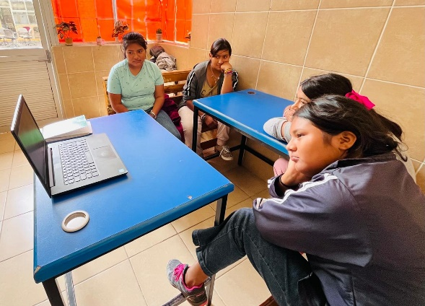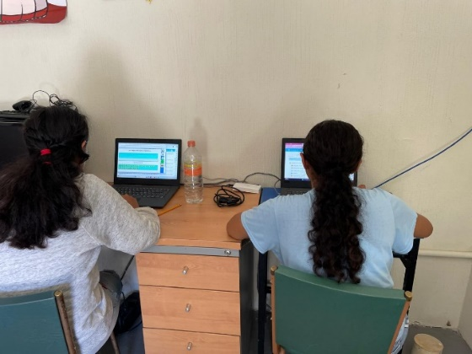

At Remar we are firmly committed to the comprehensive development of our beneficiaries, which is why we are grateful for the support we receive every day and that allows us to continue moving forward.

