Samrakshak Samuha Nepal
ANNUAL REPORT 2010-2011



CONTENT
INTRODUCTION 2
OUR PROGRAMS 2
RESCUE 2
CAPACITY BUILDING PROGRAMS 2
PARALEGAL TRAINING 2
ADVANCED PARALEGAL TRAINING 2
MEDIA TRAINING 2
ENGLISH SKILLS TRAINING 2
COMPUTER SKILLS TRAINING 2
PARALEGAL ACTIVITIES 2
PSYCHO-SOCIAL COUNSELLING 2
LEGAL COUNSELLING 2
DATA COLLECTING 2
COURT PROCEDURES 2
PARALEGAL CROSS BORDER MONITORING 2
POLICY & ADVOCACY 2
RESEARCH 2
FINANCIAL REPORT 2
CONTACT INFORMATION 2
THANK YOU 2

INTRODUCTION
”We have faced the real causes of trafficking.
We were the real victims of the crime.
We were the persons to be rescued.
We are still subordinated and our fundamental rights are violated.
We are the persons who need counselling and rehabilitation
We are the persons who need to be reintegrated
We are human beings that can take lessons from our past incidents.
We are eager to shun our dark past at the hope of a brighter future.
We need environment where we can transform ourselves.
If we get the environment we would be an asset for the society rather than a liability.
Only we can support ourselves.
And we have the motto-
Let's protect ourselves!”

SASANE was established in 2008 by former female victims of human trafficking on the principle that survivors can create social change. SASANE has adopted a rights-based approach to address the conditions facilitating the recent increase in human trafficking and the explosive growth of Nepal’s night entertainment sector. SASANE’s innovative strategy of social change consults with and engages trafficking survivors in anti-trafficking activities to simultaneously break cycle of exploitation of women transform the lives of other victims and tackle systemic inequality, exploitation, and injustice.

VISION
We believe that every human trafficking survivor can achieve her individual dream and potential. We envision a Nepal where each survivor is equipped with the self-esteem, skills, and knowledge necessary to become a leader in her chosen field
MISSION
SASANE’s mission is to end the physical and sexual exploitation of women and girls, ensure their legal rights, and empower them to live free and dignified lives.

SASANE’S LEGAL STATUS
- Date of Registration: 2064/12/17/1
- Registration Number: 1019 /2064
- Place of Registration: District Administration Office, Kathmandu, Nepal
- Affiliation: Social welfare council, Nepal

OBJECTIVES
The objectives of SASANE are as follows:
- To provide legal counselling to victims of gender based violence to end physical exploitation and unethical sexual inflictions against women and children at their workplace.
- To work with other concerned entities to end physical exploitation, violence and unethical sexual inflictions upon women, and children that occurs in the name of tradition. customs and religion.
- To work other concerned entities to end the engagement of women and children in unethical, vulgar and any risky activities or prostitution or any activities using fear, intimidation, or undue influence.
- To discourage trafficking of women and children in name of domestic and foreign employment, or opportunities, exploitation of women and children for labour, sex, illegal transaction of human organs, and enslavement.
- To identify and monitor exploitation and trafficking routes, areas and borders, and rescue women and children in those areas.
- To provide consultation, social awareness and education to women and children of the exploitation and trafficking of women and children in order to prevent additional exploitation and trafficking.
- To collaborate with other concerned entities to protect the health rights of women and children by providing information about sexual diseases and prevention and treatment.
- To carryout programs to rehabilitate victims physically, emotionally and financially.
- To mediate disputes of defamation, physical assault and civil and criminal offenses caused by caste and gender-based discrimination.
- To increase public awareness of human sex-trafficking by studying and researching prostitution, sex-trade, human trafficking, effect of drug abuse, sale of human organs and physical and psychological disease and their effects caused by physical and psychological exploitation, violence, coercion and undue influence inflicted on women and children.

OUR PROGRAMS

RESCUE
SASANE is provides help and support to victims in 25 police stations within Kathmandu Valley and at border stations at the Nepal/Indian border. Our paralegals have a history of abuse and have a great understanding of the issues. Together with the police, our paralegals can detect potential victims and identify criminals. If a woman or a girl is found experiencing any kind of abuse a rescue process is organized with the help of police personnel and staff from the SASANE’s central office.
In 2010 SASANE established for women. Voice of Women Survivor (VoWS), a network that coordinates 13 organizations. Together with this network SASANE coordinates rescue and rehabilitation activities for women who experience abuse.
In the fiscal year 2010\11 SASANE have rescued 1,404 women and girls from the Kathmandu Valley, Rupandehi, Morang and Jhapa.
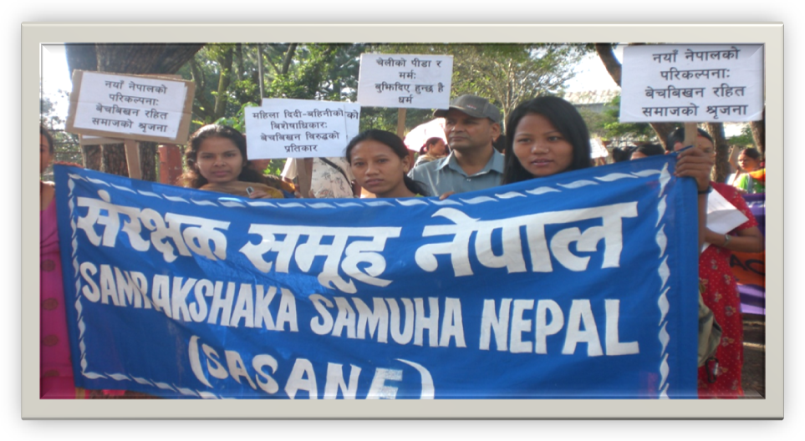

Escaping poverty
Due to poverty and domestic violence many women are forced into the sex industry and sell their bodies in Kathmandu’s dance bars, dohori restaurant, massage parlours and cabin restaurants.
One of those women is Jahindra (name changed), originally from Chitwan. “My father was a drunkard. My father used to regularly beat my mother. My mother was a strong woman, though and she got me an education. My father decided to marry me off with a 36 years old man when I was 16 years.” she expresses her grief. The marriage turned out to be a living hell for Jahindra as her husband abused her sexually every day. After one year of her marriage she couldn´t stand the abuse anymore and ran away from her husband’s home. Her father scolded her and refused to shelter for her. Jahindra had no other option than to leave her village, where she had been living her hole life and join the crowd of people looking for a better future in Kathmandu.
“To overcome my hunger, I started working in the dance bar of Balaju. explains Jahindra, Everything should be provided to the customer as they like and when we denied to do so, they abused us and threatened us to throw us out on the streets” Jahindra explains that she tolerated the abuse in fear of not being able to find another job. She needed the money to be able to stay alive. Jahindra came in contact with one of SASANE's paralegals who told her about SASANE´s paralegal training, another option for vulnerable women and girls to make a living without sexual exploitation. Jahindra attended an interview for the training and was selected for SASANE's paralegal training. After seven months of training Jahindra passed the exam with excellent grades and is a certified paralegal. Now Jahindra works at one of the police stations in Kathmandu where she´s able to gain a sustainable income and support other female victims.

CAPACITY BUILDING PROGRAMS

PARALEGAL TRAINING
The only ones who can know what a woman suffers from abuse survivors themselves. For a Nepali woman, filing a complaint against a trafficker or an abuser is too often a traumatic experience that leads to re‐victimization. Because of gender‐discrimination, patriarchal norms, and male‐domination within the legal system, women are frequently blamed or ignored by law enforcement agents. By training survivors to become paralegals, SASANE has set out to stop these injustices. Today, SASANE members work at 25 police stations, providing justice and compassion to victims and achieving positive change in the legal system and greater society.
SASANE's paralegal program started in 2008 and from its start SASANE has provided over 100 women with paralegal training. The women who attend the course are women who have experienced trafficking or are in risk of being trafficked. The selection to the program is based on interest, interview and S.L.C results. The paralegal program consists of both theoretical and practical tuition.
- Theoretical Classes :
The theoretical classes includes lessons in; Fundamental Right of the Constitution, Declaration of Human Rights, Declaration on the Women Convention, CIDA and Human Trafficking Act, Foreign Employment Act, Domestic Violence Act, Law Enforcement Procedure on Law Enforcement Agency, Police Jurisdiction and District Administration Office and the Court Procedure.
- Practical Courses :
After receiving one month of theoretical tuition it is time for the paralegals to put theory into practise. In collaboration with the police SASANE's paralegal students deal with real life cases in police stations around the Kathmandu Valley. The students are learning by doing and are supervised and supported by certified paralegals from the SASANE office.
- Paralegal Examination :
After the seventh month of training the paralegal students attend a paralegal exam in the District Court, Kathmandu. The students who pass are provided with the completion of a paralegal certificate and can begin their new profession as certified paralegals.
28 paralegal students out of 32 participants passed the paralegal examination and received a paralegal certificate in the fiscal year of 2010/2011.
.

ADVANCED PARALEGAL TRAINING
The advanced paralegal training is provided to paralegals that have passed the exam and have an interest in working in court. The training incorporates courses in Women’s Empowerment, Public Speaking, Nepalese Legal System, Nepalese Court Procedure, National Women Commission Jurisdiction, National Human Right Committee Activities, Women Rights, Gender Rights, Equality and Equity, Paralegal Code of Conduct, District and Appellate Court Jurisdiction and Court Act and Regulation and the Women Based Crime Related Law.
In the fiscal year 2010/11, SASANE provided Advanced Paralegal Training to 20 paralegals.

MEDIA TRAINING
The Nepali society can be very judgemental against a woman that has suffered from abuse and by publishing news about women’s experience SASANE creates a platform for discussion. Women who experience abuse also become aware that they are not alone and can find strength in the knowledge. From the start of the media training program 28 news articles have been published in one of Nepal´s leading newspaper.
In 2010/2011 SASANE collaborated with media professionals and arranged one month of media training for the female survivors. The objectives of media trainings are to provide the survivors with skills for future employment and to raise public awareness of violations against women. Learning media skills and getting published in Nepal’s leading newspapers strengthens the survivor’s beliefs in themselves. The writing process is also a therapeutic process of healing where survivors can explore their problems and find solutions by themselves.
Through coaching from professional paralegals, role playing and rehearsals the survivors also learn how to handle with inquiries from media professionals who want interviews.

In the fiscal year 2010/11 SASANE’s media trained paralegals provided 7 news articles to one of Nepal´s leading newspapers, The Annapurna Daily.

Similar is the Situation of Girls Trafficking
Two Nepali girls, both recently rescued from brothels in India, discussed the greed that caused them to be trafficked. "In the desire of getting enough money, people do not recognize one’s own or the other. People are just running after it. The one that we trust only creates a doomsday for us. We are not even able to trust ourselves."
Following the death of her husband and therefore the loss of her economic security, Sabina Nepali (name changed) of Lagankhel began to sell vegetables on the street in Lalitpur. A distant family relation began visiting her regularly. One day, the distant relative and his two friends, Rajkumar and Sagar, took her on a bus and sold her in G.B. Road, no. 64, brothel of Delhi, India on Jestha 2066. Sabina was able to escape back to Nepal with the help of one Nepali after she was tortured for seven days in the brothel. Sabina explains, "I have complained about it to the police in Sorakhutte, but I am worried how I will be able to solve me and my son’s needs!"
Tulbahadur of Dhading spared no expense in wooing Sharmila, and Sharmila, completely in love, thinking of him as a God, happily married Tulbahadur. Upon marriage, Sharmila came to know that her husband was instead a devil. "My husband with his other 5 friends together sold me for 70 thousand rupees in Pune, India. I was able to return back to Nepal after one month of torture and abuse there. I have no one. I am doing labour work now" says Sharmila.
Our Government does not have any statistics of how many women and children get sold in India annually. The government does not know whether trafficking is increasing or decreasing. The Supreme Court’s annual report 2064/65 shows 265 cases of trafficking are in process at the District Courts. However, this statistic grossly underestimates statistic studies performed by numerous NGOs and international governments. For example, the American Government estimates that about 10-15 thousand girls are trafficked annually in Nepal.
Even though Nepal law punishes convicted human traffickers with 20 years imprisonment and the sum equal to the money that they receive through the selling as compensation, it fails to dissuade human traffickers. The increasing instance of human trafficking begs the question, "why is human trafficking of girls increasing in Nepal?”Because of the increasing expense to live in Nepal, the migration into the larger cities, competitive nature amongst Nepalese, and too much influence from the West, people forgot about village life and cannot make their livelihood from the salaries and tips received from customers in the service industry" states Shyam Pokharel, currently researching the reasons why human trafficking is increasing in Nepal. "Because of these reasons, the human traffickers then start the illegal work of prostitution, sex activities, drug peddling, girls trafficking", adds Pokharel.
Manamaya Gurung, SASANE Paralegal
27 August 2010
Sangee Annapurna Daily

ENGLISH SKILLS TRAINING
For the purpose of sharing news and real life stories regarding human trafficking in Nepal with the international platform, English classes have been provided to the paralegals. English is also a necessity for the paralegals to be able to compete on the job market. The classes are focused on a variety of topics, where job searching, writing news articles and performing interviews are only a few. After the English course the paralegals gain sound knowledge of reading, writing and speaking English. The English course has been possible with the help from international volunteers experienced in teaching.
In 2010/2011 SASANE provided 50 hours of intensive English training to the paralegals.

COMPUTER SKILLS TRAINING
With the involvement of foreign volunteers we have been providing computer training to the survivors. 3 month basic computer training is received by all paralegals and 1 month advanced training is received by the paralegals working within the SASANE head office. The basic computer training consists of learning how to use internet and write documents. The advanced computer training furthers the paralegals knowledge and provides them with skills in power point presentations and excel.
In 2010/2011 SASANE provided basic computer training to 30 female survivors and advanced computer training to 10 survivors.

PARALEGAL ACTIVITIES
SASANE has paralegals working at 25 police stations around the Kathmandu Valley and at three border stations at the Nepali-Indian border. Since the start SASANE´s paralegals have filed 7056 complaints and First Information Report “F.I.R”s regarding women and 576 complaints and F.I.R´s concerning children. The major paralegal activities are psycho-social counselling, legal counselling including filing complaints and F.I.R, data collecting and court procedures.

PSYCHO-SOCIAL COUNSELLING
Talking about the experience of abuse is often the best way to heal, although it may be the hardest part to do. Feelings of guilt, shame, anger and fear are feelings often experienced by victims. SASANE's paralegals have been receiving training in how to counsel and support victims in an acute state and the during the reintegration process.
In the fiscal year 2010/11 we have provided psycho-social counselling to 3312 women in Kathmandu Valley, Rupandehi, Morang and Jhapa.

LEGAL COUNSELLING
For a Nepali woman, filing a complaint against a trafficker or an abuser is too often a traumatic experience that leads to re-victimization. Because of gender discrimination, patriarchal norms, and male domination within the legal system, women are frequently blamed or ignored by law enforcement agents. SASANE's paralegals provide legal counselling to victims and their close ones. The legal counselling includes information about the legal process, timeframe and possible outcomes of the measurements taken. The counselling also includes information about what police or court personnel might expect from the victim. With the help of this counselling the victim gets adequate information on how to proceed. SASANE’s paralegals help the victims to file complaints and F.I.R’s (Jaheri).
SASANE also provide legal counselling to other organisations that are working with violence against women.
In the fiscal year 2010/11 we have provided legal counselling in 3192 cases in Kathmandu Valley, Rupandehi, Morang and Jhapa.
SASANE’s paralegals filed 276 F.I.R (jaheri) and complaint applications in human trafficking, sexual harassment, domestic violence, illegal foreign employment and missing women and children in the Kathmandu Valley, Rupandehi, Morang and Jhapa

DATA COLLECTING
The data of both F.I.R’s and complaints are collected by the paralegals and provided to SASANE’s monitoring officers every week. The age, caste, family background, type of crime, how the crime happened, the culprit involved, where the crime took place, information about the perpetrator and other relevant information is collected and compiled. The collected data is a source for reference for SASANE’s, as well as partner organizations research and work.

COURT PROCEDUERS
The paralegals who have received the Advanced Paralegal Training can, when needed, provide support and assist the victims during court procedures. Before working with court procedures the paralegals make planned visits and observe the court activities to gain as much knowledge as possible before taking on a real life case. During these visits the paralegals are accompanied by paralegals who are already working with court cases. The purpose of the paralegals during court procedures are to explain legal terms, brief the judge’s decision and also function as a psycho-social support.
In 2010/2011 SASANE has brought out 20 paralegals who are working directly on the court in the Kathmandu Valley.

PARALEGAL CROSS BORDER MONITORING
Various kind of human trafficking cases are found in the border areas between India –Nepal and Nepal-China. SASANE has cross border paralegal services in Bhairahawa, (Rupandehi), Biratnagar (Morang), Kakarbitta and Bhadrapur (Jhapa). The cross border paralegals check for suspicious vehicles and in collaboration with the police they identify traffickers and potential victims. The paralegals make the victims aware of their legal rights and brief them about the Human Trafficking Control Act 2007, Human Trafficking Control Regulation Act and the Foreign Employment Regulation Act and Civil Law of Nepal (Muluki Ain).
F.I.R’s and complaints regarding Human Trafficking filed in:
Rupandehi: 11
Morang: 8
Jhapa: 18
176 victims of trafficking were reunited with their families.

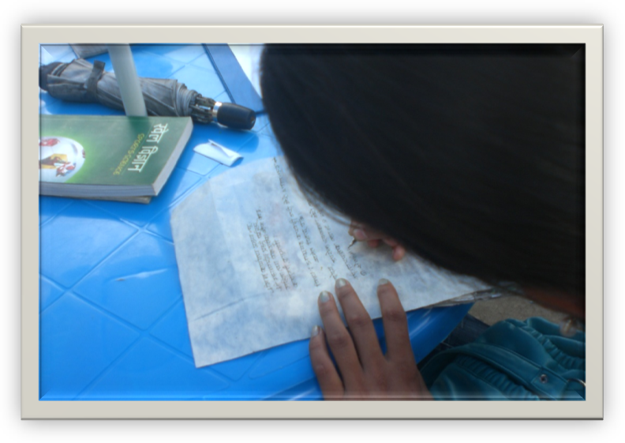

Total numbers of complaints and F.I.R’s (Jaheris) filed at SASANE´s cross border stations and at Kathmandu police stations.

Abduction (male & female): 6
Domestic Violence: 70
Human Trafficking: 37
Illegal Foreign Employment: 9
Missing Person: 68
Polygamy: 43
Rape: 8
Theft, forgery, missing passports: 1302

Total: 1543

POLICY & ADVOCACY
Despite improvements in the law, Nepal’s legal system continues to discriminate against women, both in legal code and through enforcement practices. SASANE believes that through raising awareness amongst the public and training law enforcement agencies we can strengthen the anti-human trafficking movement. SASANE is working diligently to advocate for change within the legal system and to provide legal support to victims of trafficking and sexual exploitation. In the past one of SASANE´s major achievements was to survey 100 elected members of Constituent Assembly in order to prepare recommendations to Constituent Assembly on practices of violence against women in members’ constituencies. SASANE also collaborated with Alliance Against Trafficking of Women In Nepal (AATWIN), with presenting a memorandum to chairpersons of the Constituent Assembly and Constitutional Committee calling for the constitution to ban sexual slavery.
In the fiscal year of 2010/2011 SASANE’s major policy and advocacy activities have been the following:
- SASANE organized a one day interaction program with the Law Enforcement District Agencies (police, attorneys, judge, district administration personnel’s, bar association lawyers, women development officers, local development officer, district level organizations working under anti human trafficking, communities doing cross border monitoring, Indian-Uttar Pradesh cross border monitoring police officers, Manav Sewa Samag working under human trafficking in India, Indian railway police) altogether 100 workers on the topic “Human Trafficking in the name of Foreign Employment Prevention Methods and Legal Interaction” in Rupandehi, Bhairawaha (August 22, 2010).

- SASANE organized a one day interaction program with the Law Enforcement District Agencies (police, attorneys, judge, district administration personnel’s, bar association lawyers, women development officers, local development officer, district level organizations working under anti human trafficking, communities doing cross border monitoring, Indian –Bihar cross border monitoring police officers, Manav Sewa Samag working under human trafficking in India, Indian railway police) altogether 100 workers on the topic “Human Trafficking in the name of Foreign Employment Prevention Methods and Legal Interaction” in Biratnagar, Morang (September 1, 2010).

- 100 participants from the Law Enforcement District Agencies (police, attorneys, judge, district administration personnel’s, bar association lawyers, women development officers, local development officer, district level organizations working under anti human trafficking, communities doing cross border monitoring, Indian –Bengal cross border monitoring police officers, Manav Sewa Samag working under human trafficking in India, Indian railway police), joined SASANE’s one day interaction program on the topic “Human Trafficking in the name of Foreign Employment Prevention Methods and Legal Interaction” in Bhadrapur, Jhapa (September 4, 2010).

- SASANE also carried out another interaction program related to the above mentioned topics in the invitation of ‘Mahila Ko Nimti Mahila Manch’ which is established and run by the women workers of night entertainment sectors. The main objective of the interaction program was to discuss about the below mentioned topics:

- Police behaviour is to criminalize women rather than the employers: arrest and humiliate women, ask for bribes, inducing a cycle of indebtedness

- District Committee and police do not understand, are not prioritizing, and are not implementing the Supreme Court Directives

- Women in the Entertainment Industry are unaware of legal rights, lack access to legal counselling; a shortage of specialized legal counselling services exists and organizations are hesitant to tackle casework. (February 18, 2011)

- Together with Free the Slaves and Livelihood Forestry Program in Dang District, SASANE organized a 5 hour interaction program in Gairigaun V.D.C, Tilabazaar, Dang with the 22 supervisors from 22 different V.D.C in the topic the situation of sexual slavery in Nepal and its preventive measures and its relation with human trafficking and foreign employment. This is considered to be one of the great programs organized in the remote area of Nepal by SASANE. (April 17, 2011)

- SASANE with Poverty Alleviation Fund – Sindhupalchowk, GMSP, Free the Slaves organized a one day interaction program in Chautara, Sindhupalchowk, with 33 facilitator of 33 different V.D.C of the Poverty Alleviation Fund on the topic foreign employment, child labour, human trafficking, illegal migration and sexual slavery in Nepal. (June 14, 2011)

- SASANE organized a 4 hour interaction program in Nuwakot with the Law Enforcement District Agencies (police, attorneys, judge, district administration personnel, bar association lawyers, women development officers, local development officer, district level organizations working under anti human trafficking, communities on the topic “Human Trafficking in the name of Foreign Employment Prevention Methods and Legal Interaction”. Altogether, 20 participations. (July 5, 2011)

- SASANE organized a 4 hour interaction program in Dunche, Rasuwa with the Law Enforcement District Agencies (police, attorneys, judge, district administration personnel, bar association lawyers, women development officers, local development officer, district level organizations working under anti human trafficking, communities on the topic “Human Trafficking in the name of Foreign Employment Prevention Methods and Legal Interaction”. 18 people from various law enforcement agencies participated in the program. (July 7, 2011)

In 2010/2011 SASANE held interaction programs with over 400 participants, covering members from the entertainment industry to law enforcement agencies.

RESEARCH
Nepal faces a severe shortage of reliable research and data regarding women’s livelihoods, human trafficking, the internal sex industry, and foreign employment. Without trustworthy and up‐to‐date research, stakeholders cannot accurately determine who Nepal’s most vulnerable women are or how to implement the best programs and interventions. Furthermore, comprehensive investigations are crucial to evaluating the enforcement of laws intended to protect women from trafficking and exploitation. SASANE is working to fill this glaring gap in knowledge by conducting major research and educating key actors on our findings.
SASANE staffs are currently undertaking an extensive investigation of emerging trends in the human trafficking of and foreign employment abuses against Nepalese women. The quantifiable survey covers areas such as demographic and socio‐economic trends, domestic violence and home environments, broker operations, transportation routes, experiences while in exploitative labour conditions, and repatriation and reintegration. The survey also investigates women’s experiences filing complaints with the authorities and evaluates the implementation of the Human Trafficking and Transportation Control Act of 2007 and the Foreign Employment Act of 2007. After the report’s publication in 2011, SASANE will lead national and regional conferences to facilitate a discussion of the findings and encourage collaboration among stakeholders.

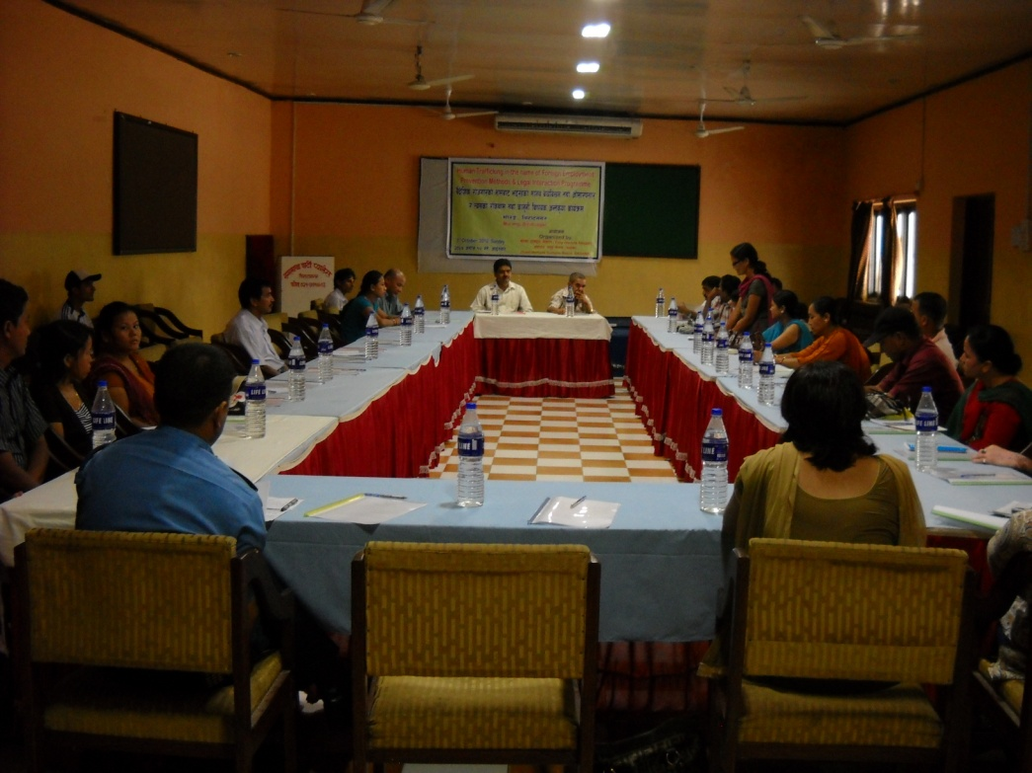

FINANCIAL REPORT

Income´s & Expenditure´s in the fiscal year 2010/2011

S. No. | Expenditure | Amount Rs | S. No. | Income | Amount Rs
1  2  3  4  5  6  7  8  9  10 | Cross Border Paralegal Service; Rupandehi, Jhapa, Morang  Monitoring and Legal interaction program in; Bhairahawa, Biratnagar. Jhapa.  Research: Return & Reintegration  Paralegal Program  Study Observation; Nuwakot, Rasuwa, Sindhupalchok  Public Speaking Training  Rent  Administration  Bank Balance  Cash Balance | 336,000  225,000  420,000  784,000  15,000  33,000  84,000  98,600  128,000  2,000 | 1  2  3  4  5  6  7  8 | Tiny Hands Nepal  Global Giving  Global Fund for Women  Private Donor  Mid Sweden University  Private Donor Research  Private loan  Last year cash & bank balance | 357,000  280,000  630,000  67,000  22,540  420,000  337,915  11,200
 | Total | 2, 125,655 |  | Total | 2,125,655

CONTACT INFORMATION
SASANE Head Office
Dili Bazaar, Kathmandu
Phone: (977-1) 2291341
Email: sasanepal@gmail.com
Website: www.sasane.org.np

THANK YOU
To all our donors and partners, thank you for your support in 2010/2011.
Tiny Hands Nepal
Global Funds for Women
Captive Daughters
Mid Sweden University
& all the private donors

We are looking forward to continue working with you to terminate human trafficking.

