**ANNUAL REPORT 2022**

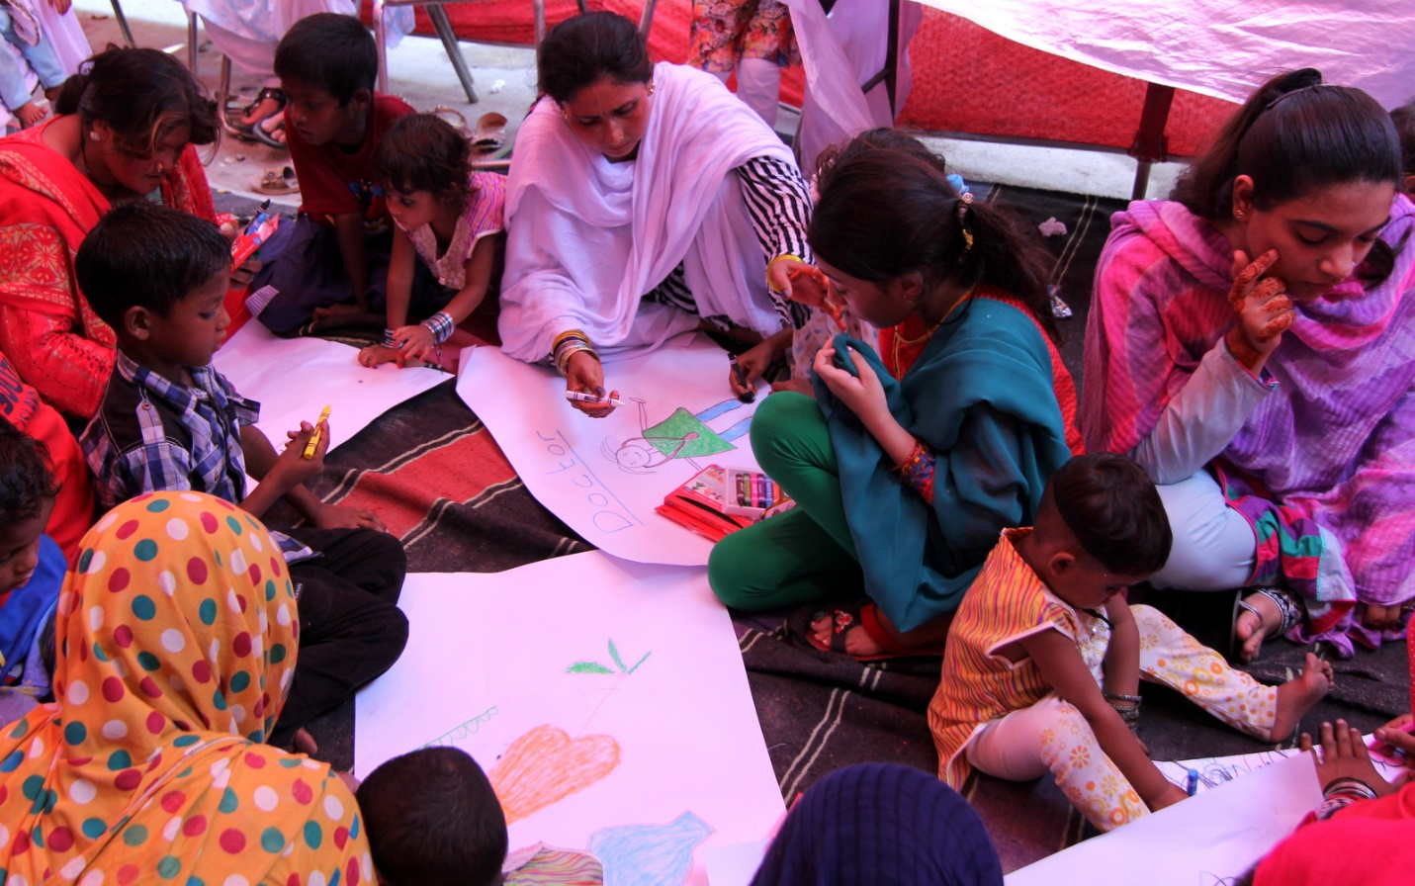

**MUWAKHAT FOUNDATION**

_____________________________________________________________

**Central Office:** House# 46 C Block A-1, Board Of Revenue Society, Lahore Pakistan

Tel: 92-042-35167560 Email: [**info@muwakhat.org**](mailto:info@muwakhat.org) URL: [www.muwakhat.org](http://www.muwakhat.org)

**Muwakhat talks**

We proudly share the achievement of Muwakhat Foundation for the poor community, especially women, girls and children with the purpose of lasting change and it became possible with collective action of members, board, management and non members who care about community’s development.

Last year, management, board members and feedback of community primarily focused on consolidation of program to make sustainable organization to serve on long term for help to break poverty trap, come out from isolated environment to integrated system and bring lasting prosperity in life of poor households.

After improved financial health of the organization by transferring soft loans of members and non members to donation with objective to adjust all cumulative losses, management and board members focused on building a positive image of organization. It is a three years strategy for sustaining organization.

This year new members joined the board and old members resigned after completion of three years. Muwakhat Foundation thanks all members who added values through their expertise during their period. New chairperson has vast experience of microfinance, adult literacy and health which is aligning with current programs of organization and her vision to take it to the next level.

Another achievement, Muwakhat Foundation got three badges from GlobalGiving (international online fundraising organization).

Demonstrated high level of engagement with GlobalGiving and got ranked 682 out of 5,496 non profit partners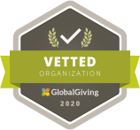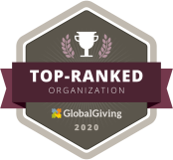

Global Giving vetted by rigorous due diligence process

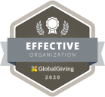GlobalGiving recognized Muwakhat Foundation on efforts to learn, improve and grow impact

During six years of operations, our primary focus is to improve the quality of life of vulnerable groups, especially women, children and old citizens and offer services with a holistic approach. It includes food, health, education, interest free loan, qard-e-hasna.

The Muwakhat Foundation has begun free legal aid services for women in Multan and Lahore cities with support of SJ Law Firm. In addition, various awareness sessions conducted on basic law and in 24 months, 625 women and girls were benefit.

Chairperson

OUTCOMES & IMPACT

|  |  |  |
| --- | --- | --- |
| **Grants & Donations**  Rs 11.61m | **Food packages to homeless**  # : 23,586  Value : Rs 85 m | **Clothes distributed to street children**  # : 3,700  Value : Rs 2.98 m |
| **Promoting Girls Education**:  awareness sessions to  4,998 parents | **19% of 500 dropout girls back to school** | **Free legal aid and awareness sessions** to women & girls  # :1960 |

**EDUCATION PROGRAM**

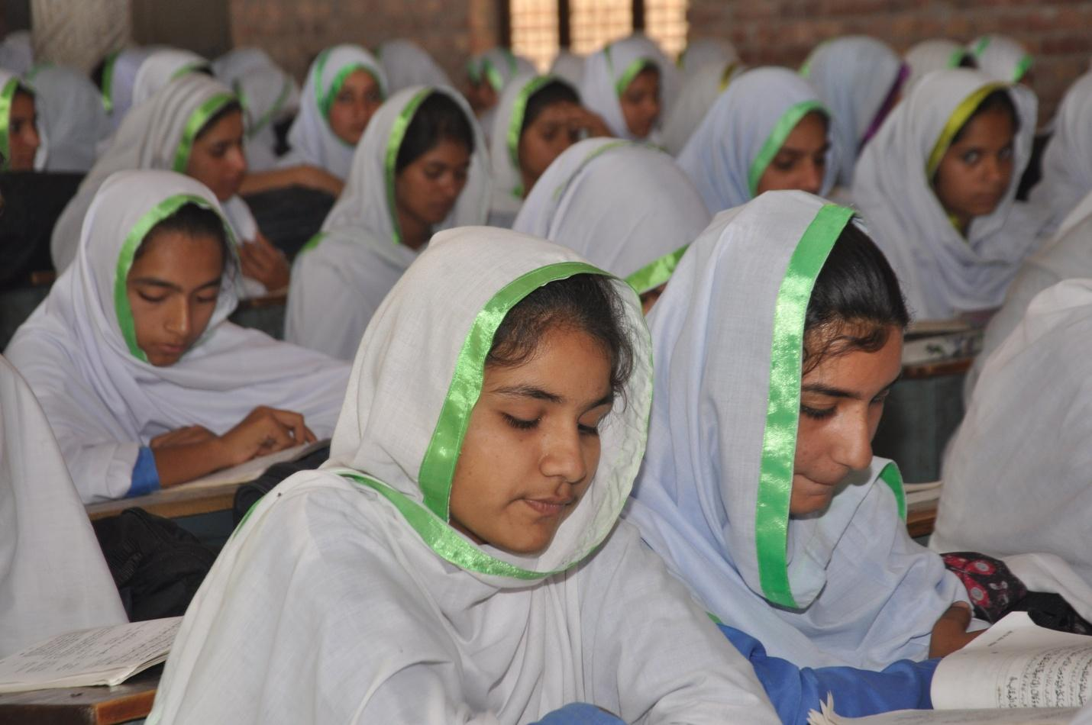

Muwakhat Foundation is a primary working for Girls education. It includes awareness sessions for parents and community on the importance of “educating a girl”. Muwakhat Foundation is the only organization working on 4 tiers or level for support girls age from 4 to above for academic, professional and health,

**Level/Tier1**: Primary education for girls and boys provide holistic approach education for development of mind, body and character.

**Level/Tier 2**: Dropout girls send back to school for secondary education. In Pakistan, the dropout school rate of girls is very high especially after completion of primary education. This program gives awareness sessions with parents and financial support for school fees.

**Level/Tier3**: Life Changing Program for girls who complete their secondary school and do not know where to go in life. This program helps to set vision of life, direction for professional education and career.

**Level/Tier4**: Girls who complete secondary school or “A” levels and are willing to further study in or out of Pakistan. Muwakhat Foundation helps for university expenses including fees, books, accommodation and travel

**Long Term Impact:**

**Every Girl in school and become investment instead of liability**

**TIER/LEVEL 1**

**Educate rural children to break poverty trap**

Muwakhat Foundation provides quality education to rural children in Pakistan who cannot access or afford it. The selected schools adopt a holistic approach for education, help them to come out from personality problems, make their healthy mind and strong body for a bright future.

#### Challenge

Out of every 10 Pakistanis, four are without the basic needs of life, which includes food, shelter, education and healthcare. Literacy rate is 36% in rural areas in 2015-16 and in some areas female literacy rate lowers to 16% because children in rural areas have been denied access to proper education with schools lacking basic facilities, teachers being unmotivated and frequently absent.

#### Solution

Quality Education helps rural children to break the poverty trap. Muwakhat Foundation selected 12 community schools and introduced holistic approach in education providing quality infrastructure, easy and joyful learning materials, computers, English language program, physical and mind development through sports, yoga & nutritious noon meals. The schools actively promote girls education. provide dry ration on monthly basis & donate three goats to each family for milk and malnourished.

#### Long-Term Impact

Rural children become assets of community rather than liability. They break the poverty trap through education and skills training. Increase literacy rate in selected areas.

**TIER/LEVEL 2**

**Dropout 500 Girls Back to High School in Pakistan**

Pakistan has one of the lowest literacy rates in the world. Women are 51% of the total country population and their literacy rate is alarming especially in rural areas due to social and cultural obstacles. Of Every 100 girls in rural Pakistan, only 18 will reach the 8th grade, only 1 complete high school. In three years, Muwakhat Foundation sends 30,000 dropout girls to high school after counseling their parents and overcoming obstacles. Result with collective effort, we can change their world

**Challenge**

According to statistics, overall women literacy rate is 41% and in rural areas literacy rate is 16%. An uneducated girl, risk high rate of maternal and child mortality will likely marry before her 15th birthday. She may never know her human basic rights. Parents feel spending on education for girls is a poor investment. Owing to all these circumstances, women have lost their employment and they are unaware about this fact that they can also play an important role in the development of the country.

**Solution**

Educating a girl is our joint responsibility. Muwakhat foundation's goal is "Education and food for every girl" Muwakhat Foundation will do counseling of parents for send back dropout girls from high school. Once parents agreed to allow her to get an education, she will receive benefits on rejoin school for education i.e One time school admission fee, books, and uniform Monthly school fees Monthly pick & drop car rent because parents did not send girls to faraway high school.

**Long-Term Impact**

Muwakhat Foundation is promoting girl education with a believe "if we educate a girl, she will change the world"

**TIER/LEVEL 3**

**LIFE CHANGING PROGRAM FOR GIRLS**

**Summary**

Every Pakistani girl who dreams for education is Malala! First Time in Pakistan developed a life changing program for girls to help believe in themself, set vision of life, focus on education, dream about career and achieve with clear direction and support. This 8 week program includes remove fear, lack of confidence, influence of community, low performance in study and will know vision of life with goal setting. At the end of the program, a girl is able to believe that she is an asset not a liability.

#### Challenge

In Pakistan, every girl brought up with the thought that she is a liability for parents instead of investment. She cannot dream for Education, professional life, feel equal with boys, respect in community as Girl, student, colleague, Mother, sister, go Abroad to get higher education, set vision of life without influence of community and culture norms Lack of gender equality, preference to boys result: 16% literacy rate, High dropout rate from school,Early marriages, poor health.

#### Solution

Muwakhat Foundation develop 8 weeks life changing program for girls age from 14 to 26 help to remove all fears, negative thoughts and lack of confidence believe, we are asset not liability clear about gender equality know importance of girl education set vision of life and set goals set professional carrier Result: After attended 8 week Life Changing Program, every participant will know "she is asset not a liability" and she able to compete with world to achieve her dream.

#### Long-Term Impact

Every girl is in school, low rate of early marriage and she become asset instead liability

**TIER/LEVEL 3**

**Support every year 20 Girls’ dream for Professional Education**

#### Summary

Our project aims to provide scholarship to youth girls to help pursue their educational goals and achieve their higher education dreams. Scholarships will be available for only girls who completed secondary school and are willing to get higher or professional education from abroad.

#### Challenge

In Pakistan, women are facing barriers for higher and professional education, because of not only inadequate financial support but also traditional thinking that women do not need a professional degree to become engineer, doctor or scientist etc. Study shows that when educational opportunity and resources are limited, women are less likely to get them. We want to change this situation by raising scholarship funds for higher and professional education for female students.

#### Solution

Every year foundation selected 20 girls who passed secondary education, talented and willing to get professional education from abroad. Foundation helps to send their application for admission to related universities abroad. Scholarship covers fees, boarding, lodging, travelling, food and books for four years.

#### Long-Term Impact

The project can fully fund 100 female students for financial support by covering 100% of costs related to higher education, allowing them to focus on their studies, follow their dreams, and achieve positive social change. Funding women's higher education has a multiplier effect on improving the development of their communities and countries as a whole. Together, we can give women the opportunity to achieve and the future to create change in honor of whole world.

**FREE LEGAL AID & AWARENESS PROGRAM FOR WOMEN**

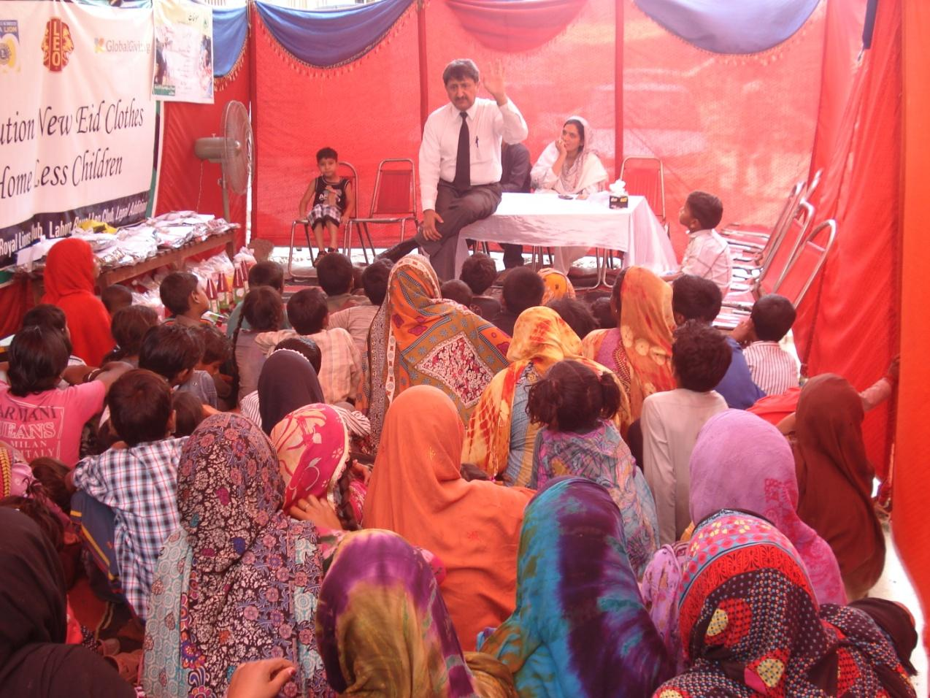

Muwakhat Foundation is a non-profit organisation working in Lahore, Gujranwala and Kasur District since July 2013 to uplift and support women of poor communities. In early 2016, free legal Aid and awareness program started with following objectives:

* Free legal aids to victim (women & children)
* Awareness on basic legal laws especially domestic violence, benefits of registered marriage contract, rights of women in property etc
* Training of young female lawyers belong to poor family as trainer for conduct awareness sessions and assist in free legal cases

Muwakhat Foundation did MOU with legal Firm “SJ Law Firm” to meet the above objectives. This law firm has 32 years experience for providing free legal aid in Lahore and Multan Court to very poor accused, especially poor ladies and children who could not engage lawyers.

Since May 2016, Muwakhat Foundation provided free legal Aid to eight women victims and four awareness sessions on basic legal rights to women and girls. (ref: page 3 and 4 Muwakhat Nama Feb 2017)

**UPLIFT LIFE OF HOMELESS FAMILIES PROGRAM**

**(show love and care )**

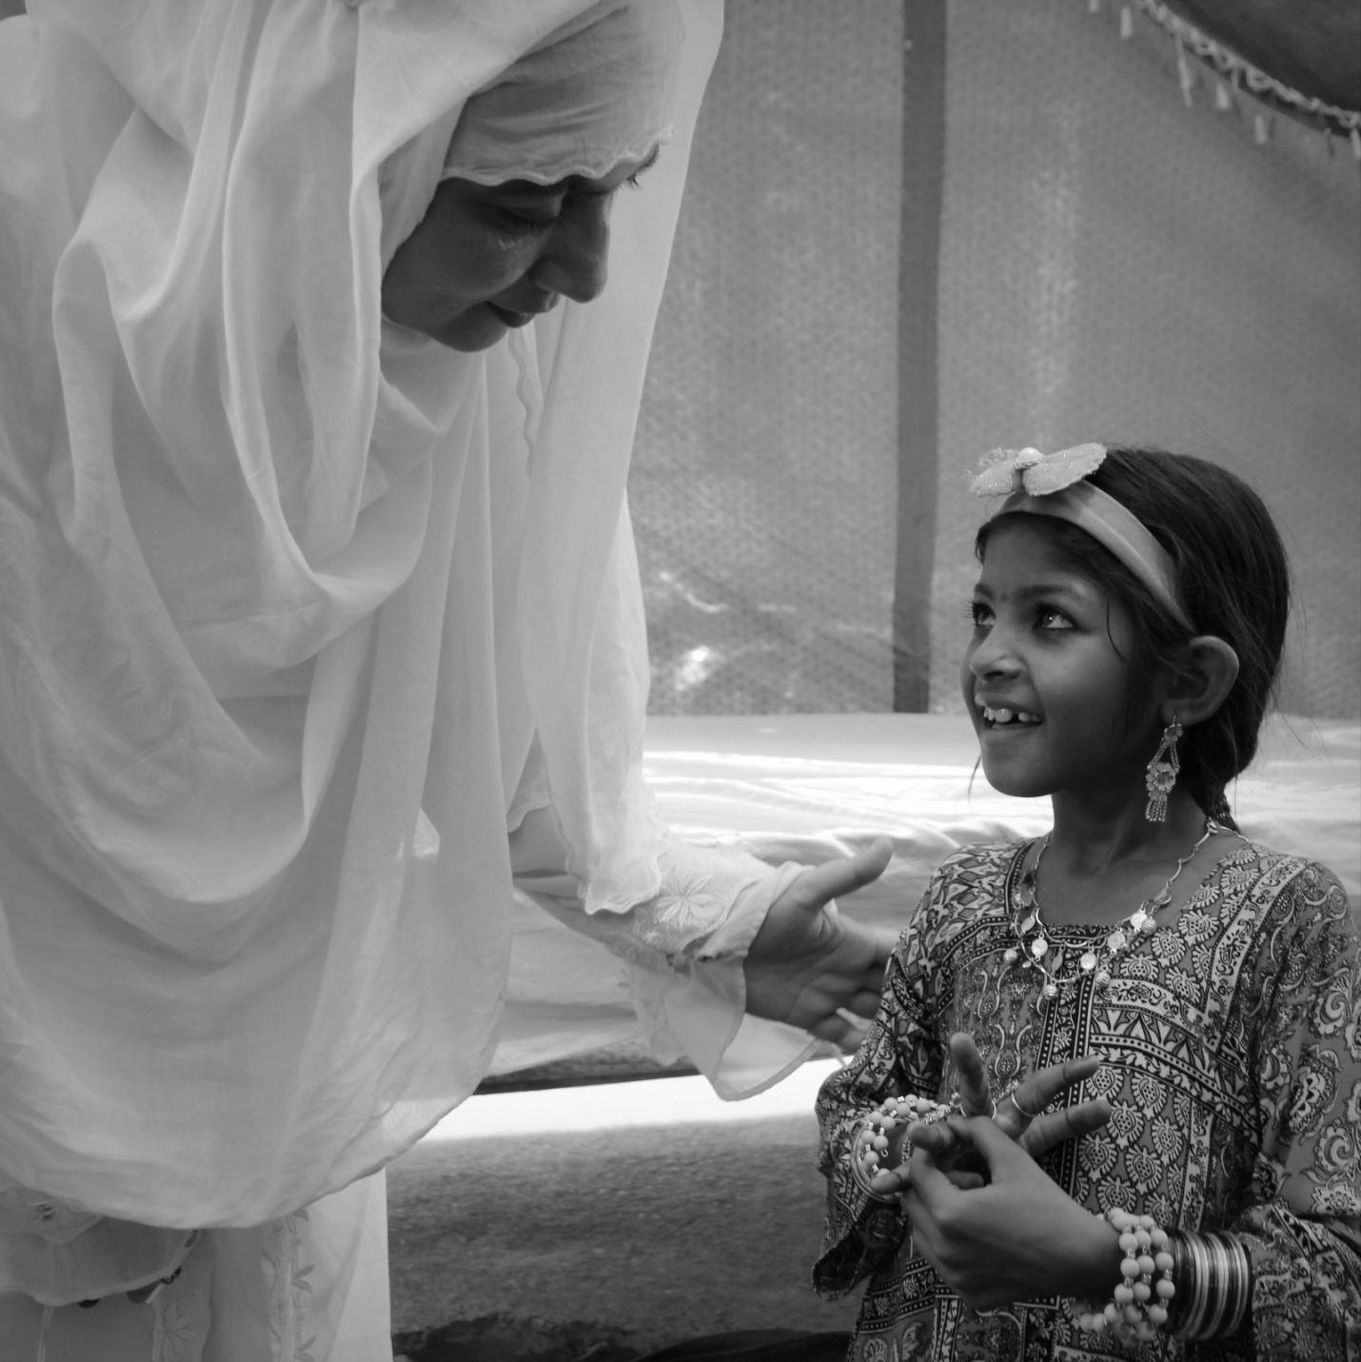

#### FOOD & EDUCATION FOR HOMELESS CHILDREN

43,000 poor Gypsy families (homeless) live in Lahore, Punjab's largest city, half of them women. They are the most neglected vulnerable group in Pakistan who lack basic needs of life. Muwakhat Foundation selected 500 families to support for three years by giving food, clothes, health facilities, education for children, clean water and finance for startup business. Results with collective effort, they come out from poverty and live respectable lives.

**Challenge**

According to statistics, there are over seven million gypsies living in Pakistan. Most are day labourers, garbage collectors, sanitary workers, dancers, or beggars. They remain deprived of basic rights despite being Pakistani citizens. The gypsy community lives below the poverty line, in severely unhygienic conditions. Among the host of problems facing the gypsy community is the severe alienation, malnutrition, early marriages and ignorance regarding health issues.

**Solution**

Muwakhat Foundation has been helping vulnerable groups since 2013 by giving food , new or used clothes, free health services and clean water. We believe that a collective effort to address the issues affecting the lives of more than seven million Pakistanis, it is possible for the gypsy community to be brought back to safety, and into the fold of society. We selected 500 gypsy families to help come out from poverty trap by providing basic needs and financial for business.

**Long-Term Impact**

It helps to reduce long term vulnerability and live a respectable life as citizen of Pakistan.

Rehabilitate & Rescue 300 street children

**Challenge**

Muwakhat Foundation has been working with street children since July 2016. During the need assessment survey, a question was asked to 45 children about their dream of the future. The result was eye opener only three children out of 45 children able to share their dream and remaining were not had any idea about their future. Children and women are 100% illiterate.

**Solution**

Rehabilitation and Pre-school center filled with toys, games, fun activities, sports, offers a hot meal for street children to provide a safe environment, help to see dreams of their better life, overcome malnourished and go to regular school.

**Long-Term Impact**

The street children will have the opportunity to develop life goals and to have a better future ahead of them. They will be the worthy and productive citizens of their community.

**ACTIVITY: New clothes on Eid for 200 children in Pakistan**

**Summary**

Each year, Muwakhat Foundation distributes new Eid clothes to underprivileged children and orphans. This makes a poor child wishes to be happy by new clothes among his friends on the day of the feast "EID" instead one night before Eid will go to sleep miserable and tears on the cheeks because child was not able to buy new clothes to celebrate the festival with friends. The price of new clothes for each child equal $10- $ 15 Your contribution bring smiles to the faces of children

**Challenge**

a poor child wishes to be happy by new clothes among his friends on the day of the feast " EID " and 1 night before Eid will go to sleep miserable and tears on the cheek because they are not able to buy clothes to celebrate the festival with their Friends

**Solution**

Buy new clothes and gifts for underprivileged children to celebrate EID with joy.

**Long-Term Impact**

This project is necessary because it makes the happiness for families who are unable to buy new clothes at EID this year for their children.

**ACTIVITY: Warm clothes & blankets for 50 homeless children**

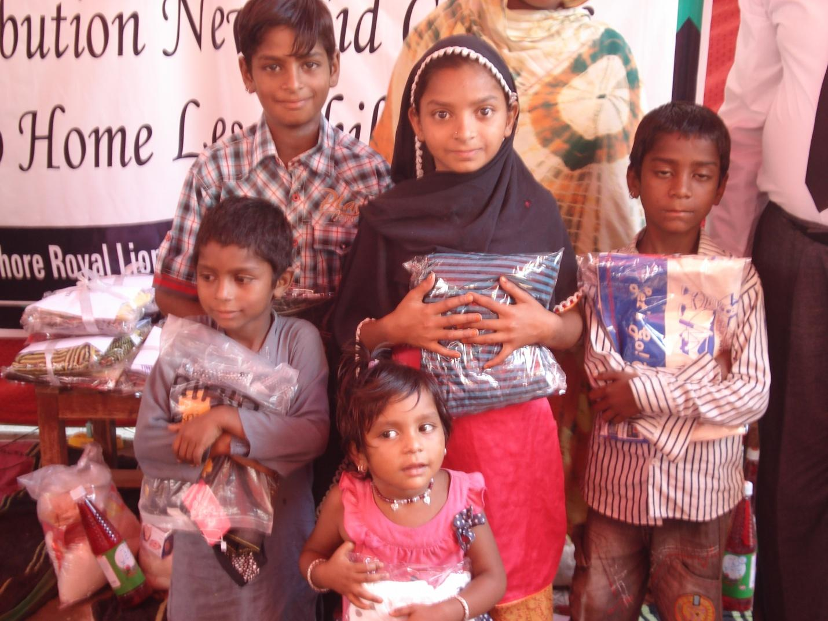

This project will help to buy warm clothes and blankets for children aged zero months to 14 years to fight with rough and cold weather. Cold weather is coming and it is a big challenge for homeless children to have warm clothes and be safe from the cold. Mostly children suffer with flu, cold, fever and cough in winter due to lack of warm clothes. Muwakhat Foundation is helping 500 homeless families to access food, clothes and health facilities and uplifting their life

This micro project helps to provide three warm suits including woolen cap, sock, 2 pair shoes and one blanket for children age from zero to 14 years and safe from cold & rough weather.

**Long-Term Impact**

It helps to reduce long term vulnerability and live a respectable life as citizen of Pakistan.

Report: March 2018  
[**Warm clothes & blankets distributed 182 homeless children**](https://www.globalgiving.org/microprojects/warm-clothes-and-blankets-for-100-homeless-children/reports/?subid=111980)

February 2018, Muwakhat team distributed warm clothes to 182 children and blankets with bed set to 62 homeless families to safe children from cold. Last year January 2017, Muwakhat Branch office located in Lahore city of Pakistan distributed warm clothes to little angels (children age between 01yrs-13yrs).

**Highlights of event “distribution of new warm clothes to homeless children”**

* Muwakhat team visit the project area, took measurements of children for purchase of new clothes
* Families registered for distribution of clothes and blankets
* Muwakhat staff members purchased clothes and made package for children
* This event was arranged by Muwakhat foundation with collaboration of Lahore Lion Club and GlobalGiving.
* In March 2018, children were invited with their mothers but some of their fathers also attended this event.
* Package of new warm clothes distributed to children
* Two blankets with bed sets distributed to one family.
* Children stamp their hands at white chart to say thank you GlobalGiving
* At the end of the event, milk, and biscuits were distributed to children.
* Zareen Aamir Chairperson thanks to all families, Lawyers, Lion Club, students and branch staff. She shared next action plan for financial sustainability, education, and health.:

**HOW YOU CONTRIBUTE TO COMMUNITY**

**Share at Social Media**

Through the use of Social media and Social Networking Sites like Facebook or twitter, you can post the project of Muwakhat Foundation with your personal message to create awareness and get a helping hand.

**Donate Old Belongings**

In order to help the poor and needy, one can donate the old stuff from old clothes to appliances, furniture and other materials. Donating clothes especially in the winter season when the weather is too cold is of great help to homeless children and families. Unneeded stuff can be donated to brighten someone else’s day.

**Donate Food Package for feeding hungry**

Donate dry ration package value from Rs. 1000 (US$ 7) till Rs.5000 (US$ 35) for homeless families to fill stomach and stay healthy.

**Adopt a child**

You can adopt one poor child for support food, cloth and education expenses to help her/him come out from poverty, learn skill, earn and sustain.

**Donate goat to educate girl**

Donate three goats to 180 school girls and their parents. Goat reproduces quickly and their offspring can be sold, providing parents with cash-to pay for their daughters' school materials and tuition fee.