

**Report on Strengthening Technical and Administrative Institutional Support to**

**Raise Institutional Capacities**

**Date: March 15, 2025  
Report prepared by: Shaif Ahmed Ali Ezz El-Din**

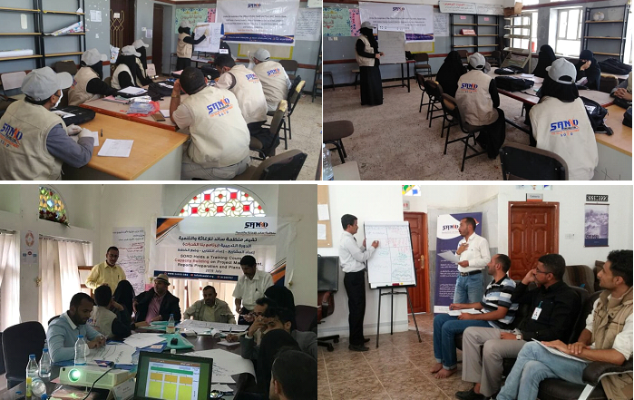

**Mar 2025/AD**

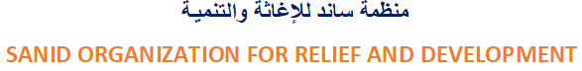**Author : Shaif Ahmed Ali Ezadeen**



**SANID Performance Report - Institutional Capacity Building Project - March 2025**

**Introduction:**

***This report*** details SANID's activities during the first quarter of 2025, specifically from January 1 to March 15, as part of the "Strengthening Technical and Administrative Institutional Support to Enhance Institutional Capacity" project. The report aims to assess progress, highlight achievements and challenges, and provide recommendations for improving performance.

**Project Details:**

**Project Name**: Strengthening Technical and Administrative Institutional Support to Enhance Institutional Capacities

**Project Location**: Yemen

**Name of Applicant Organization**: Sanid Organization for Relief and Development (SORD)

**Report Duration**: Quarterly **Start Date**: January 1, 2025 **Ending Date**: March 15, 2025

**Organization Address**: Sanad, Capital Governorate - Shu'ub District - Al-Habari

**Phone Number**: 0096701205757

**Report Prepared by:** **Shaif Ahmed Ali Ezadeen**

**Contact Information:** [Programs.officer@sanid.org](mailto:Programs.officer@sanid.org)

**Mobile NO.** :**00967778515105**

**Organization Website**: [www.sanid.org](http://www.sanid.org)

**Project Overview:**

The project aims to strengthen the institutional capacities of Sanid by providing comprehensive technical and administrative support. The project focuses on:

* Strategic Planning
* Policy Implementation
* Organizational Development
* Management and Leadership Development Programs
* International Cooperation

The ultimate goal is to enable the organization to unleash its potential, raise performance levels, and improve applied social management.

**Implemented Activities:**

* Training and qualifying the project team on project implementation.
* Conducting interviews and workshops with key stakeholders (employees, leadership, and partners).
* Continuing training on how to collect and analyze data related to organizational performance, challenges, and existing resources.
* Conducting training on preparing plans and reports and developing a comprehensive project action plan with objectives, activities, timelines, a budget, and a specific monitoring and evaluation framework.
* Continuing to conduct a comprehensive needs assessment to identify areas where institutional support is most critical (prioritization).
* Conducting and implementing four workshops and four training courses on developing clear strategic plans and effective policies.
* Conducting two training courses on enhancing leadership skills, decision-making, and conflict resolution.
* Conducting two workshops on training systems and performance management.
* Developing a recruitment strategy to attract qualified employees.

**Barriers:**

* Weak financial resources: Insufficient funds are available to implement activities.
* General situation in the country: Continuing conflicts and wars negatively impact the organization's overall performance.
* Allocating benefits to employees and volunteers: Sanad seeks to allocate benefits and incentives to activate work and complete activities.

**Recommendations:**

* **Provide adequate financial support**: Appeal to donors to provide generous support to ensure the project's continuity and achieve its objectives.
* **Develop mechanisms to adapt to the general situation**: Develop contingency plans to overcome the challenges resulting from conflicts.
* **Securing benefits and incentives for employees and volunteers**: Motivating human resources to raise performance levels.

**Conclusion:**

***This report demonstrates*** the remarkable progress Sanad has made in implementing the Institutional Capacity Building Project, despite the existing challenges. We affirm our commitment to implementing the project efficiently and effectively, and we look forward to continued support from donors to achieve our goals.