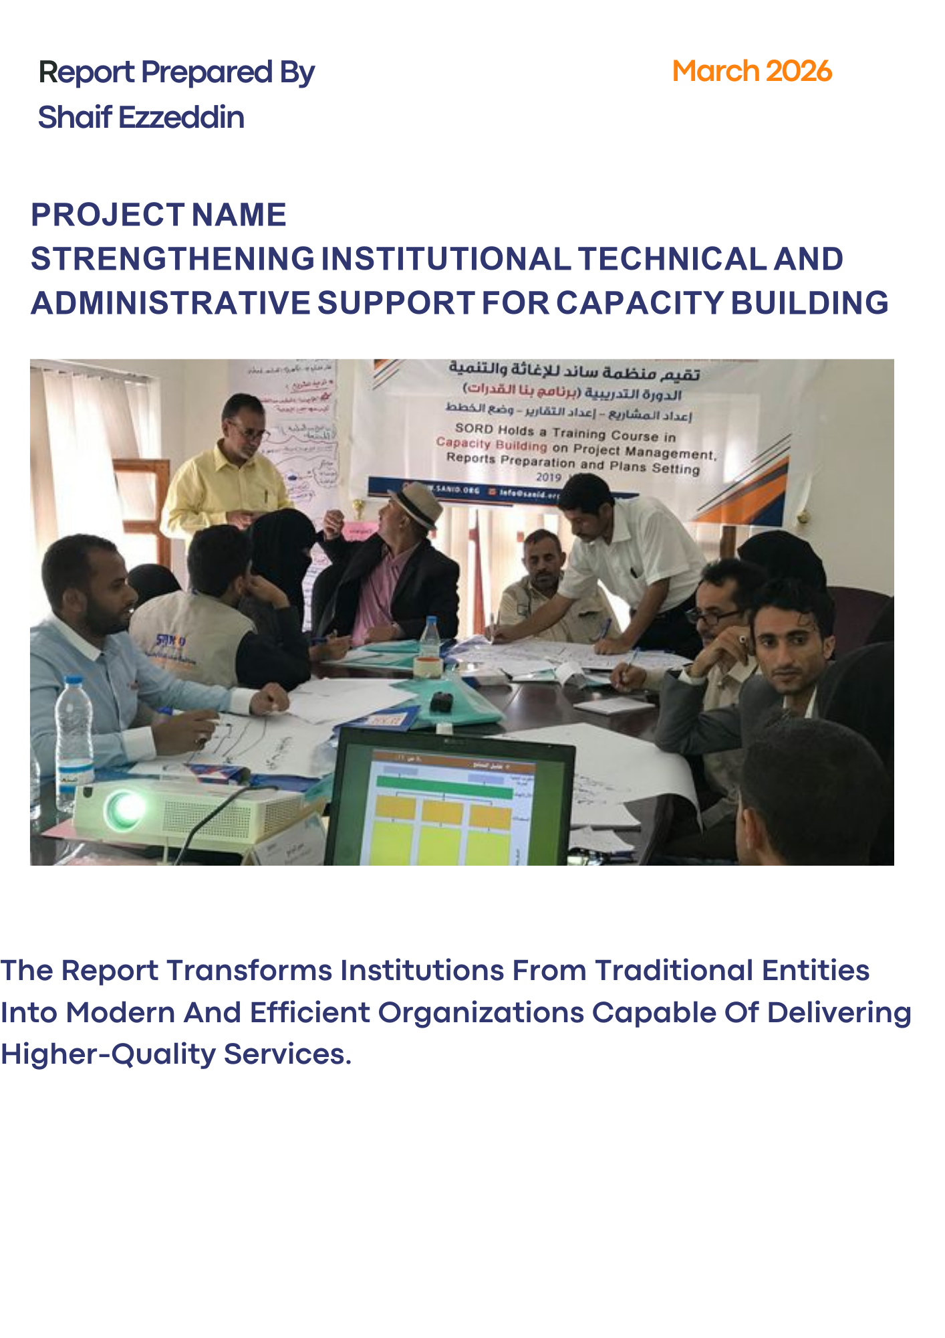

Institutional Support & Capacity Building Report
March 2026

1. Project Overview & Identification
Field | Details
Project Name | Strengthening Institutional Technical and Administrative Support for Capacity Building
Location | Yemen
Implementing Partner | Sanid Organization for Relief and Development (SORD)
Reporting Period | Quarterly
Start Date | December 2025
End Date | February 2026
Organization Address | Al-Habari, Shu'ub District, Amanat Al-Asimah, Yemen
Contact Number | +967 77
Report Prepared By | Shaif Ezzeddin
Current Position | Project Manager
Website | www.sanid.org

2. Project Executive Summary
This project focuses on enhancing the institutional frameworks of SORD through comprehensive technical and administrative support. By prioritizing strategic planning, policy implementation, and organizational development, the initiative aims to unlock latent potential and elevate operational performance.
The project seeks to empower administrative staff and humanitarian volunteers by adopting innovative management approaches and international best practices. Through the engagement of expert consultants and specialized training, the project aims to transition the organization’s performance from "good to great," fostering a culture of continuous learning and operational efficiency.

3. Key Activities & Achievements

3.1 Technical Support
- Financial Systems: Developed and upgraded accounting systems and financial policies to ensure maximum transparency and accountability.
- M&E Frameworks: Enhanced internal control processes and performance evaluation mechanisms.

3.2 Administrative Support
- Organizational Structure: Restructured internal hierarchies to streamline decision-making processes.
- Project Management: Provided specialized support in project design, lifecycle management, and action planning.

3.3 Training & Capacity Building
- Skill Development: Conducted targeted training programs to enhance staff competencies in financial management and project execution.
- Volunteer Empowerment: Strengthened the capacity of humanitarian volunteers in field operations and administrative reporting.

3.4 Reporting & Follow-up
- Performance Monitoring: Produced regular financial and operational reports to track progress against benchmarks.
- Impact Assessment: Monitored project implementation to ensure alignment with humanitarian standards.

3.5 Coordination & Partnerships
- Networking: Strengthened collaboration with international donors and local partners to ensure the sustainability of humanitarian interventions.

4. Challenges & Constraints
Despite the strategic importance of this project, several obstacles have hindered full implementation:
- Financial Constraints: A significant lack of dedicated funding has limited the execution of planned activities and the provision of necessary incentives for staff and volunteers.
- Security Context: The ongoing conflict and instability in Yemen continue to weaken the overall operational environment.
- Resource Gaps: Shortage of material resources required to modernize administrative infrastructure.
Note: SORD appeals to donors and partners for generous support to this foundational project. Institutional building is the cornerstone of effective humanitarian response; without it, long-term impact remains at risk.

5. Future Outlook & Recommendations
- Expanded Collaboration: Actively seeking new partnerships with international stakeholders to secure diversified funding.
- Quality Assurance: Implementing continuous feedback loops to improve the quality of services provided to beneficiaries.
- Sustainability: Focusing on the digital transformation of administrative records to ensure data integrity and institutional memory.

