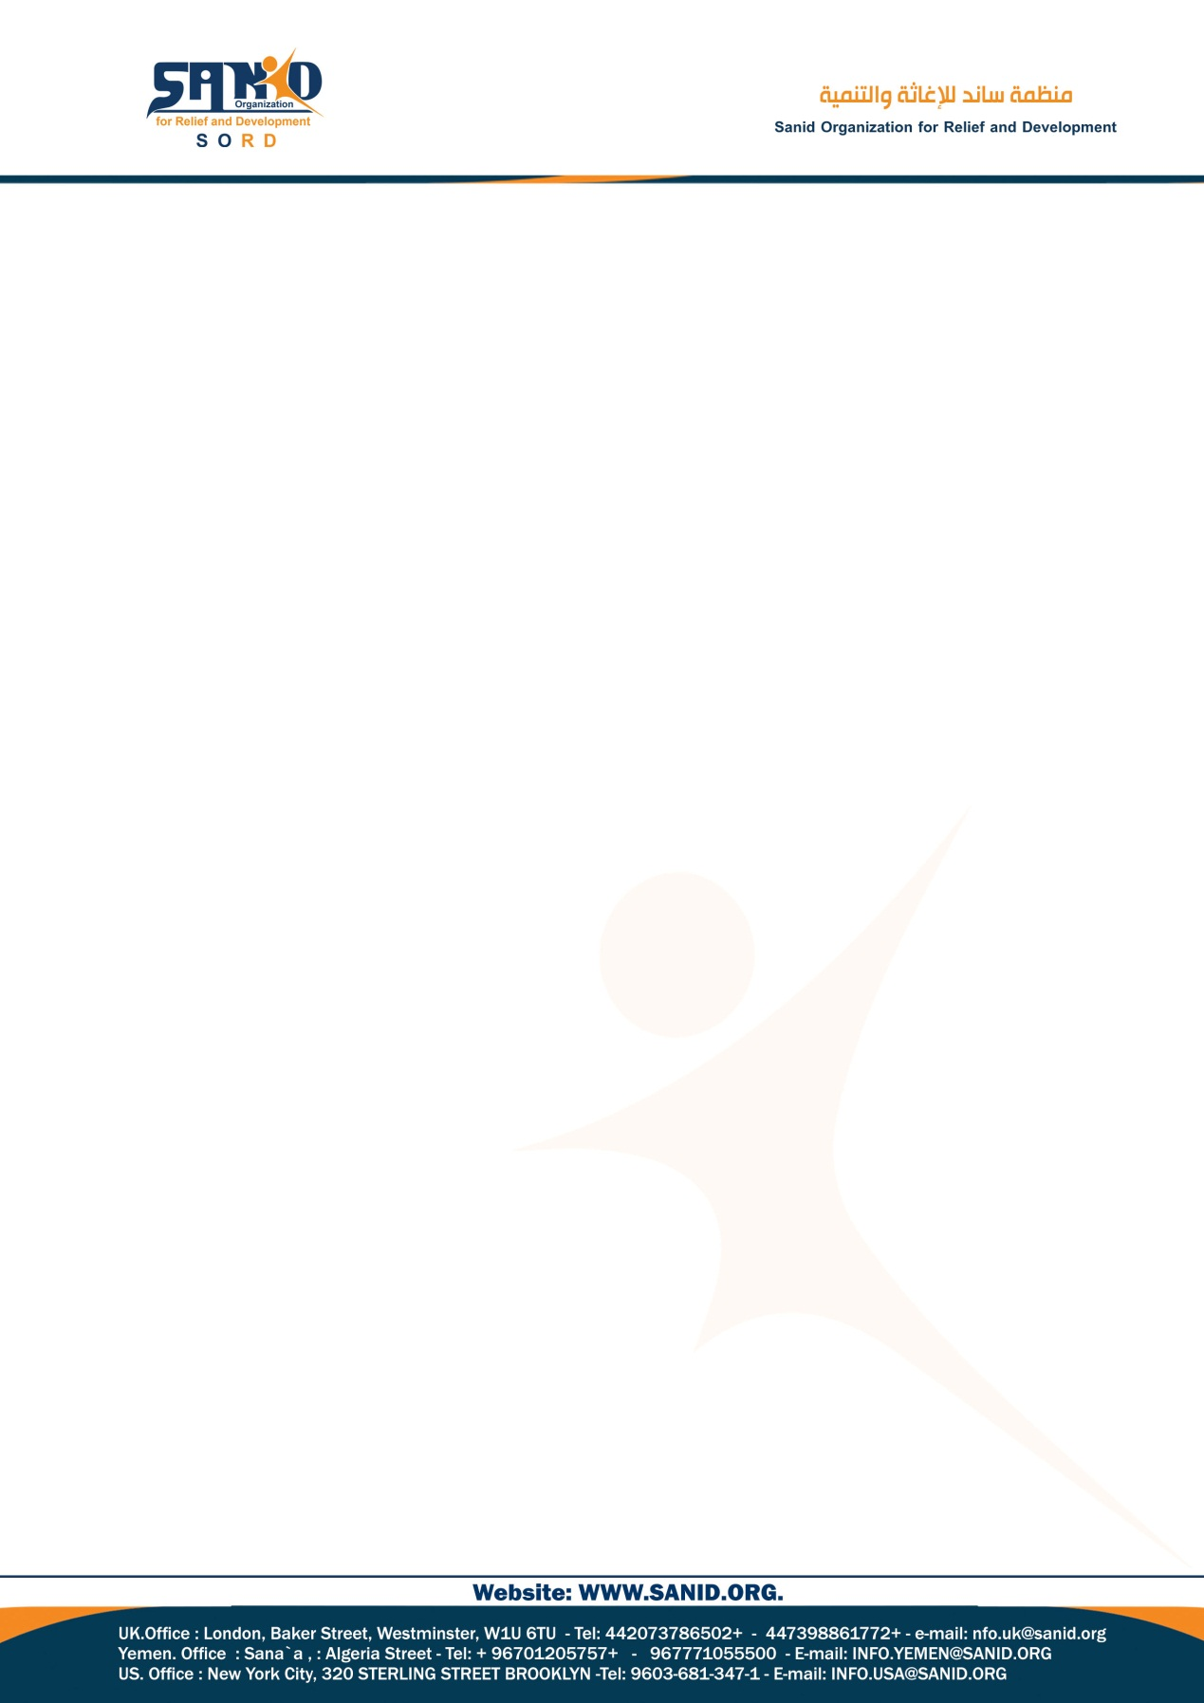

Monthly Performance Report - Local Partner (SORD)

Institutional technical and administrative support project report

July 2024/AD

Report prepared by: Muhammad Abu Haider

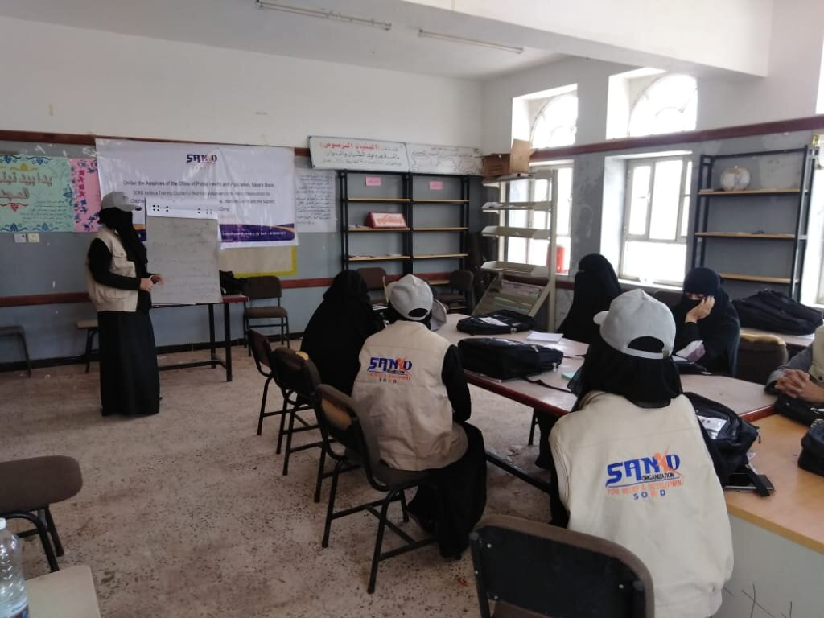

**General Information:**

* **Project Title:** Institutional technical and administrative support
* **Organization Name:** [**Sanid Organization for Relief and Development**](https://www.globalgiving.org/donate/57538/sanid-organization-for-relief-and-development/).
* **Organization Address** : Sana'a - Al-Hasba - Shu'ub District - Al-Hasba Al-Jamahiriya Street - Alhabari Round-behind Aljedri Station
* **Phone Number** : +967123174 **Mob:+967775433335 Email :** [**info@sanid.org**](mailto:info@sanid.org) Website : <https://sanid.org>
* **Project Report Period:** ( From 01-03- 2024 To 15-07-2024 )
* **Project Location :** Yemen
* **Report preparer :** Muhammad Abu Haider **Current Position :** Project Manager
* **E-mail :** programmes.officer@sanid.org ***Mobile*** *: 00967 775907606*

**About the project:**

This project aims to strengthen the institutional capabilities of the organization by providing technical and administrative support. Our focus is on strategic planning, policy implementation, organizational development, management and leadership development programs, and international cooperation. We aspire to unleash latent potential and raise performance levels. The Institutional Capacity Strengthening Project also aims to institutional empowerment through technical and administrative support. The project also aims to address the challenge of strengthening institutional capabilities within humanitarian organizations. This is a multifaceted problem that includes several areas: Strategic planning and policy implementation: Many institutions face difficulty in translating their vision and mission into implementable strategies and policies. This can lead to a lack of direction and focus, which hinders the organization's ability to achieve organizational development goals. The project also addresses the problem by addressing the following key areas: Improving technical expertise: By providing training and skills development opportunities for employees and volunteers, the project will improve their capabilities Technology. This will enable them to effectively use modern technologies, tools and methodologies relevant to their roles within the organization. As a result, they will be better equipped to handle complex tasks and troubleshoot and innovate in technical problems.

**Project impact:**

Building resilience and transforming communities By empowering S0RD humanitarian workers, this project has the potential to create a ripple effect for positive change, not only within the organization but also across the communities they serve, increasing resilience and enhancing skills and knowledge: For trained and equipped staff to respond more effectively to emergencies and implement sustainable development projects.

**Activities:**

1. Conduct a study on strengthening the organization’s institutional capabilities.
2. Implementing 3 workshops to discuss the study, come up with solutions and visions for activities, and prepare a chronic plan to implement those activities.
3. Implementing a training course in the field of strategic planning for the Sanad team.
4. Implementing a training course on strengthening skills, capabilities and knowledge to respond effectively in emergency situations.
5. Carrying out two visits to consulting centers to enhance technical and administrative support.
6. Adding 2 experts to the Sanid team, specialists in the field of preparing and implementing projects effectively and using technology and advanced methods to quickly reach and achieve goals and strategies.

**Obstacles:**  
Weak capabilities and donations. Lack of technical equipment and equipment.