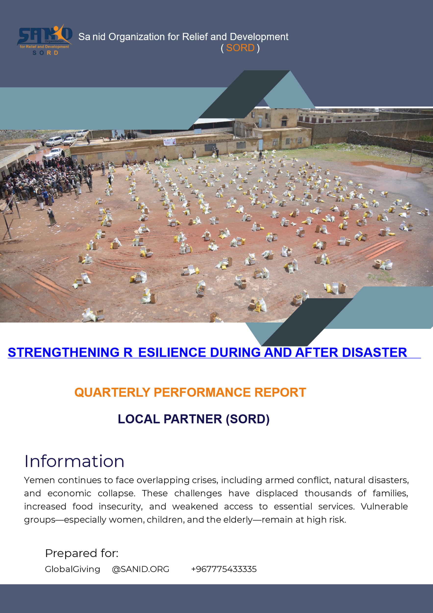
Quarterly Performance Report – Local Partner (SORD)
January 2026
Prepared by: Shaif Al-Deen Position: Project Manager Organization: Sanid Organization for Relief and Development (SORD) Email: Programs.officer@sanid.org Website: www.sanid.org
📌 Project Information
📌 Field | 📝 Details
📖 Project Title | Strengthening Resilience during Conflicts, Disasters, and Emergencies
📍 Location | Yemen
🏢 Grant Applicant Org. | Sanid Organization for Relief and Development (SORD)
📅 Start Date | October 2025
📅 End Date | January 2026
🏠 Address | Amanat Al-Asimah – Shuoub District – Al-Habbari
☎️ Phone | +967 01205757
📱 Mobile | +967 778515109

🎯 Project Overview
The project “Resilience Support: Disaster Management and Humanitarian Response Fund” implemented by SORD provides rapid and effective humanitarian assistance in Yemen’s conflict-affected and disaster-prone areas.
General Objective: To deliver emergency relief and humanitarian support to displaced families affected by conflicts and natural disasters, aiming to reduce suffering and strengthen resilience.
Key Interventions:
- Provision of food, water, shelter, and medical care.
- Psychosocial support and trauma counseling.
- Emergency nutrition programs to reduce malnutrition.
- Temporary housing and improved sanitation facilities.
- Mobile health clinics and essential medical services.
- Educational support for children affected by crises.
- Livelihood opportunities, vocational training, and microfinance.
- Community-based disaster preparedness and resilience training.
🎯 Objectives
🎯 Objective Area |  | 📝 Description
🥖 Emergency Relief | Provide food, water, shelter, and urgent medical care to displaced families.
💊 Nutrition & Health | Deliver treatment for malnutrition, chronic diseases, and maternal health support.
🧠 Psychosocial Support | Offer trauma counseling and safe spaces for children and vulnerable groups.
🏠 Shelter & Sanitation | Distribute emergency shelter kits and improve sanitation facilities in affected areas.
🚑 Mobile Health Services | Establish mobile clinics to provide essential medical care in remote communities.
📚 Education Continuity | Support children’s learning with materials and psychosocial programs.
💼 Livelihoods & Empowerment | Provide vocational training, microfinance, and income-generating opportunities.
🌍 Community Resilience | Train communities in disaster preparedness and response strategies.

✅ Achievements (January 2026)
- 40 displaced families received urgent food and shelter assistance.
- 20 families (60 individuals) benefited from food baskets, blankets, and kitchen supplies.
- 29 elderly patients with chronic diseases (diabetes, hypertension) received essential medication.
- 22 pregnant and lactating women received medical check-ups and nutritional supplements.
- 40 malnourished individuals treated at the nutrition center.
- 50 children received winter clothing, recreational kits, and psychosocial support in safe spaces.
Total Beneficiaries: 251 individuals
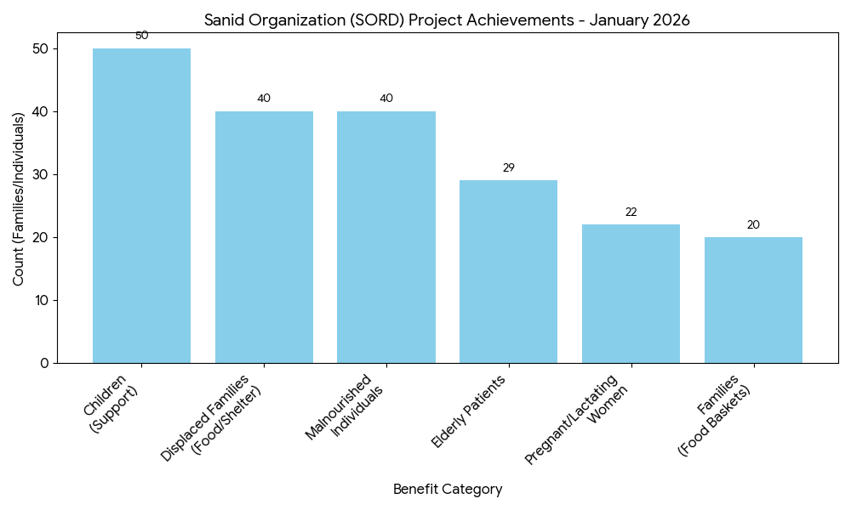

⚠️ Challenges
⚠️ Challenge | 📝 Description
💰 Funding Shortages | Limited resources and insufficient funding to sustain emergency interventions.
👨‍👩‍👧 Rising Vulnerability | Growing number of families in urgent need of humanitarian assistance.
🌪️ Multiple Disaster Sources | Overlapping crises from conflict, floods, and other emergencies across different regions.
📦 Procurement Delays | Reliance on deferred agreements with suppliers due to funding gaps.
📌 Recommendations
• Fundraising & Sustainability: Increase donor engagement and fundraising efforts to sustain emergency interventions, as the organization currently faces funding shortages and must often secure relief materials on credit.
• Expansion of Coverage: Expand project coverage to reach more severely affected areas, building on the success of reaching 15,000 individuals to date.
• Strategic Collaboration: Strengthen collaboration with local organizations and government institutions to improve the efficiency and reach of humanitarian responses.
• Long-term Resilience: Enhance the focus on economic empowerment and educational programs to help displaced families move beyond immediate relief toward self-sufficiency.

🌍 Impact
- Direct relief provided to 15,000 people in targeted communities.
- Improved resilience and coping capacity among affected families.
- Contributed to social and economic stability in conflict-affected regions.

