EFA Field Activity Report:
HIV/AIDS Community Education Outreach in Bibemi and Adoumri

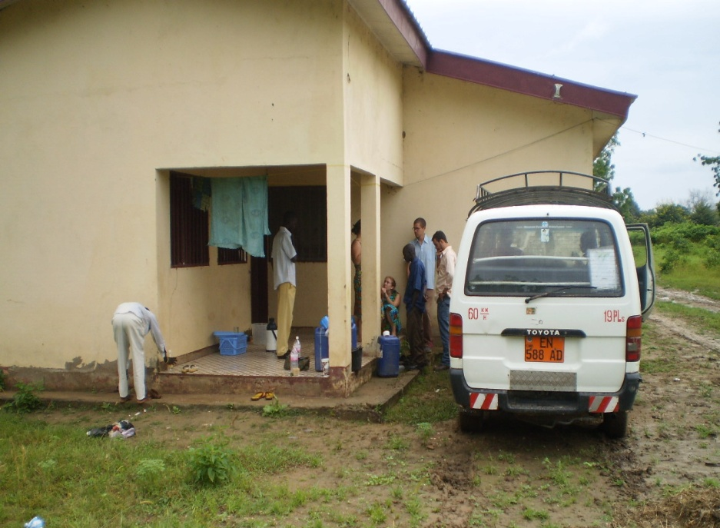
The team at the hospital of Bibémi , where they stayed, preparing to leave for the field.

Amada Tchake
September 20, 2010

Date: September 13-16, 2010
Locations: Bibemi & Adoumri, Extreme North Province, Cameroon
Transportation: Mont Mandara Voyage, van and chauffeur
Strategies Used: Door to door, group presentations, followed by testimonies
Themes:
- The different modes of transmission
- Methods of prevention
- Benefits of voluntary screening
- Living Positively
- Preventing transmission from mother to child
- Community awareness and care for persons living with HIV/AIDS
- How to correctly use a condom
- Cholera (measures to take to avoid contracting the disease)
Team: Caitlyn Bradburn, Amada Tchake, Peer Educators, Technical Assistants
Introduction:
Peace Corps volunteers and peer educators from Bibemi, Adoumri, and Maroua coordinated a trip to remote communities to conduct community education sessions. Top performing Peer Educators who had just finished their HIV/AIDS training were chosen from associations of EFA International ‘s Youth Network to visit these communities and conduct door to door outreach and community gatherings to educate people about the disease.
Results Obtained:
Location: Bibemi

Nº | Team | Location | Men | Women | Boys | Girls | Pregnant Women | TOTAL
1 | Aissatou Sali Doudou Yaya | Ouro Yadji | 35 | 32 | 91 | 20 | 0 | 178
2 | Daidouwé Marceline Nouhou | Foulbéré Sodecoton High School | 34 | 46 | 31 | 29 | 2 | 142
3 | Mairamou Hamndjouma  Soureya Oumarou | Mayo Barka | 95 | 51 | 194 | 116 | 0 | 456
4 | Salihou Fadimatou Haman | Ouro Kari | 135 | 129 | 80 | 57 | 0 | 401
5 | Hassan Amada | High School | 3 | 0 | 74 | 6 | 0 | 83
6 | Haoua Madi Aissatou Sadjo | Foulbéré | 38 | 76 | 183 | 178 | 0 | 475
7 | Djingui Hamidou Yakadam Viche | Sodecoton | 37 | 39 | 50 | 50 | 0 | 176
 | TOTAL |  | 377 | 373 | 703 | 456 | 2 | 1,911

Location: Adouri

Nº | Team | Location | Men | Women | Boys | Girls | Pregnant Women | TOTAL
1 | Amada | Djénnéo 1 | 14 | 4 | 1 | 0 | 0 | 19
2 | Amada | Djénnéo Alhadji Sali | 29 | 0 | 7 | 0 | 0 | 36
3 | Nouhou Haoua Madi | Koléré | 111 | 40 | 180 | 116 | 10 | 457
4 | Mairamou Hamandjouma Soureya Oumarou | Wafango | 88 | 97 | 199 | 141 | 0 | 525
5 | Salihou Fadimatou Haman | Roumdé | 189 | 178 | 72 | 57 | 0 | 496
6 | Aissatou Sali Doudou Yaya | Mbigou Qtier Foulbé | 112 | 68 | 124 | 67 | 0 | 371
7 | Aissatou Sadjo Djingui Hamidou | Douggué | 91 | 52 | 157 | 85 | 4 | 389
8 | Yakadam Viche | Health Center | 57 | 53 | 41 | 2 | 0 | 153
 | TOTAL |  | 691 | 492 | 781 | 468 | 14 | 2 446

Total (Bibémi & Adoumri):

TARGETED POPULATION |  | MEN | WOMEN | BOYS | GIRLS | PREGNANT WOMEN | TOTAL
TOTAL GENERAL |  | 1,068 | 865 | 1,484 | 924 | 16 | 4,357

Questions posed by community members:
- How does one use a condom?
- What precautions must be taken by midwives who perform home births?
- How long can a person live with HIV/AIDS?
- Can an HIV positive woman give birth to an HIV negative child?
- At what temperatures does the virus survive?
- People say that a condom can stay in a woman’s womb.
- It is said that the condom can carry the HIV virus.
- How does a person live with the sickness?
- How do we protect females’ health?
- How can I find a person in charge who has information?
- Why doesn’t the state send free condoms because people don’t have the means to buy them?
- It is said that the condom gives the disease.
- People wanted to know the origin of the disease, what date it was discovered, and why doesn’t the cure exist yet?
- People said they still have condoms that have already been used.

The peer educators tirelessly answered community members’ questions, and this prompted community members to ask them to stay a few days or come back to continue the information sharing, because this was the first time anyone had ever come specifically to educate the community about this incurable disease.

Complaints from Women:
- Women would like to have prenatal consultations and general healthy sanitation, but the information is not taught widely.
- Husbands do not permit them to have a consultation (Family Planning and CPN.)

Community Needs:
- A mobile health unit to visit villages in the region to provide free testing
- Many more educational sessions led by Peer Educators
- HIV testing in local health facilities.
- Less difficulties to access to treatment for people living with HIV

Positive Points:
- The community was available and attentive.
- The administrative, health, traditional and religious authorities in each town warmly welcomed EFA’s teams into their offices and homes
- The members of COSA, available to us as guides, were very patient and listened carefully before translating, which allowed us to obtain positive results.

Difficulties Encountered:
- The villages were remote and peer educators had to walk door to door throughout the community. They returned from the trip tired, and many of them became ill, forcing them to spend more money for their health.
- Very little time is allowed for this type of initiative.
- The brochures to be distributed were very insufficient.
- Nurses, who are supposed to educate communities, were asking the same questions as the members of the community, which means that messages about HIV/AIDS aren’t shared in this region because health workers aren’t equipped with the information to give.

Acknowledgements

We would like thank:
- The Peace Corps volunteers of Bibemi and Adoumri for taking the initiative to aid forgotten communities.
- Caitlyn Bradburn, for the good training she gave to peer educators that enabled this positive result in two communities.
- The doctor, for making space available for our use.
- Sadjo Warba, the Mont Mandara chauffeur, for his perseverance and his patience. Despite the malaria he was suffering from, he continued with us for the entire trip returning us safely to Maroua.

