ENCHNCE THE HEALTH STATUS OF 350 +VE CHILDREN
IN E G DISTRICT OF A.P. IN INDIA

________________________________________________________________________
- Name of the Organization. : JANAKALYAN WELFARE SOCIETY

- Address. : Janakalyan welfare society,
8-99, 2nd street, Durga nagar
Malaya pet, Rajahmundry
East Godavari District- A.P,
Pin code – 533105,
Phone no: 0883- 2442293
Cell no: 9848320500
E-mail ID : Janakalyan@rediffmail .com
Jkws2020 @gmail.com,

- Chief Functionary : B.Nageswara Rao, Secretary

- Legal Status of the Organization

Registration | Date of registration | Registration number
AP Societies registration Act 1860 | 25-01-1992 | 40/92
FCRA Act 1976 | 29-05-1995 | 0101700089
80G Act 1961 | 05-11-2007 | F.No.H.Qrs/III/30G/CITRjy/97-98
12 A of IT Act of 1961 | 28-04-98 | Hqrs.N0.III/30/97-98
PAN | 25-01-1992 | AAATJ3930C
TAN | 03-01-2008 | TANPTGNTP03010803

Summary of the proposal:
According to UNICEF there are 1 million children in sex trade, about 20% of the child prostitutes in India are from Bangladesh and Nepal. A Government of India report (1991) mentions that 25000 children are employed in prostitution in the major metropolitan cities of Bangalore, Chennai, Delhi, Hyderabad and Mumbai and this is found as a hazard to India’s development as crucial as HIV AIDS. Andhra Pradesh has emerged as one of the largest` suppliers of women and children for sexual exploitation. A survey conducted by National commission for women in1997 estimates that Andhra Pradesh represents 40% of the victims trafficked for sexual exploitation. The girls from AP are trafficked to various metropolitan cities (Delhi, Kolkata, Chennai, Mumbai and Goa). Trafficking has increased because of globalization, free market economy, poverty, lack of education and livelihood options, exacerbated by other socio – economic variables such as gender discrimination, civilization, caste and cultural sanctions. The scare of HIV/ AIDS has propelled the demand for children in prostitution, since the men who buy sex consider them sage and fresh. Recent consultations with adolescents in 10 districts of Andhra Pradesh highlighted the extent of child trafficking – either in hard form or soft form- in almost every village particularly in the recent years.
Children affected by HIV/AIDS include a relatively less number who are HIV-Positive and a far larger number who are not infected but whose parents are living with, or have died of AIDS. attention of children infected and affected by HIV/AIDS is highest in this part of the country; and the growing numbers of infected children has made HIV/AIDS an urgent agenda item. Children affected by however, for various reasons, attention to children generally, and young children specifically, have lagged behind. Moreover, there are very few child centered HIV interventions.
Development needs of the children infected and affected are yet to be addressed, for the reason that for all children there are specific development issues to be considered. These relate to emotional, psychological, social and physical development.
HIV/AIDS can affect their experience of love and being loved, their parenting experience, levels of attachment and severance occurrences. The disease brings with it premature exposure to grief, loss and bereavement. On the other hand illness as well as stigma and social circumstance trigger widespread emotional trauma. The effects then spiral up as economic deprivation, nutritional neglect, human rights abuse; inheritance obstacles, poor role modeling and the cycle of poverty contribute. This is more so in case of children from the marginalized communities. Besides being poorly nourished at home, they are turned away from schools, clinics and orphanages because their family members are HIV positive. These issues of children calls for an integrated approach of child centered community development to affectively arrest further spread of HIV/AIDS and protect children from this pandemic.

This proposal aims to promote a community safety net for the children infected and affected by HIV/AIDS to alleviate the impact of HIV AIDS on children, adolescents, families affected by AIDS in EAST GODAWARI District of Andhra Pradesh.
1. JANAKALYAN :
A Brief introduction: JANAKALYAN is a non-profitable, child focused, relief and development humanitarian voluntary organization working in partnership with the poor in EAST GODAWARI and Visakhapatnam districts of Andhra Pradesh, India, without any prejudice based on caste, color and creed.
JANAKALYAN has been operating in 10 mandals of EAST GODAWARI districts of Andhra Pradesh, India with the coverage of around 750 vulnerable families. JANAKALYAN partners over 15000 disadvantaged children for realizing their basic rights.
JANAKALYAN has been extending its considerable facilitation services in the areas of community based health care services, reproductive and child health, sexual health and life skill education for adolescent girls, prevention of sexual abuse among adolescent girls, CBR for differently able persons, Rescue, relief and rehabilitation during disasters livelihood enhancement for rural women and other development projects in 10 mandals of EAST GODAWARI districts 20 mandals of Visakhapatnam districts.
JANAKALYAN developed grass root partnerships with the most marginalized and under privileged sections of the society such as children, adolescent girls, youth, women, work force; farmers belong to most vulnerable communities in all its operational areas.

Our Vision:
Our vision is to create just a society based on values through a process of education and organization of the people with basic relief in and respect for the intrinsic worth of man and women with a clear option for the poor and the depressed.
Our Goal:
Promote a sense of belonging among PLHIVs across the state and help to improve the overall quality of life.
Our Objectives:
- To help PLHIVs and CLHIVs to live with dignity and self respect thereby protecting their rights.
- To raise awareness among PLHIVs of their responsibilities.
- To promote a positive image and give visibility to PLWHA issues among the general public.

JANAKALYAN Experience in HIV/AIDS Interventions and Community child Care HIV/AIDS Interventions

JANAKALYAN has been very impressively implementing HIV/AIDS initiatives in both EAST GODAWARI and Visakhapatnam Districts of Andhra Pradesh. JANAKALYAN is working with both General as well as High risk groups. The Basic strategies adopted are, Behavioral Change Communication, condom promotion, STI care and Management, Advocacy and lobby and empowerment of the VOCSET and PLHIVs.
JANAKALYAN paid special attention on adolescents, youth, migrants, orphan and vulnerable children etc. in mobilizing and generating critical awareness about HIV/AIDS. A community level convergence mechanism has been established in all target villages to access all services to the people/children living with HIV and high risk groups. Gross root level peer counseling system has been promoted to access counseling services at the community level as well as establishing linkages for quality services from the VCTCs, ICTs, PPTCTs, ART centers, care and support centers, RNTCP etc.,
JANAKALYAN established Drop in centers for VOCSET/Female Sex workers, STI clinics, Condom Depots etc. for enabling them to access basic preventive services in order to reduce risk and sustain safe behavior. The unique approach followed here is Community Led Structural Interventions. The approach is to foster target groups ownership to take control over their lives. It is a process of consulting with the community, creating a space for the community, giving the community a role in decision making and management of the project.
JANAKALYAN promoted Community Based Organizations with children, People Living with HIV/AIDS and VOCSET for advocating their Rights and Entailments. JANAKALYAN has been very successfully implementing livelihoods support programme for the families/care givers of OVC children with the support of PLAN India through CTHAPAP initiative.

Community child Care/extended family care

The main principle that cuts across this model is that the project communities and others coming forward in caring the child. It is community that provides `care and protection’ to both the infected and affected children within their village. This is to mainstream age-wise and category-wise OVCs from all the JANAKALYAN focused villages, especially, from the Plan-JANAKALYAN partner target communities. Community child Care to OVCs (Orphans and Vulnerable Children) specifically Children living with HIV (CLHIV) and Children affected by HIV (CAAs) is understood as facilitating an alternate and caring homely environment to the OVCs by the nearest blood relations. Until recent times, the project in JANAKALYAN adopted care-giver-model where a child is assigned to a caregiver, in most cases, the care-giver happens to be the near and dear to the family of the child, viz., grandmas and grandpas or maternal/paternal uncle and aunt of the child. In certain rare cases the child is taken care of by the neighbors. Now the project is in transition in its philosophy and thinking from caregiver model to community-care model where community as a whole takes care of the OVCs right in their community.
JANAKALYAN could be able support around 65 OVC through the community child care/foster care initiatives. All the children are mainstreamed with their extended families. The results are that all the 65 children are able to continue their education without any break or dropout. All are being promoted year after year. All the foster parents have, admittedly, risen above the stigmatization to fostering an infected or affected child in their homes. The children are being given a time of entertainment, games and competitions whereby they were provided a platform to mix with the other children and thus the process of being mainstreamed is at place. The mainstreaming of CLHAs and CAAs is successfully field-tested and now all the children are being mainstreamed.

2. Project Background: Problem statement:

1 Scenario of HIV/AIDS:
Over the last decade, HIV/AIDS has emerged as a serious global challenge having grave implications for the future economic and social development of our world. The absence of curative measures for the disease, the rapidity of its spread and its impact on the adult working population are factors that make HIV a major health and development challenge.
India holds the second largest (5.1 million as May 2004) number of HIV infections in the World following South Africa.The first HIV case in India was detected in 1986, in Chennai, Tamil Nadu. In the 19 years since then, HIV has spread all across the country penetrating even the most remote rural regions. The number of HIV positive cases has increased from 6 cases in 1986 to 51.3 lakh HIV positive cases as of 2004, which means that nearly 1/9th of all HIV positive people worldwide live in India. Within the country there are wide disparities of prevalence of HIV between urban and rural areas, and across states and its populations. However, it is evidently seen that it is often the women and children who often bear the brunt of it.
Andhra Pradesh which has the dubious distinction of being one of the highest prevalence states, is no exception to this national scenario. AP is one of the high-prevalent states in India (based on the NACO 2004 Sentinel Surveillance) and has reported a significant increase in the ANC urban prevalence rates during the last round of sentinel surveillance. The state HIV prevalence rates of 2% among antenatal clinic attendees and 16.4% among STD clinic attendees is the highest in the country (source: NACO 2004 Sentinel Surveillance) and is home to an estimated 10% of all HIV positive people in India. The state is thus faced with a challenging situation as HIV is becoming a generalised epidemic – implying that the HIV infection is no longer restricted to high risk groups like sex workers, MSMs, truckers etc but has penetrated into the general population, exacerbating vulnerability of children.

SCENARIO EAST GODAWARI
EAST GODAWARI District stands in first 4 high HIV prevalence districts in the state. EAST GODAWARI district is having around 77.0% of HIV incidence among women who have attended to Antenatal clinics. The rate of incidence is comparatively high in the rural areas than urban areas. Rampant Migration in population due to drought prone climatic conditions, large amount of area locating beside highway, increased number of CSWs population, abuse and exploitation in processing units are the factors for reporting high incidence in the district.
On the other hand poor Service accessibility conditions, poor facilities in ICT centres, limited care and support centres are also contributing factors for increase of incidence.
Profile of east Godavari
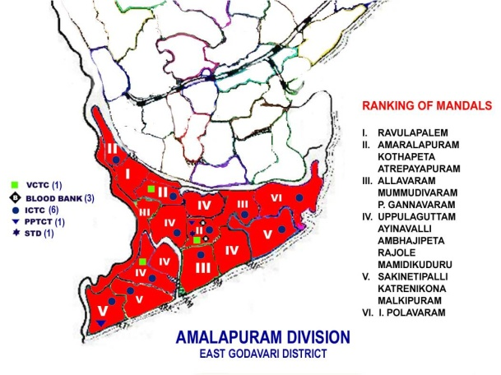
- Second most Populous District
    - 5.23 million - Density – 453/Km
    - Rural – 76.5% - Sex Ratio – 993/1000
    - SC – 18% - Literacy – 65.5%
    - ST – 3.9% - Strong presence of OBCs
- Administration
    - 5 Revenue Divisions - 2 Corporations
    - 60 Mandals - 7 Municipalities
ITDA - 7 mandals - 1012 GPs

- Contributing Factors

- Large presence of traditional and non-traditional sex workers – 2,500 registered members of CBOs (9% of state estimated total)
- Bridge groups – truckers (9% of state estimated total), MSMs
- High voluntary and involuntary in and out migration
- High (7%) prevalence of STIs
- Vast network of national and state highways
- Trafficking of girls into sex trade
District Economy
- Predominantly agricultural, but experiencing rapid changes – fishing, aqua culture, shrimp hatcheries and nurseries
- Rapid industrial changes – oil, natural gas, fertilizer, chemicals etc
- Per capita income (2004-05) – Rs.28,998/-; (State – Rs.23,729/-)
- Strong SHG movement - 62,000 Rs.312.00 crores bank linkage (2006-07)
- Some concerns
- Low work force participation for women (20.62%)
  - Low cultivator to agricultural labour ratio
  - Skewed distribution of agricultural assets
  - Increase in involuntary migration
  - Growing environmental concerns

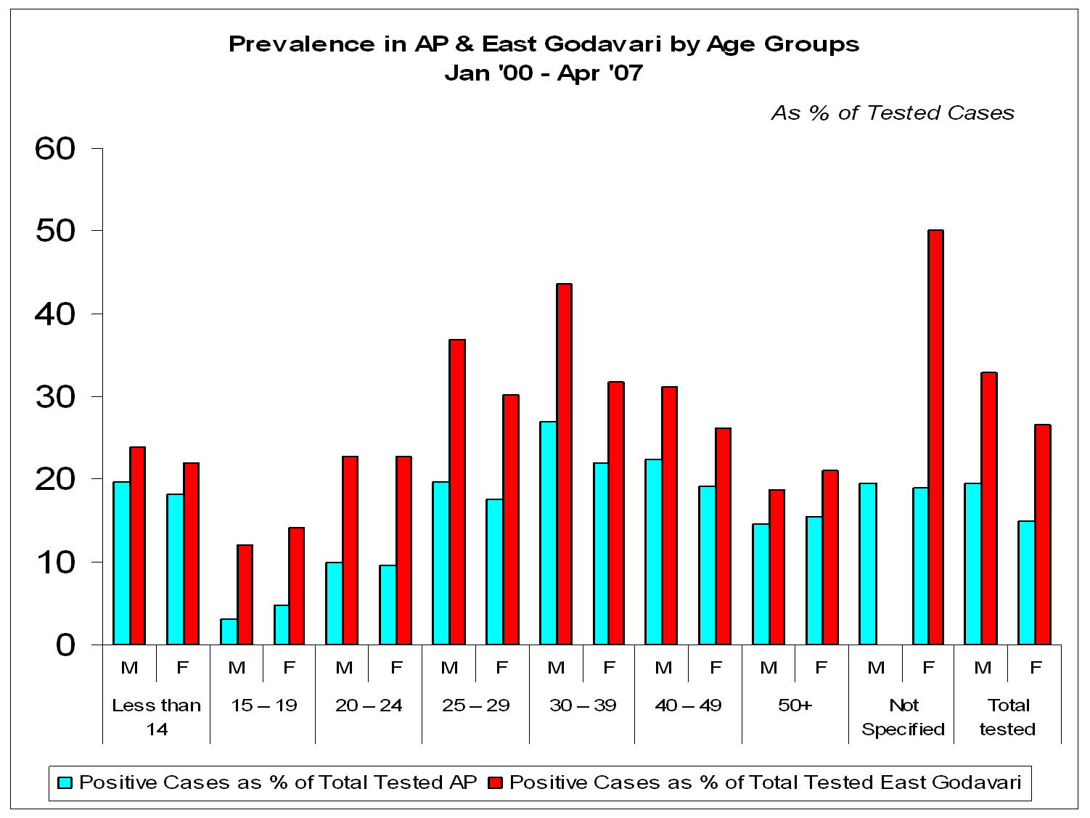
Estimates of PLHAs & CLHAs in East Godavari District:
Total PLHIVs reported in East Godavari: 41,125
Adults registered for CD4: 3,956
Adults an ART: 841
Male: 559
Female: 282
Children tested for CD4: 511
Children eligible for ART: 128
Children ( 5 to 12 year ) an ART : 84
Contributing Factors
- Large presence of traditional and non-traditional sex workers – 2,500 registered members of CBOs (9% of state estimated total)
- Bridge groups – truckers (9% of state estimated total), MSMs
- High voluntary and involuntary in and out migration
- High (7%) prevalence of STIs
- Vast network of national and state highways
- Trafficking of girls into sex trade
Prevalence Rates: Some Results
- Sentinel Surveillance (03-05) : 2.5 – 3.0
- Blood Banks (93- May ’07) : 1.7
- VCTC/ICTC (May ’01 – May ’07) : 3.80
- ANC+ Partners (May ’02 – May ’07) : 77.0
- Mobile VCTC (Up to May ’07) : 6.82

2.2 Global Scenario on children affected by HIV/AIDS:
Globally, 2.3 million children are living with HIV. In 2005, around 380,000 children died of AIDS and 540,000 children got newly infected. Over 15 million children have lost one or both parents to AIDS.
2.2.1 Effect on Children:

- 40.3 million people are living with HIV/AIDS
- 2.3 million are children under 15 years
- 700,000 children< 15 years were newly infected with HIV
- 5,70,000 children died of HIV
- More than 14 million children <15yrs have lost one or both parents to AIDS

2.3 National Scenario:

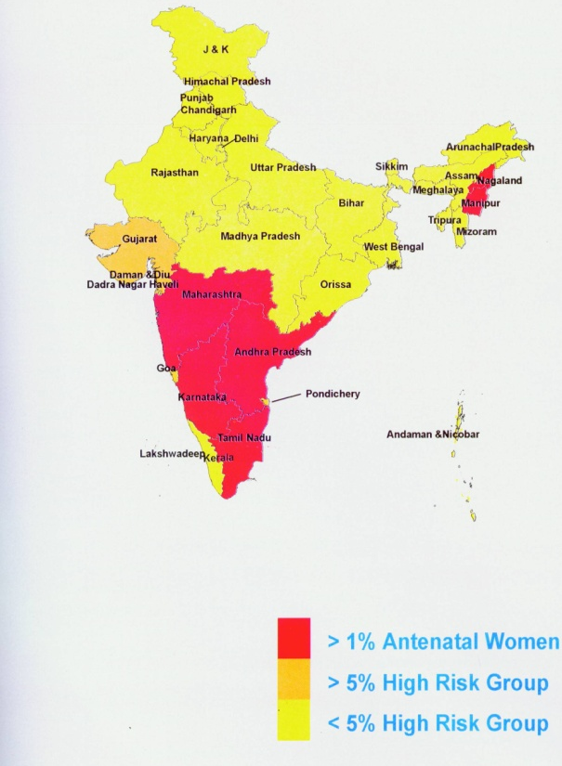
In India hundreds of thousands of children are living with HIV/AIDS, according to official statistics. Children of parents with HIV/AIDS suffer in turn: many are forced to withdraw from school to care for sick parents, are forced to work to replace their parent’s income, or are orphaned. Although the government has not conducted studies to assess the number of children affected by AIDS, some experts calculate that more than 1 million children under age 15 have lost one or both parents to HIV/AIDS. The Indian government estimates that 5.1 million people are living with HIV/AIDS in India.

2.3.1 Current estimates & future projections
- According to UNAIDS, India has 5.7 million people living with HIV
- NACO estimates there were 5.21 million Indians living with HIV at the end of 2005 (compared to 4.58 million in 2002), of whom 39% were female.
- By the end of July 2005, the total number of AIDS cases reported in India was 111,608, of whom 32,567 were women. 37% of reported AIDS cases were diagnosed among people under 30. Many more AIDS cases go unreported.
- The UN Population Division projects that India's adult HIV prevalence will peak at 1.9% in 2019.
- The UN estimates there were 2.7 million AIDS deaths in India between 1980 and 2000.
- It has also projected that India will suffer 12.3 million AIDS deaths during 2000-15, and 49.5 million deaths during 2015-50.
- A 2002 report by the CIA's National Intelligence Council predicted 20 million to 25 million AIDS cases in India by 2010, more than any other country in the world
Though many interventions are being carried out for effective prevention of the HIV, they are limited to main localities and urban areas. Most of these interventions are intended for mainstream areas and target communities.

3. Response limited to a few:
_____________________________________________________________
3.1 Gaps in the present efforts of Govt and NGOs with specific reference to Andhra Pradesh in providing care and support for CLHAs & CAAs:
A glance at the Care and support services for the children infected with HIV/AIDS in Andhra Pradesh reveals that there are very few interventions that directly address the issues of children.
3.1.1 Gaps in the existing efforts of prevention of HIV/AIDS among children:
- There is need for greater use of data for decision making including biological and behavioral surveillance data, epidemiological data, programme and services data.
- Efforts to reduce stigma and discrimination are not adequate.
- pathetic technical capacity and lack of ownership and political leadership in many places of the state.
- Lack of sufficient resources to prevent further transmission of HIV/AIDS and protect the vulnerable children.

3.1.2 Gaps in existing efforts of care and support for CLHAs/CAAs
- Lack of child centered interventions in providing sustainable care and support services
- There is no multi-sector design to ensure the sustainability and effectiveness in addressing the critical issues of the infected and the affected with HIV/AIDS in the areas of access to basic services, rights for advocacy and the mainstreaming of the affected.
- There is no multi-pronged approach followed to mobilize the key stakeholders to involve actively and collectively in addressing the HIV/AIDS like community based organization, civil society organizations, panchayat raj institutions and private health service providers etc.

3.1.3 Programme implementation initiatives:
Inadequate counseling services to the PLHIV/CLHIV/CAAs and no attempt at extending counseling services to the affected and the community.
- Inadequate efforts to reach out the people in their place of residence, work, study, access health and welfare services including information in most cases.
- Inadequate attempts to sensitize the policy makers, political-social-religious leaders, bureaucrats, media, industries, and private health care professional to motivate and to adopt a human approach towards those infected with HIV/AIDS.
- No attempt for an establishment of effective referral and chain of care and support services.
- No attempt to ensure health and nutrition security.
- The basic Health and Nutrition, Social Welfare service providers like PHC, ICDS, PDS, Line departments at grass root level are not involved in providing care and support services to the PLHA and their families.
- The private medical practitioners, who are easily accessible to the poor in villages, have not upgraded their skills in dealing with HIV infected and often exploit the poor and the illiterate.
- Inadequate dissemination of information and self-help skill building to PLHA/CLHAs in relation to care and support.
- No serious effort made to address the issue of social stigma discrimination, isolation, segregation etc.
- No adequate efforts at grass root level to bring the PLHA/ CLHA and their families into the fold of various social, development and antipoverty programme.
- Awareness campaigns did not focus on Behavioral change among the infected and the affected and also lack of focused approach to deal with the issues of HIV infected and affected.

3.1.4 Gaps in existing efforts in Advocacy and Lobbying
- The policy did not say anything about effective enforcement of legal provisions in protecting the affected against stigma, discrimination, violation of rights, denial of opportunities and entitlements.
- The policy did not make the local bodies, panchayat raj institutions etc. accountable for the prevention and the control of HIV/AIDS.
- The policy did not emphasize the need for extending counseling services to the affected family members and their relatives and neighborhood as well as married couples.
- The policy did not look into gender related issues while providing care and support services.
- The policy did not attempt to promote diversified and area/need specific strategies and interventions to cater to the needs of unreached sections of the society like working children/young people/ out of school children /marginalized women.
- The policy did not recognize the right to health and survival of PLHA/CLHA.
- There are no appropriate and locally relevant interventions designed to promote CBOs and CSOs to work with non-school going youth, migrants and un-organized population who are particularly vulnerable to HIV/AIDS.

Operational area
The project proposes to cover 15 mandals in Amalapuram Division and Rajahmundry urban and rural mandals.
Target groups and stakeholders
The project is proposed to cover around 1000 children living with/or affected by HIV AIDS in the operational area. The project would collaborate with CBOs, CSOs, Networks, PRIs, Line departments, service providers at all levels.
Time line
3 years from the inception of the project.

Project goal and objectives
To promote community initiatives for the children infected and affected by HIV/AIDS to alleviate the impact of HIV AIDS on children, adolescents affected by AIDS in EAST GODAWARI District of Andhra Pradesh and build an environment to enjoy the rights of the children that have been guaranteed under UNCRC.
General objectives
- To ensure better accessibility of preventive services include information, skills for children and adolescents to safeguard themselves for the increased vulnerability by creating a non stigmatizing and acceptance environment.
- Early detection of HIV infected parents, children and providing high quality health care services and support to prolong and maintain quality of life.
- Addressing myths, misconceptions on HIV infection to eliminate stigma and discrimination on the infected and affected
- To build congenial environment where the infected and affected children can enjoy their rights and entitlements.
- Provision of OI & ART referrals, educational services to the vulnerable children, nutritional and counseling services, foster care and livelihood services to the families of the infected children and health insurance for the infected children.

Specific objectives
- To identify and register a total number of 125 CLHIVs and 875 CAAs under the project to ensure diversified services from the project to their comprehensive development
- To ensure Psychosocial care for 1000 children include CLHIVs CAAs and families to build their confidence to lead their life like normal children and families
- To ensure Health and Medical care including access to services relating to OI treatment & prophylaxis and other referral and linkage services to at least 1000 CLHIVs/ CAAs during the project period by establishing potential linkages with different stakeholders at different levels.
- To cover around 1000 CLHIVs and CAAs under Nutrition education and support services to children living with and/or affected by HIV AIDS for reducing the impact of malnutrition affect.
- To provide access to formal or informal education and vocational skill based trainings for 800 children and adolescents to realize their right for education and development.
- To Provide care and support to at least 250 Households of children living with and/or affected by HIV AIDS
- To Provide Alternative and extended family Care for 100 needy orphan children to ensure home based care
- To promote children groups with all the targeted children to create opportunity to mix with other children and finally to address the stigma and discriminiation issues at children level.
- To ensure economic security for the HIV infected and affected children’s families to reduce the economic vulnerability through Livelihood support.
- To Sensitize the communities and stakeholders to act more responsive in working and supporting the CLHIVs/ CAAs and their families
- To Coordinate and converge with different stakeholders is to leverage utilization to remove financial barriers and ensure social security in order to remove financial barriers and provide social security to children infected affected by HIV AIDS.
- To advocate with policy makers and service providers to realize the entitlements of the HIV infected and affected children and their families.
- To provide health insurance to the infected children.

Guiding principles
The entire project implementation is dependent on some key guiding principles i.e
- Emphasizing community care rather than Institutional care
- Respecting care and coping capacities of families and communities.
- Child centered and community centered problem solving systems
- Integration of diversified services remain key strength for quality support services
- Collaboration and convergence is nothing but joining hands

Project Components
1. Identification and registration of children
The project find the identification and registration is prime initiative of the project and the project would identify the targeted children through the available sources like primary and secondary stackholdes , project records, ICTCs, ART centers, PPTCT Centers, PLHIV networks, other NGOs and services providers. The project would also collect information from the social network mapping mechanism.
The identified families and children will be given ranking according to their vulnerabilities and this ranking list would remain a base document for entire service delivery and support from the project. The project would identify 75 CLIHVs and 300 CAAs in the 1st year and identify 425 more CAAs in the second year to extend project support services to improve the quality of life of the CLHIVs and CAAs.

2. Psycho social care support
Psycho social support has been found as one of the crucial initiative from the project. The psycho social care focus on the emotional and spiritual well being of the targeted communities which have a bearing on ones psychological health.
The psychosocial care and support included interventions that assist children and families to cope up from depression, grief, upheaval, discrimination and social exclusion. The Psycho social care is aimed at enabling children to experience love, protection and support that allow them to have a sense of self worth and belonging and also build in them self confidence. The psycho social counseling services would be rendered by the project counselor and outreach workers. The outreach counselors would be supported with the project counselor on a periodical basis to ensure quality in the counseling services. The psycho social care trainings will be provided to the children to cater the immediate needs by themselves.
The project would extend psycho social care to 750 CLHIVs and CAAS on a periodical basis and ensure at least one round of support by end of second year to all 750 CLHIVs and CAAs

3. Health and medical care and referral linkage services
The health and medical care services aim to extend support to meet the needs of CLIHVs according to their age by providing referral to primary care, immunization and treatment for children. The health and medical care would cover immunization, early identification and follow-up of HIV exposed child, referrals to diagnostic and ART centers and monitoring of children who are not under ART, counseling. The project develops linkages with private and government hospitals for providing medical care for the needy children. The expenses for treatment, travel other expenses will be met by the project. The project conducts orientation and trainings to the children, parents and care givers on the health and medical care.
The project would extend referral and linage services for linking the needy with the suitable support services. The project would refer the children and families to necessity services like VCTCs, PHCs, District Hospitals, PPTCTs, ART, CD4 Counting, STI care, DOTs services and other services. The project would track the all the referral services and assess the quality of services from different services providers. The project would closely coordinate with the service providers to ensure quality support services for the targeted. The project support would be mainly in terms of food and travel of the targeted / escorts in realizing the referral services.
The project would cover total 600 CLHIVs and CAAs under the health and medical care through potential referral services and ensure at least 200 CLHIVs and CAAs to cover in a year.
4. Nutrition education and support
Nutrition support is one of the crucial support services to prevent the deaths of the children due to malnutrition. The project aims to ensure nutritional support on a periodical basis to make the children healthy like other children in the communities. Nutrition support includes nutrition demonstration, counseling, provision of supplementary nutrition to the children in need and increasing access to the existing integrated child development scheme. The project support is strategic and targets to CLHIs at first and extends support to deserving CAAs. The project develop child centered nutritional plan and kept the matrix as basis for entire nutrition support activity.
The project would extend nutrition education support services to 400 most needy CLHIVs /CAAs by end of 3 years and cover 100 in the first year and 150 each in 2nd and 3rd years.
5. Education support
Education support is a vital component of the essential basic services that will be considered as critical and necessary to ensure the immediate well being and holistic development of CLHIV and CAA. The project identifies how many children are continuing with the educational and how many children are dropped out. The project would develop systematic plan according to the conditions of the children. The project would ensure all the drop out children to join in school and extend education support like books, tuition fee, travel support and vocational training etc. Further they aim to ensure that school programs take into account the special needs of CAA by sensitizing teachers to identify signs of distress among children, promoting the availability of support groups and counseling services, and supporting programs to eliminate exclusion of CLHIVs and CAAs from Schools.
The key actions of education support would also cover to integrate life skills based HIV prevention education into the school curriculum teacher training. Build capacities of children to be peer educators including red ribbon clubs, reduce stigma and discrimination in the community and to ensure complete knowledge and skill to protest them from HIV infection. Ensure HIV prevention education in accessible to those most at risk of infection, develop life skills materials on HIV prevention and care support and this can be piloted in few schools in the operational area.
The project would provide education support to 400 children and ensure 100 in the first year and 150 in the second year and another 150 in the 3rd year. The vocational education support would also be extended as part of the education support to the adolescent children
6. House hold support
The household support would be extended to the families or adult care givers of the children. This support would mainly cater to emergency or crisis situations that the child or the family might face. Help for medicines, treatment, transport during emergency, food support when the family has no money for the next meal, support for funeral services etc could be some situations when this support is provided. The project would plan to ensure safe housing conditions by roofing the thatched houses, emergency and essential repairs for colony houses, and blankets/ mats to most vulnerable during the winter seasons. Critical provisions support may also be extended to the bedridden.
The project would ensure house hold support to at least 250 families by end of the project period by cover 50,100,100 in the 1st to 3rd year respectively.
7. Alternative/extended family care
The Alternative / extended care services aimed to ensure that no goes without shelter, clothing, and access to safe drinking water or basic personal hygiene, and that children have at least one adult who provides them with love and support. CAA, CLHIVs sometimes end up in institutional care due to limited community support systems. To ensure that the child remains within the family/ community, alternate systems of care such as extended family care, care under extended family or adoption should be promoted. In case of delay in providing the community based care services, intermediate mechanisms of institutional care through short stay homes, shelter homes orphanages needs to be provided. However it is imperative that the minimum standards of care are established at these centers and capacity of staff is strengthened to provide quality services.
The alternative /extended care services would ensure to 250 families and in the first year the project would cover 50 families in the first year and pay much attention in the 2nd year and cover 150 families and end up with 3rd year by covering 50 families

8. Child support groups and forums
Children support groups denotes a group of children affected/ living with HIV and AIDS who came together to provide emotional and psycho social support to each other in order to boost their confidence and sense of belonging . As the children grieving process is different from that of adults, the children support groups will help children perceive loss and help them overcome it with a unique approach of play based activities. The children support groups further linked with the district children forum called “EAST GODAWAR CHILD FEDARATIONS “to mainstream the issues of the OVCs.
The project would take steps to bring all the 750 children in to groups by promoting children groups in the project villages by mixing the OVC children with normal children. The project would promote 50 children groups in the 1st year and promote 100 new groups in 2nd and 3rd years separately. Totally 350 Child support groups promoted the project period.
9. Livelihood support
The orphan and vulnerable children and their foster families do not have any access to financial services from formal financial institutions due to various reasons. Stigma attached to it hindering them in participating group based activities, which are the major source of credit and livelihood support services. Their existing livelihood activity and there-by-their income undergoes stress with HIV infection due to increased expenditure on health, nutrition and sometimes due to loss of their employment. Foster parents often not in a position to augment their incomes to meet the needs of the children whom they are taking care of
The project would extent livelihood support to 250 needy families by covering 50 in the first year and 200 in 2nd and 3rd years.
10. Sensitization and community mobilization
The individual is part of the community in which he/ she lives. Therefore it is essential to work with the community to create an atmosphere of acceptance and trust for the HIV and AIDS affected individual. Stigma in the community, in health settings and educational institutions does exist and needs to be addressed. Sharing of appropriate information is the key to making people understand the epidemic as well as its impact on the lives of the affected people. Creating an understanding atmosphere will also help affected people to come out and share their status, there by opening avenues for accessing the services they need. This will also lead to the mobilization of community resources for the benefit of the affected individuals. The sensitization further covers health care providers, Teachers, AASHA health Volunteers, Anganwadi Teachers, PHC staff on HIV Prevention, care and support and against stigma and discrimination
The Sensitization and community mobilization build capacity of family and community to prevent and respond to abuse, neglect and exploitation of children to ensure that children are able to stay within family care

The project would conduct 30 community sensitization and mobilization meetings in each of the year and organize total 90 events by end of 3rd year.
11. Coordination and convergence
The project would coordinate and converge with different stakeholders include health care providers, line departments include DRDA, Panchayat raj, NREGS, Revenue, Corporations, Zilla parishad, to realize the social entitlements and to leverage social and welfare schemes to targeted children and families. The coordination would also take the CSOs in to consideration to bring different players to support the communities with a collective approach. The aim of the Coordination and convergence is to leverage utilization to remove financial barriers and ensure social security in order to remove financial barriers and provide social security to children infected affected by HIV AIDS.
The convergence meetings with different district level stakeholder will be organized for every six months to develop converging strategies. The project would take up mandal level and district level coordination and convergence meetings for every six months. The project would bring the lessons at mandal level to district level to grab much attention on the grass root level issues.
12. Advocacy
The project found advocacy is one of the key strategies to give a voice to the needs of OVCs and families infected and affected by HIV AIDS. The advocacy initiatives of the project focus on enactment of HIV AIDS bill, increasing communication campaigns and provide quality control to prevent the inadvertent use of stigmatizing messages, increasing access to care and treatment services especially PPTCT and PPTCT + services, Specific programs for protection of children at risk, child friendly environment at ICTCs, ARTs, District hospitals, develop a specific policy on stigma and discrimination, ensure access to supplementary nutrition for all children and PLHIVs under ART and realization of social entitlements. The entire advocacy efforts will be community lead and PLHIVs forums, AASHA MACS, Children forums and CSOs forums will take lead in the advocacy efforts. These forums would also advocate with district and state level networks.
The project would take up 4 advocacy event in each of the year on the eve of world AIDS day and other special days.
Expected outcome
- Ensured access to standard services and entitlements for all infected and affected children by HIV/AIDS in the project area.
- Created Conducive environment to redress the rights of those excluded and refer for additional services where required
- Reduced stigma and discrimination by overcoming the obstacles for reintegration with the main stream society.
- Secured all legal and social protection measures for OVCs to prevent and redress all forms of abuse, neglect and exploitation

Monitoring and Evaluation
JANAKALYAN will develop monitoring tools, regular monitoring of the program and evaluation of the program which will be based on the principals of confidentiality and meaningful involvement of CBOs and project beneficiaries following project components. The project will develop appropriate tools, techniques related to planning and implementation and monitoring the program towards its objectives with the support of Global Giving. Monitoring framework shall be developed and followed.

------------------------------------------------------

Janakalyan welfare society - Rajahmundry Proposed Budject for three years
Activity | Unit of measurement | Unit cost | Year 1 |  | Year 2 |  | Grand total
Activity | Unit of measurement | Unit cost | No of units | Total cost | No of units | Total cost | No of units | Total cost
Health and Medical care including access to services relating to OI treatment & prophylaxis and other referral and linkage services to childrne living and affected by HIV AIDS | Per child per annum | 900 | 150 | 135000 | 150 | 135000 | 300 | 270000
Nutrition education and support services to children living with and/or affected by HIV AIDS | Per child per annum | 1500 | 150 | 225000 | 150 | 225000 | 300 | 450000
Provide access to through formal or informal education and vocational skill based trainings for adolescent children | Per child per annum | 800 | 150 | 120000 | 200 | 160000 | 350 | 280000
Provide care and support to Households ofchildren living with and/or affected by HIV AIDS | Per family per annum | 900 | 150 | 135000 | 150 | 135000 | 300 | 270000
Provide household economic security services through Livelihood support | Per family per annum | 5000 | 150 | 750000 | 150 | 750000 | 300 | 1500000
Heath Insurance | Per person per year | 2350 | 100 | 235000 | 100 | 235000 | 200 | 470000
Administration Cost (10% on Total Cost ) |  |  |  | 222000 |  | 222000 |  | 444000
 |  | 17450 |  | 2122000 |  | 2762000 |  | 3684000

Total cost of Budget in Indian is Rs. 36, 84,000
Equivalent in US Dolores =78383

