2023
Jefiter Mang
Life Aid for Community Development Initiative
11/10/2023
Enrolling and Retaining Thirty Girls in Secondary school in Potiskum LGA, of Yobe state Nigeria
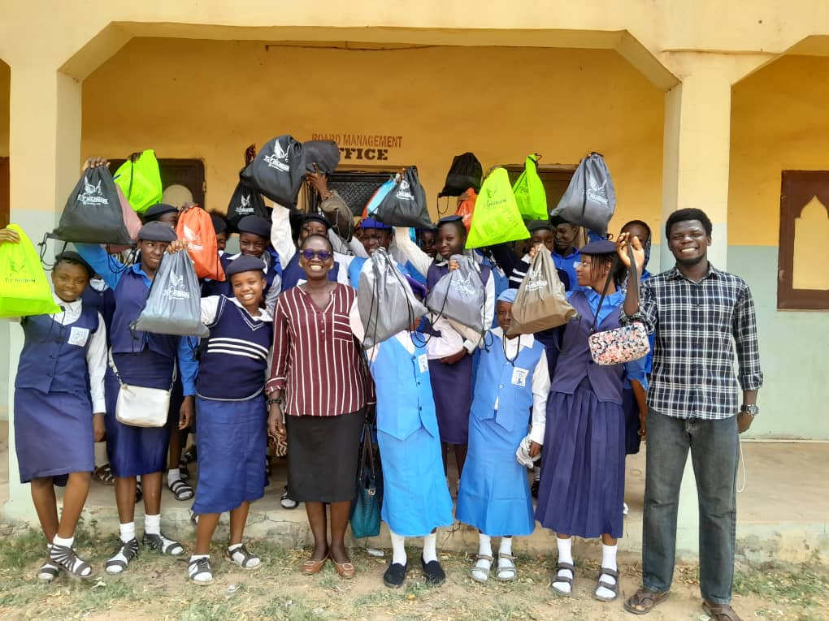
EXECUTIVE SUMMARY
This project will close the disparity between girls and boys in school and reduce the number of girls dropping out of secondary school because they cannot complete it due to a lack of funds and other school materials. It will also break the culture of silence surrounding menstruation and end period poverty for these girls, enhancing their confidence, self-esteem, and self-awareness. It will tackle the root cause of girls not being in school. It will encourage a community to work together to solve their problems.
According to statista.com, by the year 2020, approximately 77 percent of children in Nigeria will have finished the final grade of elementary school, with males having a completion rate of 78.2 percent and females at 77.1 percent. The gender gap between students attending elementary school, middle school, and high school continued to widen, reaching a gap of 13.8 percentage points in the completion rates of high school students and reaching a gap of four percentage points in the completion rates of middle school students. This is just one side of the coin, when viewed by region like the Northern Nigeria where the project is situated the gap is much wider even to unacceptable levels. According to kingmakers.com, the completion rates for senior secondary school education in Nigeria vary significantly by region, with the South East region having the highest completion rate at 82.3%, followed by the South West at 72.9% and the South South at 71%. On the other hand, the Northern regions of the country have much lower completion rates, with the North Central region having a rate of 54.3%, the North West at 36.6%, and the North East at just 33.3%.
It is this gap that this project seek to close by this scheme of seeking and enrolling thirty girls who have dropped out of school. From available data the reason females drop out from primary and not continue to secondary is lack of fees, menstrual shaming and early marriage. The project has activities designed to help in meeting some of this needs like paying the fees and other underlying needs of the girls in the scheme through the six years of secondary school. Because of the enormity of the needs, sensitizations and workshops will be conducted to community and religious leaders who have a strong influence on their followers in seeking to have a behavioral change towards the education of the girl child.
This project is seeking to raise the sum of $13,126.08 to enable thirty girls complete their secondary school education for a period of six years. The sum also covers for some of the menstrual health needs and funds to raise awareness of the importance of girl child education.

PROBLEM STATEMENT
The disparity between boys and girls is wide, and the rate of girls dropping out of school is on the rise. This will mean fewer girls graduating from school than boys. With fewer girls graduating from secondary school, fewer girls will go on to tertiary education. This will mean fewer girls than boys will earn good pay, making girls less financially independent and more dependent on others. More girls will not be able to contribute to the nation’s economy.
The root causes of fewer girls in school are patriarchal systems, beliefs, and cultures that see the girl child as less important than boys and any meaningful investment in a girl is seen as a waste. Another factor that is salient but influences girls being out of school is menstrual period poverty. Girls from low-income homes cannot afford sanitary products, so they will stay away from school because of stigmatization. When the number of days they miss school accumulates, it leads to poor school performance, and they drop out eventually. Without education, girls are vulnerable to early and child marriage, SGBVs, and making uninformed decisions about their health and life in general. They cannot know and claim their rights, and gender inequality will thrive.
GOAL
By providing at least a secondary education, girls will be literate enough and informed enough to navigate life. This will provide a level ground for girls to achieve their potential and contribute their quota as their male counterparts.
OBJECTIVES
- Sourcing for and enrolling girls who have never been in or have dropped out of school.
- Retaining them through school by paying fees for the least privileged among the girls
- Sensitizations and workshops for parents, school teachers, communities, and religious leaders on the importance of girl education.
- Advocacies to religious, traditional, and political.
- Distribution of reusable pads to end menstrual poverty and shame.
- Menstrual health and hygiene talks and workshops for girls.
- Life skills coaching and school mentorships for girls.
IMPACT
With our enrolling and retaining program, the long-term impacts expected are:
- Reduced number of out-of-school girls.
- Reduced rate of girls dropping out of school.
- Increased enrollment of girls in school.
- Behavioral change of parents and communities towards girl child education.
- Increased number of girl completing secondary school.
- Reduced rate of girls in child marriage, SGBVs.
- Steps towards achieving gender equality.
BUDGET
S/N | Item | Unit cost | Amount (N)
 | First year
1 | School fees | 24,000 | 720,000
2 | Text books | 10,000 | 300,000
3 | Menstrual pads | 4,000 | 120,000
4 | Scholastic materials | 4,000 | 120,000
5 | Uniform | 9,000 | 270,000
6 | New Intake/levies | 5,000 | 150,000
 |  |  | 1,680,000
 | Second year
1 | School fees | 24,000 | 450,000
2 | Text books | 10,000 | 300,000
3 | Menstrual pads | 4,000 | 120,000
4 | Scholastic materials | 4,000 | 120,000
 |  |  | 990,000
 | Third year
1 | School fees | 24,000 | 450,000
2 | Text books | 10,000 | 300,000
3 | Menstrual pads | 4,000 | 120,000
4 | Scholastic materials | 4,000 | 120,000
5 | Junior Secondary Examination | 3,000 | 90,000
 |  |  | 1,080,000
 | Fourth year
1 | School fees | 24,000 | 720,000
2 | Text books | 10,000 | 300,000
3 | Menstrual pads | 4,000 | 120,000
4 | Scholastic materials | 4,000 | 120,000
5 | Uniform | 9,000 | 270,000
6 | New Intake/levies | 5,000 | 150,000
 |  |  | 1,680,000
 | Fifth year
1 | School fees | 24,000 | 450,000
2 | Text books | 10,000 | 300,000
3 | Menstrual pads | 4,000 | 120,000
4 | Scholastic materials | 4,000 | 120,000
 |  |  | 990,000
 | Sixth year
1 | School fees | 24,000 | 450,000
2 | Text books | 10,000 | 300,000
3 | Menstrual pads | 4,000 | 120,000
4 | Scholastic materials | 4,000 | 120,000
5 | Senior Secondary Examination | 20,000 | 600,000
6 | Graduation activities | 5,000 | 150,000
 |  |  | 1,740,000
 | Workshops
 | Workshop for girls on menstrual health and hygiene once a year for the duration of project (6 years) | 250,000 | 1,500,000
 | Sensitization and Advocacy
 | To parents, community leaders and religious leaders three times in a year for the duration of the project (6 years) | 50,000 | 900,000
 | Total |  | 10,560,000  ($13,126.08)
Conclusion
This project is borne out of the success story that Life Aid for Community Initiative did in Bako community of the Federal Capital Territory (FCT) where girls who could not continue with their secondary education due to the reasons mentioned above were mentored, enrolled and retained in secondary school. One completed in July 2023, another will be completing in July 2024 while six (6) are at various levels of secondary school.
This project will scale up on these successes and share lessons learnt with critical stake holders with the view of strengthening local instituted structures to make them responsive to emerging challenges.

