When Aid Becomes a Future
Today, we are grateful to share that we are very close to reaching the goal of this campaign, and the progress achieved so far clearly reflects the real and lasting impact of your support.
Since the beginning of the humanitarian emergency in Acapulco, our work has remained constant and committed. Thanks to the joint efforts of donors, volunteers, and the communities themselves, we have moved from immediate emergency response into a phase of consolidation and strengthening, where results are now becoming sustainable on their own.

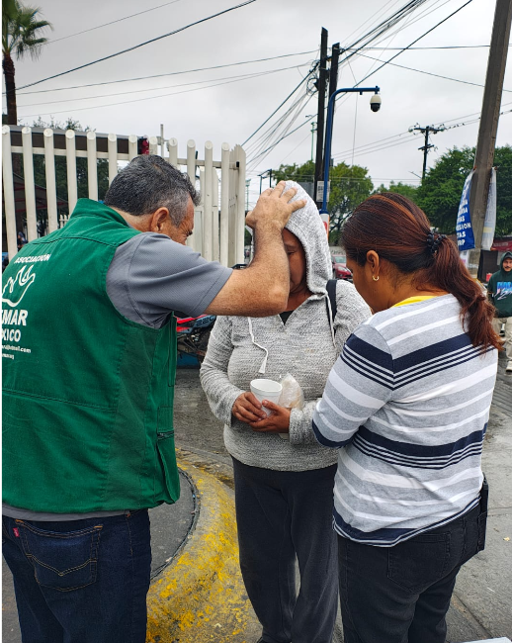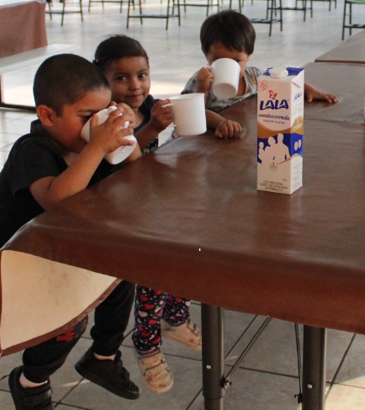
One of the most significant achievements is that many communities are now operating independently. Community kitchens continue to function in an organized manner, with active participation from beneficiaries who are no longer only receiving assistance but are also managing these initiatives themselves. This has allowed families to adapt to a new routine, restoring stability, dignity, and a strong sense of community.
Access to hot, regular meals has been essential for the physical and emotional recovery of hundreds of people. These spaces have become more than places for food—they are meeting points where community bonds are strengthened and hope is renewed.

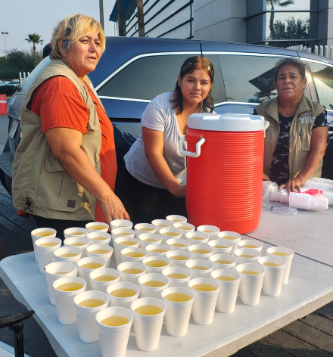

In terms of housing and reconstruction, projects continue to move forward successfully. Families have received materials, guidance, and support, enabling them to improve and maintain their homes safely, even during the rainy season. Today, we see stronger homes and communities that are better prepared to face future challenges.
We are encouraged to see how people have adapted to their new reality, resuming productive activities and actively participating in ongoing projects. This confirms that our focus on self-sufficiency and sustainable recovery is producing meaningful results.
We are now at a decisive stage. With the final push of this campaign, we will be able to fully establish community-led initiatives and ensure that projects continue to operate independently, benefiting many more families in the long term.
We extend our deepest gratitude to everyone who has believed in this mission. Your support has been essential in transforming an emergency into an opportunity for rebuilding and hope.
At Casa Hogar Remar Occidente, we reaffirm our commitment to the people of Acapulco. We will continue walking alongside them until recovery becomes a strong and lasting reality. Together, we are almost there.

