TEAM AND VOLUNTEER

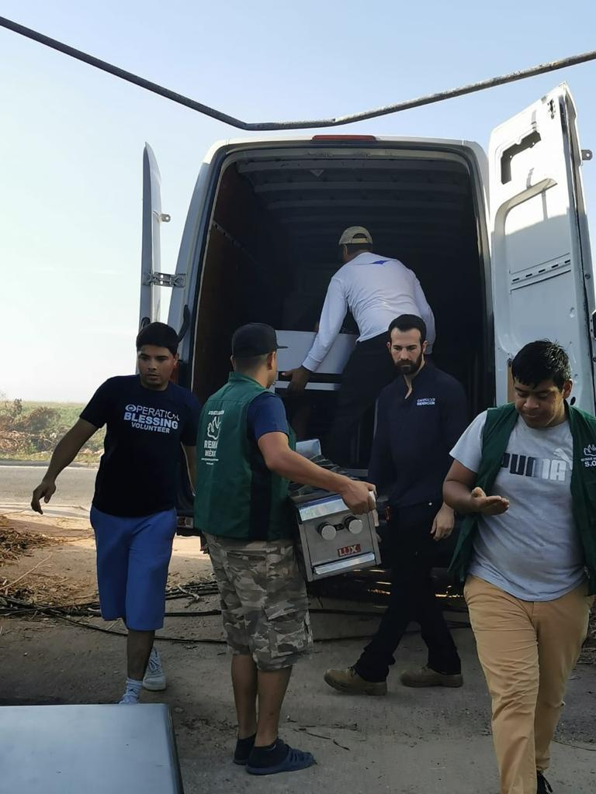

The teamwork and effort of our volunteers has allowed us to channel and deliver aid to the people most affected by the disaster left in Acapulco by Hurricane OTIS.
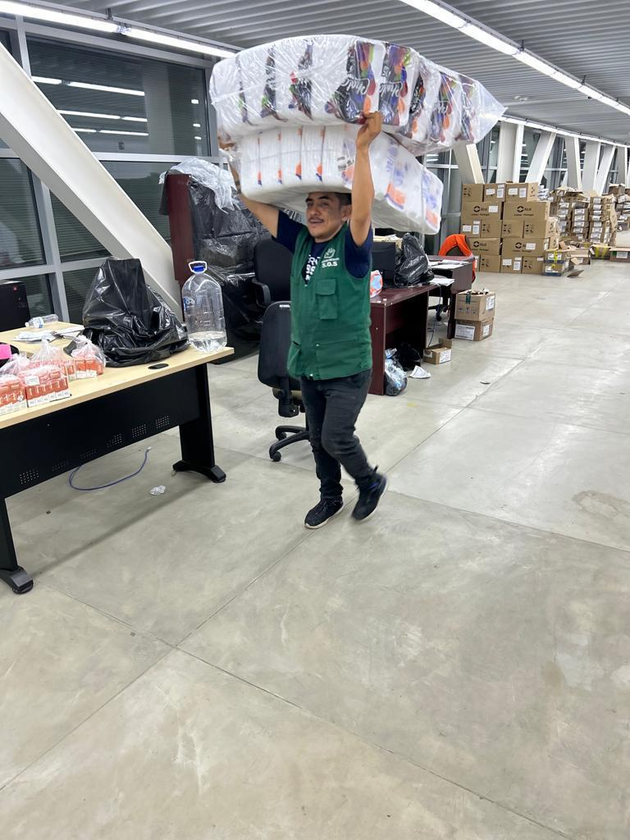

Thanks to the support received, we have been able to cover the cost of transportation of supplies, food, furniture and volunteer hands to deal with emergencies.

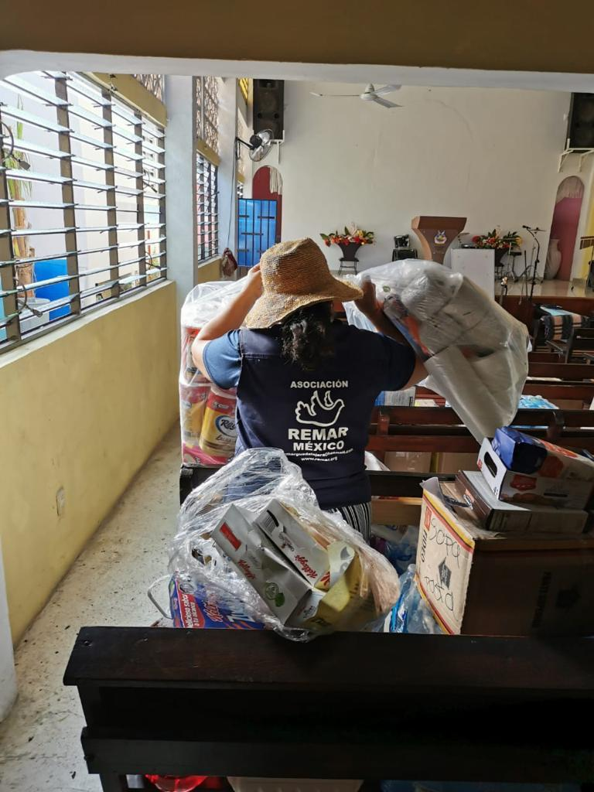

However, our efforts are being hampered by new meteorological phenomena that continue to severely affect this Mexican region, which drives us to remain committed to social work in favor of the population of Acapulco, Guerrero.

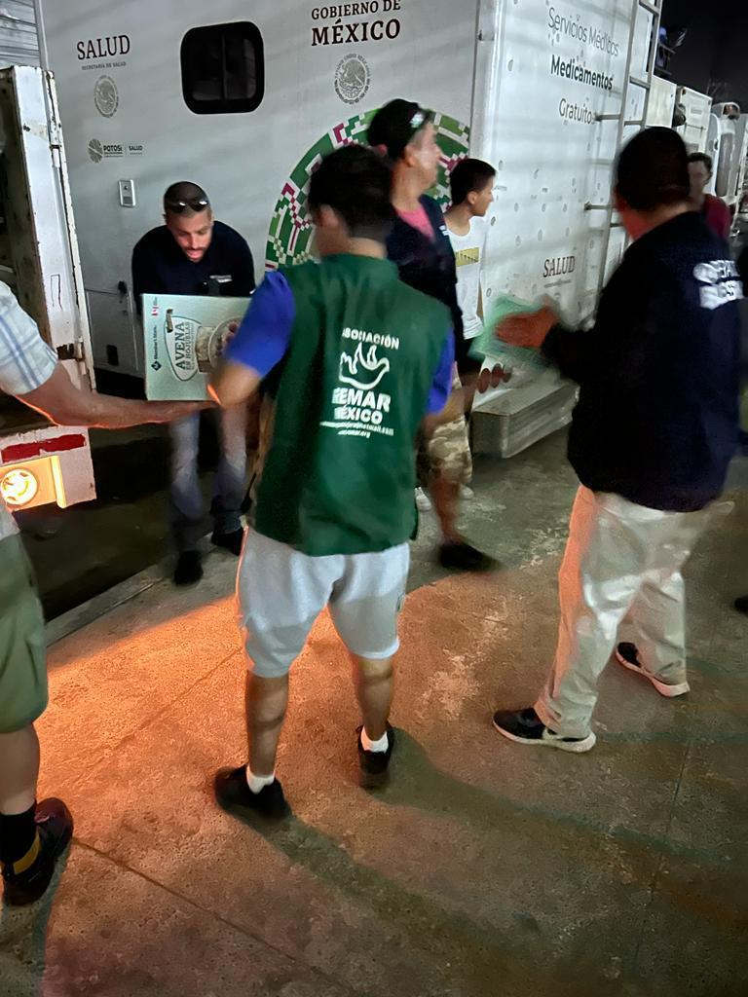

Thank you for your commitment and support!!

