Solidarity in Action: Monitoring the Aid Campaign for Acapulco
Since the beginning of the humanitarian crisis in Acapulco, at Casa Hogar Remar Occidente we have taken on the commitment to provide ongoing support to the most affected communities. This work has not ceased, and today we want to share the progress, challenges, and impact of the campaign, which continues thanks to the solidarity of our donors and volunteers.
Despite the time that has passed, the recovery process in Acapulco remains a major challenge. However, it also represents an opportunity to continue demonstrating our commitment to those who need it most. The situation remains critical in many areas, and for this reason, we have decided to maintain and strengthen our humanitarian actions. We continue to send donations regularly, prioritizing the most urgent needs and adapting our response as the emergency evolves.
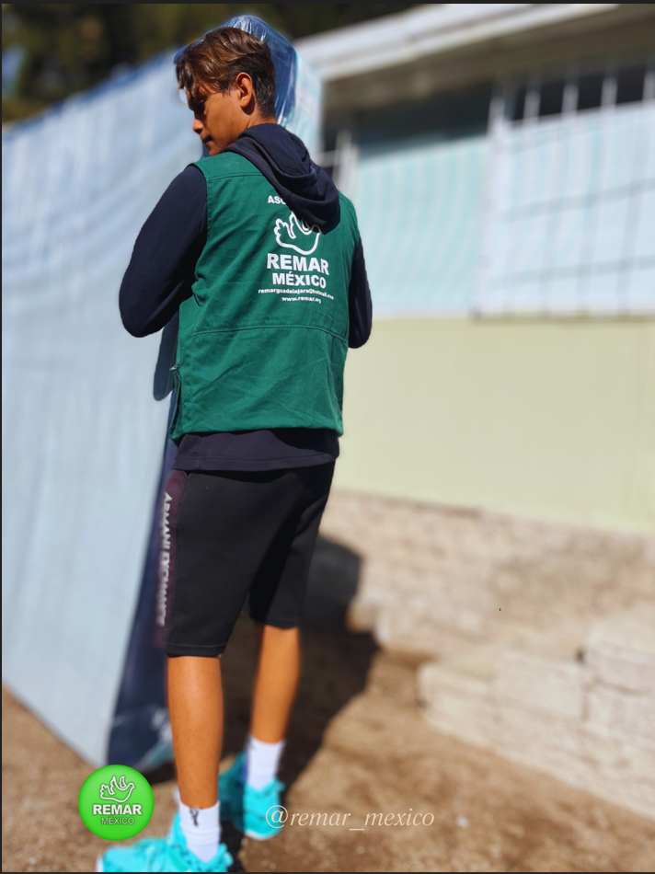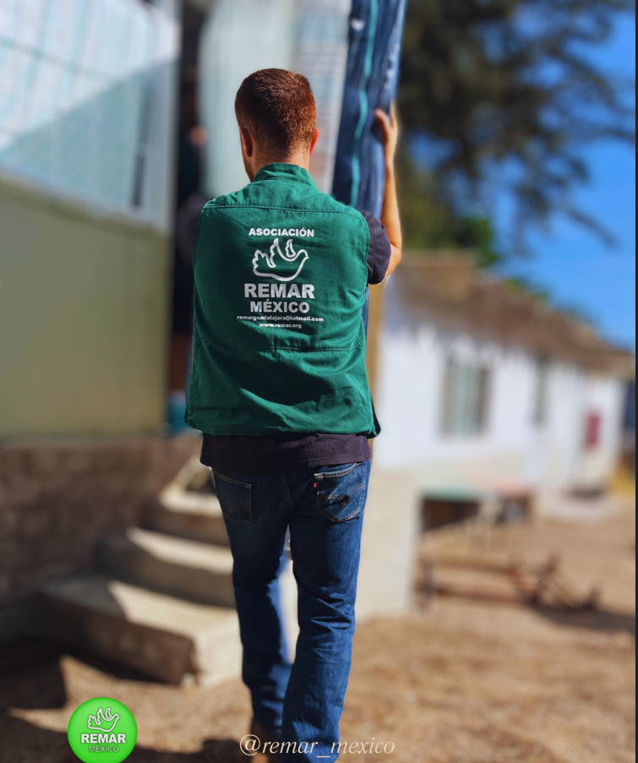
Food remains one of the most pressing needs. In response, we have managed to keep several community kitchens operational, providing hot meals daily to hundreds of people.
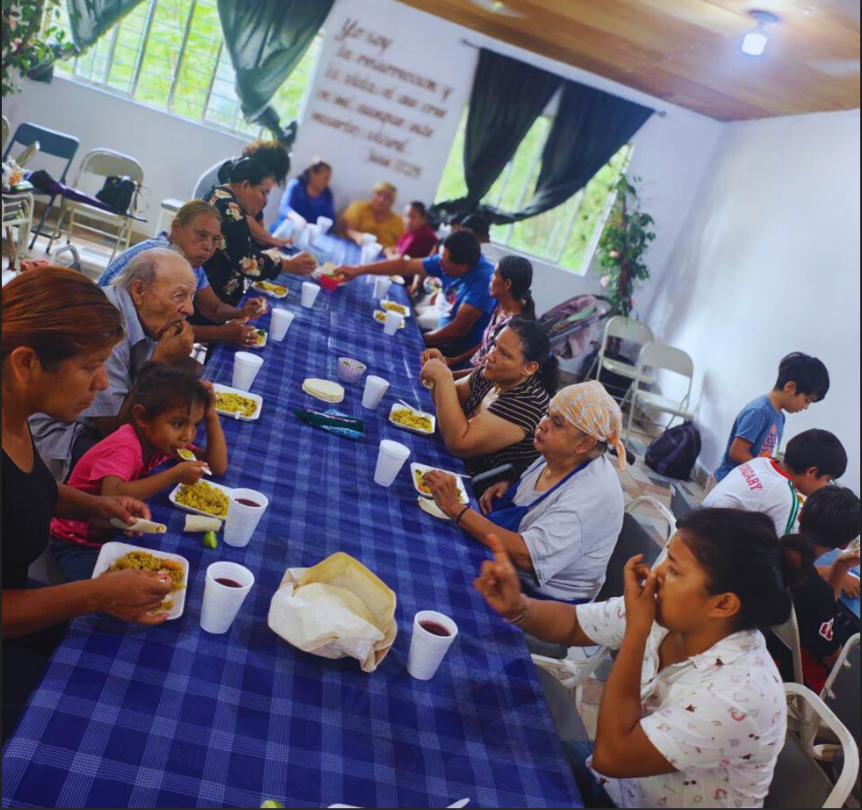
These spaces not only offer nourishment but also serve as places of gathering, support, and hope. All of this is possible thanks to the unconditional efforts of our volunteers and the support of our donors. We have expanded our efforts to include the reconstruction and maintenance of homes. We deliver materials, provide technical guidance, and work hand in hand with communities to promote self-sufficiency and sustainable recovery.
We understand that having a safe and dignified home is essential to restarting life after a tragedy. With the arrival of the rainy and cyclone season, we are redoubling our efforts to ensure minimum safety conditions for the most vulnerable families.
Our approach goes beyond immediate response. We aim to foster a strong and resilient recovery, restoring people's ability to rebuild their lives with dignity, independence, and security.
We reiterate our deepest gratitude to all who have made this mission possible. Thanks to your trust and support, many people today have a daily meal, a more stable roof, and the hope of a better future.
At Casa Hogar Remar Occidente, we reaffirm our commitment to the people of Acapulco. Recovery is a long road, but together, we continue moving forward step by step.
We still need your support. The emergency is not over, but with solidarity and commitment, every contribution makes a difference.
