Continuing Our Commitment

The recovery process in Acapulco remains a major challenge, but it is also an opportunity to continue demonstrating solidarity and commitment to those who need it most. Despite the difficulties, we have remained by the side of the people most affected by the crisis.

Food continues to be one of the most urgent needs. For this reason, we are keeping the community kitchens running, ensuring their daily operation thanks to the efforts of volunteers and the generosity of donors. These spaces remain a vital source of support for many families who have not yet regained stability in their lives.

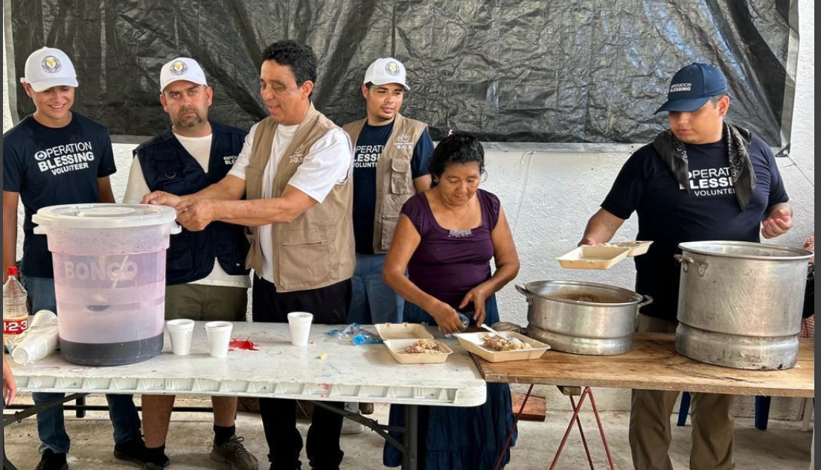

In addition, we have expanded our support through the reconstruction and maintenance of homes. With materials, guidance, and collaboration with the communities, we aim not only to respond to the emergency but also to contribute to long-term recovery—promoting self-reliance and the reestablishment of livelihoods.
We know that having a dignified place to live or work is essential for starting over. However, it is also urgent to ensure safe spaces ahead of the upcoming rainy and cyclone season, which poses an added risk for families still living in vulnerable conditions.
Our goal is not only to respond to the current emergency but also to help build a more solid and secure recovery, fostering independence and restoring people’s ability to sustain themselves.

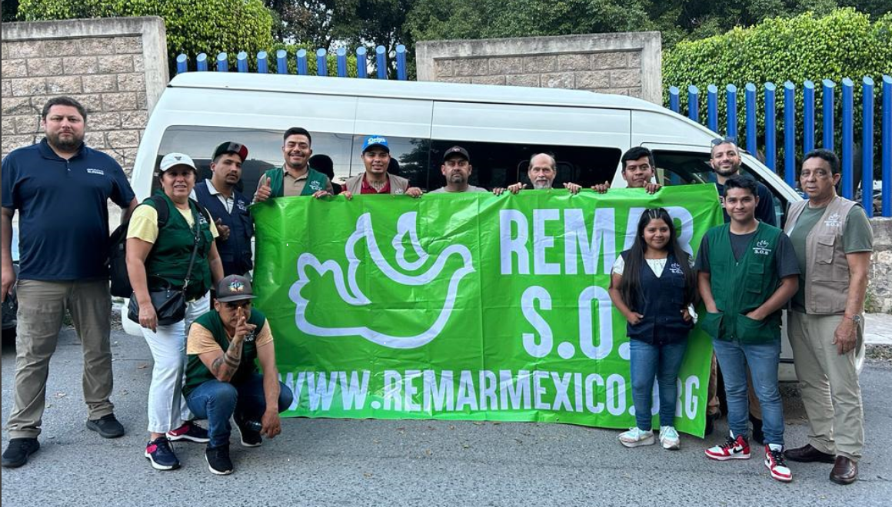
Our commitment remains firm. We know there is still much to be done, but we also know that we are not alone. Thanks to those who have placed their trust in this mission and contributed to it, more people now have access to a hot meal, a safer roof over their heads, and the hope of a more stable future.

