“Unleashing the power of women and girls through education, leadership and fellowship”

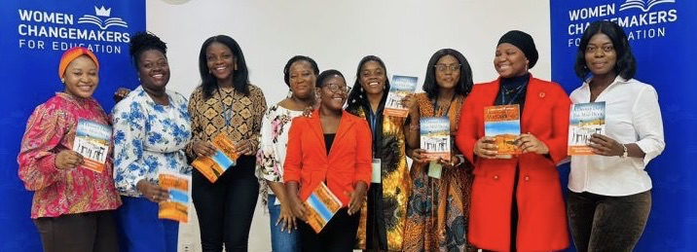

Global Giving Update: July 10, 2025

Dear friends and supporters,

Thank you so much for your recent contributions to Women Changemakers for Education via Global Giving. We asked you to support Cohort 3, pictured above, and their efforts to bring quality education and resources to girls in their communities. We are happy to share some of their accomplishments!

Through International Women’s Day, we responded to the theme of “Accelerate Action.” Among other things, we….

  - Donated $4,800 for grassroots programs (up from $1696 in 2024),
  - Served 7 of Ghana’s 17 regions,
  - Reached over 8,000 students with improved computer literacy, and increased digital confidence,
  - Directly impacted 41 girl students through STEM education, and youth mentorship,
  - Expanded entrepreneurial skills in sewing and dressmaking for 100 girls/women,
  - Trained 15 young female business leaders to build their business websites,
  - Sensitized over 200 girls, women, and community leaders on gender-based violence issues, resulting in increased confidence in reporting among women and greater active involvement from men and community leaders.
  - Strengthened ongoing peer support networks among women and girls,
  - And much more!

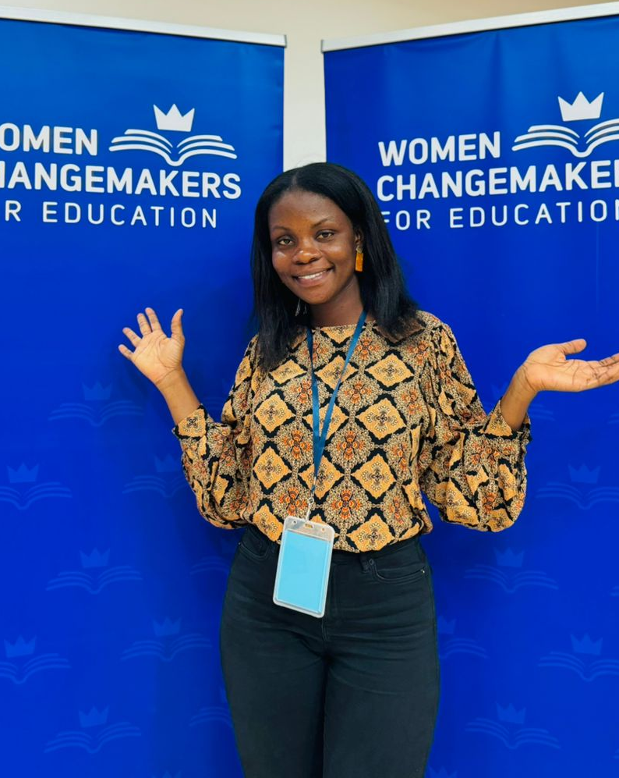
From the above, we hope you appreciate the breadth of our Fellows’ work at the grassroots and take pride in supporting the wide-ranging impacts they are having on girls’ education. To quote Patience Antwi of Cohort 3,

“It’s not just a Fellowship but a movement!”
As ever, we thank you!

Kind regards,
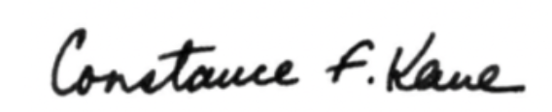

Constance F. Kane
Executive Director

