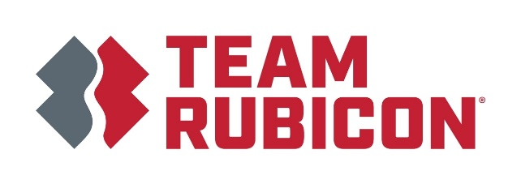

Team Rubicon International: Guatemala Disaster Risk Reduction and Water, Sanitation, and Hygiene

Community Need: Ranked the 10th country in the world most exposed to disasters by a 2020 World Risk report, Guatemala’s physical location between the Caribbean Sea and the Pacific Ocean makes it vulnerable to events like hurricanes, extreme flooding, and landslides. Guatemala is also ranked as one of the most impoverished countries in Latin America, making community members especially vulnerable to disasters and crises. At the same time, the country faces critical needs related to health as well as water, sanitation, and hygiene (WASH). More than half of all Guatemalans lack access to clean water, and more than 30% of the population in rural areas lack access to any kind of sanitation services.

Team Rubicon’s Services: In response to frequent natural disasters and WASH needs, Team Rubicon International (TRI) is establishing a physical presence in Guatemala City while expanding our disaster risk and reduction (DRR) and water, sanitation, and hygiene (WASH) services in Guatemala. These efforts will help improve the health, safety, and well-being of Guatemala communities. Services will include:

- DRR: TRI will help develop community members’ skills to respond in the event of emergencies or natural disasters. The team will train key medical and non-medical community members in courses like Community First Aid Responder (CFAR) and Basic Emergency Care (BEC). BEC is a course developed by the WHO and has proven effective for rural primary care medical professionals to better support their communities in the event of an emergency.

- WASH: TRI will train community leaders, water specialists, and women on rainwater system installation, maintenance, and WASH best practices. Trained individuals will also lead trainings themselves in partnership with TRI following their initial training completion, expanding the number of people that can help ensure access to safe drinking water. These efforts will enable individuals to harvest, store, and treat drinking water safely. Concurrently, TRI will conduct hygiene training for children and basic sanitation training for community members. Improving handwashing and sanitation practices in communities will promote better health outcomes and reduce water-borne diseases.

Measurement and Evaluation: TRI will distribute, collect, and evaluate pre-, post- and long-term retention surveys to assess community members’ knowledge of materials. As we build out this program, TRI plans to begin by collecting the following metrics, which will expand throughout the development of our services in Guatemala and be updated accordingly.

- # of People Trained
- # of Trainings Conducted
- # of WASH Systems Updated
- # of People that Retained Skills/Practices
- # of Communities Served

Funding Need: Team Rubicon seeks $150,000 to pilot our programming in Guatemala. The total budget for one year of services is approximately $1 million. We appreciate your time and consideration of supporting TRI’s DDR and WASH services in the country.

