

GlobalGiving News Letter June - October 2024
One Million Trees for Peace Project - Nigeria
A Renewed Push to Bring Back Our Forest
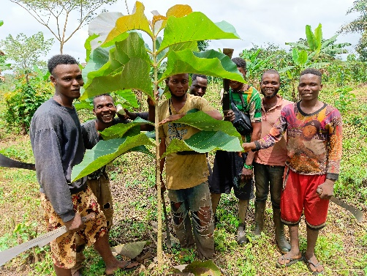
Even more than before, the One Million Trees for Peace Project is committed to restoring our lost forest in Africa. With our renewed commitment in forest regeneration, we are bringing back some indigenous tree species like Opepe, Omar and White Afara. We are continuing to provide jobs for the less privileged people in Africa while also sustaining the African forest biodiversity. Without the support of Bauknecht Foundation Germany, our Association Bernadette Strebel World Peace and our GlobalGiving Partners couldn’t do this. We hereby send our deep hearted thanks and appreciation to our loving partners.
Figure 1: Workers around a success-fully planted tree.
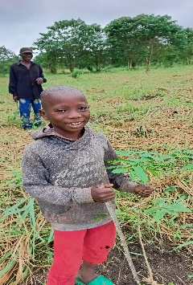
16.5 Hectares of Deforested Land Planted
We are pleased to inform our donors that the 16.5 hectares of deforested land, which we reported as prepared in our last edition, have now been planted. Both indigenous and exotic tree species were used. With a smiling face Master Yakubu Abu stands next to an indigenous forest tree planted in June 2024.
Figure 2: Yakubu Abu next to an indigenous tree.
A renewed care for planted trees
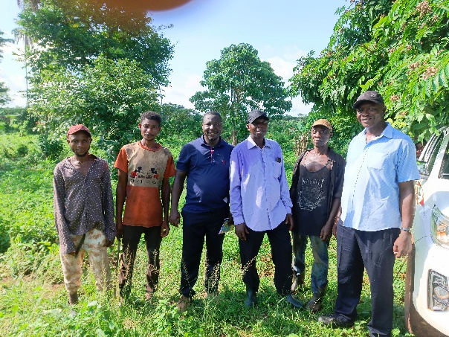
In any forest regeneration project, weeding is the most challenging and cost-intensive operation. From August to September 2024, the 16.5 hectares of land planted in June and July were ring-weeded and subsequently weeded. This was a difficult operation as the workers had to work in the rain. Additionally, the 5.5 hectares of forest planted in 2023 were also weeded. These efforts are crucial to protect the young forest trees from competition for soil nutrients with weeds and climbers, as well as beaing eating by rodents or grasscutters.
Figure 3: Workers after a hard day of working.

Beat-up operations
We are pleased to report that some of the baby trees planted in June and July that did not survive could be replanted. After weeding, our forest supervisors carry out a forest inventory to identify dead trees, and those found dead were replaced. This is an ongoing process. Moreover, seedlings that were planted in other areas in 2022 and 2023 but did not survive, were replaced as well. To complete this work, we need an additional $3000 for seedlings and wages. We kindly ask for your continued support.

Worker’s welfare
Worker’s welfare is taken seriously by the Board of Association Bernadette Strebel world peace. Even though, some workers sustained injuries during forest operation. The workers were treated, and they are fully back to work.
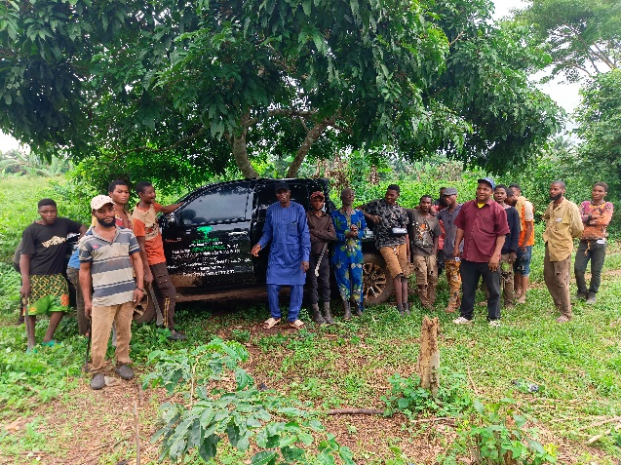
As part of our commitment to workers’ welfare, we are passionately asking for your support to build huts in the forest for our workers. These huts will provide temporary shelter for the workers during rain. Workers resume to forestry work by 8am daily, and with the help of huts, preparing meals like roasted plantain, yam or cooked rice, beans and other edibles would be possible.
Figure 4: Workers next to a project vehicle.
The cost of this is estimated to be $7000. If funds are available, we intend to sink a borehole for water and install a small solar light, allowing the worker to charge their mobile phone and mini radio.
This will go a long way in motivating them, as they love to enjoy more time in the forest. It will also help to reduce the cost of fuel and the usage of the workers project vehicle.

Support us by sharing our Newsletter
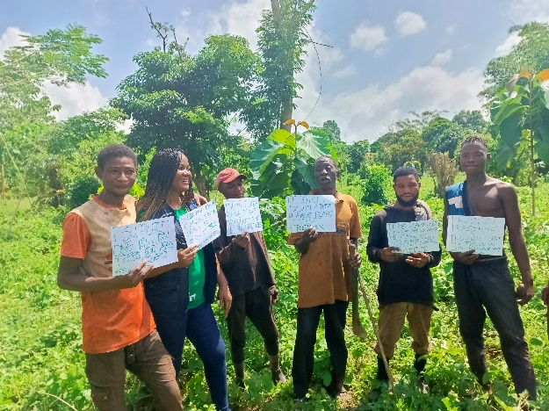
Larger projects require greater support. In 2024 our initial budget aimed to regenerate less that 5 hectares, but due to our dedication to restoring the forest, the workers successfully prepared 16.5 hectares. This are also has been planted. We need more support to pay for these workers for the maintenance operations and replanting of trees that didn’t survive. Your contributions will help us pay the workers’ wages, allowing them to support their families and pay their children's school fees.
Figure 5: Notes to us from our Nigerian workers.
Finally, we would like to express our heartfelt gratitude to Mr. Christian Gut for his generous donation for trees in commemoration of his dear mother’s transition to the LIGHT. We also thank the Association Bernadette Strebel World Peace for approving funds that enabled us to pay for the restoration of the Project Manager's official Toyota Hilux.
If you are interested in Joining our team you can contact Laura Schirlo at laura@bsworldpeace.org

