

GlobalGiving Newsletter June 2025
One Million Trees for Peace Project - Nigeria

ABSWP delegation and family Bauknecht visit Nigeria

After landing in Benin City around afternoon on the 3rd of June, we were greeted by a traditional dance and our Nigerian team of ABSWP. From the airport, we made our way to the hotel—graciously arranged by the Governor of Edo State. Without wasting any time, we began our journey of meetings and meaningful encounters.
Our first stop was the Edo State Ministry of Environment and Sustainability, where we were introduced to the staff and warmly welcomed. Dr. Festus Onogholo, project manager for the African side of ABSWP, introduced the European and Nigerian teams and outlined the project’s mission and vision. Words of gratitude and appreciation for the continued collaboration were shared on both sides. In anticipation of the tree planting flag-off on World Environment Day, shirts and caps were handed out to all participants to wear.
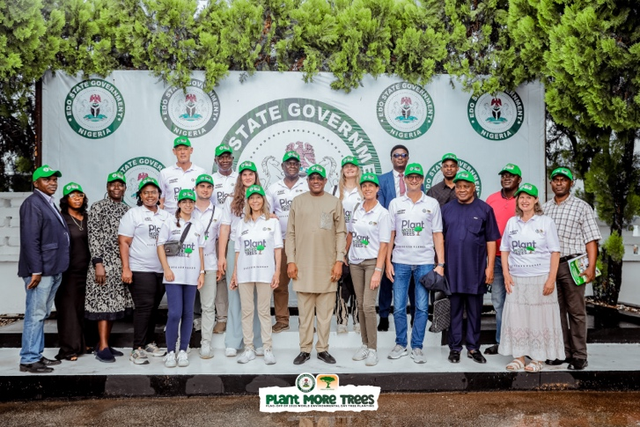
Next, we were received at the office of the Governor of Edo State by the Chief of Staff, Honourable Gani Audu, and his team. The ABSWP delegation was formally introduced, and we expressed our heartfelt thanks for the generous hospitality, security, and ongoing support provided. We reflected on the strong and long-standing partnership and looked ahead with excitement to the upcoming ceremony on June 5th. Once again, shirts and caps were distributed by Dr. Festus Onogholo and Bernadette Strebel, President of ABSWP.
The last meeting of the day was with the honorable Dr. Valentine Asuen and his team, where we cheered to each other with a non-alcoholic malt beer to the ongoing collaboration. Outside the building, Bernadette Strebel and honorable Dr. Valentine Asuen were interviewed by a TV team and we later got to take group pictures.
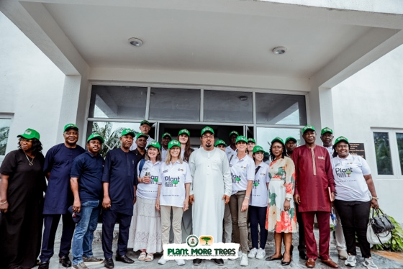
After a long and successful day, some team members of the ABSWP made it back to the hotel and others visited the plant nursery, where the small seedlings are being taken care off before they are ready to be planted.
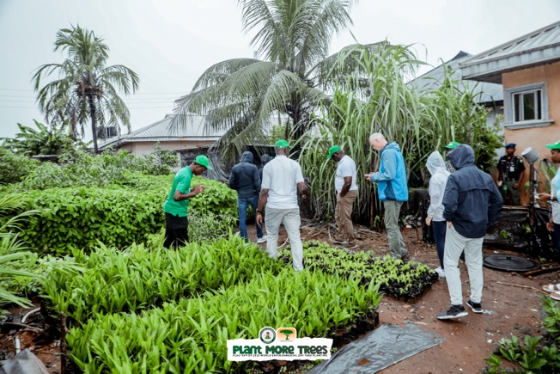

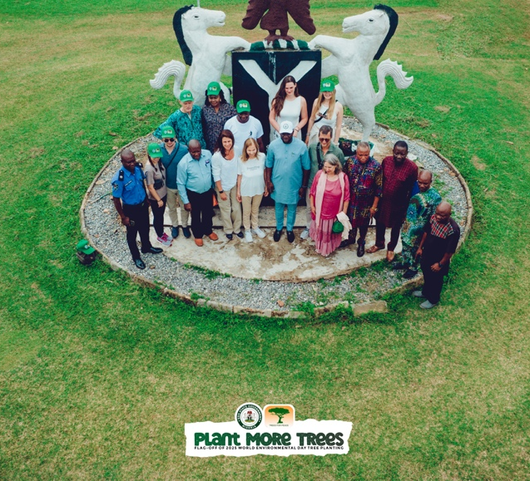
On the 4th of June, we had breakfast at the hotel and shortly after made our way to the team of Acting Chairman of the Local Government Council in Ehor, Mr. Benjamin Iredia. We were introduced to each other and stated how grateful we are for the amazing collaboration and the enthusiasm for the project.
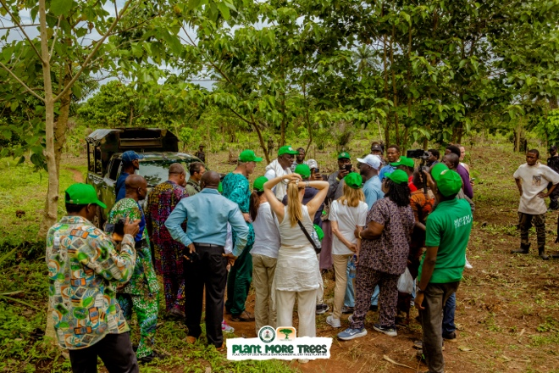
Together, we travelled to the Trees For Peace plantation in Ehor, where we toured different zones of the forest—ranging from one-year-old saplings to thriving ten-year-old trees. Everyone was deeply impressed and moved by what had been achieved through collective effort and commitment.

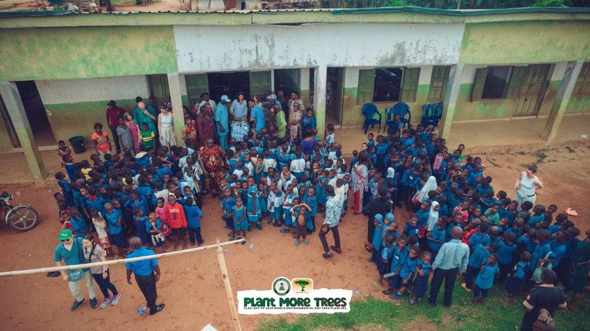
After an amazing afternoon spent in nature and in the forest, we were headed to the school. We were kindly greeted by many shy children’s eyes and excited teachers. We greeted and introduced each other, and following Bernadette Strebel’s heartfelt wish, we distributed school notebooks and pencils to the students.

Following such an eventful, emotional and amazing day, we headed to a restaurant to get a late dinner and then to the hotel for a much needed, long night of sleep.

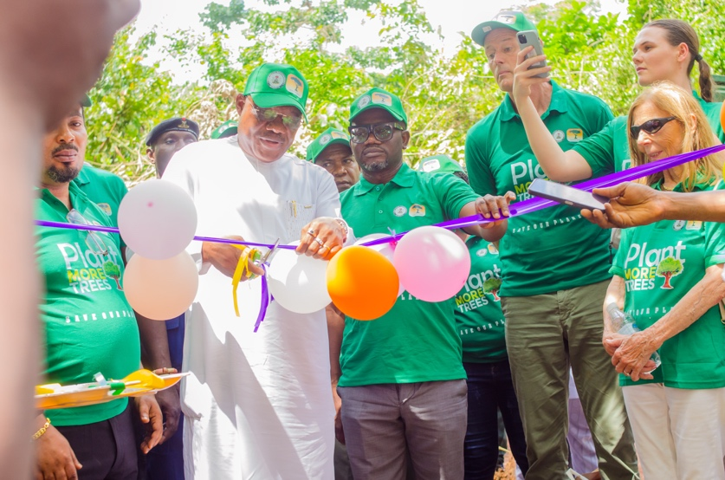
The next morning, we all excitedly got up in anticipation of the flag-off ceremony for the 1 million tree project on the world environmental day.
On our way to the Ehor plantation, we stopped at the headquarters of the Edo State local government, where we joined Honourable Gani Audu, Honourable Dr. Valentine Asuen, Mr. Benjamin Iredia, and other dignitaries, all ready for the celebrations ahead.
Our first stop was deep in the forest, where Honourable Gani Audu, together with Honourable Dr. Valentine Asuen and Dr. Cyril Adams A. Oshiomohole (Commissioner for Health, Edo State), inaugurated a 28.5-hectare reforestation area to officially launch the event.
Followed by that, we were given an amzing tour by Dr. Festus Onogholo through different areas of the forest, looking at small seedlings to meter-high trees.

We then headed to the nicely decorated festivity area, where we sat down in the shade. Speeches from different people were given, all excited about how far the collaborative project has come, the promised efforts that will be put into the project in the future and how important the impact of humans and their doing is on the environment. To wrap up the ceremony, new seedlings were planted, and we danced to let the ceremony wind down.
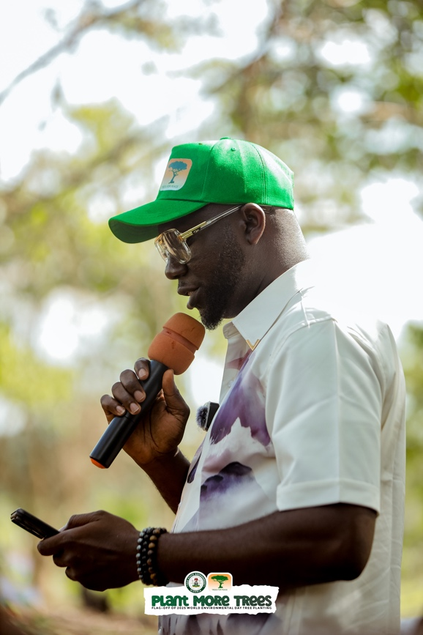
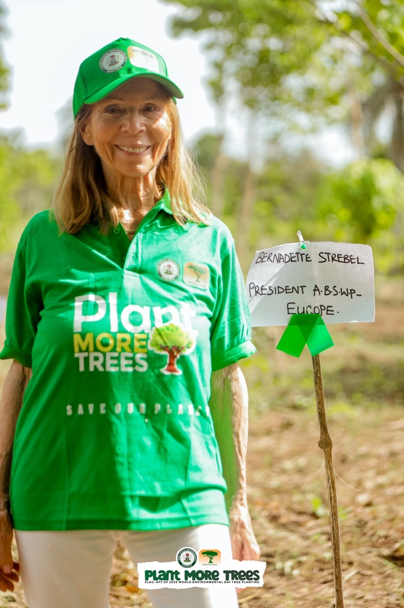

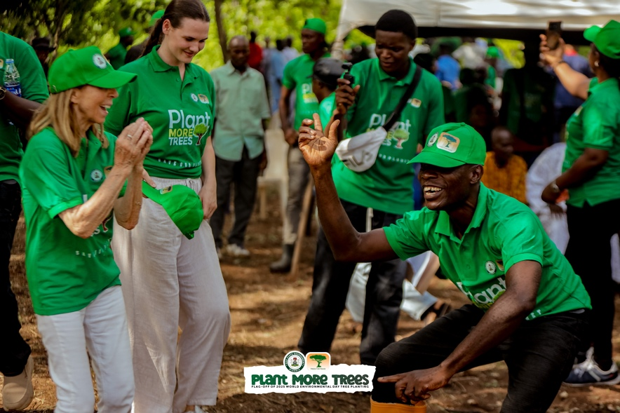
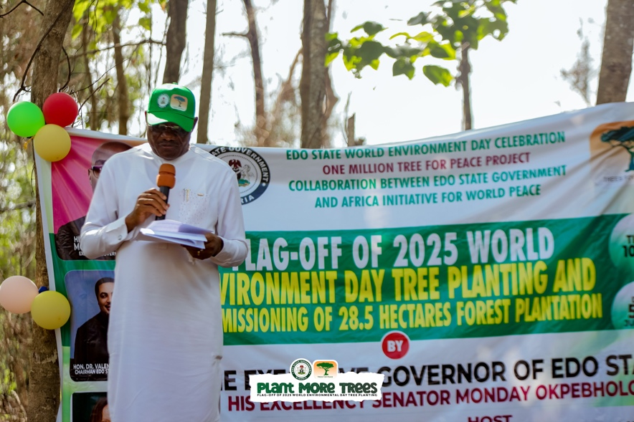

For the ABSWP delegation, the day was not yet over. Bernadette Strebel was nominated for an award to recognize and appreciate the impact of individuals or organizations for the contributions for the environment. We therefore drove to the ceremony location and were able to listen to experts talking about plastic pollution and the impact thereof on the environment. We attended the ceremony, where we listened to enlightening talks about plastic pollution and its effects on the ecosystem. In a moment of happiness, honor and joy, Bernadette Strebel received the award - joined on stage by her granddaughter Maria-Angela.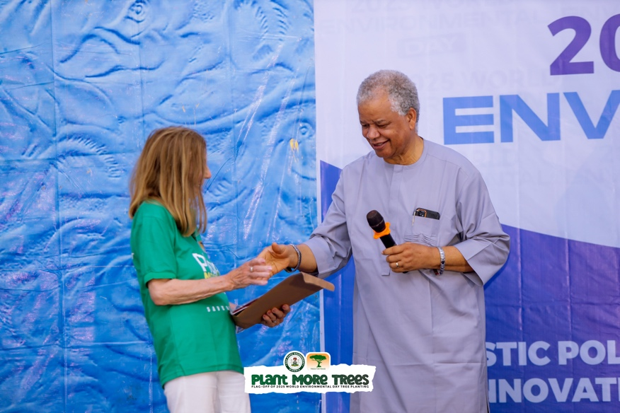

The following evening, we were honoured to be invited for a farewell dinner hosted by Honourable Dr. Valentine Asuen. It was a warm and heartfelt gathering, filled with gratitude, reflections, and hopes for the future. The next morning, we said our goodbyes and boarded our flight home - carrying with us unforgettable memories and a renewed sense of purpose for our mission.

For more information, find some links attached below:
https://www.youtube.com/watch?v=8lI8-sB5wbI
https://www.youtube.com/watch?v=r2_0ZHZ0upU&t=3629s
https://www.youtube.com/watch?v=ICG_Y5d2T_4
https://www.youtube.com/watch?v=Cy2u-ZRVnb8

If you are interested in joining our team you can contact Laura Schirlo at laura@bsworldpeace.org

