Self Managed Home had been a place for
- Socially went through challenging situations like child labour, raped survived, child marriage
- Financially weak
- Need to continue education
Background:
In 2018, Console Mission had a project called Rescue Support Services to manage places for the people abandoned in the street. Console since its starting had been assisting the Shelter Homes, mainly elderly/aged homes, by providing relevant training to its human resources. And, found that the origin of those beneficiaries is street. They were found by police, or someone brought them finding in the street. Console Mission had been weekly monitoring the streets and street corners of the Kathmandu valley and even in the sides. A room was set up where someone rescued could be brought. The plan was to hold them maximum for fortnight until their need is found. Console Mission had good number and various types of Shelter Homes like some put aged female or aged male or both. And there were homes for children, for those suffering from diseases, mental health conditions and physically impaired. There was an unpleasant situation that was found that a girl half naked was lying and behaving psychologically distracted close to two hospitals in Lalitpur called Lagankhel. She was lying and playing with the papers and clothes surrounded her. And people were watching her. She was doing that smiling and she looked jubilant. But that was not a pleasant thing to see. There were some females who wanted to help her but there were crowds that they could not do anything. Console Mission thought that could be a girl that was once rescued and placed in a home, but she ran away. At the very young age below 18, she was found smoking fag.
Console Mission started working in rural communities starting from 2016. And there were volunteers coming for monthly meetings and for training. Therefore, the room was empty. In this situation there were 7 students who completed their grade 10 and planning to continue their studies. They were the scholarship students. Among them there were 3 who were planning for technical subjects. They needed to prepare for the entrance examination. It was at the start of 2019. After they got through the entrance, they started their further studies and since they could not afford to manage living in a hostel, they asked to continue living with Console Mission. They were occupying one room. They have a timetable to cleanup, cooking and purchasing goods necessary. Working in community and peaceful rally to abolish human trafficking, Console Mission faced a situation that teenage girls were suffering. If they want to continue their studies that is a burden for the family - 3 girls were getting help. And there were child labour and forced marriage and even rape cases. Following the Rescue Support Services project working style, Console Mission needed to bring them, do social, health and all together need assessment before they are placed in the proper place. Console Mission knew that it is not supportive to continue in a rented flat that they can stay for long. Among the 3, 1 girl who could not go to her home because she had no parents and the other 3 girls related to child labour, raped, they were found a place. But that place was not suitable because there were girls who were rescued from certain situation that these 4 girls never knew. They had social issues and problems, but Console Mission knew that being with those in a safe home organised by another NGO would not be suitable. That home was also taking time for admission to school for 2 girls. They were planning to move to any city. These girls were handed by the community who did not want them to go to another city. In that situation, Console Mission with 3-year agreement with the house owner continued providing shelter for 6 girls. And in one room 4 beds was possible, the capacity was 8. Similarly Console Mission is in a hub city, girls come for colleges who could hardly afford hostel fee. To manage financial needs, Console Mission opened 2 beds for outsiders as a monthly paid but not that high as hostel charges.
Impact of Self Managed Home:
- When it was running it was a hope for the children who were about to attend grade 10 because after that there is no colleges that they could join
- Before, children had no hope, walking a long way to school was a waste of time rather they take care of their livestock and focus on growing vegetables. Because after completing grade 10, they have to manage living costs and tuition fees. And migrating to a new place, far from home is already hesitating. But SMH home was a hope.
- When it stopped in July 2023 girls were facing a similar situation. Those who came to attend college in the closest town, returned because they could not afford it. Like Sushmita, age 15 passed her grade 10, she knew she will get place at SMH, but she did not because it was in a transition period (that is now). She joined a college, Console Mission helped to get a scholarship for tuition, but since she could not afford the rent, she returned home. Console Mission is following her and planning to visit (October 2023)
Overall Console Mission started, as a test project called CSELAP, under it based on the need SHM was necessary. Now we need to start this project to help children from rural areas where there are not further solutions then coming to urban areas for further study. Otherwise 'wheel of illiteracy continues rotating'. And still children, mainly teenage girls, become vulnerable to various types of human trafficking and social issues.

Financials Fund Management Plan |  | Cost | Total Cost
Land square feet | 2738 | 250,000 | 2,500,000 | Countryside but close to the schools
Construction | 2738 | 1,460.92 | 4,000,000 | using interlock brick
Furnishing rooms  (average per room) | 8 | 43750 | 350,000 | Sleeping Room 3, Recreation, Library/study, Prayer, Warden's room, computer and other including Kitchen, Bathroom, Toilet 2 (inside outside)
Misc, wall, gate, watch house |  |  | 290,000
 |  | NPR 7,140,000.00
 |  | USD 51,000.00
Based on the experiences, after teenage girls who are motivated directly or indirectly for marriage, they continue their school living at Self Managed Home. Later their children, whom they abandoned or let them go, do well in their studies, parents welcome them home. Therefore, until the children complete their school and are capable of being independent and taking the right decision, they will stay. The plan is they stay until the age of 18. During this time, they will be capable of earning.

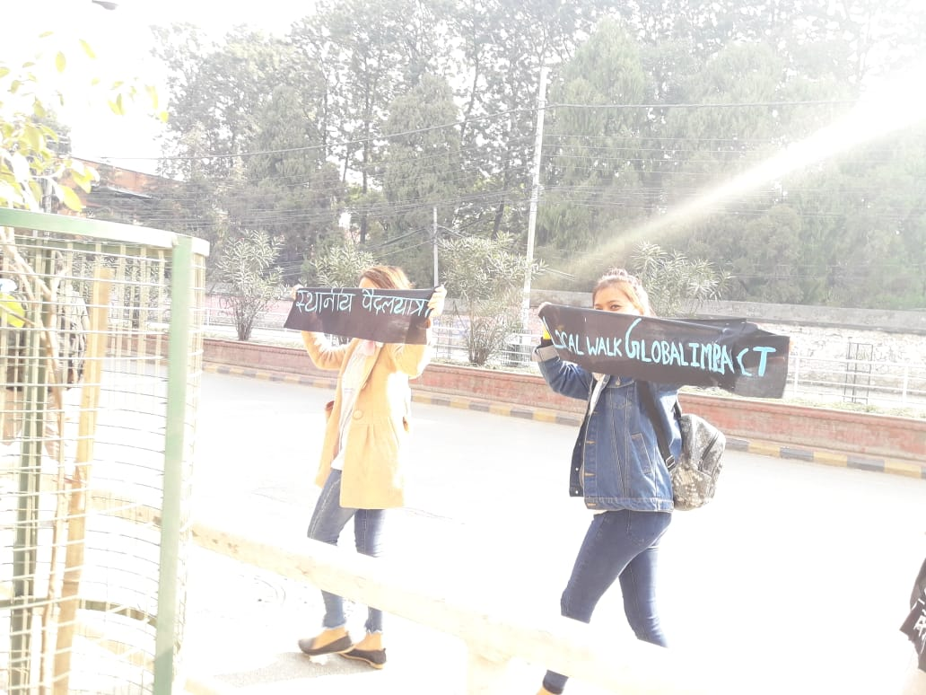Console Mission

