Project Report
Project Title: She Belongs: A Daughter’s Right to Be Family
Organization: Console Mission (CoMi)
Date: February 2026

Summary
In February 2026, Console Mission took important steps to strengthen its work in rural and urban Nepal. Following board discussions, members sought permission to continue Our Study Place—a vital base for understanding the needs of schoolchildren. This initiative laid the foundation for our project She Belongs: A Daughter’s Right to Be Family, which addresses the urgent need for safe, supportive environments for girls who lack parental care.

Story & Activities
- Village Engagement: In the second week of February, two board members formally approached village authorities with a letter to secure permission for continuing Our Study Place. This center helps identify children’s needs and prepares them for life after school.
- Self-Managed Home: From this foundation, CoMi launched a Self-Managed Home in an urban flat with three rooms—one for sleeping, one for study, and one for cooking. Initially, no women volunteers stepped forward to support the girls. In response, a founding member, himself a father, took responsibility under safeguarding policies. He minimized personal interaction while ensuring structured timetables for study, cooking, cleaning, and daily routines.
- Urban Challenge: Land costs in urban areas remain a major barrier. Yet cities are the hubs where children from across Nepal come for education. Those with relatives may manage, but many—especially girls without parental support—struggle. In Nepali society, girls are still too often not seen as equal family members, making this project essential.
- Network Support: CoMi continues to leverage its network to place children under age 10 without parents in hostels and to manage scholarships. While profit-focused hostels exist, CoMi identifies affordable, trustworthy options.
- Beyond Shelter: The Self-Managed Home is more than housing. It connects with schools and colleges, offering activities and counseling to help girls stay focused on their studies. It also provides timely support when personal or social issues create barriers. Importantly, it addresses the growing trend of teenagers planning to migrate abroad for work or study, helping them see education as a pathway to dignity and opportunity at home.

Impact
- Girls gained independence and responsibility through structured routines.
- Vulnerable children accessed hostels and scholarships through CoMi’s network.
- The Self-Managed Home became a hub for counseling and academic support, reducing dropout risks.
- The project highlighted systemic challenges—urban costs, societal attitudes toward girls, and migration pressures—and offered innovative, cost-conscious solutions.

Challenges
- High cost of land in urban centers.
- Limited volunteer engagement, especially from women.
- Societal norms that undervalue girls as family members.

Looking Ahead
CoMi envisions scaling the Self-Managed Home model to connect more deeply with educational institutions, expand counseling services, and strengthen scholarship support. With sustained donor engagement, we aim to build a future where every girl belongs, is valued, and has the opportunity to thrive.
"From 2019–2023, CoMi’s Self-Managed Home gave vulnerable girls without parental support a safe place to live, study, and grow—turning dreams of belonging into reality."

Story Title: Sirjana wasn’t hopeless
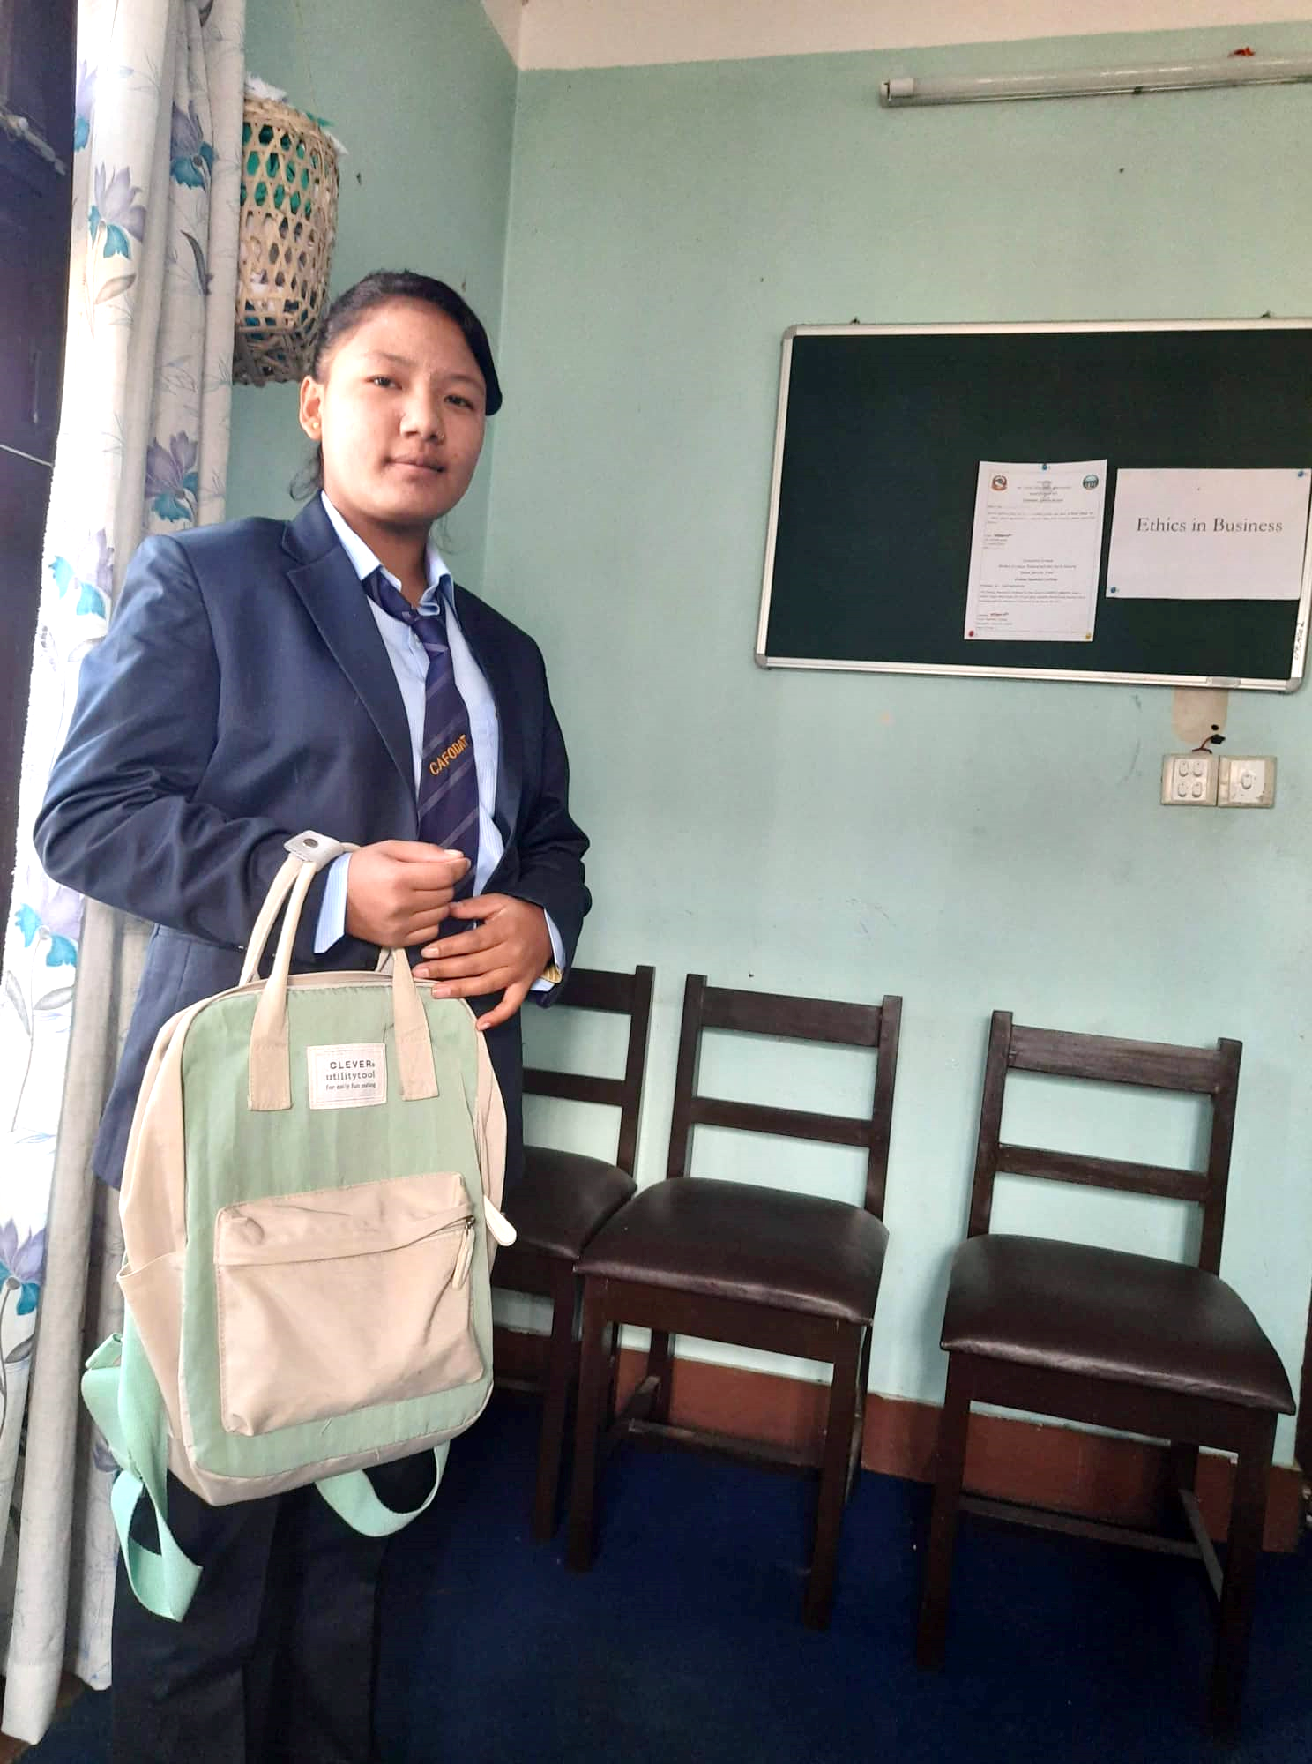
It was 2015 when Console Mission reached her village, Bulakhi Chawor, in the hills. From her village, at about 2000–3000 meters, there is another hill where a plane had once crashed.
At first, Sirjana was just another scholarship student for CoMi. Later, the village seniors shared that she had two younger brothers. Her father had migrated abroad as a laborer, and her mother remarried, leaving the three children behind. The village was caring for them, but when CoMi began supporting the siblings, hope was raised.
In grade 9 and 10, Sirjana nearly left school because she heard she needed paid coaching. CoMi provided that support, and she graduated in 2018. For further study, she needed more funds and had to move to the urban area to manage everything. She was told she could get a job, but instead she came to CoMi’s office for the first time. Sharing her reality, it became clear that rumors about her mother’s support were false.
To join a technical course, her math grade was insufficient, so she needed tuition. She lived at CoMi’s flat—where the office was located—cooking in the small kitchen and sleeping in one of the rooms. She became an inspiration for CoMi and her entire village.
Sirjana studied Food and Technology, learning about dairy production and brewing. She even interned at Chaudhary Group’s plant. Though her father remarried, she supported that family too. After completing her study, she could not stay long in her village. She married, and now, with her child and while her husband is away, she has a job. She also helped her brothers continue their studies, managing funds with Console Mission’s support.

a Pakistan International Airlines (PIA) plane did crash at Bhattedanda, Nepal. This was Flight 268, an Airbus A300B4-103, which crashed on 28 September 1992 while approaching Kathmandu’s Tribhuvan International Airport. Tragically, all 167 people on board (155 passengers and 12 crew) lost their lives, making it the deadliest aviation accident in Nepal’s history.

