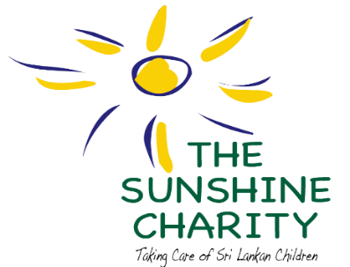

Sambalthivu, Trincomalee
www.sunshinecharity.org

The Sunshine Charity was founded in the aftermath of the December 2004 tsunami to take care of children affected by the devastation through the establishment of a day care centre in Sambalthivu, Trincomalee District, Eastern Province, Sri Lanka. In 2019, The day care centre was granted pre-school status by the Pre-school Education Bureau of The Eastern Provincial Council. Today, the 50 vulnerable children attending, include orphaned, abandoned and those affected by poverty. With generous funding received from local philanthropists and international donors, the centre provides the children with day-care facilities, preschool education and educational material, creative opportunities, uniforms, English language classes, the mid-day meal and milk programme, medical programmes including pharmaceutical drugs and worming treatment, footwear to prevent worm infection, health camps including eye and dental examinations.
Additionally, the Charity has empowered members of staff through teacher training programmes, which have encouraged the teachers to be engaging, committed, and understanding of the children's needs. The Sunshine Charity has also conducted numerous workshops for the mothers of the children on health and wellbeing, nutritional needs of children, oral hygiene, prevention of child sexual exploitation, abuse, and trafficking. Field visits to the homes of the beneficiaries have supported the monitoring and evaluation of these programmes through which, the organization seeks to strengthen the capacity and improve the lives of the children and their families.
The Sunshine Charity is a charitable, not-for-profit civil society organization (CSO), registered in Sri Lanka by a Trust Deed (Deed no: 2019 dated 30 December 2005 and Deed no: 234 dated 8th February 2011) and managed by five Trustees who are directly engaged with the children and their families on a voluntary basis. The organization has adopted the child rights and child protection policies accordingly.

