Water scarcity in western Uganda.

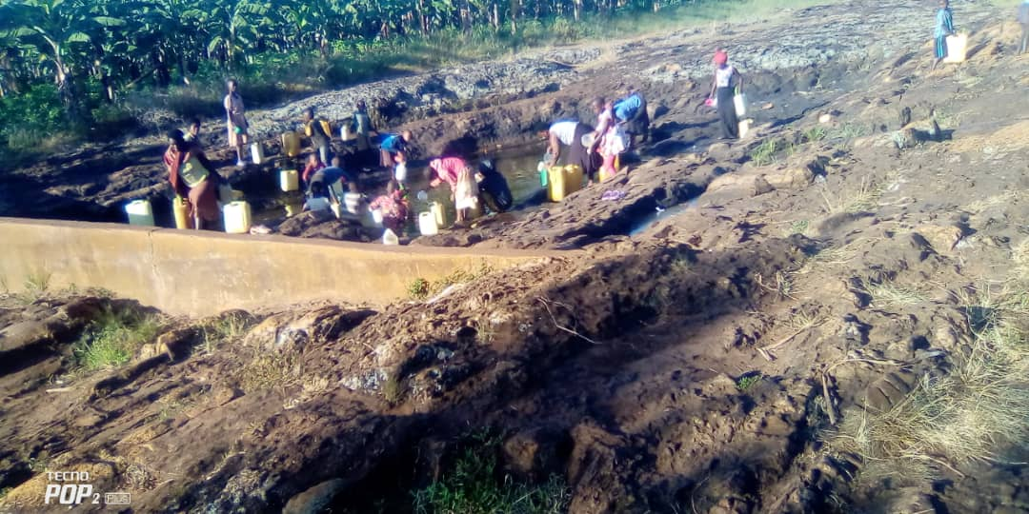

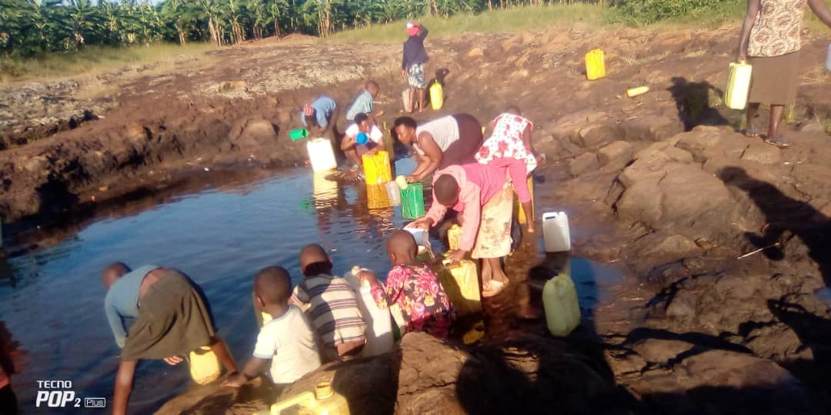

*People competing for water.*

In western Uganda particularly in isingiro district, its mountainous areas where they always have water scarcity during dry season.

There's season water sources where rain water collects itself in one place.

This water source usually serve a big population of around 20000 people and they end up drying up early.

After these water sources dry up, the community walks 10 kilometers to fetch water which is long distance.

This is very risk to younger girls and women walking long distances.