This forward-looking plan strengthens the foundation of the Preventive Initiative by leveraging existing community structures to ensure long-term protection for children across South Lalitpur.

Strategic Plan: May – August 2026

1. Expansion to 21 Villages
The primary goal is to scale the "Ghurdum Model" to reach all 21 villages in the target rural municipalities. By moving beyond the initial foothold, Console Mission aims to create a district-wide safety net against social vulnerabilities like human trafficking, child labor, and domestic servitude.

2. Establishing the Community Learning Centre (CLC) Network
To provide consistent "Consoling" and academic support, the plan involves establishing seven Community Learning Centres.
- The "1 for 3" Model: Each centre will serve a cluster of three villages, ensuring geographic accessibility for all children.
- Resource Sharing: These centres will act as hubs for the "Our Study Place" initiative, providing a physical symbol of hope and safety.

3. Forming People’s Committees
Sustainability is driven by local participation rather than massive outside investment.
- Governance: A People’s Committee will be formed for each cluster to oversee the CLC and monitor at-risk children.
- Local Leadership: Following the example in Ghurdum, these committees will prioritize the participation of local women and parents who understand the specific risks of the area, such as the pressure for youth migration.

4. Engaging Female Community Health Volunteers (FCHVs)
Console Mission recognizes that Female Community Health Volunteers (FCHVs) are the most effective agents for change due to their deep community roots and existing trust.
- Strategic Partnership: Interacting with local Health Posts is essential to integrate child protection with community health.
- Agents of Prevention: FCHVs will be trained to identify not just health issues, but social risks—acting as an "early warning system" for families facing the kind of economic despair that often leads to child labor or early marriage.

Summary of Objectives for the Next Period
Goal | Action Item
Reach | Expand from 1 village (Ghurdum) to all 21 villages.
Infrastructure | Launch at least 7 Community Learning Centres (1 per 3 villages).
Collaboration | Formalize partnerships with local Health Posts and FCHV networks.
Governance | Establish People’s Committees to ensure local ownership and sustainability.
Note to Donors: This expansion is not just about growth; it is about building a sustainable, locally-led defense system for the children of South Lalitpur. Your support helps us move from one rented room to a network of hope across 21 villages.

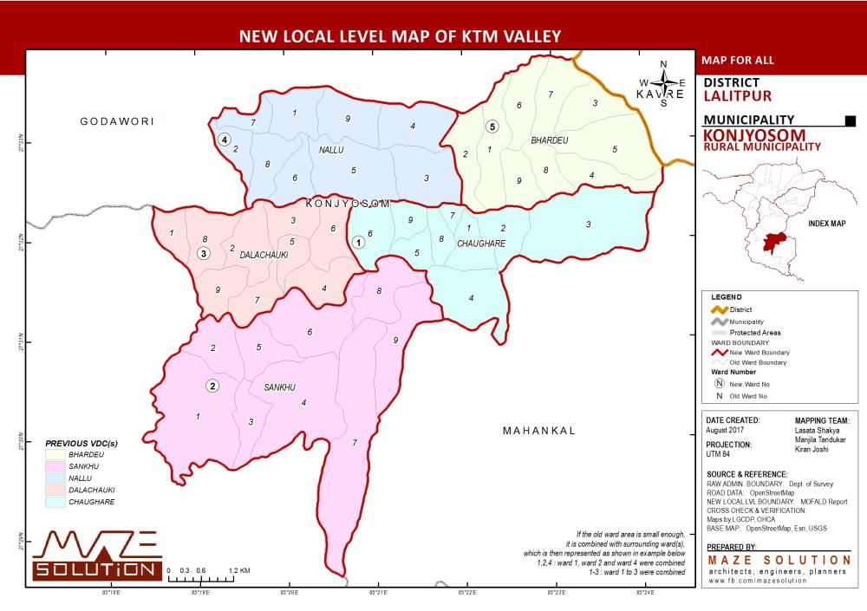
Figure 1: Current maps of Chaughare Ward (Konjyosom RM) focus on temples (numbered 1–9). Console Mission is updating this data to include 21 villages, focusing on the demographics and educational needs of the local youth population (ages 0–22) to drive our Community Learning Centre strategy.
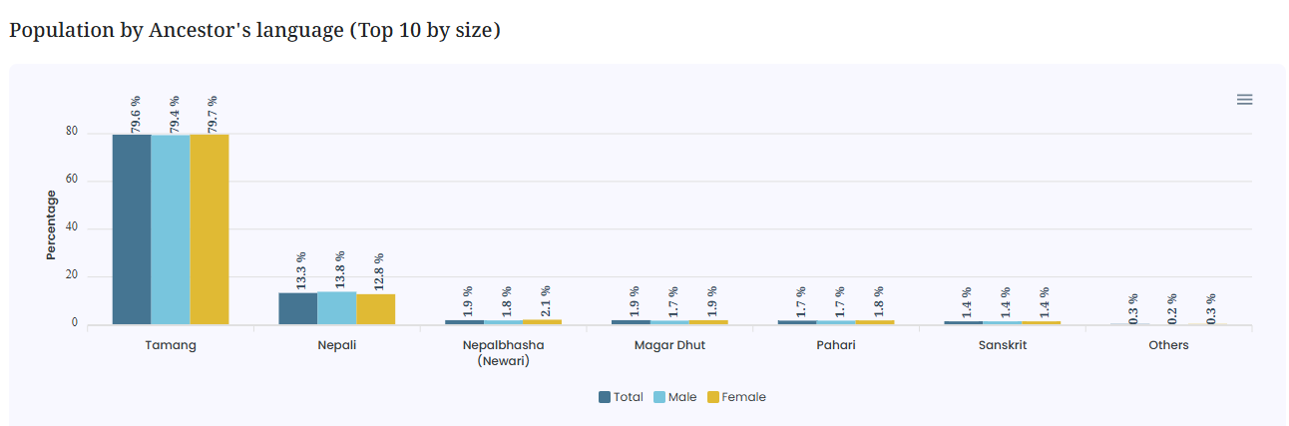
Figure 2: Tamang speakers represent the vast majority in South Lalitpur. By documenting this demographic (81% tribal/ethnic overall), Console Mission ensures that our expansion into 21 villages respects local ancestry while providing the necessary literacy and protection status to navigate the modern risks of labor and migration.

