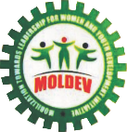
MOBILIZATION TOWARDS LEADERSHIP FOR WOMEN AND YOUTHS DEVELOPMENT INITIATIVE (MOLDEV)

PROJECT TITLE
NUTRITIONAL FOOD FOR 3700 INTERNALLY DISPLACE AND MALNOURISHED CHILDREN

SUMMARY
This project will provide nutritional food to 3700 internally displaced and malnourished children as a result of terrorist’s attacks on 74 villages between May and June, 2023 to February and August, 2024 in Mangu and Bokkos local governments of Plateau State Nigeria. The children, ages 5-10 years, are facing starvation and acute malnutrition due to poor feeding in the IDP camps, making their body vulnerable to illness and the long term effect can be devastating.
A meal per day for these children will not only save and sustain their body system, but will translate to better nutrition, healthier children and invariably better future.
CHALLENGES
Over 3000 children have been displaced and living in temporary shelter(internally displaced persons camps) without proper feeding due to the killing of some of their parents and the destruction of means of livelihood. Therefore, this provision will help provide nutritional food and improve children's nutrition. They are in dire need of nutritional foods to sustain their health while waiting for a permanent solution.
SOLUTION
This project will provide nutritional meals to 3700 facing starvation and malnutrition in the IDP Camps. It will mitigate hunger, and malnutrition and improve the health and well-being of the displaced children.
LONG-TERM IMPACT
Nutritional food will build a healthy immune and body system in the children for healthy growth and development. It will strengthen their mental and general wellbeing thereby helping them to stay focused on other restoration and resettlement efforts by their immediate communities. It will also inculcate the virtues of love and support for one another and build the spirit of unity among the children growing up. It will strengthen their confidence and hope for a better future
RESOURCE MOBILIZATION EFFORTS
We have partnered crowdfunding platforms to raise the needed funds to accomplish the project goal and objectives. These include-:
- Partnership with Global Giving: The project has been uploaded and promoted to prospective donors and philanthropists around the whole to make donations to provide nutritional food for the displaced children in IDP camps. Some of the major campaign that featured the project on global giving include, little by little campaign and Giving Tuesday. In the cause of these campaigns, a total of USD 10(Ten Dollars) worth of financial donation was raised through the global giving crowdfunding platform.
The goal of the project is to raise $13,307 to provide nutritional food to 3700 displaced and malnourished children in mangu local government, plateau state Nigeria.

- Networking with Local friends and volunteers: Apart from the crowdfunding initiative, we have also reached out to friends and volunteers to support the fundraising goal of the project. This has provided us with the following items in support of the project goal and other pressing needs in the IDP Camp.
- 14 Wheel chairs for displaced people living with disability in the IDP Camp.
- 2 bags of Garri (Cassava Produce)
- 1 bag of sugar
- 3 bags of clothes
- 1 bag of shoes
- 56 blankets(sleeping Aid)
- 6 cartons of 6x40 biscuits food
These items were collected and distributed to the beneficiaries in the IDP Camp.
RISING CHALLENGES
While these efforts are being made to tackle the documented challenges, the attacks continues unabated on more communities in mangu and other nearby local governments leading to more deaths and increased number of displaced children in the IDP Camps. The demand for food has increased and the risk of malnutrition is on the rise therefore, the need to urgently achieve the existing goal of this project becomes imperative to cushion the effect of the hardship being faced by these children.
An estimated 10, 000 people has been reportedly displaced from 24th to 26 December, 2023 following another terrorist attacks on 20 villages. Over 200 people lost their lives to the attacks, mostly women and children. At least 2000 people sustained bullets and other various degrees of injuries and currently being treated in hospitals. Over 300 houses were completely burnt down by the terrorists.
As at the time of filing this quarterly project report, additionally 1200 children have been displaced to more IDP Camps in the local government area bringing the total number of children in need of nutritional meal to 3700.
OUR PLAN AND EXPECTATION
With the current challenges facing the implementation of this project in terms of lack of resources and the increase number of displaced children, we will be conducting another need assessment in the IDP camp to ascertain the actual number of displaced children following the renewed attacks carried out on more communities. This is necessary to review the current project goal and the number of displaced children in dire needs of this intervention.
We remain committed to participating in all global giving funding campaigns in 2024 with a view to reaching the project goal.
We will also be expanding our network of friends and volunteers to support the project goal and needs.
Our expectation is to reach the project goal by the first quarter of 2025.
THANK YOU
We are sincerely grateful to our donors for their support and kindness towards the victims in this project. We remain committed to ensure that, your contributions are always channel to the right cause at the right time.
PROJECT BUDGET:
SN | ITEM | NO. OF PERSONS | Unit Cost NGN | No. of  Days | No. of Months | Cost  NGN | Cost  USD
1 | Enhanced Cereals | 3700 | 1500.00 |  | 3 | 16, 650,000.00 | 10, 406.5
2 | Staff Stipends | 7 | 20,000 |  | 1 | 140,000.00 | 151.35
3 | Transportation |  | 80,000 | 1 |  | 80,000.00 | 50.00
4 | Refreshment | 3800 | 200 | 1 |  | 760,000.00 | 475
 | TOTAL |  |  |  |  | 17, 630,000.00 | 11,019.00
NOTE: 1 USD=1600 NGN As at November 2024
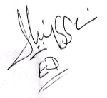

Comr. Ladi Iliya
Founder/Executive Director
ANNEX.
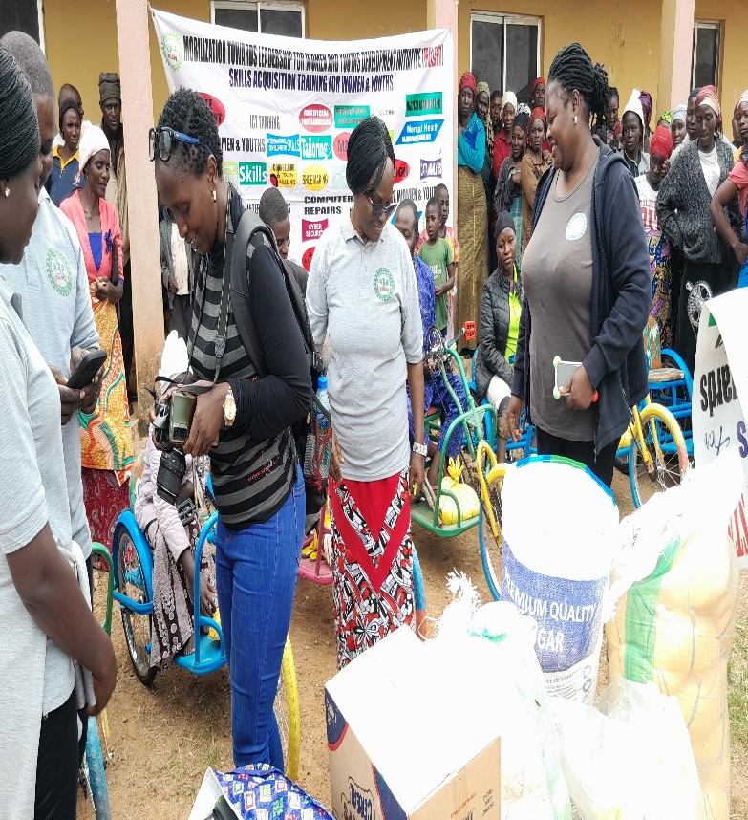
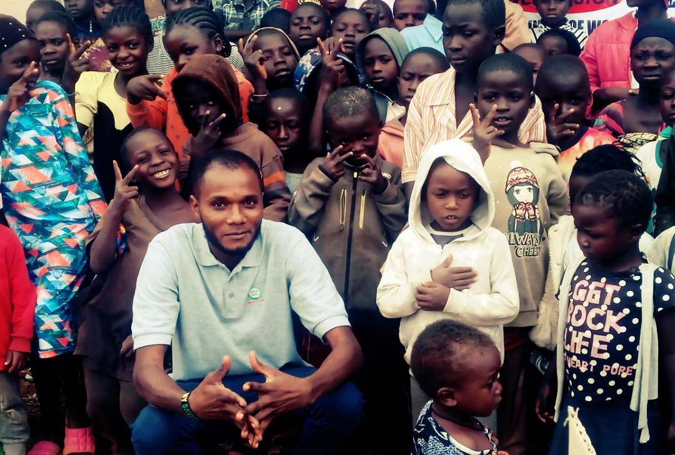
PICTURES GALLERY OF DISPLACED PERSONS IN THE CAMP DURING OUR VISIT

