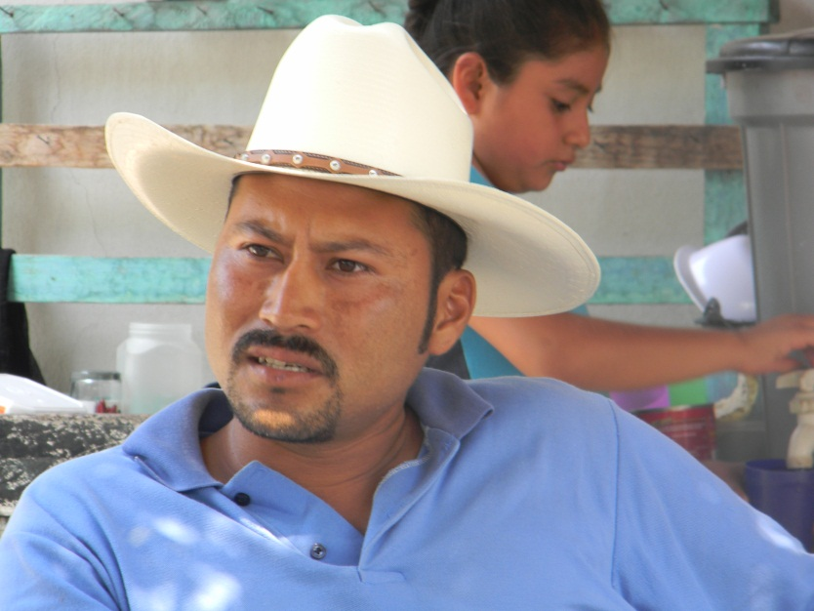
Mr. Ricardo Barrera

Mr. Ricardo Barrera is a member of the La Libertad community at the Jiquipilas county in Chiapas, Mexico. Before Fundacion came to his community with the Educampo program, he used to be part of other program in which he harvested less than 3 tons/ha. In 2007, he decided to give the Educampo program a try and became part of a group called “La Libertad”, currently in the process of creation as a legal entity.
At the beginning he started with the program with only 3 hectares and has increased his productivity to over 5 tons/ha average. Because of the earnings Ricardo has had in the past years for this 2011 spring-summer cycle, he is able to work on 14 hectares. However, Ricardo does not have land of his own and he has been renting some neighboring lands.
Ricardo lives with his parents and helps them out in their everyday expenses. In addition, he has seen that the earnings he has received for the past years which have allowed him to rent additional plots and make improvements to his parents´ home; he is currently saving to acquire a parcel of his own so he can continue working with Educampo.
Ricardo has now realized that working in the field, does give you a profit and allows you to live well. However, he says, you need to put your work, your biggest effort and your heart into it but it pays off. Whenever his neighbors tell him that agriculture is not a way to make a living, he replies that they are not invested in what they do and that Educampo gives you the opportunity to develop skills for everyday life, but most of all, Educampo makes you responsible for your own development.
Ricardo is soon to be married to his girlfriend Laura and expects to be working in Educampo for a long time.
Educampo for 2011 spring-summer cycle
- Fundacion has started the 2011 agricultural cycle working with 521 farmers and 2,986 hectares.
- Inputs have been delivered to participating farmers and everyone is hoping for a good year—not too much rain but not too dry either.
- As in previous years, our work includes mentoring and training, farm inputs financing; commercialization; and human and social development for grower´s organization. We are expecting a productivity of 5.5 – 6 ton/ha which will have a direct impact on the family income.
- We are still working with over 40 solidarity groups and our goal is to have them formally established, open their bank account and negotiate directly with the buyers. Our goal is to include these groups into modern economy so they can also increase their quality of life.

Your contribution to our project will allow us keep working in Chiapas with Ricardo and other low-income farmers. Our goal is to have farmers remain in Mexico, working in the fields and earning an income that will allow them to increase their quality of life.
We know there are a lot of other ways you could spend your money, but you believe in our cause and we invite you to keep investing in our project. Please consider telling your friends and family about our Educampo Chiapas project - share the link on your blogs or social networks, use the tell-a-friend feature on the project page to email your network, or just bring us up in conversation.
Was this information helpful? Do you still have questions? Send us your comments to fundacion@sembrandotrabajo.org.mx

